Table of Contents
UNITED STATES
SECURITIES AND EXCHANGE COMMISSION
Washington, D.C. 20549
Form 10-Q
(Mark One)
x |  |  | QUARTERLY REPORT PURSUANT TO SECTION 13 OR 15(d) OF THE SECURITIES EXCHANGE ACT OF 1934
For the quarterly period ended March 31, 2024
or
o |  |  | TRANSITION REPORT PURSUANT TO SECTION 13 OR 15(d) OF THE SECURITIES EXCHANGE ACT OF 1934
For the transition period from to
Commission file number: 001-35666
Summit Midstream Partners, LP
(Exact name of registrant as specified in its charter)
Delaware
(State or other jurisdiction of
incorporation or organization)
910 Louisiana Street, Suite 4200
Houston, TX
(Address of principal executive offices)
45-5200503
(I.R.S. Employer
Identification No.)

77002
(Zip Code)
(832) 413-4770
(Registrant’s telephone number, including area code)
Not applicable
(Former name, former address and former fiscal year, if changed since last report)
Securities registered pursuant to Section 12(b) of the Act:
Title of each class |  |  | Trading Symbol(s) |  |  | Name of each exchange on which registered
Common Units |  |  | SMLP |  |  | New York Stock Exchange
Indicate by check mark whether the registrant (1) has filed all reports required to be filed by Section 13 or 15(d) of the Securities Exchange Act of 1934 during the preceding 12 months (or for such shorter period that the registrant was required to file such reports), and (2) has been subject to such filing requirements for the past 90 days. x Yes o No
Indicate by check mark whether the registrant has submitted electronically every Interactive Data File required to be submitted pursuant to Rule 405 of Regulation S-T (§232.405 of this chapter) during the preceding 12 months (or for such shorter period that the registrant was required to submit such files).
x |  |  | Yes |  |  | o |  |  | No
Indicate by check mark whether the registrant is a large accelerated filer, an accelerated filer, a non-accelerated filer, smaller reporting company, or an emerging growth company. See the definitions of “large accelerated filer,” “accelerated filer,” “smaller reporting company,” and "emerging growth company" in Rule 12b-2 of the Exchange Act.
Large accelerated filer |  |  | ☐ |  |  | Accelerated filer |  |  | x
Non-accelerated filer |  |  | ☐ |  |  | Smaller reporting company |  |  | x
Emerging growth company |  |  | ☐
If an emerging growth company, indicate by check mark if the registrant has elected not to use the extended transition period for complying with any new or revised financial accounting standards provided pursuant to Section 13(a) of the Exchange Act. o
Indicate by check mark whether the registrant is a shell company (as defined in Rule 12b-2 of the Exchange Act). ☐ Yes x No
Indicate the number of shares outstanding of each of the issuer’s classes of common stock, as of the latest practicable date.
Class |  |  |  |  |  | As of April 30, 2024
Common Units |  |  |  |  |  | 10,648,685 units

Table of Contents
TABLE OF CONTENTS
COMMONLY USED OR DEFINED TERMS |  |  |  |  |  | 2
PART I |  |  | FINANCIAL INFORMATION
Item 1. |  |  | Financial Statements.
 |  |  | Unaudited Condensed Consolidated Balance Sheets. |  |  | 6
 |  |  | Unaudited Condensed Consolidated Statements of Operations. |  |  | 7
 |  |  | Unaudited Condensed Consolidated Statements of Partners' Capital. |  |  | 8
 |  |  | Unaudited Condensed Consolidated Statements of Cash Flows. |  |  | 9
 |  |  | Notes to Unaudited Condensed Consolidated Financial Statements. |  |  | 10
Item 2. |  |  | Management’s Discussion and Analysis of Financial Condition and Results of Operations. |  |  | 23
Item 3. |  |  | Quantitative and Qualitative Disclosures about Market Risk. |  |  | 42
Item 4. |  |  | Controls and Procedures. |  |  | 42
PART II |  |  | OTHER INFORMATION |  |  | 43
Item 1. |  |  | Legal Proceedings. |  |  | 43
Item 1A. |  |  | Risk Factors. |  |  | 44
Item 5. |  |  | Other Information. |  |  | 44
Item 6. |  |  | Exhibits. |  |  | 45
SIGNATURES |  |  |  |  |  | 46

1
Table of Contents
COMMONLY USED OR DEFINED TERMS
2015 Blacktail Release |  |  | a 2015 rupture of our four-inch produced water gathering pipeline near Williston, North Dakota
2022 DJ Acquisitions |  |  | the acquisition of Outrigger DJ Midstream LLC from Outrigger Energy II LLC, and each of Sterling Energy Investments LLC, Grasslands Energy Marketing LLC and Centennial Water Pipelines LLC from Sterling Investment Holdings LLC
2025 Senior Notes |  |  | Summit Holdings' and Finance Corp.’s 5.75% senior unsecured notes due April 2025
2026 Secured Notes |  |  | Summit Holdings' and Finance Corp.’s 8.500% senior secured second lien notes due October 2026
2026 Secured Notes Indenture |  |  | Indenture, dated as of November 2, 2021, by and among Summit Holdings, Finance Corp., the guarantors party thereto and Regions Bank, as trustee
2026 Unsecured Notes |  |  | Summit Holdings’ and Finance Corp.’s 12.00% senior unsecured notes due October 2026
ABL Agreement |  |  | Loan and Security Agreement, dated as of November 2, 2021, among Summit Holdings, as borrower, SMLP and certain subsidiaries from time to time party thereto, as guarantors, Bank of America, N.A., as agent, ING Capital LLC, Royal Bank of Canada and Regions Bank, as co-syndication agents, and Bank of America, N.A., ING Capital LLC, RBC Capital Markets and Regions Capital Markets, as joint lead arrangers and joint bookrunners
ABL Facility |  |  | the asset-based lending credit facility governed by the ABL Agreement
ASU |  |  | Accounting Standards Update
Bcf/d |  |  | one billion cubic feet per day
Board of Directors |  |  | the board of directors of our General Partner
Co-Issuers |  |  | Summit Holdings and Finance Corp., as co-issuers of the 2025 Senior Notes, the 2026  Unsecured Notes and the 2026 Secured Notes
condensate |  |  | a natural gas liquid with a low vapor pressure, mainly composed of propane, butane,  pentane and heavier hydrocarbon fractions
DFW Midstream |  |  | DFW Midstream Services LLC
DJ Basin |  |  | Denver-Julesburg Basin
Double E |  |  | Double E Pipeline, LLC
Double E Pipeline |  |  | a 135 mile, 1.35 Bcf/d, FERC-regulated interstate natural gas transmission pipeline that commenced operations in November 2021 and provides transportation service from multiple receipt points in the Delaware Basin to various delivery points in and around the Waha hub in Texas
Double E Project |  |  | the development and construction of the Double E Pipeline
EPA |  |  | Environmental Protection Agency
2
Table of Contents
EPU |  |  | earnings or loss per unit
FASB |  |  | Financial Accounting Standards Board
Finance Corp. |  |  | Summit Midstream Finance Corp.
fracking |  |  | the process of injecting liquid at high pressure into subterranean rocks, boreholes, etc. so as to force open existing fissures and extract oil or gas
frac-protect activities |  |  | activities that are designed to protect existing hydrocarbon wells from harm by shutting in existing hydrocarbon production until new well activities have concluded
GAAP |  |  | accounting principles generally accepted in the United States of America
General Partner |  |  | Summit Midstream GP, LLC
GP |  |  | general partner
Grand River |  |  | Grand River Gathering, LLC
Guarantor Subsidiaries |  |  | Grand River and its subsidiaries, DFW Midstream, Summit Marketing, OpCo, Meadowlark Midstream, Summit Permian II, LLC, Mountaineer Midstream, Epping Transmission Company, LLC, Red Rock Gathering, Polar Midstream, LLC and Summit Niobrara
Hub |  |  | geographic location of a storage facility and multiple pipeline interconnections
LIBOR |  |  | London Interbank Offered Rate
Mbbl/d |  |  | one thousand barrels per day
MD&A |  |  | Management's Discussion and Analysis of Financial Condition and Results of Operations
Meadowlark Midstream |  |  | Meadowlark Midstream Company, LLC
MMBTU |  |  | metric million British thermal units
MMcf/d |  |  | one million cubic feet per day
Mountaineer Midstream |  |  | Mountaineer Midstream Company, LLC
MVC |  |  | minimum volume commitment
NGLs |  |  | natural gas liquids; the combination of ethane, propane, normal butane, iso-butane and natural gasolines that when removed from unprocessed natural gas streams become liquid under various levels of higher pressure and lower temperature
NYSE |  |  | New York Stock Exchange
OCC |  |  | Ohio Condensate Company, L.L.C.
OGC |  |  | Ohio Gathering Company, L.L.C.
3
Table of Contents
Ohio Gathering |  |  | Ohio Gathering Company, L.L.C. and Ohio Condensate Company, L.L.C.
OpCo |  |  | Summit Midstream OpCo, LP
play |  |  | a proven geological formation that contains commercial amounts of hydrocarbons
Permian Holdco |  |  | Summit Permian Transmission Holdco, LLC
Permian Term Loan Facility |  |  | the term loan governed by the Credit Agreement, dated as of March 8, 2021, among Summit Permian Transmission, LLC, as borrower, MUFG Bank Ltd., as administrative agent, Mizuho Bank (USA), as collateral agent, ING Capital LLC, Mizuho Bank, Ltd. and MUFG Union Bank, N.A., as L/C issuers, coordinating lead arrangers and joint bookrunners, and the lenders from time to time party thereto
Permian Transmission Credit Facilities |  |  | the credit facilities governed by the Credit Agreement, dated as of March 8, 2021, among Summit Permian Transmission, LLC, as borrower, MUFG Bank Ltd., as administrative agent, Mizuho Bank (USA), as collateral agent, ING Capital LLC, Mizuho Bank, Ltd. and MUFG Union Bank, N.A., as L/C issuers, coordinating lead arrangers and joint bookrunners, and the lenders from time to time party thereto
produced water |  |  | water from underground geologic formations that is a by-product of natural gas and crude oil production
Red Rock Gathering |  |  | Red Rock Gathering Company, LLC
Revolving Credit Facility |  |  | the Third Amended and Restated Credit Agreement dated as of May 26, 2017, as amended by the First Amendment to Third Amended and Restated Credit Agreement dated as of September 22, 2017, the Second Amendment to Third Amended and Restated Credit Agreement dated as of June 26, 2019, the Third Amendment to Third Amended and Restated Credit Agreement dated as of December 24, 2019 and the Fourth Amendment to Third Amended and Restated Credit Agreement dated as of December 18, 2020
SEC |  |  | Securities and Exchange Commission
Securities Act |  |  | Securities Act of 1933, as amended
segment adjusted EBITDA |  |  | total revenues less total costs and expenses; plus (i) other income excluding interest income, (ii) our proportional adjusted EBITDA for equity method investees, (iii) depreciation and amortization, (iv) adjustments related to MVC shortfall payments, (v) adjustments related to capital reimbursement activity, (vi) unit-based and noncash compensation, (vii) impairments and (viii) other noncash expenses or losses, less other noncash income or gains
Senior Notes |  |  | The 2025 Senior Notes and the 2026 Secured Notes, collectively
Series A Preferred Units |  |  | Series A Fixed-to-Floating Rate Cumulative Redeemable Perpetual Preferred Units issued  by the Partnership
shortfall payment |  |  | the payment received from a counterparty when its volume throughput does not meet its MVC for the applicable period
SMLP |  |  | Summit Midstream Partners, LP
SMLP LTIP |  |  | SMLP Long-Term Incentive Plan
4
Table of Contents
SOFR |  |  | Secured Overnight Financing Rate
Subsidiary Series A Preferred Units |  |  | Series A Fixed Rate Cumulative Redeemable Preferred Units issued by Permian Holdco
Summit Holdings |  |  | Summit Midstream Holdings, LLC
Summit Investments |  |  | Summit Midstream Partners, LLC
Summit Marketing |  |  | Summit Midstream Marketing, LLC
Summit Niobrara |  |  | Summit Midstream Niobrara, LLC
Summit Permian II |  |  | Summit Midstream Permian II, LLC
Summit Permian Transmission |  |  | Summit Permian Transmission, LLC
Summit Utica |  |  | Summit Midstream Utica, LLC
the Partnership |  |  | Summit Midstream Partners, LP and its subsidiaries
the Partnership Agreement |  |  | the Fourth Amended and Restated Agreement of Limited Partnership of the Partnership dated May 28, 2020, as amended
throughput volume |  |  | the volume of natural gas, crude oil or produced water gathered, transported or passing through a pipeline, plant or other facility during a particular period; also referred to as volume throughput
unconventional resource basin |  |  | a basin where natural gas or crude oil production is developed from unconventional sources that require hydraulic fracturing as part of the completion process, for instance, natural gas produced from shale formations and coalbeds; also referred to as an unconventional resource play
wellhead |  |  | the equipment at the surface of a well, used to control the well's pressure; also, the point at which the hydrocarbons and water exit the ground

5
Table of Contents
PART I - FINANCIAL INFORMATION

Item 1. Financial Statements.

SUMMIT MIDSTREAM PARTNERS, LP AND SUBSIDIARIES
UNAUDITED CONDENSED CONSOLIDATED BALANCE SHEETS
 |  |  | March 31,  2024 |  |  |  |  |  | December 31,  2023
 |  |  | (In thousands, except unit amounts)
ASSETS
Cash and cash equivalents |  |  | $ | 344,590 |  |  |  |  | $ | 14,044
Restricted cash |  |  | 3,454 |  |  |  |  |  | 2,601
Accounts receivable |  |  | 66,587 |  |  |  |  |  | 76,275
Other current assets |  |  | 5,935 |  |  |  |  |  | 5,502
Total current assets |  |  | 420,566 |  |  |  |  |  | 98,422
Property, plant and equipment, net |  |  | 1,447,443 |  |  |  |  |  | 1,698,585
Intangible assets, net |  |  | 147,304 |  |  |  |  |  | 175,592
Investment in equity method investees |  |  | 273,476 |  |  |  |  |  | 486,434
Other noncurrent assets |  |  | 31,786 |  |  |  |  |  | 35,165
TOTAL ASSETS |  |  | $ | 2,320,575 |  |  |  |  | $ | 2,494,198
LIABILITIES AND CAPITAL
Trade accounts payable |  |  | $ | 18,063 |  |  |  |  | $ | 22,714
Accrued expenses |  |  | 36,554 |  |  |  |  |  | 32,377
Deferred revenue |  |  | 8,899 |  |  |  |  |  | 10,196
Ad valorem taxes payable |  |  | 3,282 |  |  |  |  |  | 8,543
Accrued compensation and employee benefits |  |  | 2,824 |  |  |  |  |  | 6,815
Accrued interest |  |  | 44,826 |  |  |  |  |  | 19,298
Accrued environmental remediation |  |  | 1,854 |  |  |  |  |  | 1,483
Accrued settlement payable |  |  | 6,667 |  |  |  |  |  | 6,667
Current portion of long-term debt |  |  | 29,098 |  |  |  |  |  | 15,524
Other current liabilities |  |  | 7,476 |  |  |  |  |  | 10,395
Total current liabilities |  |  | 159,543 |  |  |  |  |  | 134,012
Long-term debt, net of issuance costs |  |  | 1,127,287 |  |  |  |  |  | 1,455,166
Noncurrent deferred revenue |  |  | 28,761 |  |  |  |  |  | 30,085
Noncurrent accrued environmental remediation |  |  | 1,278 |  |  |  |  |  | 1,454
Other noncurrent liabilities |  |  | 28,298 |  |  |  |  |  | 30,266
TOTAL LIABILITIES |  |  | 1,345,167 |  |  |  |  |  | 1,650,983
Commitments and contingencies (Note 14)
Mezzanine Capital
Subsidiary Series A Preferred Units (93,039 units issued and outstanding at March 31, 2024 and December 31, 2023) |  |  | 126,794 |  |  |  |  |  | 124,652
Partners' Capital
Series A Preferred Units (65,508 units issued and outstanding at March 31, 2024 and December 31, 2023) |  |  | 100,113 |  |  |  |  |  | 96,893
Common limited partner capital (10,648,685 and 10,376,189 units issued and outstanding at March 31, 2024 and December 31, 2023, respectively) |  |  | 748,501 |  |  |  |  |  | 621,670
Total partners' capital |  |  | 848,614 |  |  |  |  |  | 718,563
TOTAL LIABILITIES AND CAPITAL |  |  | $ | 2,320,575 |  |  |  |  | $ | 2,494,198
The accompanying notes are an integral part of these unaudited condensed consolidated financial statements.

6
Table of Contents
SUMMIT MIDSTREAM PARTNERS, LP AND SUBSIDIARIES
UNAUDITED CONDENSED CONSOLIDATED STATEMENTS OF OPERATIONS
Three Months Ended
March 31,
 |  |  |  |  |  |  | 2024 |  |  |  |  |  | 2023
 |  |  |  |  |  |  | (In thousands, except per-unit amounts)
Revenues:
Gathering services and related fees |  |  |  |  |  |  | $ | 61,985 |  |  |  |  | $ | 57,371
Natural gas, NGLs and condensate sales |  |  |  |  |  |  | 49,092 |  |  |  |  |  | 49,163
Other revenues |  |  |  |  |  |  | 7,794 |  |  |  |  |  | 5,965
Total revenues |  |  |  |  |  |  | 118,871 |  |  |  |  |  | 112,499
Costs and expenses:
Cost of natural gas and NGLs |  |  |  |  |  |  | 30,182 |  |  |  |  |  | 30,882
Operation and maintenance |  |  |  |  |  |  | 25,012 |  |  |  |  |  | 23,972
General and administrative |  |  |  |  |  |  | 14,785 |  |  |  |  |  | 9,987
Depreciation and amortization |  |  |  |  |  |  | 27,867 |  |  |  |  |  | 29,824
Transaction costs |  |  |  |  |  |  | 7,791 |  |  |  |  |  | 302
Acquisition integration costs |  |  |  |  |  |  | 40 |  |  |  |  |  | 1,502
Gain on asset sales, net |  |  |  |  |  |  | (27) |  |  |  |  |  | (68)
Long-lived asset impairments |  |  |  |  |  |  | 67,916 |  |  |  |  |  | —
Total costs and expenses |  |  |  |  |  |  | 173,566 |  |  |  |  |  | 96,401
Other income (expense), net |  |  |  |  |  |  | (13) |  |  |  |  |  | 56
Gain (loss) on interest rate swaps |  |  |  |  |  |  | 2,590 |  |  |  |  |  | (1,273)
Gain on sale of business |  |  |  |  |  |  | 86,202 |  |  |  |  |  | 18
Gain on sale of equity method investment |  |  |  |  |  |  | 126,261 |  |  |  |  |  | —
Interest expense |  |  |  |  |  |  | (37,846) |  |  |  |  |  | (34,223)
Income (loss) before income taxes and equity method investment income |  |  |  |  |  |  | 122,499 |  |  |  |  |  | (19,324)
Income tax benefit (expense) |  |  |  |  |  |  | (210) |  |  |  |  |  | 252
Income from equity method investees |  |  |  |  |  |  | 10,638 |  |  |  |  |  | 4,909
Net income (loss) |  |  |  |  |  |  | $ | 132,927 |  |  |  |  | $ | (14,163)
Less: Net income attributable to Subsidiary Series A Preferred Units |  |  |  |  |  |  | (3,770) |  |  |  |  |  | (1,746)
Net income (loss) attributable to Summit Midstream Partners, LP |  |  |  |  |  |  | $ | 129,157 |  |  |  |  | $ | (15,909)
Less: net income attributable to Series A Preferred Units |  |  |  |  |  |  | (3,220) |  |  |  |  |  | (2,639)
Net income (loss) attributable to common limited partners |  |  |  |  |  |  | $ | 125,937 |  |  |  |  | $ | (18,548)
Net income (loss) per limited partner unit:
Common unit – basic |  |  |  |  |  |  | $ | 12.05 |  |  |  |  | $ | (1.82)
Common unit – diluted |  |  |  |  |  |  | $ | 11.47 |  |  |  |  | $ | (1.82)
Weighted-average limited partner units outstanding:
Common units – basic |  |  |  |  |  |  | 10,449 |  |  |  |  |  | 10,213
Common units – diluted |  |  |  |  |  |  | 10,980 |  |  |  |  |  | 10,213
The accompanying notes are an integral part of these unaudited condensed consolidated financial statements.

7
Table of Contents
SUMMIT MIDSTREAM PARTNERS, LP AND SUBSIDIARIES
UNAUDITED CONDENSED CONSOLIDATED STATEMENTS OF PARTNERS' CAPITAL
 |  |  |  |  | Partners' Capital
 |  |  |  |  |  |  | Series A Preferred Units |  |  |  |  |  | Common Limited Partners Capital |  |  |  |  |  | Total
 |  |  |  |  |  |  | (In thousands)
Partners' capital, December 31, 2023 |  |  |  |  |  |  | $ | 96,893 |  |  |  |  | $ | 621,670 |  |  |  |  | $ | 718,563
Net income |  |  |  |  |  |  | 3,220 |  |  |  |  |  | 125,937 |  |  |  |  |  | 129,157
Unit-based compensation |  |  |  |  |  |  | — |  |  |  |  |  | 2,772 |  |  |  |  |  | 2,772
Tax withholdings and associated payments on vested SMLP LTIP awards |  |  |  |  |  |  | — |  |  |  |  |  | (1,878) |  |  |  |  |  | (1,878)
Partners' capital, March 31, 2024 |  |  |  |  |  |  | $ | 100,113 |  |  |  |  | $ | 748,501 |  |  |  |  | $ | 848,614

 |  |  |  |  | Partners' Capital
 |  |  |  |  |  |  | Series A Preferred Units |  |  |  |  |  | Common Limited Partners Capital |  |  |  |  |  | Total
 |  |  |  |  |  |  | (In thousands)
Partners' capital, December 31, 2022 |  |  |  |  |  |  | $ | 85,327 |  |  |  |  | $ | 679,491 |  |  |  |  | $ | 764,818
Net income (loss) |  |  |  |  |  |  | 2,639 |  |  |  |  |  | (18,548) |  |  |  |  |  | (15,909)
Unit-based compensation |  |  |  |  |  |  | — |  |  |  |  |  | 1,929 |  |  |  |  |  | 1,929
Tax withholdings and associated payments on vested SMLP LTIP awards |  |  |  |  |  |  | — |  |  |  |  |  | (1,136) |  |  |  |  |  | (1,136)
Partners' capital, March 31, 2023 |  |  |  |  |  |  | $ | 87,966 |  |  |  |  | $ | 661,736 |  |  |  |  | $ | 749,702
The accompanying notes are an integral part of these unaudited condensed consolidated financial statements.

8
Table of Contents
SUMMIT MIDSTREAM PARTNERS, LP AND SUBSIDIARIES
UNAUDITED CONDENSED CONSOLIDATED STATEMENTS OF CASH FLOWS
 |  |  | Three Months Ended March 31,
 |  |  | 2024 |  |  |  |  |  | 2023
 |  |  | (In thousands)
Cash flows from operating activities:
Net income (loss) |  |  | $ | 132,927 |  |  |  |  | $ | (14,163)
Adjustments to reconcile net loss to net cash provided by operating activities:
Depreciation and amortization |  |  | 28,102 |  |  |  |  |  | 30,059
Noncash lease expense |  |  | 1,009 |  |  |  |  |  | 784
Amortization of debt issuance costs |  |  | 3,505 |  |  |  |  |  | 3,161
Unit-based and noncash compensation |  |  | 2,772 |  |  |  |  |  | 1,929
Income from equity method investees |  |  | (10,638) |  |  |  |  |  | (4,909)
Distributions from equity method investees |  |  | 17,082 |  |  |  |  |  | 10,403
Gain on asset sales, net |  |  | (27) |  |  |  |  |  | (68)
Foreign currency (gain) loss |  |  | 19 |  |  |  |  |  | (32)
Gain on sale of business |  |  | (86,202) |  |  |  |  |  | —
Gain on sale of equity method investment |  |  | (126,261) |  |  |  |  |  | —
Unrealized (gain) loss on interest rate swaps |  |  | (1,244) |  |  |  |  |  | 2,417
Long-lived asset impairment |  |  | 67,916 |  |  |  |  |  | —
Changes in operating assets and liabilities:
Accounts receivable |  |  | 2,961 |  |  |  |  |  | 12,377
Trade accounts payable |  |  | (3,497) |  |  |  |  |  | 6,033
Accrued expenses |  |  | 3,833 |  |  |  |  |  | 2,816
Deferred revenue, net |  |  | (2,293) |  |  |  |  |  | (1,082)
Ad valorem taxes payable |  |  | (5,261) |  |  |  |  |  | (6,990)
Accrued interest |  |  | 25,528 |  |  |  |  |  | 21,961
Accrued environmental remediation, net |  |  | 195 |  |  |  |  |  | (289)
Other, net |  |  | (6,810) |  |  |  |  |  | (14,712)
Net cash provided by operating activities |  |  | 43,616 |  |  |  |  |  | 49,695
Cash flows from investing activities:
Proceeds from sale of business |  |  | 292,266 |  |  |  |  |  | —
Proceeds from sale of equity method investment |  |  | 332,734 |  |  |  |  |  | —
Capital expenditures |  |  | (16,398) |  |  |  |  |  | (16,438)
Proceeds from asset sale |  |  | 27 |  |  |  |  |  | —
Investment in Double E equity method investee |  |  | — |  |  |  |  |  | (3,500)
Other, net |  |  | — |  |  |  |  |  | (2,611)
Net cash provided by (used in) investing activities |  |  | 608,629 |  |  |  |  |  | (22,549)
Cash flows from financing activities:
Repayments on ABL Facility |  |  | (313,000) |  |  |  |  |  | (13,000)
Repayments on Permian Transmission Term Loan |  |  | (3,794) |  |  |  |  |  | (2,519)
Distributions on Subsidiary Series A Preferred Units |  |  | (1,628) |  |  |  |  |  | (1,628)
Debt issuance costs |  |  | — |  |  |  |  |  | (97)
Other, net |  |  | (2,424) |  |  |  |  |  | (150)
Net cash used in financing activities |  |  | (320,846) |  |  |  |  |  | (17,394)
Net change in cash, cash equivalents and restricted cash |  |  | 331,399 |  |  |  |  |  | 9,752
Cash, cash equivalents and restricted cash, beginning of period |  |  | 16,645 |  |  |  |  |  | 13,531
Cash, cash equivalents and restricted cash, end of period |  |  | $ | 348,044 |  |  |  |  | $ | 23,283
The accompanying notes are an integral part of these unaudited condensed consolidated financial statements.

9
Table of Contents
SUMMIT MIDSTREAM PARTNERS, LP AND SUBSIDIARIES
NOTES TO UNAUDITED CONDENSED CONSOLIDATED FINANCIAL STATEMENTS

1. ORGANIZATION, BUSINESS OPERATIONS AND PRESENTATION AND CONSOLIDATION
Organization. Summit Midstream Partners, LP (including its subsidiaries, collectively “SMLP” or the “Partnership”) is a Delaware limited partnership that was formed in May 2012 and began operations in October 2012. SMLP is a value-oriented limited partnership focused on developing, owning and operating midstream energy infrastructure assets that are strategically located in unconventional resource basins, primarily shale formations, in the continental United States. The Partnership’s business activities are primarily conducted through various operating subsidiaries, each of which is owned or controlled by its wholly owned subsidiary holding company, Summit Holdings, a Delaware limited liability company.
Business Operations. The Partnership provides natural gas gathering, compression, treating and processing services as well as crude oil and produced water gathering services pursuant to primarily long-term, fee-based agreements with its customers. In addition to these services, the Partnership also provides freshwater delivery services pursuant to short-term agreements with customers. The Partnership’s results are primarily driven by the volumes of natural gas that it gathers, compresses, treats and/or processes as well as by the volumes of crude oil and produced water that it gathers. As of March 31, 2024, other than the Partnership’s investment in Double E, all of its business activities are conducted through wholly owned operating subsidiaries.
Presentation and Consolidation. The Partnership prepares its condensed consolidated financial statements in accordance with GAAP as established by the FASB and pursuant to the rules and regulations of the SEC pertaining to interim financial information. The unaudited condensed consolidated financial statements contained in this report include all normal and recurring material adjustments that, in the opinion of management, are necessary for a fair statement of the financial position, results of operations and cash flows for the interim periods presented herein. These unaudited condensed consolidated financial statements and notes thereto should be read in conjunction with the consolidated financial statements and related notes that are included in the Partnership’s Annual Report on Form 10-K for the year ended December 31, 2023.
The Partnership makes estimates and assumptions that affect the reported amounts of assets and liabilities at the balance sheet dates, including fair value measurements, the reported amounts of revenues and expenses and the disclosure of commitments and contingencies. Although management believes these estimates are reasonable, actual results could differ from its estimates.
The unaudited condensed consolidated financial statements include the assets, liabilities and results of operations of SMLP and its subsidiaries. All intercompany transactions among the consolidated entities have been eliminated in consolidation. Comprehensive income or loss is the same as net income or loss for all periods presented.

2. SUMMARY OF SIGNIFICANT ACCOUNTING POLICIES AND RECENTLY ISSUED ACCOUNTING STANDARDS APPLICABLE TO THE PARTNERSHIP
There have been no changes to the Partnership’s significant accounting policies since December 31, 2023.
Accounting standards recently implemented. ASU No. 2020-06 Debt – Debt with Conversion and Other Options (Subtopic 470-20) and Derivatives and Hedging – Contracts in Entity’s Own Equity (Subtopic 815–40) (“ASU 2020-06”). ASU 2020-06 simplifies the accounting for certain financial instruments with characteristics of liabilities and equity, including convertible instruments and contracts on an entity’s own equity. The ASU is part of the FASB’s simplification initiative, which aims to reduce unnecessary complexity in GAAP. The ASU’s amendments are effective for fiscal years beginning after December 15, 2023, and interim periods within those fiscal years. The provisions of ASU 2020-06 did not have a material impact on the Partnership’s condensed consolidated financial statements and disclosures.
New accounting standards not yet implemented. ASU No. 2023-07, Segment Reporting (Topic 280): Improvements to Reportable Segment Disclosures (“ASU 2023-07”). ASU 2023-07 enhances disclosures on reportable segments and provides additional detailed information about significant segment expenses. The guidance in ASU 2023-07 is effective for fiscal years beginning after December 15, 2023 and interim periods within fiscal years beginning after December 15, 2024. The Partnership continues to assess the impact of the new guidance, but does not expect the provisions of ASU 2023-07 will have a material impact on its consolidated financial statements and disclosures.

10
Table of Contents
3. DIVESTITURES
Summit Utica Sale. On March 22, 2024, the Partnership completed the disposition of Summit Utica, LLC (“Summit Utica”) to a subsidiary of MPLX LP (“MPLX”) for a cash sale price of $625.0 million, subject to customary post-closing adjustments (the “Utica Sale”). Summit Utica is the owner of (i) approximately 36% of the issued and outstanding equity interests in OGC, (ii) approximately 38% of the issued and outstanding equity interests in OCC, together with OGC, Ohio Gathering and (iii) midstream assets located in the Utica Shale. Ohio Gathering is the owner of a natural gas gathering system and condensate stabilization facility located in Belmont and Monroe counties in the Utica Shale in southeastern Ohio.
During the quarterly period ended March 31, 2024, the Partnership recognized a total gain on the disposition of Summit Utica of $212.5 million based on total cash proceeds received of $625.0 million and net assets sold of $412.5 million. A portion of the cash proceeds was used to reduce amounts outstanding under the ABL Facility (see Note 8 - Debt, for additional information) and are subject to final working capital adjustments.
The $625.0 million sale price did not discretely list values for either OGC, OCC or the Partnership’s midstream assets located in the Utica Shale. Using fair value methods allowed by GAAP, the Partnership derived a preliminary fair value estimate for the disposed assets and then determined the appropriate gain recognition amount for each disposal to include in its unaudited condensed consolidated financial statements. The estimated fair values were determined utilizing a discounted cash flow technique based on estimated revenues, costs, capital expenditures and an appropriate discount rate. Given the unobservable nature of the inputs, the fair value measurement is deemed to use Level 3 inputs. These fair value estimates are preliminary, and subject to change and such changes could be material. Based on these preliminary fair values, the Partnership recognized a gain on the disposition of the Utica midstream business of $86.2 million, which is recorded within gain on sale of business in the unaudited condensed consolidated statements of operations, and a gain of $126.3 million related to the disposition of Ohio Gathering, which is recorded within gain on sale of equity method investment in the unaudited condensed consolidated statements of operations.

4. REVENUE
The following table presents estimated revenue expected to be recognized during the remainder of 2024 and over the remaining contract period related to performance obligations that are unsatisfied and are comprised of estimated MVC shortfall payments.
(In thousands) |  |  | 2024 |  |  |  |  |  | 2025 |  |  |  |  |  | 2026 |  |  |  |  |  | 2027 |  |  |  |  |  | 2028 |  |  |  |  |  | Thereafter
Gathering services and related fees |  |  | $ | 48,833 |  |  |  |  | $ | 45,594 |  |  |  |  | $ | 29,292 |  |  |  |  | $ | 7,685 |  |  |  |  | $ | 5,137 |  |  |  |  | $ | —
Revenue by category. In the following tables, revenue is disaggregated by geographic area and major products and services. For more detailed information about reportable segments, see Note 15 – Segment Information.
 |  |  | Three Months Ended March 31, 2024
 |  |  | Gathering services and related fees |  |  |  |  |  | Natural gas, NGLs and condensate sales |  |  |  |  |  | Other revenues |  |  |  |  |  | Total
 |  |  | (In thousands)
Reportable Segments:
Northeast |  |  | $ | 16,853 |  |  |  |  | $ | — |  |  |  |  | $ | — |  |  |  |  | $ | 16,853
Rockies |  |  | 16,516 |  |  |  |  |  | 47,970 |  |  |  |  |  | 4,108 |  |  |  |  |  | 68,594
Permian |  |  | — |  |  |  |  |  | — |  |  |  |  |  | 910 |  |  |  |  |  | 910
Piceance |  |  | 20,387 |  |  |  |  |  | 948 |  |  |  |  |  | 1,245 |  |  |  |  |  | 22,580
Barnett |  |  | 8,229 |  |  |  |  |  | 174 |  |  |  |  |  | 1,457 |  |  |  |  |  | 9,860
Total reportable segments |  |  | 61,985 |  |  |  |  |  | 49,092 |  |  |  |  |  | 7,720 |  |  |  |  |  | 118,797
Corporate and other |  |  | — |  |  |  |  |  | — |  |  |  |  |  | 74 |  |  |  |  |  | 74
Total |  |  | $ | 61,985 |  |  |  |  | $ | 49,092 |  |  |  |  | $ | 7,794 |  |  |  |  | $ | 118,871
11
Table of Contents
 |  |  | Three Months Ended March 31, 2023
 |  |  | Gathering services and related fees |  |  |  |  |  | Natural gas, NGLs and condensate sales |  |  |  |  |  | Other revenues |  |  |  |  |  | Total
 |  |  | (In thousands)
Reportable Segments:
Northeast |  |  | $ | 12,755 |  |  |  |  | $ | — |  |  |  |  | $ | — |  |  |  |  | $ | 12,755
Rockies |  |  | 15,303 |  |  |  |  |  | 47,329 |  |  |  |  |  | 2,619 |  |  |  |  |  | 65,251
Permian |  |  | — |  |  |  |  |  | — |  |  |  |  |  | 893 |  |  |  |  |  | 893
Piceance |  |  | 19,119 |  |  |  |  |  | 1,641 |  |  |  |  |  | 1,426 |  |  |  |  |  | 22,186
Barnett |  |  | 10,194 |  |  |  |  |  | 193 |  |  |  |  |  | 1,064 |  |  |  |  |  | 11,451
Total reportable segments |  |  | 57,371 |  |  |  |  |  | 49,163 |  |  |  |  |  | 6,002 |  |  |  |  |  | 112,536
Corporate and other |  |  | — |  |  |  |  |  | — |  |  |  |  |  | (37) |  |  |  |  |  | (37)
Total |  |  | $ | 57,371 |  |  |  |  | $ | 49,163 |  |  |  |  | $ | 5,965 |  |  |  |  | $ | 112,499

5. PROPERTY, PLANT AND EQUIPMENT
Details on the Partnership’s property, plant and equipment follow.
 |  |  | March 31, 2024 |  |  |  |  |  | December 31, 2023
 |  |  | (In thousands)
Gathering and processing systems and related equipment |  |  | $ | 2,124,517 |  |  |  |  | $ | 2,335,980
Construction in progress |  |  | 41,888 |  |  |  |  |  | 56,064
Land and line fill |  |  | 11,546 |  |  |  |  |  | 11,534
Other |  |  | 64,319 |  |  |  |  |  | 65,029
Total |  |  | 2,242,270 |  |  |  |  |  | 2,468,607
Less: accumulated depreciation |  |  | (794,827) |  |  |  |  |  | (770,022)
Property, plant and equipment, net |  |  | $ | 1,447,443 |  |  |  |  | $ | 1,698,585
Depreciation expense and capitalized interest for the Partnership follow.
 |  |  | Three Months Ended March 31,
 |  |  | 2024 |  |  |  |  |  | 2023
 |  |  | (In thousands)
Depreciation expense |  |  | $ | 23,571 |  |  |  |  | $ | 22,918
Capitalized interest |  |  | 472 |  |  |  |  |  | 193

6. EQUITY METHOD INVESTMENTS
As of March 31, 2024, the Partnership has an equity method investment in Double E, the balance of which is included in the Investment in equity method investees caption on the unaudited condensed consolidated balance sheets. On March 22, 2024, in connection with the Utica Sale, the Partnership sold its investment in Ohio Gathering and recognized an estimated $126.3 million gain, which is recorded within Gain on sale of equity method investment within the unaudited condensed consolidated statements of operations. See Note 3 - Divestitures for additional information.
Details of the Partnership’s equity method investments follow.
 |  |  | March 31, 2024 |  |  |  |  |  | December 31, 2023
 |  |  | (In thousands)
Double E |  |  | $ | 273,476 |  |  |  |  | $ | 276,221
Ohio Gathering |  |  | — |  |  |  |  |  | 210,213
Total |  |  | $ | 273,476 |  |  |  |  | $ | 486,434

12
Table of Contents
7. DEFERRED REVENUE
Certain of the Partnership’s gathering and/or processing agreements provide for monthly or annual MVCs. The amount of the shortfall payment is based on the difference between the actual throughput volume shipped and/or processed for the applicable period and the MVC for the applicable period, multiplied by the applicable gathering or processing fee.
Many of the Partnership’s gas gathering agreements contain provisions that can reduce or delay the cash flows that it expects to receive from MVCs to the extent that a customer's actual throughput volumes are above or below its MVC for the applicable contracted measurement period.
The balances in deferred revenue as of March 31, 2024 and December 31, 2023 are primarily related to contributions in aid of construction which will be recognized as revenue over the life of the contract. An update of current deferred revenue follows.
 |  |  | Total
 |  |  | (In thousands)
Current deferred revenue, December 31, 2023 |  |  | $ | 10,196
Add: additions |  |  | 1,696
Less: revenue recognized and other |  |  | (2,993)
Current deferred revenue, March 31, 2024 |  |  | $ | 8,899
An update of noncurrent deferred revenue follows.
 |  |  | Total
 |  |  | (In thousands)
Noncurrent deferred revenue, December 31, 2023 |  |  | $ | 30,085
Add: additions |  |  | 563
Less: reclassification to current deferred revenue and other |  |  | (1,887)
Noncurrent deferred revenue, March 31, 2024 |  |  | $ | 28,761

8. DEBT
Debt for the Partnership at March 31, 2024 and December 31, 2023, follows:
 |  |  | March 31, 2024 |  |  |  |  |  | December 31, 2023
 |  |  | (In thousands)
ABL Facility: Summit Holdings' asset based credit facility due May 1, 2026 |  |  | $ | — |  |  |  |  | $ | 313,000
Permian Transmission Term Loan: Summit Permian Transmission's variable rate senior secured term loan due January 2028 |  |  | 141,052 |  |  |  |  |  | 144,846
2026 Unsecured Notes: 12.00% senior unsecured notes due October 15, 2026 |  |  | 209,510 |  |  |  |  |  | 209,510
2025 Senior Notes: 5.75% senior unsecured notes due April 15, 2025 |  |  | 49,783 |  |  |  |  |  | 49,783
2026 Secured Notes: 8.50% senior second lien notes due October 15, 2026 |  |  | 785,000 |  |  |  |  |  | 785,000
Less: unamortized debt discount and debt issuance costs |  |  | (28,960) |  |  |  |  |  | (31,449)
Total debt, net of unamortized debt discount and debt issuance costs |  |  | 1,156,385 |  |  |  |  |  | 1,470,690
Less: current portion of Permian Transmission Term Loan and 2026 Secured Notes tender |  |  | (29,098) |  |  |  |  |  | (15,524)
Total long-term debt |  |  | $ | 1,127,287 |  |  |  |  | $ | 1,455,166
ABL Facility. On November 2, 2021, the Partnership, the Partnership’s subsidiary, Summit Holdings, and the subsidiaries of Summit Holdings party thereto entered into a first-lien, senior secured credit facility, consisting of a $400.0 million asset-based revolving credit facility (the “ABL Facility”), subject to a borrowing base comprised of a percentage of eligible accounts receivable of Summit Holdings and its subsidiaries that guarantee the ABL Facility (collectively, the “ABL Facility Subsidiary Guarantors”) and a percentage of eligible above-ground fixed assets including eligible compression units, processing plants, compression stations and related equipment of Summit Holdings and the ABL Facility Subsidiary Guarantors. As of March 31, 2024, the most recent borrowing base determination of eligible assets totaled $683.6 million, an amount greater than the $400.0 million of aggregate lending commitments.
The ABL Facility will mature on May 1, 2026; provided that if the outstanding amount of the 2025 Senior Notes (or any permitted refinancing indebtedness in respect thereof that has a final maturity, scheduled amortization or any other scheduled
13
Table of Contents
repayment, mandatory prepayment, mandatory redemption or sinking fund obligation prior to the date that is 120 days after the Termination Date (as defined in the ABL Agreement)) on such date equals or exceeds $50.0 million, then the ABL Facility will mature on December 13, 2024. As of March 31, 2024, the outstanding balance of the 2025 Senior Notes was $49.8 million.
As of March 31, 2024, the applicable margin under the adjusted SOFR borrowings was 3.25%, the interest rate was 8.69% and the available borrowing capacity of the ABL Facility totaled $383.7 million after giving effect to the issuance of $4.3 million in outstanding but undrawn irrevocable standby letters of credit and $12.0 million of commitment reserves.
In connection with the closing of the Utica Sale, the ABL Facility was amended to, among other things, (i) permit the Utica Sale, (ii) amend the change of control provision to permit certain structural changes in connection with a conversion to a C-corporation and (iii) amend the Interest Coverage Ratio (as defined in the ABL Agreement) covenant such that the Interest Coverage Ratio as of the last day of any fiscal quarter must be less than (a) for any fiscal quarter ending on or before December 31, 2024, (x) if no loans under the Credit Agreement are outstanding and unrestricted cash exceeds $200.0 million, 1.50:1.00 and (y) if any loans under the Credit Agreement are outstanding or unrestricted cash is less than such threshold, 1.75:1.00 and (b) thereafter, 1.90:1.00.
The ABL Facility also requires that Summit Holdings not permit the First Lien Net Leverage Ratio (as defined in the ABL Agreement) as of the last day of any fiscal quarter to be greater than 2.50:1.00. As of March 31, 2024, the First Lien Net Leverage Ratio was -0.26:1.00 and the Interest Coverage Ratio was 1.87:1.00. As of March 31, 2024, the Partnership was in compliance with the financial covenants of the ABL Facility.
A portion of the proceeds from the Utica Sale were used to repay all amounts outstanding under the ABL Facility. As of March 31, 2024, there were no amounts outstanding under the ABL Facility.
Permian Transmission Credit Facilities. On March 8, 2021, the Partnership’s unrestricted subsidiary, Summit Permian Transmission, entered into a Credit Agreement which allows for $175.0 million of senior secured credit facilities (the “Permian Transmission Credit Facilities”), including a $160.0 million Term Loan Facility and a $15.0 million working capital facility. The Permian Transmission Credit Facilities can be used to finance Summit Permian Transmission’s capital calls associated with its investment in Double E, debt service and other general corporate purposes. Unexpended proceeds from draws on the Permian Transmission Credit Facilities are classified as restricted cash on the accompanying unaudited condensed consolidated balance sheets.
As of March 31, 2024, the applicable margin under adjusted term SOFR borrowings was 2.475%, the average interest rate was 7.79% and the unused portion of the Permian Transmission Credit Facilities totaled $4.5 million, subject to a commitment fee of 0.7% after giving effect to the issuance of $10.5 million in outstanding but undrawn irrevocable standby letters of credit. Summit Permian Transmission, LLC entered into interest rate hedges with notional amounts representing approximately 90% of the Permian Term Loan facility at a fixed SOFR rate of 1.23%. As of March 31, 2024, the Partnership was in compliance with the financial covenants of the Permian Transmission Credit Facilities.
Permian Transmission Term Loan. In accordance with the terms of the Permian Transmission Credit Facilities, in January 2022, the Permian Term Loan Facility was converted into a Term Loan (the “Permian Transmission Term Loan”). The Permian Transmission Term Loan is due January 2028. As of March 31, 2024, the applicable margin under adjusted term SOFR borrowings was 2.475% and the average interest rate was 7.79%. As of March 31, 2024, the Partnership was in compliance with the financial covenants governing the Permian Transmission Term Loan.
In accordance with the terms of the Permian Transmission Term Loan, Summit Permian Transmission is required to make mandatory principal repayments. Below is a summary of the remaining mandatory principal repayments as of March 31, 2024:
(In thousands) |  |  |  |  |  | Total |  |  |  |  |  | 2024 |  |  |  |  |  | 2025 |  |  |  |  |  | 2026 |  |  |  |  |  | 2027 |  |  |  |  |  | 2028
Amortizing principal repayments |  |  |  |  |  | $ | 141,052 |  |  |  |  | $ | 11,730 |  |  |  |  | $ | 16,580 |  |  |  |  | $ | 16,967 |  |  |  |  | $ | 17,769 |  |  |  |  | $ | 78,006
2026 Secured Notes. In 2021, the Co-Issuers issued $700.0 million of 8.500% Senior Secured Second Lien Notes due 2026 to eligible purchasers pursuant to Rule 144A and Regulation S of the Securities Act, at a price of 98.5% of their face value. Additionally, in November 2022, in connection with the 2022 DJ Acquisitions, the Co-Issuers issued an additional $85.0 million of 2026 Secured Notes at a price of 99.26% of their face value. The 2026 Secured Notes will pay interest semi-annually on April 15 and October 15 of each year, commencing on April 15, 2022 and are jointly and severally guaranteed, on a senior second-priority secured basis (subject to permitted liens), by the Partnership and each restricted subsidiary of the Partnership (other than the Co-Issuers) that is an obligor under the ABL Agreement, or under the Co-Issuers’ 2025 Senior Notes on the issue date of the 2026 Secured Notes.
The 2026 Secured Notes are effectively subordinated to any of our or the guarantors’ current and future secured first lien indebtedness, including indebtedness incurred under the ABL Facility, to the extent of the value of the collateral securing such
14
Table of Contents
indebtedness, and our and the guarantors’ current and future debt that is secured by liens on assets other than the collateral, to the extent of the value of such assets. The 2026 Secured Notes are structurally subordinated to all indebtedness and other liabilities of our subsidiaries that do not guarantee the 2026 Secured Notes. The 2026 Secured Notes are effectively equal to our and the guarantors’ obligations under any future second lien indebtedness and effectively senior to all of our future junior lien indebtedness and existing and future unsecured indebtedness, including our outstanding senior unsecured notes, to the extent of the value of the collateral, and senior to any of our future subordinated indebtedness. The 2026 Secured Notes will mature on October 15, 2026.
At any time prior to October 15, 2023, the Co-Issuers could have on any one or more occasions redeemed up to 35% of the aggregate principal amount of the 2026 Secured Notes (including any additional notes) issued under the 2026 Secured Notes Indenture at a redemption price of 108.5% of the principal amount of the 2026 Secured Notes, plus accrued and unpaid interest, if any, to, but not including the redemption date, in an amount not greater than the net cash proceeds of certain equity offerings by the Partnership, provided that: (i) at least 65% of the initial aggregate principal amount of the 2026 Secured Notes (including any additional notes) remains outstanding immediately after the occurrence of such redemption (excluding notes held by the Partnership and its subsidiaries); and (ii) the redemption occurs within 180 days of the date of the closing of each such equity offering by the Partnership. On and after October 15, 2023, the Co-Issuers may redeem all or part of the 2026 Secured Notes at redemption prices (expressed as percentages of principal amount) equal to: (a) 104.250% for the twelve-month period beginning October 15, 2023; (b) 102.125% for the twelve-month period beginning October 15, 2024; and (c) 100.000% for the twelve-month period beginning on October 15, 2025 and at any time thereafter, in each case plus accrued and unpaid interest, if any, to, but not including the redemption date. As of March 31, 2024, the Partnership was in compliance with the financial covenants governing its 2026 Secured Notes.
Starting in the first quarter of 2023 with respect to the fiscal year ended 2022, and continuing annually through the fiscal year ended 2025, the Partnership is required under the terms of the 2026 Secured Notes Indenture to, if it has Excess Cash Flow (as defined in the 2026 Secured Notes Indenture), and subject to its ability to make such an offer under the ABL Facility, offer to purchase an amount of the 2026 Secured Notes, at 100% of the principal amount plus accrued and unpaid interest, equal to 100% of the Excess Cash Flow generated in the prior year. Excess Cash Flow is generally defined as consolidated cash flow minus the sum of capital expenditures and cash payments in respect of permitted investments and permitted restricted payments.
Generally, if the Partnership does not offer to purchase designated annual amounts of its 2026 Secured Notes or reduce its first lien capacity under the 2026 Secured Notes Indenture per annum from 2023 through 2025, the interest rate on the 2026 Secured Notes is subject to certain rate escalations. Per the terms of the 2026 Secured Notes Indenture, the designated amounts are to offer to purchase $50.0 million aggregate principal amount of the 2026 Secured Notes by April 1, 2023, otherwise the interest rate shall automatically increase by 50 basis points per annum; $100.0 million aggregate principal amount of the 2026 Secured Notes by April 1, 2024, otherwise the interest rate shall automatically increase by 100 basis points per annum (minus any amount previously increased); and $200.0 million aggregate principal amount of the 2026 Secured Notes by April 1, 2025, otherwise the interest rate shall automatically increase by 200 basis points per annum (minus any amount previously increased).
Based on the amount of our Excess Cash Flow for the fiscal year ended 2023, on March 27, 2024, the Partnership commenced a cash tender offer to purchase up to $19.3 million aggregate principal amount of the outstanding 2026 Secured Notes at 100% of the principal amount plus accrued and unpaid interest. The cash flow offer expired on April 24, 2024 with $13.6 million tendered and validly accepted. Accordingly, $13.6 million of the 2026 Secured Notes is reflected as current debt in the March 31, 2024 unaudited condensed consolidated balance sheet.
As of April 1, 2024, the Partnership had not made offers to purchase in the required amount of $100.0 million and the interest rate on the 2026 Secured Notes increased an incremental 50 basis points to 9.50% effective on such date.
To the extent the Partnership makes an offer to purchase, and the offer is not fully accepted by the holders of the 2026 Secured Notes, the Partnership may use any remaining amount not accepted for any purpose not prohibited by the 2026 Secured Notes Indenture or the ABL Facility.
15
Table of Contents
2026 Unsecured Notes. In November 2023, the Co-Issuers issued a total of $209.5 million aggregate principal amount of 2026 Unsecured Notes in exchange for $180.0 million aggregate principal amount of the 2025 Senior Notes and $29.5 million in cash. The cash raised was used to repurchase $29.7 million aggregate principal amount of the remaining 2025 Senior Notes that were not exchanged. The Partnership pays interest on the 2026 Unsecured Notes semi-annually in cash in arrears on April 15 and October 15 of each year. The 2026 Unsecured Notes are senior, unsecured obligations and rank equally in right of payment with all of the Partnership’s existing and future senior obligations. The 2026 Unsecured Notes are effectively subordinated in right of payment to all of the Partnership’s secured indebtedness, to the extent of the collateral securing such indebtedness.
The Co-Issuers have the right to redeem all or part of the 2026 Unsecured Notes at a redemption price of (a) on or before April 15, 2025, 101.000%, and (b) after April 15, 2025, 102.000%, plus accrued and unpaid interest, if any, to, but not including the redemption date.
As March 31, 2024, the Partnership was in compliance with the financial covenants of the 2026 Unsecured Notes. The 2026 Unsecured Notes will mature on October 15, 2026.
2025 Senior Notes. In February 2017, the Co-Issuers co-issued the 2025 Senior Notes. The Partnership pays interest on the 2025 Senior Notes semi-annually in cash in arrears on April 15 and October 15 of each year. The 2025 Senior Notes are senior, unsecured obligations and rank equally in right of payment with all of the Partnership’s existing and future senior obligations. The 2025 Senior Notes are effectively subordinated in right of payment to all of the Partnership’s secured indebtedness, to the extent of the collateral securing such indebtedness.
The Co-Issuers have the right to redeem all or part of the 2025 Senior Notes at a redemption price of 100.00%, plus accrued and unpaid interest, if any, to, but not including the redemption date.
As discussed above, in November, 2023, the Partnership exchanged $180.0 million aggregate principal amount of the 2025 Senior Notes and repurchased $29.7 million aggregate principal amount of the remaining 2025 Senior Notes that were not exchanged.
As of March 31, 2024, the Partnership was in compliance with the financial covenants of the 2025 Senior Notes. The 2025 Senior Notes will mature on April 15, 2025.

9. FINANCIAL INSTRUMENTS
Fair Value. A summary of the estimated fair value of our debt financial instruments follows.
 |  |  | March 31, 2024 |  |  |  |  |  |  |  |  |  |  |  | December 31, 2023
 |  |  | Carrying  Value (1) |  |  |  |  |  | Estimated  fair value  (Level 2) |  |  |  |  |  | Carrying  Value (1) |  |  |  |  |  | Estimated  fair value  (Level 2)
 |  |  | (In thousands)
2025 Senior Notes |  |  | $ | 49,783 |  |  |  |  | $ | 49,016 |  |  |  |  | $ | 49,783 |  |  |  |  | $ | 48,414
2026 Secured Notes |  |  | $ | 785,000 |  |  |  |  | $ | 794,485 |  |  |  |  | $ | 785,000 |  |  |  |  | $ | 778,131
2026 Unsecured Notes |  |  | $ | 209,510 |  |  |  |  | $ | 211,605 |  |  |  |  | $ | 209,510 |  |  |  |  | $ | 203,225
________
(1) Excludes applicable unamortized debt issuance costs and debt discounts.
The carrying values on the balance sheets of the ABL Facility and Permian Transmission Term Loan represent their fair value due to their floating interest rates. The fair values of the 2026 Unsecured Notes, 2026 Secured Notes and 2025 Senior Notes are based on an average of nonbinding broker quotes as of March 31, 2024 and December 31, 2023. The use of different market assumptions or valuation methodologies may have a material effect on their estimated fair value of the Senior Notes.
Deferred earn-out. The Partnership’s deferred earn-out liability is remeasured each reporting period. As of March 31, 2024 and December 31, 2023, the estimated fair value of the deferred earn-out liability was $4.9 million and $5.1 million, respectively, and was estimated using a discounted cash flow technique based on estimated future freshwater deliveries and appropriate discount rates. Given the unobservable nature of the inputs, the fair value measurement of the deferred earn-out is deemed to use Level 3 inputs. The deferred earn-out sits within Centennial Water Pipelines LLC, one of the Partnership’s unrestricted subsidiaries.
Interest Rate Swaps. In connection with the Permian Transmission Term Loan, the Partnership entered into amortizing interest rate swap agreements. As of March 31, 2024 and December 31, 2023, the outstanding notional amounts of interest rate swaps were $126.9 million and $130.4 million, respectively. These interest rate swaps manage exposure to variability in expected cash flows attributable to interest rate risk. Interest rate swaps convert a portion of the Partnership’s variable rate debt to fixed rate debt. The Partnership chooses counterparties for its derivative instruments that it believes are creditworthy at the time the
16
Table of Contents
transactions are entered into, and the Partnership actively monitors the creditworthiness where applicable. However, there can be no assurance that a counterparty will be able to meet its obligations to the Partnership. The Partnership presents its derivative positions on a gross basis and does not net the asset and liability positions.
As of March 31, 2024 and December 31, 2023, the Partnership’s interest rate swap agreements had a fair value of $13.2 million and $11.9 million, respectively, and are recorded within other noncurrent assets within the unaudited condensed consolidated balance sheets. The derivative instruments’ fair value are determined using level 2 inputs from the fair value hierarchy. For the three months ended March 31, 2024 and 2023, the Partnership recorded a gain on interest rate swaps of $2.6 million and a loss on interest rate swaps of $1.3 million, respectively.

10. PARTNERS' CAPITAL AND MEZZANINE CAPITAL
Common Units. An update on the number of common units is as follows for the period from December 31, 2023 to March 31, 2024.
 |  |  | Common Units
Units, December 31, 2023 |  |  | 10,376,189
Common units issued for SMLP LTIP, net |  |  | 272,496
Units, March 31, 2024 |  |  | 10,648,685
Series A Preferred Units. As of March 31, 2024, the Partnership had 65,508 Series A Preferred Units outstanding and $36.3 million of accrued and unpaid distributions on its Series A Preferred Units.
Subsidiary Series A Preferred Units. The Partnership records its Subsidiary Series A Preferred Units at fair value upon issuance, net of issuance costs, and subsequently records an effective interest method accretion amount each reporting period to accrete the carrying value to a most probable redemption value that is based on a predetermined internal rate of return measure. The Partnership also elected to make PIK distributions to holders of the Subsidiary Series A Preferred Units during portions of the year ended December 31, 2022, which increase the liquidation preference on each Subsidiary Series A Preferred Unit. Ultimately, Net income (loss) attributable to common limited partners includes adjustments for PIK distributions and redemption accretion.
As of March 31, 2024, the Partnership had 93,039 Subsidiary Series A Preferred Units issued and outstanding.
If the Subsidiary Series A Preferred Units were redeemed on March 31, 2024, the redemption amount would be $127.1 million when considering the applicable multiple of invested capital metric and make-whole amount provisions contained in the Amended and Restated Limited Liability Company Agreement of Permian Holdco.
The following table shows the change in the Partnership’s Subsidiary Series A Preferred Unit balance from January 1, 2024 to March 31, 2024, net of $1.6 million and $1.7 million of unamortized issuance costs at March 31, 2024 and December 31, 2023, respectively:
 |  |  | (In thousands)
Balance at December 31, 2023 |  |  | $ | 124,652
Redemption accretion, net of issuance cost amortization |  |  | 3,770
Cash distribution (includes a $1.6 million distribution payable as of March 31, 2024) |  |  | (1,628)
Balance at March 31, 2024 |  |  | $ | 126,794
Cash Distribution Policy. The Partnership suspended its cash distributions to holders of its common units and Series A Preferred Units, commencing with respect to the quarter ended March 31, 2020. Upon the resumption of distributions, the Partnership Agreement requires that it distribute all available cash, subject to reserves established by its General Partner, within 45 days after the end of each quarter to unitholders of record on the applicable record date. The amount of distributions paid under this policy is subject to fluctuations based on the amount of cash the Partnership generates from its business and the decision to make any distribution is determined by the General Partner, taking into consideration the terms of the Partnership Agreement. There were no distributions paid during the three months ended March 31, 2024 or during the twelve months ended December 31, 2023.

17
Table of Contents
11. EARNINGS PER UNIT
The following table details the components of EPU.
Three Months Ended
March 31,
 |  |  |  |  |  |  | 2024 |  |  |  |  |  | 2023
 |  |  |  |  |  |  | (In thousands, except per-unit amounts)
Numerator for basic and diluted EPU:
Allocation of net loss among limited partner interests:
Net income (loss) |  |  |  |  |  |  | $ | 132,927 |  |  |  |  | $ | (14,163)
Less: Net income attributable to Subsidiary Series A Preferred Units |  |  |  |  |  |  | (3,770) |  |  |  |  |  | (1,746)
Net income (loss) attributable to Summit Midstream Partners, LP |  |  |  |  |  |  | $ | 129,157 |  |  |  |  | (15,909)
Less: Net income attributable to Series A Preferred Units |  |  |  |  |  |  | $ | (3,220) |  |  |  |  | (2,639)
Net income (loss) attributable to common limited partners |  |  |  |  |  |  | $ | 125,937 |  |  |  |  | $ | (18,548)
Denominator for basic and diluted EPU:
Weighted-average common units outstanding – basic |  |  |  |  |  |  | 10,449 |  |  |  |  |  | 10,213
Effect of nonvested phantom units |  |  |  |  |  |  | 531 |  |  |  |  |  | —
Weighted-average common units outstanding – diluted |  |  |  |  |  |  | 10,980 |  |  |  |  |  | 10,213
Net income (loss) per limited partner unit:
Common unit – basic |  |  |  |  |  |  | $ | 12.05 |  |  |  |  | $ | (1.82)
Common unit – diluted |  |  |  |  |  |  | $ | 11.47 |  |  |  |  | $ | (1.82)
Nonvested anti-dilutive phantom units excluded from the calculation of diluted EPU |  |  |  |  |  |  | 38 |  |  |  |  |  | 285

12. SUPPLEMENTAL CASH FLOW INFORMATION
 |  |  | Three Months Ended March 31,
 |  |  | 2024 |  |  |  |  |  | 2023
 |  |  | (In thousands)
Supplemental cash flow information:
Cash interest paid |  |  | $ | 9,210 |  |  |  |  | $ | 9,420
Noncash investing and financing activities:
Capital expenditures in trade accounts payable (period-end accruals) |  |  | $ | 6,183 |  |  |  |  | $ | 8,735
Accretion of Subsidiary Series A Preferred Units, net of issuance cost amortization |  |  | $ | 3,770 |  |  |  |  | $ | 1,746

18
Table of Contents
13. UNIT-BASED AND NONCASH COMPENSATION
SMLP Long-Term Incentive Plan. The Partnership’s Long-Term Incentive Plan (“SMLP LTIP”) provides for equity awards to eligible officers, employees, consultants and directors of the Partnership, thereby linking the recipients’ compensation directly to SMLP’s performance. Significant items to note:
•For the three-month period ended March 31, 2024, the Partnership granted 230,815 time-based phantom units and associated distribution equivalent rights to employees in connection with the Partnership’s annual incentive compensation award cycle. The grant date fair value of these awards totaled $3.7 million and the awards vest ratably over a 3-year period.
•For the three-month period ended March 31, 2024, the Partnership granted 122,867 performance-based phantom units and associated distribution equivalent rights to certain members of management in connection with the Partnership’s annual incentive compensation award cycle. The grant date fair value of these awards totaled $2.4 million and the awards vest at the end of three years.
•For the three-month period ended March 31, 2024, the Partnership issued 39,486 common units to the Partnership’s six independent directors in connection with their annual compensation plan. The grant date fair value of these awards totaled $0.6 million and became fully vested at the grant date.
•As of March 31, 2024, approximately 0.1 million common units remained available for future issuance under the SMLP LTIP, which includes the impact of 0.7 million granted but unvested phantom units.

14. COMMITMENTS AND CONTINGENCIES
Environmental Matters. Although the Partnership believes that it is in material compliance with applicable environmental regulations, the risk of environmental remediation costs and liabilities are inherent in pipeline ownership and operation. Furthermore, the Partnership can provide no assurances that significant environmental remediation costs and liabilities will not be incurred in the future. The Partnership is currently not aware of any material contingent liabilities that exist with respect to environmental matters, except as noted below.
As of March 31, 2024, the Partnership has recognized (i) a current liability for remediation effort expenditures expected to be incurred within the next 12 months and (ii) a noncurrent liability for estimated remediation expenditures expected to be incurred subsequent to March 31, 2025. Each of these amounts represent the Partnership’s best estimate for costs expected to be incurred. Neither of these amounts have been discounted to their present value.
An update of the Partnership’s undiscounted accrued environmental remediation is as follows and is primarily related to the 2015 Blacktail Release and other environmental remediation activities, as detailed below.
 |  |  | (In thousands)
Accrued environmental remediation, December 31, 2023 |  |  | $ | 2,937
Payments made |  |  | (226)
Changes in estimates |  |  | 421
Accrued environmental remediation, March 31, 2024 |  |  | $ | 3,132
In 2015, the Partnership learned of the rupture of a four-inch produced water gathering pipeline on the Meadowlark Midstream system near Williston, North Dakota (“2015 Blacktail Release”). On August 4, 2021, subsidiaries of the Partnership entered into the following agreements to resolve the U.S. federal and North Dakota state governments’ environmental claims with respect to the 2015 Blacktail Release: (i) a Consent Decree with the U.S. Department of Justice (“DOJ”), the U.S. Environmental Protection Agency (“EPA”), and the State of North Dakota (“Consent Decree”); (ii) a Plea Agreement with the United States (“Plea Agreement”); and (iii) a Consent Agreement with the North Dakota Industrial Commission (“Consent Agreement” together with the Consent Decree and Plea Agreement, the “Global Settlement”). As of March 31, 2024 and December 31, 2023, the accrued loss liability for the 2015 Blacktail Release was $21.7 million and are recorded within Other noncurrent liabilities and Accrued settlement payable within the unaudited condensed consolidated balance sheets.
Key terms of the Global Settlement included (i) payment of penalties and fines totaling $36.3 million, consisting of $1.25 million in natural resource damages payable to federal and state governments, a $25.0 million payable to the federal government over 5 years, and a $10.0 million payable to state governments over, for the federal and state civil amounts, six years and, for the federal criminal amounts, five years, with interest applied to unpaid amounts accruing at, for the federal and state civil amounts, a fixed rate of 3.25% and, for the federal criminal amounts, a variable rate set by statute, and of which $6.7 million is expected to be paid within the next twelve months; (ii) continuation of remediation efforts at the site of the 2015 Blacktail Release; (iii) other injunctive relief including but not limited to control room management, environmental management system audit, training, and reporting; (iv) guilty pleas by Defendant subsidiary for (a) one charge of negligent
19
Table of Contents
discharge of a harmful quantity of oil and (b) one charge of knowing failure to immediately report a discharge of oil; and (v) organizational probation for a minimum period of three years from sentencing on December 6, 2021, including payment in full of certain components of the fines and penalty amounts. The agreements comprising the Global Settlement were subject to the approval of the U.S. District Court for the District of North Dakota (the “U.S. District Court”). The U.S. District Court entered an order making the civil components of the Global Settlement effective on September 28, 2021 and accepted the sentencing in the Plea Agreement on December 6, 2021, completing approval of the Global Settlement.
Subsidiaries of the Partnership are also participating in two proceedings before the EPA as a result of the Plea Agreement becoming effective. Following the U.S. District Court’s entering judgment on Defendant subsidiary’s guilty plea to one count of negligent discharge of produced water in violation of the Clean Water Act, Defendant subsidiary was statutorily debarred by operation of law pursuant to 33 U.S.C. § 1368(a) to participate in federal awards performed at the “violating facility,” which EPA determined to be the Marmon subsystem of the produced water gathering system in North Dakota. The scope and effect of the debarment as defined do not materially affect our operations. Defendant has submitted a petition for reinstatement, which was denied by the EPA’s suspension and debarment office (“SDO”) on July 11, 2022. The SDO determined that the term of probation in the Plea Agreement was the appropriate period of time to demonstrate Defendant subsidiary’s change of corporate attitude, policies, practices, and procedures. The Partnership and certain subsidiaries have also received a show cause notice from the EPA requesting us to “show cause” why SDO should not issue a Notice of Proposed Debarment to the Defendant subsidiary and certain affiliates under 2 C.F.R. § 180.800(d), to which the Partnership has responded, and in which proceeding no further developments have occurred.
Legal Proceedings. The Partnership is involved in various litigation and administrative proceedings arising in the ordinary course of business. In the opinion of management, any liabilities, which include insured claims, would not individually or in the aggregate have a material adverse effect on the Partnership's financial position or results of operations.

15. SEGMENT INFORMATION
As of March 31, 2024, the Partnership’s reportable segments are:
•Rockies – Includes the Partnership’s wholly owned midstream assets located in the Williston Basin and the DJ Basin.
•Permian – Includes the Partnership’s equity method investment in Double E.
•Northeast – Includes the Partnership’s wholly owned midstream assets located in the Marcellus shale play and its wholly owned midstream assets located in the Utica shale play together with its equity method investment in Ohio Gathering that is focused on the Utica Shale. For additional information regarding the Utica Sale, see Note 3 - Divestitures regarding the disposition of Northeast assets.
•Piceance – Includes the Partnership’s wholly owned midstream assets located in the Piceance Basin.
•Barnett – Includes the Partnership’s wholly owned midstream assets located in the Barnett Shale.
20
Table of Contents
Corporate and Other represents those results that: (i) are not specifically attributable to a reportable segment; (ii) are not individually reportable; or (iii) have not been allocated to our reportable segments, including certain general and administrative expense items, transaction costs, acquisition integration costs and interest expense.
Assets by reportable segment follow.
 |  |  | March 31, 2024 |  |  |  |  |  | December 31, 2023
 |  |  | (In thousands)
Assets:
Rockies |  |  | $ | 906,854 |  |  |  |  | $ | 904,974
Permian |  |  | 290,168 |  |  |  |  |  | 291,073
Northeast |  |  | 80,460 |  |  |  |  |  | 573,663
Piceance |  |  | 419,773 |  |  |  |  |  | 431,687
Barnett |  |  | 276,378 |  |  |  |  |  | 281,861
Total reportable segment assets |  |  | 1,973,633 |  |  |  |  |  | 2,483,258
Corporate and Other |  |  | 346,942 |  |  |  |  |  | 10,940
Total assets |  |  | $ | 2,320,575 |  |  |  |  | $ | 2,494,198
Segment adjusted EBITDA by reportable segment follows.
 |  |  |  |  | Three Months Ended March 31,
 |  |  |  |  |  |  | 2024 |  |  |  |  |  | 2023
 |  |  |  |  |  |  | (In thousands)
Reportable segment adjusted EBITDA
Rockies |  |  |  |  |  |  | $ | 22,874 |  |  |  |  | $ | 23,130
Permian |  |  |  |  |  |  | 7,265 |  |  |  |  |  | 5,073
Northeast |  |  |  |  |  |  | 29,021 |  |  |  |  |  | 17,854
Piceance |  |  |  |  |  |  | 15,233 |  |  |  |  |  | 13,983
Barnett |  |  |  |  |  |  | 5,100 |  |  |  |  |  | 7,027
Total of reportable segments' measures of profit |  |  |  |  |  |  | $ | 79,493 |  |  |  |  | $ | 67,067
21
Table of Contents
A reconciliation of income or loss before income taxes and income from equity method investees to total of reportable segments' measures of profit follows.
 |  |  |  |  | Three Months Ended March 31,
 |  |  |  |  |  |  |  |  | 2024 |  |  |  |  |  | 2023
 |  |  |  |  |  | (In thousands)
Reconciliation of loss before income taxes and income from equity method
investees to total of reportable segments' measures of profit:
Income (loss) before income taxes and income from equity method investees |  |  |  |  |  |  |  |  | $ | 122,499 |  |  |  |  | $ | (19,324)
Add:
Corporate and Other expense |  |  |  |  |  |  |  |  | 15,096 |  |  |  |  |  | 9,796
Interest expense |  |  |  |  |  |  |  |  | 37,846 |  |  |  |  |  | 34,223
Depreciation and amortization (1) |  |  |  |  |  |  |  |  | 28,102 |  |  |  |  |  | 30,059
Proportional adjusted EBITDA for equity method investees |  |  |  |  |  |  |  |  | 20,675 |  |  |  |  |  | 11,638
Adjustments related to capital reimbursement activity |  |  |  |  |  |  |  |  | (2,923) |  |  |  |  |  | (1,186)
Unit-based and noncash compensation |  |  |  |  |  |  |  |  | 2,772 |  |  |  |  |  | 1,929
Gain on asset sales, net |  |  |  |  |  |  |  |  | (27) |  |  |  |  |  | (68)
Gain on sale of business |  |  |  |  |  |  |  |  | (86,202) |  |  |  |  |  | —
Gain on sale of equity method investment |  |  |  |  |  |  |  |  | (126,261) |  |  |  |  |  | —
Long-lived asset impairment |  |  |  |  |  |  |  |  | 67,916 |  |  |  |  |  | —
Total of reportable segments' measures of profit |  |  |  |  |  |  |  |  | $ | 79,493 |  |  |  |  | $ | 67,067
________
(1) Includes the amortization expense associated with our favorable gas gathering contracts as reported in other revenues.
(2) The Partnership records financial results of its investment in Ohio Gathering on a one-month lag and is based on the financial information available to us during the reporting period. With the divestiture of Ohio Gathering in March 2024, proportional adjusted EBITDA includes financial results from December 1, 2023 through March 22, 2024.

16. SUBSEQUENT EVENTS
Mountaineer Midstream. On May 1, 2024, the Partnership completed the sale of its Mountaineer Midstream system, to Antero Midstream LLC for a cash sale price of $70 million, subject to customary post-closing adjustments (the “Mountaineer Transaction”). Mountaineer Midstream is the owner of midstream assets located in the Marcellus Shale. Prior to closing the Mountaineer Transaction, the Partnership sold related compression assets located in the Marcellus Shale to a compression service provider for approximately $5 million in April 2024.
During the three months ended March 31, 2024, the Partnership recognized an impairment of $68 million, in connection with the Mountaineer Transaction and the sale of compression assets, based on total cash proceeds of approximately $75 million and net assets of approximately $143 million.
Cash Tender. As discussed in Note 8 - Debt, on March 27, 2024, the Partnership commenced a cash tender offer to purchase up to $19.3 million aggregate principal amount of the outstanding 2026 Secured Notes at 100% of the principal amount plus accrued and unpaid interest. The cash flow offer expired on April 24, 2024 with $13.6 million tendered and validly accepted. Accordingly, $13.6 million of the 2026 Secured Notes is reflected as current debt in the March 31, 2024 unaudited condensed consolidated balance sheet.

22
Table of Contents
Item 2. Management’s Discussion and Analysis of Financial Condition and Results of Operations.
This Management’s Discussion and Analysis of Financial Condition and Results of Operations (“MD&A”) is intended to inform the reader about matters affecting the financial condition and results of operations of the Partnership and its subsidiaries for the periods since December 31, 2023. As a result, the following discussion should be read in conjunction with the unaudited condensed consolidated financial statements and notes thereto included in this report and the MD&A and the audited consolidated financial statements and related notes that are included in the Partnership’s Annual Report on Form 10-K for the year ended December 31, 2023 (the “2023 Annual Report”). Among other things, those financial statements and the related notes include more detailed information regarding the basis of presentation for the following information. This discussion contains forward-looking statements that constitute our plans, estimates and beliefs. These forward-looking statements involve numerous risks and uncertainties, including, but not limited to, those discussed in Forward-Looking Statements. Actual results may differ materially from those contained in any forward-looking statements.
Overview
We are a value-driven limited partnership focused on developing, owning and operating midstream energy infrastructure assets that are strategically located in unconventional resource basins, primarily shale formations, in the continental United States.
Our financial results are driven primarily by volume throughput across our gathering systems and by expense management. We generate the majority of our revenues from the gathering, compression, treating and processing services that we provide to our customers. A majority of the volumes that we gather, compress, treat and/or process have a fixed-fee rate structure which enhances the stability of our cash flows by providing a revenue stream that is not subject to direct commodity price risk. We also earn a portion of our revenues from the following activities that directly expose us to fluctuations in commodity prices: (i) the sale of physical natural gas and/or NGLs purchased under percentage-of-proceeds or other processing arrangements with certain of our customers in the Rockies and Piceance segments, (ii) the sale of natural gas we retain from certain Barnett segment customers, (iii) the sale of condensate we retain from our gathering services in the Rockies and Piceance segment and (iv) additional gathering fees that are tied to the performance of certain commodity price indexes which are then added to the fixed gathering rates.
We also have indirect exposure to changes in commodity prices such that persistently low commodity prices may cause our customers to delay and/or cancel drilling and/or completion activities or temporarily shut-in production, which would reduce the volumes of natural gas and crude oil (and associated volumes of produced water) that we gather. If certain of our customers cancel or delay drilling and/or completion activities or temporarily shut-in production, the associated MVCs, if any, ensure that we will earn a minimum amount of revenue.

23
Table of Contents
The following table presents certain consolidated and reportable segment financial data. For additional information on our reportable segments, see the "Segment Overview for the Three Months Ended March 31, 2024 and 2023" section included herein.
 |  |  |  |  | Three Months Ended March 31,
 |  |  |  |  |  |  | 2024 |  |  |  |  |  | 2023
 |  |  |  |  |  |  | (In thousands)
Net income (loss) |  |  |  |  |  |  | $ | 132,927 |  |  |  |  | $ | (14,163)
Reportable segment adjusted EBITDA
Northeast |  |  |  |  |  |  | $ | 29,021 |  |  |  |  | $ | 17,854
Rockies |  |  |  |  |  |  | 22,874 |  |  |  |  |  | 23,130
Permian |  |  |  |  |  |  | 7,265 |  |  |  |  |  | 5,073
Piceance |  |  |  |  |  |  | 15,233 |  |  |  |  |  | 13,983
Barnett |  |  |  |  |  |  | 5,100 |  |  |  |  |  | 7,027
Net cash provided by operating activities |  |  |  |  |  |  | $ | 43,616 |  |  |  |  | $ | 49,695
Capital expenditures (1) |  |  |  |  |  |  | 16,398 |  |  |  |  |  | 16,438
Proceeds from sale of business |  |  |  |  |  |  | 292,266 |  |  |  |  |  | —
Proceeds from sale of equity method investment |  |  |  |  |  |  | 332,734 |  |  |  |  |  | —
Investment in Double E equity method investee |  |  |  |  |  |  | — |  |  |  |  |  | 3,500
Repayments on ABL Facility |  |  |  |  |  |  | (313,000) |  |  |  |  |  | (13,000)
Repayments on Permian Transmission Term Loan |  |  |  |  |  |  | (3,794) |  |  |  |  |  | (2,519)
________
(1)See "Liquidity and Capital Resources" herein to the unaudited condensed consolidated financial statements for additional information on capital expenditures.

Trends and Outlook
Our business has been, and we expect our future business to continue to be, affected by the following key trends:
•Ongoing impact of political and economic conditions and events in foreign oil and natural gas producing countries on commodity prices, including the continued conflict in the Middle East, current Russia-Ukraine conflict, the international sanctions against Russia and other sustained military campaigns;
•Natural gas, NGL and crude oil supply and demand dynamics;
•Actions of the OPEC and its allies, including the ability and willingness of the members of OPEC and other exporting nations to agree to and maintain oil price and production controls;
•Production from U.S. shale plays;
•Capital markets availability and cost of capital; and
•Inflation and shifts in operating costs.
Our expectations are based on assumptions made by us and information currently available to us. To the extent our underlying assumptions about, or interpretations of, available information prove to be incorrect, our actual results may vary materially from our expected results. For additional information, see the "Trends and Outlook" section of MD&A included in the 2023 Annual Report.
Summit Utica Sale. As previously announced on March 22, 2024, we completed the Utica Sale for a cash sale price of $625.0 million, subject to customary post-closing adjustments. Summit Utica is the owner of (i) approximately 36% of the issued and outstanding equity interests in OGC, (ii) approximately 38% of the issued and outstanding equity interests in OCC, together with OGC, Ohio Gathering and (iii) midstream assets located in the Utica Shale. Ohio Gathering is the owner of a natural gas gathering system and condensate stabilization facility located in Belmont and Monroe counties in the Utica Shale in southeastern Ohio.
Mountaineer Transaction. On May 1, 2024, we completed the Mountaineer Transaction for a cash sale price of $70 million, subject to customary post-closing adjustments. Mountaineer Midstream is the owner of midstream assets located in the
24
Table of Contents
Marcellus Shale. Prior to closing the Mountaineer Transaction, we sold related compression assets located in the Marcellus Shale to a compression service provider for approximately $5 million in April 2024.
Conclusion of Strategic Alternatives Review. In connection with the announcement of the Utica Sale, we also announced the conclusion of the strategic alternative review process undertaken by our Board of Directors that was previously announced on October 3, 2023. While we have concluded our active process, we remain open to all potential value-enhancing transactions.
Capital structure optimization and portfolio management. We intend to continue to improve our capital structure in the future by reducing our indebtedness with free cash flow, and when appropriate, we may pursue opportunistic transactions with the objective of increasing long term unitholder value. This may include opportunistic acquisitions, divestitures (such as the Utica Sale in 2024), re-allocation of capital to new or existing areas, and development of joint ventures involving our existing midstream assets or new investment opportunities. We believe that our current cash balance, internally generated cash flow, our ABL Facility, the Permian Credit Facility, and access to debt (such as the additional 2026 Unsecured Notes) or equity will be adequate to finance our strategic initiatives. To attain our overall corporate strategic objectives, we may conduct an asset divestiture, or divestitures, at a transaction valuation that is less than the net book value of the divested asset.
Ongoing impact of political and economic conditions and events in foreign oil and natural gas producing countries on commodity prices. Although we operate solely in the United States, certain events and conditions in foreign oil and natural gas producing countries, such as the continued conflict in the Middle East, including the Hamas-Israel war and Russia’s invasion of Ukraine, could have potential effects on us, including, but not limited to, volatility in currencies and commodity prices, higher inflation, cost and supply chain pressures and availability and disruptions in banking systems and capital markets. As of the date of filing, there have been no material impacts to us.
Based on recently updated production forecasts and 2024 development plans from our customers, we currently expect that 2024 activity will be higher than 2023 and be at an activity level near our historical periods prior to COVID-19.
Impact of increases in interest rates. Increases in interest rates could adversely affect our future ability to obtain financing or materially increase the cost of existing and any additional financing. Since March 2022, the Federal Reserve has raised its target range for the federal funds rate multiple times to a current target range of 5.25% to 5.50%, and the timing of any potential further increases or decreases remains uncertain. As of March 31, 2024, we had approximately $1.0 billion principal of fixed-rate debt, nil outstanding under our variable rate ABL Facility and $141.1 million outstanding under the variable rate Permian Transmission Term Loan (see Note 8 - Debt). As of March 31, 2024, we had $126.9 million of interest rate exposure hedged to offset the impact of changes in interest rates on our Permian Transmission Term Loan.
C-Corporation conversion. In connection with the recently concluded strategic alternatives review, we evaluated various corporate structures to determine how to drive the greatest long-term value for unitholders. We believe converting to a C-Corp positions us to maximize value by optimizing long-term tax consequences to unitholders, enhancing trading liquidity, and expanding the universe of potential investors. We plan to seek approval from Summit unitholders to convert the Partnership to a C-Corp at a Special Meeting later this year. Summit will file a proxy statement to provide unitholders with additional information about the rationale and benefits of the C-Corp conversion in advance of the Special Meeting.

How We Evaluate Our Operations
We conduct and report our operations in the midstream energy industry through five reportable segments: Northeast, Rockies, Permian, Piceance and Barnett. Each of our reportable segments provides midstream services in a specific geographic area and our reportable segments reflect the way in which we internally report the financial information used to make decisions and allocate resources in connection with our operations. For additional information see Note 15 - Segment Information.
Our management uses a variety of financial and operational metrics to analyze our consolidated and segment performance. We view these metrics as important factors in evaluating our profitability. These metrics include:
•throughput volume;
•revenues;
•operation and maintenance expenses;
•capital expenditures; and
•segment adjusted EBITDA.
We review these metrics on a regular basis for consistency and trend analysis. There have been no changes in the composition or characteristics of these metrics during the three months ended March 31, 2024.
Additional Information. For additional information, see the "Results of Operations" section herein and the notes to the unaudited condensed consolidated financial statements. For additional information on how these metrics help us manage our
25
Table of Contents
business, see the "How We Evaluate Our Operations" section of MD&A included in the 2023 Annual Report. For information on impending accounting changes that are expected to materially impact our financial results reported in future periods, see Note 2 – Summary of Significant Accounting Policies and Recently Issued Accounting Standards Applicable to the Partnership.

26
Table of Contents
Results of Operations

Consolidated Overview for the Three Months Ended March 31, 2024 and 2023
The following table presents certain consolidated financial and operating data.
 |  |  |  |  | Three Months Ended March 31,
 |  |  |  |  |  |  | 2024 |  |  |  |  |  | 2023
 |  |  |  |  |  |  | (In thousands)
Revenues:
Gathering services and related fees |  |  |  |  |  |  | $ | 61,985 |  |  |  |  | $ | 57,371
Natural gas, NGLs and condensate sales |  |  |  |  |  |  | 49,092 |  |  |  |  |  | 49,163
Other revenues |  |  |  |  |  |  | 7,794 |  |  |  |  |  | 5,965
Total revenues |  |  |  |  |  |  | 118,871 |  |  |  |  |  | 112,499
Costs and expenses:
Cost of natural gas and NGLs |  |  |  |  |  |  | 30,182 |  |  |  |  |  | 30,882
Operation and maintenance |  |  |  |  |  |  | 25,012 |  |  |  |  |  | 23,972
General and administrative |  |  |  |  |  |  | 14,785 |  |  |  |  |  | 9,987
Depreciation and amortization |  |  |  |  |  |  | 27,867 |  |  |  |  |  | 29,824
Transaction costs |  |  |  |  |  |  | 7,791 |  |  |  |  |  | 302
Acquisition integration costs |  |  |  |  |  |  | 40 |  |  |  |  |  | 1,502
Gain on asset sales, net |  |  |  |  |  |  | (27) |  |  |  |  |  | (68)
Long-lived asset impairment |  |  |  |  |  |  | 67,916 |  |  |  |  |  | —
Total costs and expenses |  |  |  |  |  |  | 173,566 |  |  |  |  |  | 96,401
Other income (expense), net |  |  |  |  |  |  | (13) |  |  |  |  |  | 56
Gain (loss) on interest rate swaps |  |  |  |  |  |  | 2,590 |  |  |  |  |  | (1,273)
Gain on sale of business |  |  |  |  |  |  | 86,202 |  |  |  |  |  | 18
Gain on sale of equity method investment |  |  |  |  |  |  | 126,261 |  |  |  |  |  | —
Interest expense |  |  |  |  |  |  | (37,846) |  |  |  |  |  | (34,223)
Income (loss) before income taxes and equity method investment income |  |  |  |  |  |  | 122,499 |  |  |  |  |  | (19,324)
Income tax (expense) benefit |  |  |  |  |  |  | (210) |  |  |  |  |  | 252
Income from equity method investees |  |  |  |  |  |  | 10,638 |  |  |  |  |  | 4,909
Net income (loss) |  |  |  |  |  |  | $ | 132,927 |  |  |  |  | $ | (14,163)
Volume throughput (1):
Aggregate average daily throughput - natural gas (MMcf/d) |  |  |  |  |  |  | 1,327 |  |  |  |  |  | 1,185
Aggregate average daily throughput - liquids (Mbbl/d) |  |  |  |  |  |  | 74 |  |  |  |  |  | 74
________
(1)Excludes volume throughput for Ohio Gathering and Double E. For additional information, see the Northeast and Permian sections herein under the caption “Segment Overview for the Three Months Ended March 31, 2024 and 2023”.

27
Table of Contents

Volumes – Gas. Natural gas throughput volumes increased 142 MMcf/d for the three months ended March 31, 2024 compared to the three months ended March 31, 2023, primarily reflecting:
•a volume throughput increase of 121 MMcf/d for the Northeast segment.
•a volume throughput increase of 25 MMcf/d for the Piceance segment.
•a volume throughput increase of 16 MMcf/d for the Rockies segment.
•a volume throughput decrease of 20 MMcf/d for the Barnett segment.
Volumes – Liquids. Crude oil and produced water throughput volumes at the Rockies segment remained consistent for the three months ended March 31, 2024, compared to the three months ended March 31, 2023, primarily as a result of 60 new well connections that came online subsequent to March 31, 2023, offset by natural production declines.
For additional information on volumes, see the "Segment Overview for the Three Months Ended March 31, 2024 and 2023" section herein.
Revenues. Total revenues increased $6.4 million during the three months ended March 31, 2024 compared to the three months ended March 31, 2023, comprised of a $4.6 million increase in gathering services and related fees, a $1.8 million increase in other revenue; offset by a $0.1 million decrease in natural gas, NGLs and condensate sales.
Gathering Services and Related Fees. Gathering services and related fees increased $4.6 million compared to the three months ended March 31, 2023, primarily reflecting:
•a $4.1 million increase in the Northeast, primarily due to increased volume throughput;
•a $1.3 million increase in the Piceance, primarily due to increased volume throughput;
•a $1.2 million increase in the Rockies, primarily due to increased volume throughput; offset by
•a $2.0 million decrease in the Barnett, primarily due to decreased volume throughput.
Natural Gas, NGLs and Condensate Sales. Natural gas, NGLs and condensate revenues decreased $0.1 million compared to the three months ended March 31, 2023.
Costs and Expenses. Total costs and expenses increased $77.2 million during the three months ended March 31, 2024 compared to the three months ended March 31, 2023.
Cost of Natural Gas and NGLs. Cost of natural gas and NGLs decreased $0.7 million for the three months ended March 31, 2024, compared to the three months ended March 31, 2023.
Operation and Maintenance. Operation and maintenance expense increased $1.0 million for the three months ended March 31, 2024, compared to the three months ended March 31, 2023.
Acquisition Integration Costs. Acquisition integration costs in 2023 were primarily related to costs associated with the ongoing integration of the 2022 DJ Acquisitions.
Long-lived asset impairments. During the quarterly period ended March 31, 2024, we recognized an impairment charge of $67.9 million in connection with the Mountaineer Transaction.
Interest Expense. Interest expense increased $3.6 million for the three months ended March 31, 2024, compared to three months ended March 31, 2023, primarily due to $6.3 million of increased borrowing costs on the recently issued 2026 Unsecured Notes, partially offset by $3.0 million of reduced interest expense as a result of the exchange and repurchase of $209.7 million of the 2025 Senior Notes that occurred in November 2023.

28
Table of Contents
Segment Overview for the Three Months Ended March 31, 2024 and 2023

Northeast.
Volume throughput for the Northeast reportable segment follows.
 |  |  |  |  |  |  |  |  | Northeast
 |  |  |  |  |  |  | Three Months Ended March 31,
 |  |  |  |  |  |  |  |  | 2024 |  |  |  |  |  | 2023 |  |  |  |  |  | Percentage  Change
Average daily throughput (MMcf/d) |  |  |  |  |  |  |  |  | 712 |  |  |  |  |  | 591 |  |  |  |  |  | 20%
Average daily throughput (MMcf/d) (Ohio Gathering) |  |  |  |  |  |  |  |  | 849 |  |  |  |  |  | 636 |  |  |  |  |  | 33%
On March 22, 2024, we completed the disposition of Summit Utica. Summit Utica is also the owner of our equity method investment, Ohio Gathering.
Volume throughput for the Northeast, excluding Ohio Gathering, increased 20% compared to the three months ended March 31, 2023, primarily due to 29 well connections that came online subsequent to March 31, 2023, partially offset by natural production declines as well as the disposition of Summit Utica as discussed above.
Volume throughput for the Ohio Gathering system increased 33%, compared to the three months ended March 31, 2023, primarily as a result of 43 new well connections that came online subsequent to March 31, 2023, partially offset by natural production declines as well as the disposition of Summit Utica as discussed above, which owns an interest in the Ohio Gathering System.
Financial data for our Northeast reportable segment follows.
 |  |  |  |  |  |  |  |  | Northeast
 |  |  |  |  |  |  | Three Months Ended March 31,
 |  |  |  |  |  |  |  |  | 2024 |  |  |  |  |  | 2023 |  |  |  |  |  | Percentage  Change
 |  |  |  |  |  |  | (In thousands)
Revenues:
Gathering services and related fees |  |  |  |  |  |  |  |  | $ | 16,853 |  |  |  |  | $ | 12,755 |  |  |  |  | 32%
Total revenues |  |  |  |  |  |  |  |  | 16,853 |  |  |  |  |  | 12,755 |  |  |  |  |  | 32%
Costs and expenses:
Operation and maintenance |  |  |  |  |  |  |  |  | 1,893 |  |  |  |  |  | 2,085 |  |  |  |  |  | (9%)
General and administrative |  |  |  |  |  |  |  |  | 201 |  |  |  |  |  | 210 |  |  |  |  |  | (4%)
Depreciation and amortization |  |  |  |  |  |  |  |  | 4,248 |  |  |  |  |  | 4,453 |  |  |  |  |  | (5)%
Long-lived asset impairment |  |  |  |  |  |  |  |  | 67,916 |  |  |  |  |  | — |  |  |  |  |  | *
Total costs and expenses |  |  |  |  |  |  |  |  | 74,258 |  |  |  |  |  | 6,748 |  |  |  |  |  | *
Add:
Depreciation and amortization |  |  |  |  |  |  |  |  | 4,248 |  |  |  |  |  | 4,453
Adjustments related to capital reimbursement activity |  |  |  |  |  |  |  |  | (20) |  |  |  |  |  | (20)
Long-lived asset impairment |  |  |  |  |  |  |  |  | 67,916 |  |  |  |  |  | —
Proportional adjusted EBITDA for Ohio Gathering (1) |  |  |  |  |  |  |  |  | 14,282 |  |  |  |  |  | 7,414 |  |  |  |  |  | 93%
Segment adjusted EBITDA |  |  |  |  |  |  |  |  | $ | 29,021 |  |  |  |  | $ | 17,854 |  |  |  |  | 63%
* Not considered meaningful
(1)The Partnership records financial results of its investment in Ohio Gathering on a one-month lag based on financial information available to us during the reporting period. With the divestiture of Ohio Gathering in March 2024, proportional adjusted EBITDA includes financial results from December 1, 2023 through March 22, 2024 ($2.5 million for March 1, 2024 - March 22, 2024).
Three months ended March 31, 2024. Segment adjusted EBITDA increased $11.2 million, compared to the three months ended March 31, 2023 primarily as the result of an increase of $6.9 million, in proportional adjusted EBITDA from Ohio Gathering during the three months ended March 31, 2024, as well as an increase in gathering services and related fees. These results were partially offset by the disposition of Summit Utica on March 22, 2024.

29
Table of Contents
Rockies.
Volume throughput for our Rockies reportable segment follows.
 |  |  |  |  |  |  |  |  | Rockies
 |  |  |  |  |  |  | Three Months Ended March 31,
 |  |  |  |  |  |  |  |  | 2024 |  |  |  |  |  | 2023 |  |  |  |  |  | Percentage  Change
Aggregate average daily throughput - natural gas (MMcf/d) |  |  |  |  |  |  |  |  | 124 |  |  |  |  |  | 108 |  |  |  |  |  | 15%
Aggregate average daily throughput - liquids (Mbbl/d) |  |  |  |  |  |  |  |  | 74 |  |  |  |  |  | 74 |  |  |  |  |  | *
Natural gas. Natural gas volume throughput increased 15% compared to the three months ended March 31, 2023, primarily reflecting 120 new well connections that came online subsequent to March 31, 2023, partially offset by winter related interruptions which occurred during the first quarter of 2024.
For the three months ended March 31, 2024 and 2023, costs of natural gas and NGLs includes $11.2 million and $10.9 million, respectively, of gathering fees collected under percentage of proceeds arrangements.
Liquids. Liquids volume throughput remained consistent compared to the three months ended March 31, 2023, primarily associated with 60 new well connections that came online subsequent to March 31, 2023 offset by natural production declines.
Financial data for our Rockies reportable segment follows.
 |  |  |  |  |  |  |  |  | Rockies
 |  |  |  |  |  |  | Three Months Ended March 31,
 |  |  |  |  |  |  |  |  | 2024 |  |  |  |  |  | 2023 |  |  |  |  |  | Percentage  Change
 |  |  |  |  |  |  | (In thousands)
Revenues:
Gathering services and related fees |  |  |  |  |  |  |  |  | $ | 16,516 |  |  |  |  | $ | 15,303 |  |  |  |  | 8%
Natural gas, NGLs and condensate sales |  |  |  |  |  |  |  |  | 47,970 |  |  |  |  |  | 47,329 |  |  |  |  |  | 1%
Other revenues |  |  |  |  |  |  |  |  | 4,108 |  |  |  |  |  | 2,619 |  |  |  |  |  | 57%
Total revenues |  |  |  |  |  |  |  |  | 68,594 |  |  |  |  |  | 65,251 |  |  |  |  |  | 5%
Costs and expenses:
Cost of natural gas and NGLs |  |  |  |  |  |  |  |  | 29,808 |  |  |  |  |  | 29,808 |  |  |  |  |  | *
Operation and maintenance |  |  |  |  |  |  |  |  | 13,012 |  |  |  |  |  | 12,069 |  |  |  |  |  | 8%
General and administrative |  |  |  |  |  |  |  |  | 1,431 |  |  |  |  |  | 673 |  |  |  |  |  | 113%
Depreciation and amortization |  |  |  |  |  |  |  |  | 8,945 |  |  |  |  |  | 8,378 |  |  |  |  |  | 7%
Integration costs |  |  |  |  |  |  |  |  | — |  |  |  |  |  | 411 |  |  |  |  |  | *
Gain on asset sales, net |  |  |  |  |  |  |  |  | (19) |  |  |  |  |  | (57) |  |  |  |  |  | (67%)
Total costs and expenses |  |  |  |  |  |  |  |  | 53,177 |  |  |  |  |  | 51,282 |  |  |  |  |  | 4%
Add:
Depreciation and amortization |  |  |  |  |  |  |  |  | 8,945 |  |  |  |  |  | 8,378
Integration costs |  |  |  |  |  |  |  |  | — |  |  |  |  |  | 411
Adjustments related to capital reimbursement activity |  |  |  |  |  |  |  |  | (1,469) |  |  |  |  |  | 404
Gain on asset sales, net |  |  |  |  |  |  |  |  | (19) |  |  |  |  |  | (57)
Other |  |  |  |  |  |  |  |  | — |  |  |  |  |  | 25
Segment adjusted EBITDA |  |  |  |  |  |  |  |  | $ | 22,874 |  |  |  |  | $ | 23,130 |  |  |  |  | *
* Not considered meaningful
Three months ended March 31, 2024. Segment adjusted EBITDA remained consistent, compared to the three months ended March 31, 2023.

30
Table of Contents
Permian.
Volume throughput for our Permian reportable segment follows.
 |  |  |  |  |  |  |  |  | Permian
 |  |  |  |  |  |  | Three Months Ended March 31,
 |  |  |  |  |  |  |  |  | 2024 |  |  |  |  |  | 2023 |  |  |  |  |  | Percentage  Change
Average daily throughput (MMcf/d) (Double E) |  |  |  |  |  |  |  |  | 467 |  |  |  |  |  | 264 |  |  |  |  |  | 77%
Volume throughput for Double E increased 77% compared to the three months ended March 31, 2023.
The following table presents the MVC quantities that Double E’s shippers have contracted to with firm transportation service agreements and related negotiated rate agreements. This table excludes two new firm transportation agreements executed during the fourth quarter of 2023 and first half of 2024 with large independent oil and gas exploration and production companies aggregating to 115,000 MMBTU/day. The firm transportation agreements contain 10 year contract terms and commence upon the completion of in service construction activities or other contractual start dates:
(Amounts in MMBTU/day) |  |  | Weighted average MVC quantities for the year ended December 31,
2024 |  |  | 986,803
2025 |  |  | 1,000,000
2026 |  |  | 1,000,000
2027 |  |  | 1,000,000
2028 |  |  | 1,000,000
2029 |  |  | 1,000,000
2030 |  |  | 1,000,000
2031 |  |  | 879,452
Financial data for our Permian reportable segment follows.
 |  |  |  |  |  |  |  |  | Permian
 |  |  |  |  |  |  | Three Months Ended March 31,
 |  |  |  |  |  |  |  |  | 2024 |  |  |  |  |  | 2023 |  |  |  |  |  | Percentage  Change
 |  |  |  |  |  |  | (In thousands)
Revenues:
Other revenues |  |  |  |  |  |  |  |  | 910 |  |  |  |  |  | 893 |  |  |  |  |  | 2%
Total revenues |  |  |  |  |  |  |  |  | 910 |  |  |  |  |  | 893 |  |  |  |  |  | 2%
Costs and expenses:
General and administrative |  |  |  |  |  |  |  |  | 36 |  |  |  |  |  | 44 |  |  |  |  |  | (18)%
Total costs and expenses |  |  |  |  |  |  |  |  | 36 |  |  |  |  |  | 44 |  |  |  |  |  | (18)%
Add:
Proportional adjusted EBITDA for Double E |  |  |  |  |  |  |  |  | 6,391 |  |  |  |  |  | 4,224 |  |  |  |  |  | 51%
Segment adjusted EBITDA |  |  |  |  |  |  |  |  | $ | 7,265 |  |  |  |  | $ | 5,073 |  |  |  |  | 43%
*Not considered meaningful
Three months ended March 31, 2024. Segment adjusted EBITDA increased $2.2 million compared to the three months ended March 31, 2023, primarily as a result of an increase in proportional adjusted EBITDA from our equity method investment in Double E.

31
Table of Contents
Piceance.
Volume throughput for our Piceance reportable segment follows.
 |  |  |  |  |  |  |  |  | Piceance
 |  |  |  |  |  |  | Three Months Ended March 31,
 |  |  |  |  |  |  |  |  | 2024 |  |  |  |  |  | 2023 |  |  |  |  |  | Percentage  Change
Aggregate average daily throughput (MMcf/d) |  |  |  |  |  |  |  |  | 312 |  |  |  |  |  | 287 |  |  |  |  |  | 9%
Volume throughput increased 9% compared to the three months ended March 31, 2023 primarily as a result of 48 new well connections that came online subsequent to March 31, 2023, partially offset by natural production declines.
Financial data for our Piceance reportable segment follows.
 |  |  |  |  |  |  |  |  | Piceance
 |  |  |  |  |  |  | Three Months Ended March 31,
 |  |  |  |  |  |  |  |  | 2024 |  |  |  |  |  | 2023 |  |  |  |  |  | Percentage  Change
 |  |  |  |  |  |  | (In thousands)
Revenues:
Gathering services and related fees |  |  |  |  |  |  |  |  | $ | 20,387 |  |  |  |  | $ | 19,119 |  |  |  |  | 7%
Natural gas, NGLs and condensate sales |  |  |  |  |  |  |  |  | 948 |  |  |  |  |  | 1,641 |  |  |  |  |  | (42)%
Other revenues |  |  |  |  |  |  |  |  | 1,245 |  |  |  |  |  | 1,426 |  |  |  |  |  | (13)%
Total revenues |  |  |  |  |  |  |  |  | 22,580 |  |  |  |  |  | 22,186 |  |  |  |  |  | 2%
Costs and expenses:
Cost of natural gas and NGLs |  |  |  |  |  |  |  |  | 374 |  |  |  |  |  | 1,074 |  |  |  |  |  | (65)%
Operation and maintenance |  |  |  |  |  |  |  |  | 5,672 |  |  |  |  |  | 5,749 |  |  |  |  |  | (1)%
General and administrative |  |  |  |  |  |  |  |  | 306 |  |  |  |  |  | 239 |  |  |  |  |  | 28%
Depreciation and amortization |  |  |  |  |  |  |  |  | 10,468 |  |  |  |  |  | 12,881 |  |  |  |  |  | (19%)
Gain on asset sales, net |  |  |  |  |  |  |  |  | (8) |  |  |  |  |  | (4) |  |  |  |  |  | 100%
Total costs and expenses |  |  |  |  |  |  |  |  | 16,812 |  |  |  |  |  | 19,939 |  |  |  |  |  | (16)%
Add:
Depreciation and amortization |  |  |  |  |  |  |  |  | 10,468 |  |  |  |  |  | 12,881
Adjustments related to capital reimbursement activity |  |  |  |  |  |  |  |  | (1,105) |  |  |  |  |  | (1,245)
Gain on asset sales, net |  |  |  |  |  |  |  |  | (8) |  |  |  |  |  | (4)
Other |  |  |  |  |  |  |  |  | 110 |  |  |  |  |  | 104
Segment adjusted EBITDA |  |  |  |  |  |  |  |  | $ | 15,233 |  |  |  |  | $ | 13,983 |  |  |  |  | 9%
________
*Not considered meaningful
Three months ended March 31, 2024. Segment adjusted EBITDA increased $1.3 million, compared to the three months ended March 31, 2023.

32
Table of Contents
Barnett.
Volume throughput for our Barnett reportable segment follows.
 |  |  |  |  |  |  |  |  | Barnett
 |  |  |  |  |  |  | Three Months Ended March 31,
 |  |  |  |  |  |  |  |  | 2024 |  |  |  |  |  | 2023 |  |  |  |  |  | Percentage  Change
Average daily throughput (MMcf/d) |  |  |  |  |  |  |  |  | 179 |  |  |  |  |  | 199 |  |  |  |  |  | (10%)
Volume throughput decreased 10% compared to the three months ended March 31, 2023, primarily due to temporary production curtailments associated with reductions in commodity pricing, partially offset by 14 wells that came online subsequent to March 31, 2023.
Financial data for our Barnett reportable segment follows.
 |  |  |  |  |  |  |  |  | Barnett
 |  |  |  |  |  |  | Three Months Ended March 31,
 |  |  |  |  |  |  |  |  | 2024 |  |  |  |  |  | 2023 |  |  |  |  |  | Percentage  Change
 |  |  |  |  |  |  | (In thousands)
Revenues:
Gathering services and related fees |  |  |  |  |  |  |  |  | $ | 8,229 |  |  |  |  | $ | 10,194 |  |  |  |  | (19%)
Natural gas, NGLs and condensate sales |  |  |  |  |  |  |  |  | 174 |  |  |  |  |  | 193 |  |  |  |  |  | (10%)
Other revenues (1) |  |  |  |  |  |  |  |  | 1,457 |  |  |  |  |  | 1,064 |  |  |  |  |  | 37%
Total revenues |  |  |  |  |  |  |  |  | 9,860 |  |  |  |  |  | 11,451 |  |  |  |  |  | (14%)
Costs and expenses:
Operation and maintenance |  |  |  |  |  |  |  |  | 4,376 |  |  |  |  |  | 4,069 |  |  |  |  |  | 8%
General and administrative |  |  |  |  |  |  |  |  | 291 |  |  |  |  |  | 265 |  |  |  |  |  | 10%
Depreciation and amortization |  |  |  |  |  |  |  |  | 3,820 |  |  |  |  |  | 3,805 |  |  |  |  |  | *
Total costs and expenses |  |  |  |  |  |  |  |  | 8,487 |  |  |  |  |  | 8,139 |  |  |  |  |  | 4%
Add:
Depreciation and amortization |  |  |  |  |  |  |  |  | 4,055 |  |  |  |  |  | 4,039
Adjustments related to capital reimbursement activity |  |  |  |  |  |  |  |  | (328) |  |  |  |  |  | (324)
Segment adjusted EBITDA |  |  |  |  |  |  |  |  | $ | 5,100 |  |  |  |  | $ | 7,027 |  |  |  |  | (27)%
________
*Not considered meaningful
(1)Includes the amortization expense associated with our favorable gas gathering contracts as reported in Other revenues.
Three months ended March 31, 2024. Segment adjusted EBITDA decreased $1.9 million, compared to the three months ended March 31, 2023, primarily as a result of decreased throughput described above.

33
Table of Contents
Corporate and Other Overview for the Three Months Ended March 31, 2024 and 2023
Corporate and Other represents those results that are not specifically attributable to a reportable segment or that have not been allocated to our reportable segments, including certain general and administrative expense items, transaction costs, acquisition integration costs and interest expense. Corporate and Other includes intercompany eliminations.
 |  |  |  |  |  |  |  |  | Corporate and Other
 |  |  |  |  |  |  | Three Months Ended March 31,
 |  |  |  |  |  |  |  |  | 2024 |  |  |  |  |  | 2023 |  |  |  |  |  | Percentage  Change
 |  |  |  |  |  |  | (In thousands)
Costs and expenses:
General and administrative |  |  |  |  |  |  |  |  | 12,520 |  |  |  |  |  | 8,556 |  |  |  |  |  | 46%
Transaction costs |  |  |  |  |  |  |  |  | 7,791 |  |  |  |  |  | 302 |  |  |  |  |  | *
Interest expense |  |  |  |  |  |  |  |  | 37,846 |  |  |  |  |  | 34,223 |  |  |  |  |  | 11%
________
* Not considered meaningful
General and administrative. General and administrative expenses increased by $4.0 million, compared to the three months ended March 31, 2023, primarily due to increased employee salaries and benefit expense.
Transaction costs. Transaction costs in 2024 are primarily related to the Utica Sale that closed on March 22, 2024.
Interest expense. Interest expense increased $3.6 million for the three months ended March 31, 2024, compared to three months ended March 31, 2023, primarily due to $6.3 million of increased borrowing costs on the recently issued 2026 Unsecured Notes, partially offset by $3.0 million of reduced interest expense as a result of the exchange and repurchase of $209.7 million of the 2025 Senior Notes that occurred in November 2023.

Liquidity and Capital Resources
We rely primarily on internally generated cash flows as well as current cash balance and external financing sources, including commercial bank borrowings, and the issuance of debt, equity and preferred equity securities, and proceeds from potential asset divestitures to fund our capital expenditures. We believe that our ABL Facility and Permian Transmission Credit Facility, together with internally generated cash flows, current cash balance and access to debt or equity capital markets, will be adequate to finance our operations for the next twelve months without adversely impacting our liquidity.
We may enter into off-balance sheet arrangements and transactions that can give rise to material off-balance sheet obligations. As of March 31, 2024, our material off-balance sheet arrangements and transactions include (i) letters of credit outstanding against our ABL Facility aggregating to $4.3 million, and (ii) letters of credit outstanding against our Permian Transmission Credit Facility aggregating to $10.5 million. There are no other transactions, arrangements or other relationships with unconsolidated entities or other persons that are reasonably likely to materially affect our liquidity or availability of our capital resources.
As of March 31, 2024, we were in compliance with all covenants contained in the Senior Notes, the ABL Facility and the Permian Transmission Credit Facility. The ABL Facility requires that Summit Holdings not permit (i) the First Lien Net Leverage Ratio (as defined in the ABL Agreement) as of the last day of any fiscal quarter to be greater than 2.50:1.00, or (ii) the Interest Coverage Ratio (as defined in the ABL Agreement) for any fiscal quarter ending on or before December 31, 2024, (x) if no loans under the Credit Agreement are outstanding and unrestricted cash exceeds $200.0 million, 1.50:1.00 and (y) if any loans under the Credit Agreement are outstanding or unrestricted cash is less than such threshold, 1.75:1.00 and (b) thereafter, 1.90:1.00. As of March 31, 2024, the First Lien Net Leverage Ratio and Interest Coverage Ratio was -0.26:1.00 and 1.87:1.00, respectively.

34
Table of Contents
ABL Facility. As of March 31, 2024, we had a $400.0 million revolving ABL Facility with a maturity date of May 1, 2026. As of March 31, 2024, there were no amounts outstanding under the ABL Facility and the available borrowing capacity totaled $383.7 million after giving effect to the issuance thereunder of $4.3 million of outstanding but undrawn irrevocable standby letters of credit and $12.0 million of commitment reserves.
2025 Senior Notes. In February 2017, the Co-Issuers co-issued $500.0 million of 5.75% senior unsecured notes maturing April 15, 2025 (the “2025 Senior Notes”). As of March 31, 2024, the outstanding balance of the 2025 Senior Notes was $49.8 million. The 2025 Senior Notes are senior, unsecured obligations and rank equally in right of payment with all of our existing and future senior obligations. The 2025 Senior Notes are effectively subordinated in right of payment to all of our secured indebtedness, to the extent of the collateral securing such indebtedness. As of March 31, 2024, the Co-Issuers could redeem all or part of the 2025 Senior Notes at a redemption price of 100.000%, plus accrued and unpaid interest, if any, to, but not including the redemption date.
2026 Secured Notes. In November 2021, we issued $700.0 million of the 2026 Secured Notes, at a price of 98.5% of face value. Additionally, in November 2022, we issued an additional $85.0 million of 2026 Secured Notes at a price of 99.26% of their face value. The Co-Issuers pay interest on the 2026 Secured Notes semi-annually on April 15 and October 15 of each year, and the 2026 Secured Notes are jointly and severally guaranteed, on a senior second-priority secured basis (subject to permitted liens), by us and each of our restricted subsidiaries that is an obligor under the ABL Facility, or under the 2025 Senior Notes on the issue date of the 2026 Secured Notes. As of March 31, 2024, the outstanding balance of the 2026 Secured Notes was $785.0 million.
The 2026 Secured Notes will mature on October 15, 2026; provided that, if the outstanding amount of the 2025 Senior Notes (or any refinancing indebtedness in respect thereof that has a final maturity on or prior to the date that is 91 days after the Initial Maturity Date (as defined in the 2026 Secured Notes Indenture)) is greater than or equal to $50.0 million on January 14, 2025, which is 91 days prior to the scheduled maturity date of the 2025 Senior Notes, then the 2026 Secured Notes will mature on January 14, 2025.
Starting in the first quarter of 2023 with respect to the fiscal year ended 2022, and continuing annually through the fiscal year ended 2025, we are required under the terms of the 2026 Secured Notes Indenture to, if it has Excess Cash Flow (as defined in the 2026 Secured Notes Indenture), and subject to its ability to make such an offer under the ABL Facility, offer to purchase an amount of the 2026 Secured Notes, at 100% of the principal amount plus accrued and unpaid interest, equal to 100% of the Excess Cash Flow generated in the prior year. Excess Cash Flow is generally defined as consolidated cash flow minus the sum of capital expenditures and cash payments in respect of permitted investments and permitted restricted payments.
Generally, if we do not offer to purchase designated annual amounts of its 2026 Secured Notes or reduce its first lien capacity under the 2026 Secured Notes Indenture per annum from 2023 through 2025, the interest rate on the 2026 Secured Notes is subject to certain rate escalations. Per the terms of the 2026 Secured Notes Indenture, the designated amounts are $50.0 million aggregate principal amount of the 2026 Secured Notes by April 1, 2023, otherwise the interest rate shall automatically increase by 50 basis points per annum; $100.0 million aggregate principal amount of the 2026 Secured Notes by April 1, 2024, otherwise the interest rate shall automatically increase by 100 basis points per annum (minus any amount previously increased); and $200.0 million aggregate principal amount of the 2026 Secured Notes by April 1, 2025, otherwise the interest rate shall automatically increase by 200 basis points per annum (minus any amount previously increased).
Based on the amount of our Excess Cash Flow for the fiscal year ended 2023, on March 27, 2024, we commenced a cash tender offer to purchase up to $19.3 million aggregate principal amount of the outstanding 2026 Secured Notes at 100% of the principal amount plus accrued and unpaid interest. The cash flow offer expired on April 24, 2024 with $13.6 million tendered and validly accepted. Accordingly, $13.6 million of the 2026 Secured Notes is reflected as current debt in the March 31, 2024 unaudited condensed consolidated balance sheet.
As of April 1, 2024, we have not made offers to purchase in the required amount of $100.0 million and the interest rate on the 2026 Secured Notes increased an incremental 50 basis points to 9.50% effective on such date.
To the extent we make an offer to purchase, and the offer is not fully accepted by the holders of the 2026 Secured Notes, we may use any remaining amount not accepted for any purpose not prohibited by the 2026 Secured Notes Indenture or the ABL Facility.
35
Table of Contents
We may in the future use a combination of cash, secured or unsecured borrowings and issuances of our common units or other securities and the proceeds from asset sales to retire or refinance our outstanding debt or Series A Preferred Units through privately negotiated transactions, open market repurchases, redemptions, exchange offers, tender offers or otherwise, but we are under no obligation to do so. Any such transactions may produce allocations of taxable income to a unitholder, such as gains on asset sales or income from cancellation of indebtedness, that are large on a per-unit basis relative to the trading price of our common units and are not accompanied by any corresponding distribution of cash to fund the payment of the resulting tax liability to the unitholder.
2026 Unsecured Notes. In November 2023, we issued a total of $209.5 million aggregate principal amount of 2026 Unsecured Notes in exchange for $180.0 million aggregate principal amount of the 2025 Senior Notes and $29.5 million in cash. As of March 31, 2024, the outstanding balance of the 2026 Unsecured Notes was $209.5 million. The 2026 Unsecured Notes bear interest at 12.00% and mature on October 15, 2026, in line with the maturity date of the 2026 Secured Notes. The 2026 Unsecured Notes are senior, unsecured obligations and rank equally in right of payment with all of our existing and future senior obligations. The 2026 Unsecured Notes are effectively subordinated in right of payment to all of our secured indebtedness, to the extent of the collateral securing such indebtedness. The Co-Issuers may redeem all or a part of the 2026 Unsecured Notes at a redemption price of (a) on or before April 15, 2025, 101.00%, and (b) after April 15, 2025, 102.00%, plus accrued and unpaid interest, if any, to, but not including the redemption date.

Cash Flows
The components of the net change in cash and cash equivalents were as follows:
 |  |  | Three Months Ended March 31,
 |  |  | 2024 |  |  |  |  |  | 2023
 |  |  | (In thousands)
Net cash provided by operating activities |  |  | $ | 43,616 |  |  |  |  | $ | 49,695
Net cash provided by (used in) investing activities |  |  | 608,629 |  |  |  |  |  | (22,549)
Net cash used in financing activities |  |  | (320,846) |  |  |  |  |  | (17,394)
Net change in cash, cash equivalents and restricted cash |  |  | $ | 331,399 |  |  |  |  | $ | 9,752
Operating activities.
Cash flows provided by operating activities for the three months ended March 31, 2024 primarily reflected:
•a net income of $132.9 million plus positive adjustments of $104.0 million for non-cash operating items; and
•a $14.7 million change in working capital accounts.
Cash flows provided by operating activities for the three months ended March 31, 2023 primarily reflected:
•a net loss of $14.2 million plus adjustments of $43.7 million for non-cash operating items; and
•a $20.1 million change in working capital accounts.
Investing activities.
Cash flows provided by investing activities during the three months ended March 31, 2024 primarily reflected:
•$332.7 million of cash inflows from the proceeds of the sale of our equity method investment;
•$292.3 million of cash inflows from the proceeds of the sale of Summit Utica; and
•$16.4 million of cash outflows for capital expenditures.
Cash flows used in investing activities during the three months ended March 31, 2023 primarily reflected:
•$16.4 million of cash outflows for capital expenditures; and
•$3.5 million for cash investments in the Double E Project.
Financing activities.
Cash flows used in financing activities during the three months ended March 31, 2024 primarily reflected:
•$313.0 million of cash outflows for repayments on the ABL Facility; and
•$3.8 million of cash outflows for repayments on the Permian Transmission Term Loan.
Cash flows used in financing activities during the three months ended March 31, 2023 primarily reflected:
36
Table of Contents
•$13.0 million of cash outflows for repayments on the ABL Facility;
•$2.5 million of cash outflows for repayments on the Permian Transmission Term Loan.

Capital Requirements
Overall.
Our business is capital intensive, requiring significant investment for the maintenance of existing gathering systems and the acquisition or construction and development of new gathering systems and other midstream assets and facilities. Our Partnership Agreement requires that we categorize our capital expenditures as either:
•maintenance capital expenditures, which are cash expenditures (including expenditures for the addition or improvement to, or the replacement of, our capital assets or for the acquisition of existing, or the construction or development of, new capital assets) made to maintain our long-term operating income or operating capacity; or
•expansion capital expenditures, which are cash expenditures incurred for acquisitions or capital improvements that we expect will increase our operating income or operating capacity over the long term.
For the three months ended March 31, 2024, cash paid for capital expenditures totaled $16.4 million which included $2.7 million of maintenance capital expenditures. For the three months ended March 31, 2024, we did not make any contributions to Double E and Ohio Gathering.
We rely primarily on internally generated cash flows, our current cash balance as well as external financing sources, including commercial bank borrowings and the issuance of debt, equity and preferred equity securities, and proceeds from potential asset divestitures to fund our capital expenditures. We believe that our internally generated cash flows, current cash balance, our ABL Facility and the Permian Transmission Credit Facility, and access to debt or equity capital markets, will be adequate to finance our operations for the next twelve months without adversely impacting our liquidity. .
We estimate that our 2024 capital program will range from $30.0 million to $40.0 million, including between $10.0 million and $15.0 million of maintenance capital expenditures. We estimate that our 2024 investment in our Double E equity method investee will be approximately $5.0 million.
There are a number of risks and uncertainties that could cause our current expectations to change, including, but not limited to, (i) the ability to reach agreements with third parties; (ii) prevailing conditions and outlook in the natural gas, crude oil and NGLs and markets, and (iii) our ability to obtain financing from commercial banks, the capital markets, or other financing sources.
Excess Cash Flow Offers to Purchase.
Starting in the first quarter of 2023 with respect to the fiscal year ended 2022, and continuing annually through the fiscal year 2025, we are required under the terms of the 2026 Secured Notes Indenture to, if it has Excess Cash Flow (as defined in the 2026 Secured Notes Indenture), and subject to its ability to make such an offer under the ABL Facility, offer to purchase an amount of the 2026 Secured Notes, at 100% of the principal amount plus accrued and unpaid interest, equal to 100% of the Excess Cash Flow generated in the prior year. Excess Cash Flow is generally defined as consolidated cash flow minus the sum of capital expenditures and cash payments in respect of permitted investments and permitted restricted payments.
Generally, if we do not offer to purchase designated annual amounts of its 2026 Secured Notes or reduce its first lien capacity under the 2026 Secured Notes Indenture per annum from 2023 through 2025, the interest rate on the 2026 Secured Notes is subject to certain rate escalations. Per the terms of the 2026 Secured Notes Indenture, the designated amounts are to offer to purchase $50.0 million aggregate principal amount of the 2026 Secured Notes by April 1, 2023, otherwise the interest rate shall automatically increase by 50 basis points per annum; $100.0 million aggregate principal amount of the 2026 Secured Notes by April 1, 2024, otherwise the interest rate shall automatically increase by 100 basis points per annum (minus any amount previously increased); and $200.0 million aggregate principal amount of the 2026 Secured Notes by April 1, 2025, otherwise the interest rate shall automatically increase by 200 basis points per annum (minus any amount previously increased).
Based on the amount of our Excess Cash Flow for the fiscal year ended 2023, on March 27, 2024, we commenced a cash tender offer to purchase up to $19.3 million aggregate principal amount of the outstanding 2026 Secured Notes at 100% of the principal amount plus accrued and unpaid interest. The cash flow offer expired on April 24, 2024 with $13.6 million tendered and validly accepted. Accordingly, $13.6 million of the 2026 Secured Notes is reflected as current debt in the March 31, 2024 unaudited condensed consolidated balance sheet.
As of April 1, 2024, we had not made offers to purchase in the required amount of $100.0 million and the interest rate on the 2026 Secured Notes increased an incremental 50 basis points to 9.50% effective on such date.
37
Table of Contents
To the extent we make an offer to purchase, and the offer is not fully accepted by the holders of the 2026 Secured Notes, we may use any remaining amount not accepted for any purpose not prohibited by the 2026 Secured Notes Indenture or the ABL Facility.

Credit and Counterparty Concentration Risks
We examine the creditworthiness of counterparties to whom we extend credit and manage our exposure to credit risk through credit analysis, credit approval, credit limits and monitoring procedures, and for certain transactions, we may request letters of credit, prepayments or guarantees.
Certain of our customers may be temporarily unable to meet their current obligations. While this may cause disruption to cash flows, we believe that we are properly positioned to deal with the potential disruption because the vast majority of our gathering assets are strategically positioned at the beginning of the midstream value chain. The majority of our infrastructure is connected directly to our customers’ wellheads and pad sites, which means our gathering systems are typically the first third-party infrastructure through which our customers’ commodities flow and, in many cases, the only way for our customers to get their production to market.
We have exposure due to nonperformance under our MVC contracts whereby a potential customer, may not have the wherewithal to make its MVC shortfall payments when they become due. We typically receive payment for all prior-year MVC shortfall billings in the quarter immediately following billing. Therefore, our exposure to risk of nonperformance is limited to and accumulates during the current year-to-date contracted measurement period.

Off-Balance Sheet Arrangements
During the three months ended March 31, 2024, there were no material changes to the off-balance sheet obligations disclosed in our 2023 Annual Report.

Summarized Financial Information
The supplemental summarized financial information below reflects SMLP's separate accounts, the combined accounts of Summit Holdings and Finance Corp. (together, the “Co-Issuers”) and its guarantor subsidiaries (the “Guarantor Subsidiaries” and together with the Co-Issuers, the “Obligor Group”) for the dates and periods indicated. The financial information of the Obligor Group is presented on a combined basis and intercompany balances and transactions between the Co-Issuers and Guarantor Subsidiaries have been eliminated. There were no reportable transactions between the Co-Issuers and Obligor Group and the subsidiaries that were not issuers or guarantors of the Senior Notes.
Payments to holders of the Senior Notes are affected by the composition of and relationships among the Co-Issuers, the Guarantor Subsidiaries and Permian Holdco and Summit Permian Transmission, both of which are unrestricted subsidiaries of SMLP and are not issuers or guarantors of the Senior Notes. The assets of our unrestricted subsidiaries are not available to satisfy the demands of the holders of the Senior Notes. In addition, our unrestricted subsidiaries are subject to certain contractual restrictions related to the payment of dividends, and other rights in favor of their non-affiliated stakeholders, that limit their ability to satisfy the demands of the holders of the Senior Notes.
On March 22, 2024, we completed the disposition of Summit Utica, to a subsidiary of MPLX LP. In connection with the disposition, the status of Summit Utica as guarantor subsidiary, was modified prior to the occurrence of the disposition.
The summarized financial information below presents the activities and balances of Summit Utica as guarantor subsidiaries for all summarized income statement periods and balance sheet dates presented in which they were owned by the Partnership. Summit Utica was not included in the Partnership’s balance sheet as of March 31, 2024.
A list of each of SMLP’s subsidiaries that is a guarantor, issuer or co-issuer of our registered securities subject to the reporting requirements in Release 33-10762 is filed as Exhibit 22.1 to this report.

38
Table of Contents
Summarized Balance Sheet Information. Summarized balance sheet information as of March 31, 2024 and December 31, 2023 follows.
 |  |  | March 31, 2024
 |  |  | SMLP |  |  |  |  |  | Obligor Group
 |  |  | (In thousands)
Assets
Current assets |  |  | $ | 3,963 |  |  |  |  | $ | 411,806
Noncurrent assets |  |  | 9,960 |  |  |  |  |  | 1,575,023
Liabilities
Current liabilities |  |  | $ | 15,587 |  |  |  |  | $ | 124,283
Noncurrent liabilities |  |  | 1,986 |  |  |  |  |  | 1,056,379
 |  |  | December 31, 2023
 |  |  | SMLP |  |  |  |  |  | Obligor Group
 |  |  | (In thousands)
Assets
Current assets |  |  | $ | 2,993 |  |  |  |  | $ | 93,035
Noncurrent assets |  |  | 9,801 |  |  |  |  |  | 2,069,149
Liabilities
Current liabilities |  |  | $ | 10,395 |  |  |  |  | $ | 104,694
Noncurrent liabilities |  |  | 2,054 |  |  |  |  |  | 1,383,704
Summarized Statements of Operations Information. For the purposes of the following summarized statements of operations, we allocate a portion of general and administrative expenses recognized at the SMLP parent to the Obligor Group to reflect what those entities' results would have been had they operated on a stand-alone basis. Summarized statements of operations for the three months ended March 31, 2024 and for the year ended December 31, 2023 follow.
Three Months Ended
March 31, 2024
 |  |  | SMLP |  |  |  |  |  | Obligor Group
 |  |  | (In thousands)
Total revenues |  |  | $ | — |  |  |  |  | $ | 115,168
Total costs and expenses |  |  | 8,477 |  |  |  |  |  | 162,711
Income (loss) before income taxes and income from equity method investees |  |  | (8,477) |  |  |  |  |  | 130,202
Income from equity method investees |  |  | — |  |  |  |  |  | 7,039
Net income (loss) |  |  | $ | (8,687) |  |  |  |  | $ | 137,241
 |  |  | Year Ended December 31, 2023
 |  |  | SMLP |  |  |  |  |  | Obligor Group
 |  |  | (In thousands)
Total revenues |  |  | $ | — |  |  |  |  | $ | 451,032
Total costs and expenses |  |  | 3,882 |  |  |  |  |  | 373,245
Loss before income taxes and income from equity method investees |  |  | (3,661) |  |  |  |  |  | (60,615)
Income from equity method investees |  |  | — |  |  |  |  |  | 22,922
Net loss |  |  | $ | (3,983) |  |  |  |  | $ | (37,693)

Critical Accounting Estimates
We prepare our financial statements in accordance with GAAP. These principles are established by the FASB. We employ methods, estimates and assumptions based on currently available information when recording transactions resulting from business operations. There have been no significant changes to our critical accounting estimates from those disclosed on Form 10-K for the fiscal year ended December 31, 2023.

39
Table of Contents
Forward-Looking Statements
Investors are cautioned that certain statements contained in this report as well as in periodic press releases and certain oral statements made by our officers and employees during our presentations are “forward-looking” statements. Forward-looking statements include, without limitation, any statement that may project, indicate or imply future results, events, performance or achievements and may contain the words “expect,” “intend,” “plan,” “anticipate,” “estimate,” “believe,” “will be,” “will continue,” “will likely result,” and similar expressions, or future conditional verbs such as “may,” “will,” “should,” “would,” and “could.” In addition, any statement concerning future financial performance (including future revenues, earnings or growth rates), ongoing business strategies or prospects, and possible actions taken by us or our subsidiaries are also forward-looking statements. These forward-looking statements involve various risks and uncertainties, including, but not limited to, those described in Part II. Item 1A. Risk Factors included in this report.
Forward-looking statements are based on current expectations and projections about future events and are inherently subject to a variety of risks and uncertainties, many of which are beyond the control of our management team. All forward-looking statements in this report and subsequent written and oral forward-looking statements attributable to us, or to persons acting on our behalf, are expressly qualified in their entirety by the cautionary statements in this paragraph. These risks and uncertainties include, among others:
•our decision whether to pay, or our ability to grow, our cash distributions;
•fluctuations in natural gas, NGLs and crude oil prices, including as a result of political or economic measures taken by various countries or OPEC;
•the extent and success of our customers' drilling and completion efforts, as well as the quantity of natural gas, crude oil, freshwater deliveries, and produced water volumes produced within proximity of our assets;
•failure or delays by our customers in achieving expected production in their natural gas, crude oil and produced water projects;
•competitive conditions in our industry and their impact on our ability to connect hydrocarbon supplies to our gathering and processing assets or systems;
•actions or inactions taken or nonperformance by third parties, including suppliers, contractors, operators, processors, transporters and customers, including the inability or failure of our shipper customers to meet their financial obligations under our gathering agreements and our ability to enforce the terms and conditions of certain of our gathering agreements in the event of a bankruptcy of one or more of our customers;
•our ability to divest of certain of our assets to third parties on attractive terms, which is subject to a number of factors, including prevailing conditions and outlook in the natural gas, NGL and crude oil industries and markets;
•the ability to attract and retain key management personnel;
•commercial bank and capital market conditions and the potential impact of changes or disruptions in the credit and/or capital markets;
•changes in the availability and cost of capital and the results of our financing efforts, including availability of funds in the credit and/or capital markets;
•restrictions placed on us by the agreements governing our debt and preferred equity instruments;
•the availability, terms and cost of downstream transportation and processing services;
•natural disasters, accidents, weather-related delays, casualty losses and other matters beyond our control;
•the current and potential future impact of the COVID-19 pandemic or other pandemics on our business, results of operations, financial position or cash flows;
•operational risks and hazards inherent in the gathering, compression, treating and/or processing of natural gas, crude oil and produced water;
•our ability to comply with the terms of the agreements comprising the Global Settlement;
•weather conditions and terrain in certain areas in which we operate;
•physical and financial risks associated with climate change;
•any other issues that can result in deficiencies in the design, installation or operation of our gathering, compression, treating, processing and freshwater facilities;
40
Table of Contents
•timely receipt of necessary government approvals and permits, our ability to control the costs of construction, including costs of materials, labor and rights-of-way and other factors that may impact our ability to complete projects within budget and on schedule;
•our ability to finance our obligations related to capital expenditures, including through opportunistic asset divestitures or joint ventures and the impact any such divestitures or joint ventures could have on our results;
•the effects of existing and future laws and governmental regulations, including environmental, safety and climate change requirements and federal, state and local restrictions or requirements applicable to oil and/or gas drilling, production or transportation;
•changes in tax status;
•the effects of litigation;
•interest rates;
•changes in general economic conditions;
•our ability to effect a transaction pursuant to our strategic review; and
•certain factors discussed elsewhere in this report.
Developments in any of these areas could cause actual results to differ materially from those anticipated or projected or cause a significant reduction in the market price of our common units, preferred units and senior notes.
The foregoing list of risks and uncertainties may not contain all of the risks and uncertainties that could affect us. In addition, in light of these risks and uncertainties, the matters referred to in the forward-looking statements contained in this document may not in fact occur. Accordingly, undue reliance should not be placed on these statements. We undertake no obligation to publicly update or revise any forward-looking statements as a result of new information, future events or otherwise, except as otherwise required by law.

Information About Us
Investors should note that we make available, free of charge on our website at www.summitmidstream.com, our annual reports on Form 10-K, quarterly reports on Form 10-Q, current reports on Form 8-K, and any amendments to those reports as soon as reasonably practicable after we electronically file such material with, or furnish it to, the SEC. We also post announcements, updates, events, investor information and presentations on our website in addition to copies of all recent news releases. We may use the Investors section of our website to communicate with investors. It is possible that the financial and other information posted there could be deemed to be material information. Documents and information on our website are not incorporated by reference herein.
The SEC maintains a website at www.sec.gov that contains reports, proxy and information statements, and other information regarding issuers, including us, that file electronically with the SEC.

41
Table of Contents
Item 3. Quantitative and Qualitative Disclosures About Market Risk.
Interest Rate Risk
Our interest rate risk exposure, which is largely related to our indebtedness, has not changed materially since December 31, 2023. As of March 31, 2024, we had approximately $1.0 billion principal of fixed-rate debt, nil outstanding under our variable rate ABL Facility and $141.1 million outstanding under the variable rate Permian Transmission Term Loan (see Note 8 - Debt). As of March 31, 2024, we had $126.9 million of interest rate exposure hedged to offset the impact of changes in interest rates on our Permian Transmission Term Loan. While existing fixed-rate debt mitigates the downside impact of fluctuations in interest rates, future issuances of long-term debt could be impacted by increases in interest rates, which could result in higher overall interest costs. In addition, the borrowings under our ABL Facility, which have a variable interest rate, also expose us to the risk of increasing interest rates. For additional information, see the "Interest Rate Risk" section included in Item 7A. Quantitative and Qualitative Disclosures About Market Risk of the 2023 Annual Report and updates to our risk factors included herein.
Commodity Price Risk
We generate a majority of our revenues pursuant to primarily long-term and fee-based gathering agreements, many of which include MVCs and areas of mutual interest. Our direct commodity price exposure relates to (i) the sale of physical natural gas and/or NGLs purchased under percentage-of-proceeds and other processing arrangements with certain of our customers in the Rockies and Piceance segments, (ii) the sale of natural gas we retain from certain Barnett segment customers and (iii) the sale of condensate we retain from certain gathering services in the Piceance segment. Our gathering agreements with certain Barnett customers permit us to retain a certain quantity of natural gas that we sell to offset the power costs we incur to operate our electric-drive compression assets. We manage our direct exposure to natural gas and power prices through the use of forward power purchase contracts with wholesale power providers that require us to purchase a fixed quantity of power at a fixed heat rate based on prevailing natural gas prices on the Henry Hub Index. We sell retainage natural gas at prices that are based on the Atmos Zone 3 Index. By basing the power prices on a system and basin-relevant market, we are able to closely associate the relationship between the compression electricity expense and natural gas retainage sales. We do not enter into risk management contracts for speculative purposes. Our current commodity price risk exposure has not changed materially since December 31, 2023. For additional information, see the "Commodity Price Risk" section included in Item 7A. Quantitative and Qualitative Disclosures About Market Risk of the 2023 Annual Report.

Item 4. Controls and Procedures.
Under the direction of our General Partner's Chief Executive Officer and Chief Financial Officer, we evaluated our disclosure controls and procedures and internal control over financial reporting and concluded that (i) our disclosure controls and procedures were effective as of March 31, 2024 and (ii) no change in internal control over financial reporting occurred during the quarter ended March 31, 2024, that has materially affected, or is reasonably likely to materially affect, our internal control over financial reporting.

42
Table of Contents
PART II - OTHER INFORMATION

Item 1. Legal Proceedings.
Although we may, from time to time, be involved in litigation and claims arising out of our operations in the ordinary course of business, we are not currently a party to any significant legal or governmental proceedings, except as described below. In addition, we are not aware of any significant legal or governmental proceedings contemplated to be brought against us, under the various environmental protection statutes to which we are subject.
Fiberspar Corporation. On May 3, 2022, Fiberspar Corporation (“Fiberspar”) filed a petition in state court alleging, before costs and interest, over $5.0 million owed but not paid for orders of pipeline product from Fiberspar. The petition asserts causes of action for breach of contract and suit on sworn account. A civil action on the same claims had been filed by Fiberspar in 2016 but was dismissed without prejudice pursuant to a standstill and tolling agreement that expired in 2021. We filed an answer on September 6, 2022 denying Fiberspar’s claims and asserting counter claims. The case is pending in the District Court of Harris County, Texas. We are unable to predict the final outcome of this matter.
Global Settlement. On August 4, 2021, the Partnership and several of its subsidiaries entered into agreements to resolve government investigations into the previously disclosed 2015 Blacktail Release, from a pipeline owned and operated by Meadowlark Midstream, which at the time was a wholly owned subsidiary of Summit Investments, (together with Meadowlark Midstream, the “Companies”). The Companies entered into the following agreements to resolve the U.S. federal and North Dakota state governments’ environmental claims against the Companies with respect to the 2015 Blacktail Release: (i) a Consent Decree with (a) the DOJ, on behalf of the U.S. Environmental Protection Agency and the U.S. Department of Interior, and (b) the State of North Dakota, on behalf of the North Dakota Department of Environmental Quality and the North Dakota Game and Fish Department, lodged with the U.S. District Court; (ii) a Plea Agreement with the United States, by and through the U.S. Attorney for the District of North Dakota, and the Environmental Crimes Section of the DOJ; and (iii) a Consent Agreement with the North Dakota Industrial Commission (together, the “Global Settlement”).
The Consent Decree provides for, among other requirements and subject to the conditions therein, (i) payment of total civil penalties and reimbursement of assessment costs of $21.25 million, with the federal portion of penalties payable over up to five years and the state portion of penalties payable over up to, for the federal and state civil amounts, six years and, for the federal criminal amounts, five years, with interest accruing at, for the federal and state civil amounts, a fixed rate of 3.25% and, for the federal criminal amounts, a variable rate set by statute; (ii) continuation of remediation efforts at the site of the 2015 Blacktail Release; (iii) other injunctive relief including but not limited to control room management, an environmental management system audit, training, and reporting; and (iv) no admission of liability to the U.S. or North Dakota. The Consent Decree was entered by the U.S. District Court on September 28, 2021.
The Consent Agreement settles a complaint brought by the NDIC in an administrative action against the Companies for alleged violations of the North Dakota Administrative Code (“NDAC”) arising from the 2015 Blacktail Release on the following terms: (i) the Companies admit to three counts of violating the NDAC; (ii) the Companies agree to follow the terms and conditions of the Consent Decree, including payment of penalty and reimbursement amounts set forth in the Consent Decree; and (iii) specified conditions in the Consent Decree regarding operation and testing of certain existing produced water pipelines shall survive until those pipelines are properly abandoned.
Under the Plea Agreement, the Companies agreed to, among other requirements and subject to the conditions therein, (i) enter guilty pleas for one charge of negligent discharge of a harmful quantity of oil and one charge of knowing failure to immediately report a discharge of oil; (ii) sentencing that includes payment of a fine of $15.0 million plus mandatory special assessments over a period of up to five years with interest accruing at the federal statutory rate; (iii) organizational probation for a minimum period of three years from sentencing on December 6, 2021, which will include payment in full of certain components of the fines and penalty amounts; and (iv) compliance with the remedial measures in the Consent Decree.
On December 6, 2021, the U.S. District Court accepted the Plea Agreement. This Global Settlement resulted in losses amounting to $36.3 million and will be paid over five to six years, of which we have paid principal amounts of $14.7 million as of March 31, 2024.
Sage Natural Resources. In July 2022, the Partnership’s subsidiary DFW Midstream filed a petition in the District Court of Dallas County, Texas seeking payment, before costs and interest, of approximately $1.0 million in electric power costs for gathering services provided to Sage Natural Resources, LLC (“Sage”) in 2021-2022. Sage has denied the amounts are owed and has filed counterclaims seeking damages and other relief for DFW Midstream’s alleged breaches of the gathering agreement. The issues in this case arose from events in February 2021 impacting the oil and gas industry in the Barnett during Winter Storm Uri. A non-jury trial is currently scheduled for August 2024, and we are unable to predict the final outcome of this matter.

43
Table of Contents
Item 1A. Risk Factors.
The risk factors contained in the Item 1A. Risk Factors of the 2023 Annual Report are incorporated herein by reference except to the extent they address risks arising from or relating to the failure of events described therein to occur, which events have since occurred.

Item 5. Other Information.
Mountaineer Disposition
On May 1, 2024, Mountaineer Midstream, a wholly owned subsidiary of the Partnership, closed the sale (the “Mountaineer Sale”) of its operated gathering system, the Mountaineer Midstream System, to Antero Midstream LLC (“Antero”) for a cash sale price of $70.0 million, subject to customary closing adjustments, pursuant to a purchase and sale agreement between Mountaineer Midstream and Antero, and solely for the purpose of unconditionally and irrevocably guaranteeing the payment and performance of all of Mountaineer Midstream’s obligations under the agreement, the Partnership, and its wholly owned subsidiary, Summit Midstream Holdings, LLC. Under the agreement, Mountaineer Midstream has agreed to customary indemnification obligations for breaches of covenants, warranties, and representations, including environmental representations.
The Mountaineer Midstream system, located within the Marcellus shale, is in Doddridge and Harrison counties in West Virginia.
The Partnership intends to use the proceeds from the Mountaineer Sale for general partnership purposes or future acquisitions. In addition, a subsidiary of the Partnership has agreed to provide customary transition services to Antero for an initial period of 60 days, unless terminated or otherwise extended.
The foregoing summary of the Purchase agreement is not complete and is qualified in its entirety by reference to the full and complete Purchase agreement, a copy of which is filed as Exhibit 10.1 to this Quarterly Report on Form 10-Q and is incorporated herein by reference.
See the unaudited condensed consolidated proforma financial information of the Partnership filed as exhibit 99.1 to this Quarterly Report on form 10-Q.

44
Table of Contents
Item 6. Exhibits.
Exhibit number |  |  |  |  |  | Description
3.1 |  |  |  |  |  | Fourth Amended and Restated Agreement of Limited Partnership of Summit Midstream Partners, LP, dated May 28, 2020 (Incorporated herein by reference to Exhibit 3.1 to SMLP’s Current Report on Form 8-K dated June 2, 2020 (Commission File No. 001-35666))
3.2 |  |  |  |  |  | First Amendment to Fourth Amended and Restated Agreement of Limited Partnership of Summit Midstream Partners, LP, dated February 23, 2023 (Incorporated herein by reference to Exhibit 3.2 to SMLP's Annual Report on Form 10-K filed March 1, 2023 (Commission File No. 001-35666))
3.3 |  |  |  |  |  | Second Amended and Restated Limited Liability Company Agreement of Summit Midstream GP, LLC, dated May 28, 2020 (Incorporated herein by reference to Exhibit 3.2 to SMLP's Current Report on Form 8-K filed June 2, 2020 (Commission File No. 001-35666))
3.4 |  |  |  |  |  | Certificate of Limited Partnership of Summit Midstream Partners, LP (Incorporated herein by reference to Exhibit 3.1 to SMLP's Form S-1 Registration Statement dated August 21, 2012 (Commission File No. 333-183466))
3.5 |  |  |  |  |  | Certificate of Formation of Summit Midstream GP, LLC (Incorporated herein by reference to Exhibit 3.4 to SMLP's Form S-1 Registration Statement dated August 21, 2012 (Commission File No. 333-183466))
10.1 |  |  | + |  |  | Purchase and Sale Agreement, dated May 1, 2024, by and among Mountaineer Midstream Company, LLC, as Seller, and Antero Midstream LLC, as Buyer, and for the limited purposes expressly set forth thereto, Summit Midstream Partners, LP
22.1 |  |  | + |  |  | Summit Midstream Partners, LP Subsidiary Issuers and Guarantors of Registered Securities
31.1 |  |  | + |  |  | Rule 13a-14(a)/15d-14(a) Certification, executed by Heath Deneke, President, Chief Executive Officer and Director
31.2 |  |  | + |  |  | Rule 13a-14(a)/15d-14(a) Certification, executed by William J. Mault, Executive Vice President and Chief Financial Officer
32.1 |  |  | + |  |  | Certifications required by Rule 13a-14(b) or Rule 15d-14(b) and Section 1350 of Chapter 63 of Title 18 of the United States Code (18 U.S.C. 1350), executed by Heath Deneke, President, Chief Executive Officer and Director, and William J. Mault, Executive Vice President and Chief Financial Officer
99.1 |  |  | + |  |  | The unaudited pro forma condensed consolidated balance sheet as of March 31, 2024 and the unaudited pro forma condensed consolidated statements of operations for the year ended December 31, 2023 and the three-months ended March 31, 2024
101.INS |  |  | * |  |  | Inline XBRL Instance Document – the instance document does not appear in the Interactive Data File because its XBRL tags are embedded within the Inline XBRL document
101.SCH |  |  | * |  |  | Inline XBRL Taxonomy Extension Schema
101.CAL |  |  | * |  |  | Inline XBRL Taxonomy Extension Calculation Linkbase
101.DEF |  |  | * |  |  | Inline XBRL Taxonomy Extension Definition Linkbase
101.LAB |  |  | * |  |  | Inline XBRL Taxonomy Extension Label Linkbase
101.PRE |  |  | * |  |  | Inline XBRL Taxonomy Extension Presentation Linkbase
104 |  |  | * |  |  | Cover Page Interactive Data File (formatted as Inline XBRL and contained in Exhibit 101).
+ Filed herewith.
* Pursuant to Rule 406T of Regulation S-T, the Interactive Data Files on Exhibit 101 hereto are deemed not filed or part of a registration statement or prospectus for purposes of Sections 11 or 12 of the Securities Act of 1933, as amended, are deemed not filed for purposes of Section 18 of the Securities and Exchange Act of 1934, as amended, and otherwise are not subject to liability under those sections. The financial information contained in the XBRL (eXtensible Business Reporting Language)-related documents is unaudited and unreviewed.

45
Table of Contents
SIGNATURES
Pursuant to the requirements of the Securities Exchange Act of 1934, the registrant has duly caused this report to be signed on its behalf by the undersigned thereunto duly authorized.
 |  |  | Summit Midstream Partners, LP
 |  |  | (Registrant)
 |  |  | By: Summit Midstream GP, LLC (its General Partner)
May 6, 2024 |  |  | /s/ WILLIAM J. MAULT
 |  |  | William J. Mault, Executive Vice President and Chief Financial Officer (Principal Financial Officer)

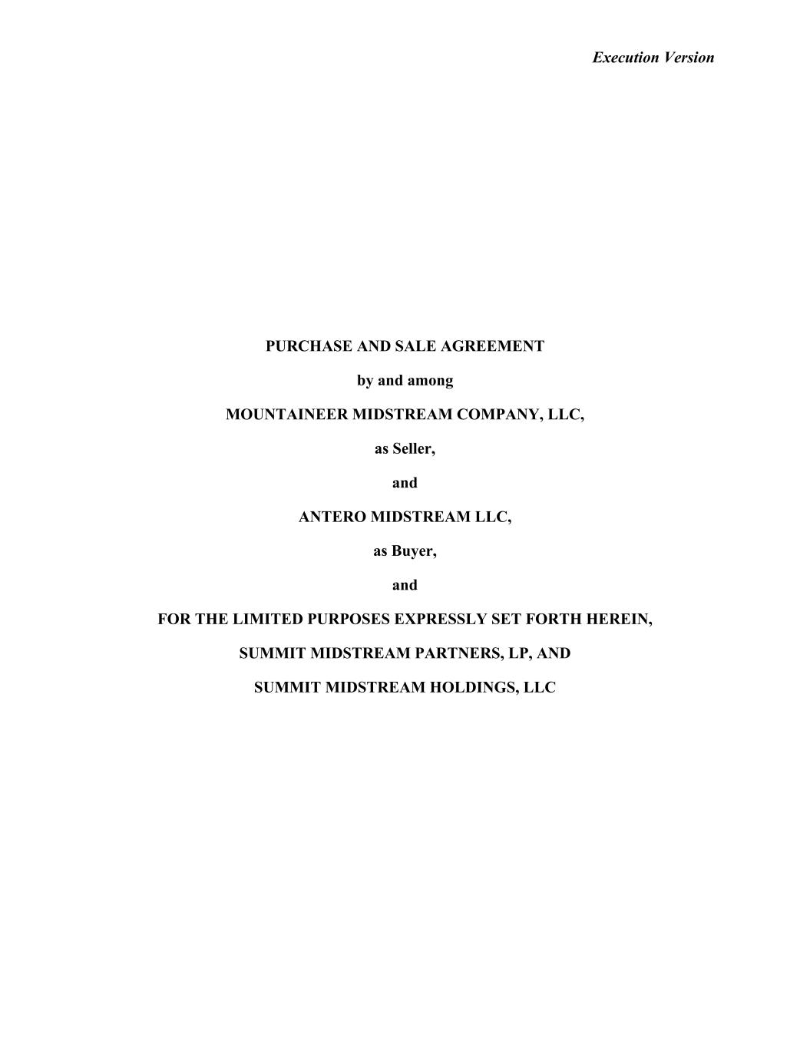
46
Execution Version PURCHASE AND SALE AGREEMENT by and among MOUNTAINEER MIDSTREAM COMPANY, LLC, as Seller, and ANTERO MIDSTREAM LLC, as Buyer, and FOR THE LIMITED PURPOSES EXPRESSLY SET FORTH HEREIN, SUMMIT MIDSTREAM PARTNERS, LP, AND SUMMIT MIDSTREAM HOLDINGS, LLC

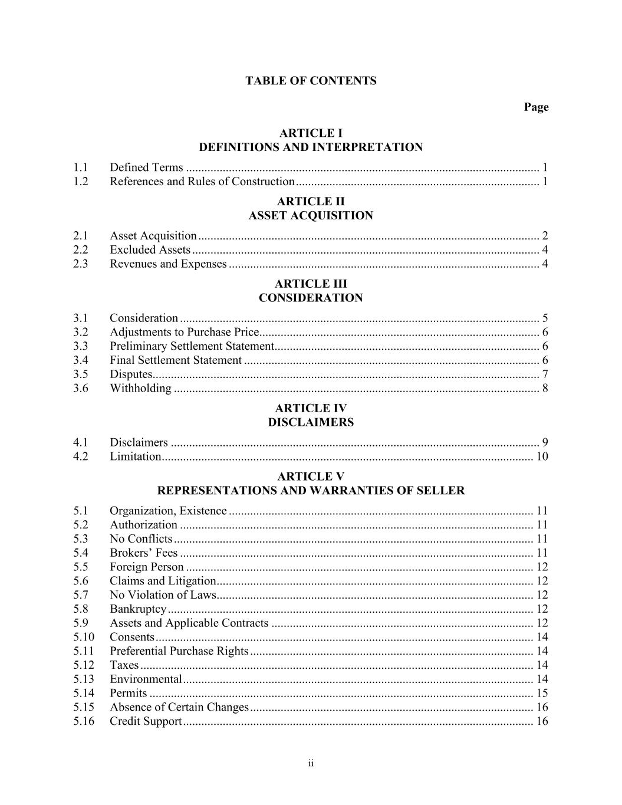
ii TABLE OF CONTENTS Page ARTICLE I DEFINITIONS AND INTERPRETATION 1.1 Defined Terms .................................................................................................................... 1 1.2 References and Rules of Construction ................................................................................ 1 ARTICLE II ASSET ACQUISITION 2.1 Asset Acquisition ................................................................................................................ 2 2.2 Excluded Assets .................................................................................................................. 4 2.3 Revenues and Expenses ...................................................................................................... 4 ARTICLE III CONSIDERATION 3.1 Consideration ...................................................................................................................... 5 3.2 Adjustments to Purchase Price ............................................................................................ 6 3.3 Preliminary Settlement Statement ....................................................................................... 6 3.4 Final Settlement Statement ................................................................................................. 6 3.5 Disputes............................................................................................................................... 7 3.6 Withholding ........................................................................................................................ 8 ARTICLE IV DISCLAIMERS 4.1 Disclaimers ......................................................................................................................... 9 4.2 Limitation .......................................................................................................................... 10 ARTICLE V REPRESENTATIONS AND WARRANTIES OF SELLER 5.1 Organization, Existence .................................................................................................... 11 5.2 Authorization .................................................................................................................... 11 5.3 No Conflicts ...................................................................................................................... 11 5.4 Brokers’ Fees .................................................................................................................... 11 5.5 Foreign Person .................................................................................................................. 12 5.6 Claims and Litigation ........................................................................................................ 12 5.7 No Violation of Laws........................................................................................................ 12 5.8 Bankruptcy ........................................................................................................................ 12 5.9 Assets and Applicable Contracts ...................................................................................... 12 5.10 Consents ............................................................................................................................ 14 5.11 Preferential Purchase Rights ............................................................................................. 14 5.12 Taxes ................................................................................................................................. 14 5.13 Environmental ................................................................................................................... 14 5.14 Permits .............................................................................................................................. 15 5.15 Absence of Certain Changes ............................................................................................. 16 5.16 Credit Support ................................................................................................................... 16

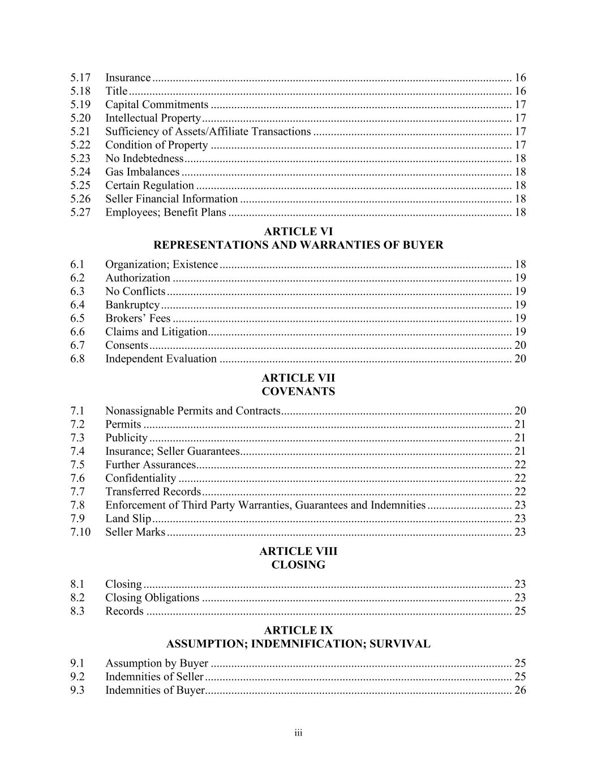
iii 5.17 Insurance ........................................................................................................................... 16 5.18 Title ................................................................................................................................... 16 5.19 Capital Commitments ....................................................................................................... 17 5.20 Intellectual Property .......................................................................................................... 17 5.21 Sufficiency of Assets/Affiliate Transactions .................................................................... 17 5.22 Condition of Property ....................................................................................................... 17 5.23 No Indebtedness ................................................................................................................ 18 5.24 Gas Imbalances ................................................................................................................. 18 5.25 Certain Regulation ............................................................................................................ 18 5.26 Seller Financial Information ............................................................................................. 18 5.27 Employees; Benefit Plans ................................................................................................. 18 ARTICLE VI REPRESENTATIONS AND WARRANTIES OF BUYER 6.1 Organization; Existence .................................................................................................... 18 6.2 Authorization .................................................................................................................... 19 6.3 No Conflicts ...................................................................................................................... 19 6.4 Bankruptcy ........................................................................................................................ 19 6.5 Brokers’ Fees .................................................................................................................... 19 6.6 Claims and Litigation ........................................................................................................ 19 6.7 Consents ............................................................................................................................ 20 6.8 Independent Evaluation .................................................................................................... 20 ARTICLE VII COVENANTS 7.1 Nonassignable Permits and Contracts ............................................................................... 20 7.2 Permits .............................................................................................................................. 21 7.3 Publicity ............................................................................................................................ 21 7.4 Insurance; Seller Guarantees............................................................................................. 21 7.5 Further Assurances............................................................................................................ 22 7.6 Confidentiality .................................................................................................................. 22 7.7 Transferred Records .......................................................................................................... 22 7.8 Enforcement of Third Party Warranties, Guarantees and Indemnities ............................. 23 7.9 Land Slip ........................................................................................................................... 23 7.10 Seller Marks ...................................................................................................................... 23 ARTICLE VIII CLOSING 8.1 Closing .............................................................................................................................. 23 8.2 Closing Obligations .......................................................................................................... 23 8.3 Records ............................................................................................................................. 25 ARTICLE IX ASSUMPTION; INDEMNIFICATION; SURVIVAL 9.1 Assumption by Buyer ....................................................................................................... 25 9.2 Indemnities of Seller ......................................................................................................... 25 9.3 Indemnities of Buyer......................................................................................................... 26

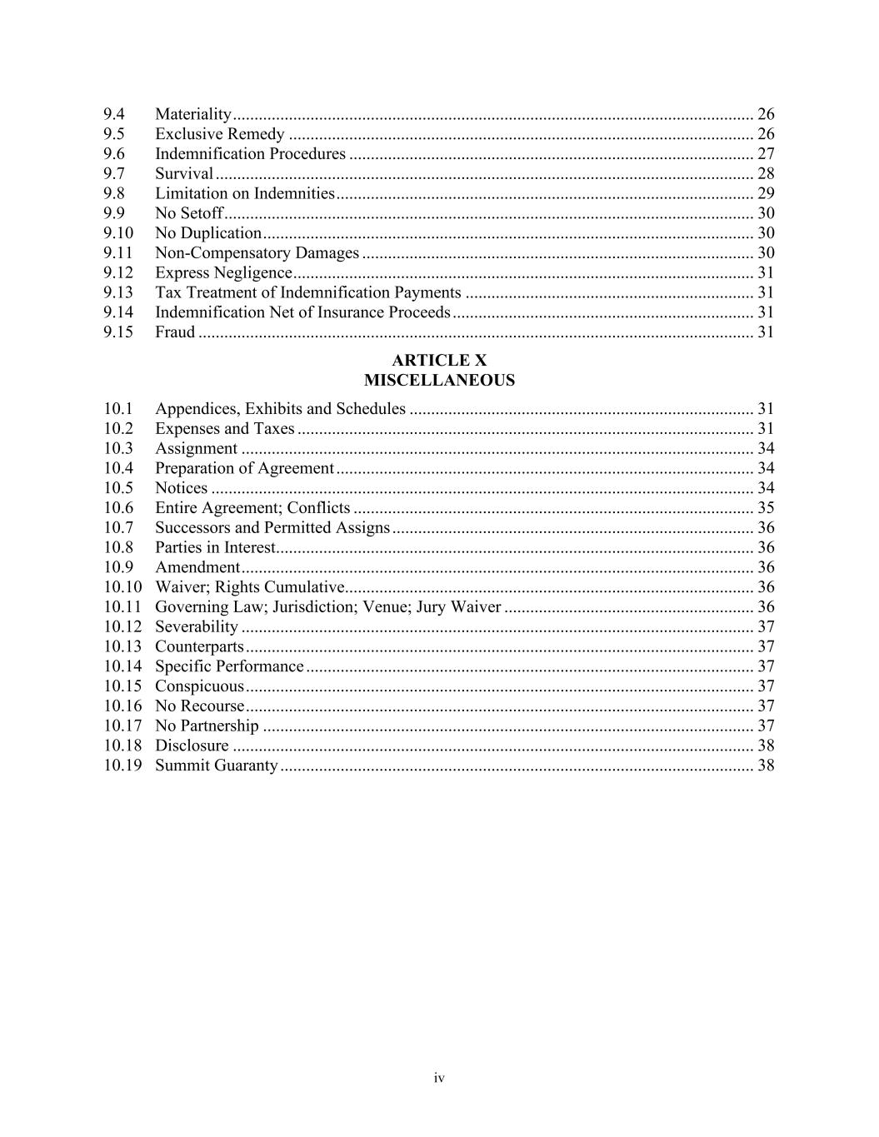
iv 9.4 Materiality ......................................................................................................................... 26 9.5 Exclusive Remedy ............................................................................................................ 26 9.6 Indemnification Procedures .............................................................................................. 27 9.7 Survival ............................................................................................................................. 28 9.8 Limitation on Indemnities ................................................................................................. 29 9.9 No Setoff ........................................................................................................................... 30 9.10 No Duplication .................................................................................................................. 30 9.11 Non-Compensatory Damages ........................................................................................... 30 9.12 Express Negligence ........................................................................................................... 31 9.13 Tax Treatment of Indemnification Payments ................................................................... 31 9.14 Indemnification Net of Insurance Proceeds ...................................................................... 31 9.15 Fraud ................................................................................................................................. 31 ARTICLE X MISCELLANEOUS 10.1 Appendices, Exhibits and Schedules ................................................................................ 31 10.2 Expenses and Taxes .......................................................................................................... 31 10.3 Assignment ....................................................................................................................... 34 10.4 Preparation of Agreement ................................................................................................. 34 10.5 Notices .............................................................................................................................. 34 10.6 Entire Agreement; Conflicts ............................................................................................. 35 10.7 Successors and Permitted Assigns .................................................................................... 36 10.8 Parties in Interest............................................................................................................... 36 10.9 Amendment ....................................................................................................................... 36 10.10 Waiver; Rights Cumulative ............................................................................................... 36 10.11 Governing Law; Jurisdiction; Venue; Jury Waiver .......................................................... 36 10.12 Severability ....................................................................................................................... 37 10.13 Counterparts ...................................................................................................................... 37 10.14 Specific Performance ........................................................................................................ 37 10.15 Conspicuous ...................................................................................................................... 37 10.16 No Recourse ...................................................................................................................... 37 10.17 No Partnership .................................................................................................................. 37 10.18 Disclosure ......................................................................................................................... 38 10.19 Summit Guaranty .............................................................................................................. 38

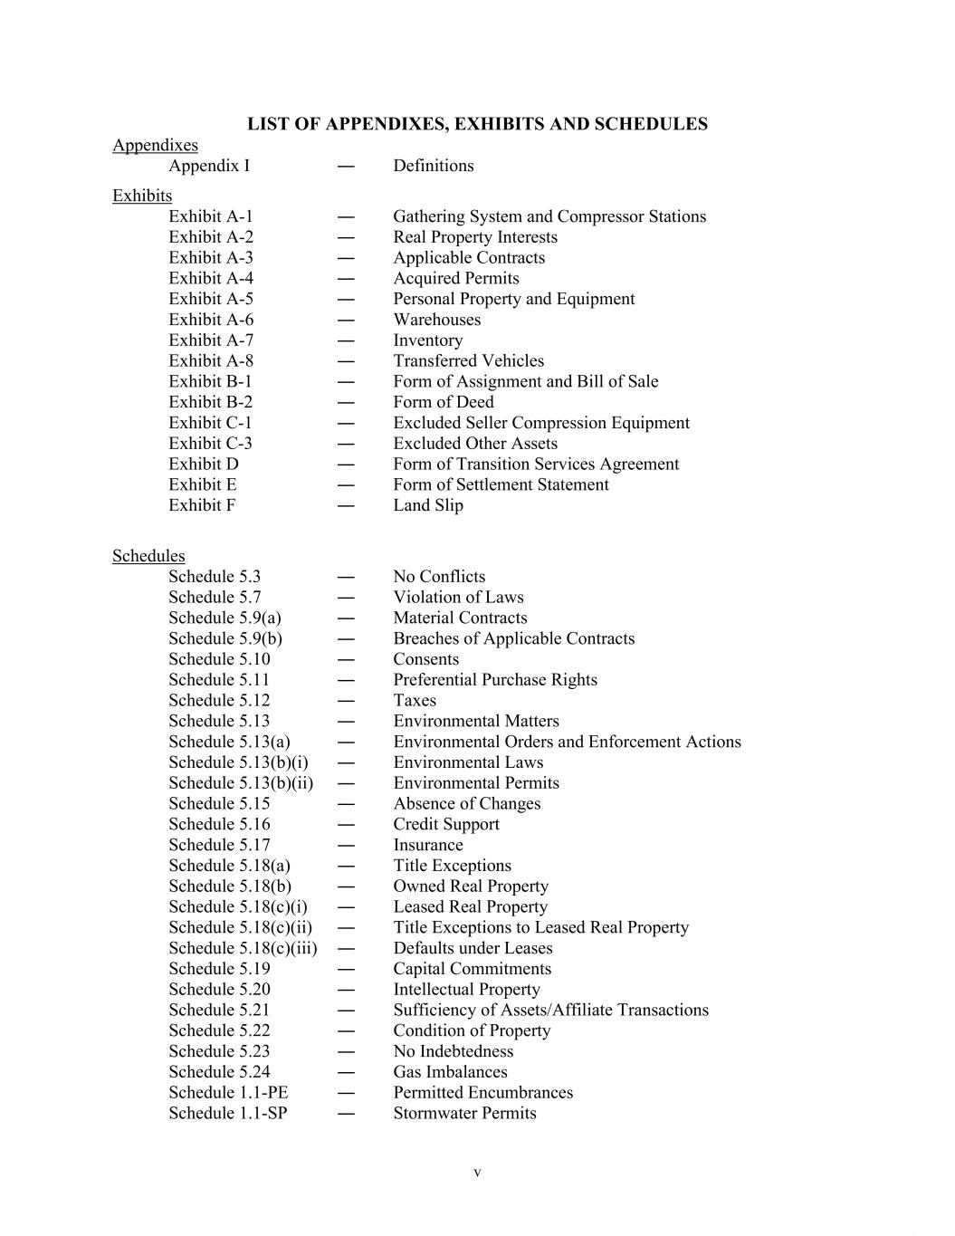
v LIST OF APPENDIXES, EXHIBITS AND SCHEDULES Appendixes Appendix I ― Definitions Exhibits Exhibit A-1 ― Gathering System and Compressor Stations Exhibit A-2 ― Real Property Interests Exhibit A-3 ― Applicable Contracts Exhibit A-4 ― Acquired Permits Exhibit A-5 ― Personal Property and Equipment Exhibit A-6 ― Warehouses Exhibit A-7 ― Inventory Exhibit A-8 ― Transferred Vehicles Exhibit B-1 ― Form of Assignment and Bill of Sale Exhibit B-2 ― Form of Deed Exhibit C-1 ― Excluded Seller Compression Equipment Exhibit C-3 ― Excluded Other Assets Exhibit D ― Form of Transition Services Agreement Exhibit E ― Form of Settlement Statement Exhibit F ― Land Slip Schedules Schedule 5.3 ― No Conflicts Schedule 5.7 ― Violation of Laws Schedule 5.9(a) ― Material Contracts Schedule 5.9(b) ― Breaches of Applicable Contracts Schedule 5.10 ― Consents Schedule 5.11 ― Preferential Purchase Rights Schedule 5.12 ― Taxes Schedule 5.13 ― Environmental Matters Schedule 5.13(a) ― Environmental Orders and Enforcement Actions Schedule 5.13(b)(i) ― Environmental Laws Schedule 5.13(b)(ii) ― Environmental Permits Schedule 5.15 ― Absence of Changes Schedule 5.16 ― Credit Support Schedule 5.17 ― Insurance Schedule 5.18(a) ― Title Exceptions Schedule 5.18(b) ― Owned Real Property Schedule 5.18(c)(i) ― Leased Real Property Schedule 5.18(c)(ii) ― Title Exceptions to Leased Real Property Schedule 5.18(c)(iii) ― Defaults under Leases Schedule 5.19 ― Capital Commitments Schedule 5.20 ― Intellectual Property Schedule 5.21 ― Sufficiency of Assets/Affiliate Transactions Schedule 5.22 ― Condition of Property Schedule 5.23 ― No Indebtedness Schedule 5.24 ― Gas Imbalances Schedule 1.1-PE ― Permitted Encumbrances Schedule 1.1-SP ― Stormwater Permits

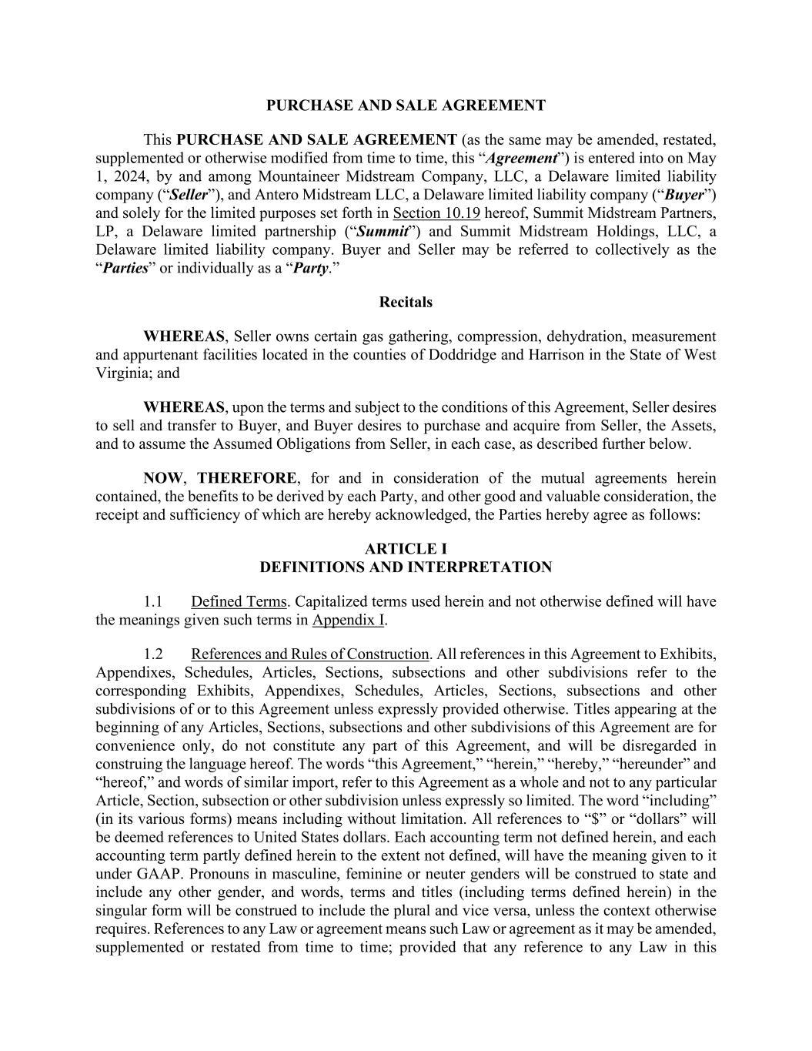
PURCHASE AND SALE AGREEMENT This PURCHASE AND SALE AGREEMENT (as the same may be amended, restated, supplemented or otherwise modified from time to time, this “Agreement”) is entered into on May 1, 2024, by and among Mountaineer Midstream Company, LLC, a Delaware limited liability company (“Seller”), and Antero Midstream LLC, a Delaware limited liability company (“Buyer”) and solely for the limited purposes set forth in Section 10.19 hereof, Summit Midstream Partners, LP, a Delaware limited partnership (“Summit”) and Summit Midstream Holdings, LLC, a Delaware limited liability company. Buyer and Seller may be referred to collectively as the “Parties” or individually as a “Party.” Recitals WHEREAS, Seller owns certain gas gathering, compression, dehydration, measurement and appurtenant facilities located in the counties of Doddridge and Harrison in the State of West Virginia; and WHEREAS, upon the terms and subject to the conditions of this Agreement, Seller desires to sell and transfer to Buyer, and Buyer desires to purchase and acquire from Seller, the Assets, and to assume the Assumed Obligations from Seller, in each case, as described further below. NOW, THEREFORE, for and in consideration of the mutual agreements herein contained, the benefits to be derived by each Party, and other good and valuable consideration, the receipt and sufficiency of which are hereby acknowledged, the Parties hereby agree as follows: ARTICLE I DEFINITIONS AND INTERPRETATION 1.1 Defined Terms. Capitalized terms used herein and not otherwise defined will have the meanings given such terms in Appendix I. 1.2 References and Rules of Construction. All references in this Agreement to Exhibits, Appendixes, Schedules, Articles, Sections, subsections and other subdivisions refer to the corresponding Exhibits, Appendixes, Schedules, Articles, Sections, subsections and other subdivisions of or to this Agreement unless expressly provided otherwise. Titles appearing at the beginning of any Articles, Sections, subsections and other subdivisions of this Agreement are for convenience only, do not constitute any part of this Agreement, and will be disregarded in construing the language hereof. The words “this Agreement,” “herein,” “hereby,” “hereunder” and “hereof,” and words of similar import, refer to this Agreement as a whole and not to any particular Article, Section, subsection or other subdivision unless expressly so limited. The word “including” (in its various forms) means including without limitation. All references to “$” or “dollars” will be deemed references to United States dollars. Each accounting term not defined herein, and each accounting term partly defined herein to the extent not defined, will have the meaning given to it under GAAP. Pronouns in masculine, feminine or neuter genders will be construed to state and include any other gender, and words, terms and titles (including terms defined herein) in the singular form will be construed to include the plural and vice versa, unless the context otherwise requires. References to any Law or agreement means such Law or agreement as it may be amended, supplemented or restated from time to time; provided that any reference to any Law in this

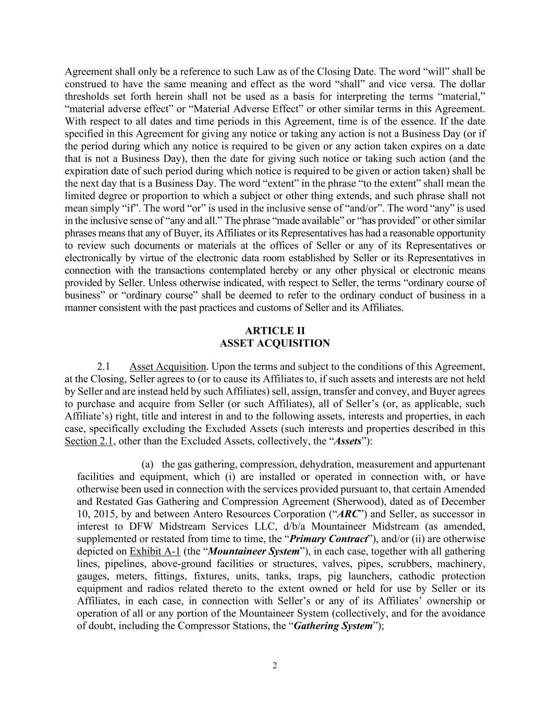
2 Agreement shall only be a reference to such Law as of the Closing Date. The word “will” shall be construed to have the same meaning and effect as the word “shall” and vice versa. The dollar thresholds set forth herein shall not be used as a basis for interpreting the terms “material,” “material adverse effect” or “Material Adverse Effect” or other similar terms in this Agreement. With respect to all dates and time periods in this Agreement, time is of the essence. If the date specified in this Agreement for giving any notice or taking any action is not a Business Day (or if the period during which any notice is required to be given or any action taken expires on a date that is not a Business Day), then the date for giving such notice or taking such action (and the expiration date of such period during which notice is required to be given or action taken) shall be the next day that is a Business Day. The word “extent” in the phrase “to the extent” shall mean the limited degree or proportion to which a subject or other thing extends, and such phrase shall not mean simply “if”. The word “or” is used in the inclusive sense of “and/or”. The word “any” is used in the inclusive sense of “any and all.” The phrase “made available” or “has provided” or other similar phrases means that any of Buyer, its Affiliates or its Representatives has had a reasonable opportunity to review such documents or materials at the offices of Seller or any of its Representatives or electronically by virtue of the electronic data room established by Seller or its Representatives in connection with the transactions contemplated hereby or any other physical or electronic means provided by Seller. Unless otherwise indicated, with respect to Seller, the terms “ordinary course of business” or “ordinary course” shall be deemed to refer to the ordinary conduct of business in a manner consistent with the past practices and customs of Seller and its Affiliates. ARTICLE II ASSET ACQUISITION 2.1 Asset Acquisition. Upon the terms and subject to the conditions of this Agreement, at the Closing, Seller agrees to (or to cause its Affiliates to, if such assets and interests are not held by Seller and are instead held by such Affiliates) sell, assign, transfer and convey, and Buyer agrees to purchase and acquire from Seller (or such Affiliates), all of Seller’s (or, as applicable, such Affiliate’s) right, title and interest in and to the following assets, interests and properties, in each case, specifically excluding the Excluded Assets (such interests and properties described in this Section 2.1, other than the Excluded Assets, collectively, the “Assets”): (a) the gas gathering, compression, dehydration, measurement and appurtenant facilities and equipment, which (i) are installed or operated in connection with, or have otherwise been used in connection with the services provided pursuant to, that certain Amended and Restated Gas Gathering and Compression Agreement (Sherwood), dated as of December 10, 2015, by and between Antero Resources Corporation (“ARC”) and Seller, as successor in interest to DFW Midstream Services LLC, d/b/a Mountaineer Midstream (as amended, supplemented or restated from time to time, the “Primary Contract”), and/or (ii) are otherwise depicted on Exhibit A-1 (the “Mountaineer System”), in each case, together with all gathering lines, pipelines, above-ground facilities or structures, valves, pipes, scrubbers, machinery, gauges, meters, fittings, fixtures, units, tanks, traps, pig launchers, cathodic protection equipment and radios related thereto to the extent owned or held for use by Seller or its Affiliates, in each case, in connection with Seller’s or any of its Affiliates’ ownership or operation of all or any portion of the Mountaineer System (collectively, and for the avoidance of doubt, including the Compressor Stations, the “Gathering System”);

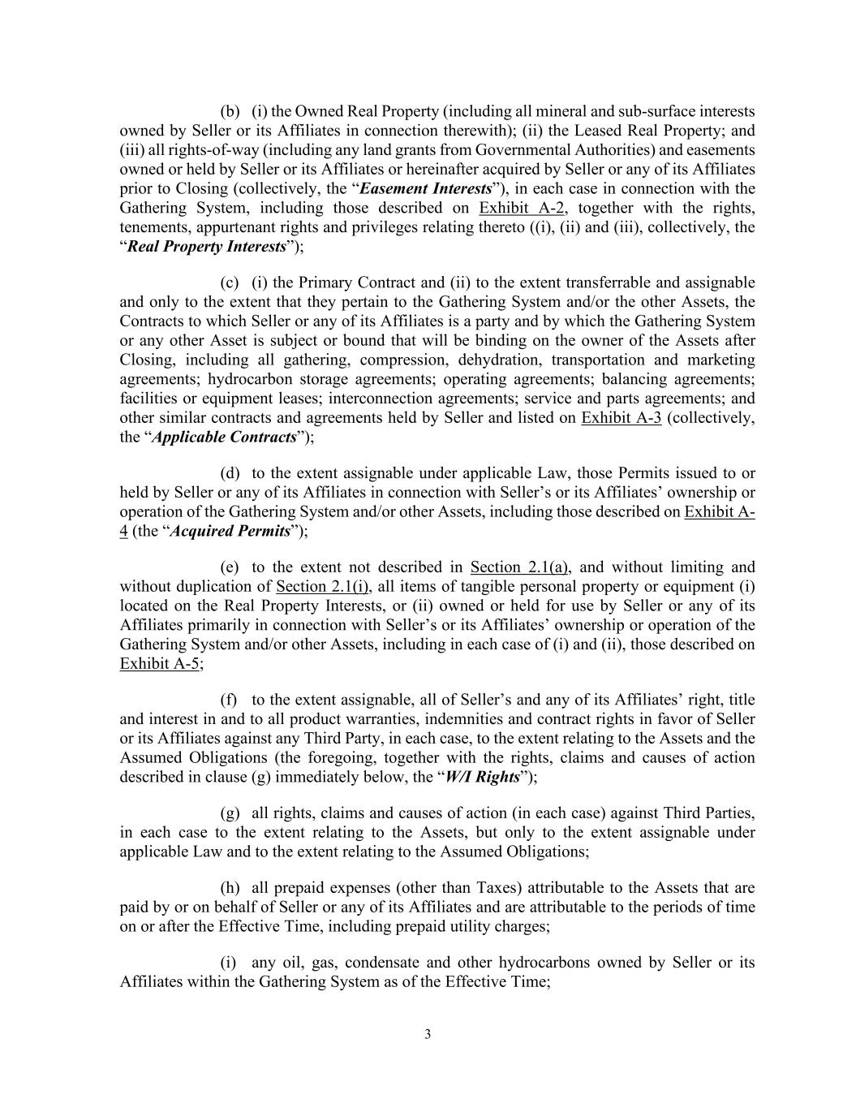
3 (b) (i) the Owned Real Property (including all mineral and sub-surface interests owned by Seller or its Affiliates in connection therewith); (ii) the Leased Real Property; and (iii) all rights-of-way (including any land grants from Governmental Authorities) and easements owned or held by Seller or its Affiliates or hereinafter acquired by Seller or any of its Affiliates prior to Closing (collectively, the “Easement Interests”), in each case in connection with the Gathering System, including those described on Exhibit A-2, together with the rights, tenements, appurtenant rights and privileges relating thereto ((i), (ii) and (iii), collectively, the “Real Property Interests”); (c) (i) the Primary Contract and (ii) to the extent transferrable and assignable and only to the extent that they pertain to the Gathering System and/or the other Assets, the Contracts to which Seller or any of its Affiliates is a party and by which the Gathering System or any other Asset is subject or bound that will be binding on the owner of the Assets after Closing, including all gathering, compression, dehydration, transportation and marketing agreements; hydrocarbon storage agreements; operating agreements; balancing agreements; facilities or equipment leases; interconnection agreements; service and parts agreements; and other similar contracts and agreements held by Seller and listed on Exhibit A-3 (collectively, the “Applicable Contracts”); (d) to the extent assignable under applicable Law, those Permits issued to or held by Seller or any of its Affiliates in connection with Seller’s or its Affiliates’ ownership or operation of the Gathering System and/or other Assets, including those described on Exhibit A- 4 (the “Acquired Permits”); (e) to the extent not described in Section 2.1(a), and without limiting and without duplication of Section 2.1(i), all items of tangible personal property or equipment (i) located on the Real Property Interests, or (ii) owned or held for use by Seller or any of its Affiliates primarily in connection with Seller’s or its Affiliates’ ownership or operation of the Gathering System and/or other Assets, including in each case of (i) and (ii), those described on Exhibit A-5; (f) to the extent assignable, all of Seller’s and any of its Affiliates’ right, title and interest in and to all product warranties, indemnities and contract rights in favor of Seller or its Affiliates against any Third Party, in each case, to the extent relating to the Assets and the Assumed Obligations (the foregoing, together with the rights, claims and causes of action described in clause (g) immediately below, the “W/I Rights”); (g) all rights, claims and causes of action (in each case) against Third Parties, in each case to the extent relating to the Assets, but only to the extent assignable under applicable Law and to the extent relating to the Assumed Obligations; (h) all prepaid expenses (other than Taxes) attributable to the Assets that are paid by or on behalf of Seller or any of its Affiliates and are attributable to the periods of time on or after the Effective Time, including prepaid utility charges; (i) any oil, gas, condensate and other hydrocarbons owned by Seller or its Affiliates within the Gathering System as of the Effective Time;

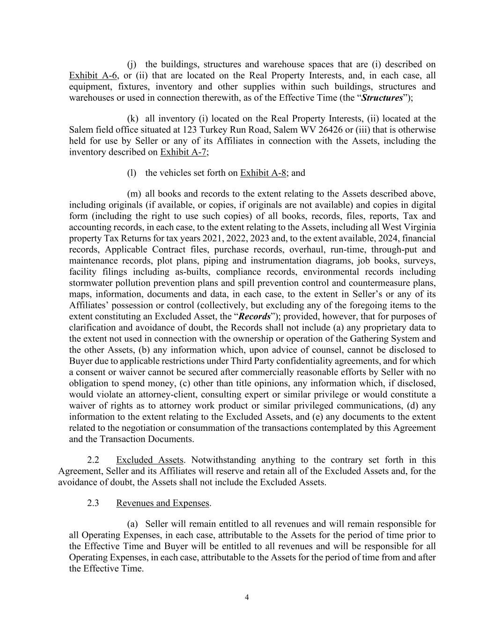
4 (j) the buildings, structures and warehouse spaces that are (i) described on Exhibit A-6, or (ii) that are located on the Real Property Interests, and, in each case, all equipment, fixtures, inventory and other supplies within such buildings, structures and warehouses or used in connection therewith, as of the Effective Time (the “Structures”); (k) all inventory (i) located on the Real Property Interests, (ii) located at the Salem field office situated at 123 Turkey Run Road, Salem WV 26426 or (iii) that is otherwise held for use by Seller or any of its Affiliates in connection with the Assets, including the inventory described on Exhibit A-7; (l) the vehicles set forth on Exhibit A-8; and (m) all books and records to the extent relating to the Assets described above, including originals (if available, or copies, if originals are not available) and copies in digital form (including the right to use such copies) of all books, records, files, reports, Tax and accounting records, in each case, to the extent relating to the Assets, including all West Virginia property Tax Returns for tax years 2021, 2022, 2023 and, to the extent available, 2024, financial records, Applicable Contract files, purchase records, overhaul, run-time, through-put and maintenance records, plot plans, piping and instrumentation diagrams, job books, surveys, facility filings including as-builts, compliance records, environmental records including stormwater pollution prevention plans and spill prevention control and countermeasure plans, maps, information, documents and data, in each case, to the extent in Seller’s or any of its Affiliates’ possession or control (collectively, but excluding any of the foregoing items to the extent constituting an Excluded Asset, the “Records”); provided, however, that for purposes of clarification and avoidance of doubt, the Records shall not include (a) any proprietary data to the extent not used in connection with the ownership or operation of the Gathering System and the other Assets, (b) any information which, upon advice of counsel, cannot be disclosed to Buyer due to applicable restrictions under Third Party confidentiality agreements, and for which a consent or waiver cannot be secured after commercially reasonable efforts by Seller with no obligation to spend money, (c) other than title opinions, any information which, if disclosed, would violate an attorney-client, consulting expert or similar privilege or would constitute a waiver of rights as to attorney work product or similar privileged communications, (d) any information to the extent relating to the Excluded Assets, and (e) any documents to the extent related to the negotiation or consummation of the transactions contemplated by this Agreement and the Transaction Documents. 2.2 Excluded Assets. Notwithstanding anything to the contrary set forth in this Agreement, Seller and its Affiliates will reserve and retain all of the Excluded Assets and, for the avoidance of doubt, the Assets shall not include the Excluded Assets. 2.3 Revenues and Expenses. (a) Seller will remain entitled to all revenues and will remain responsible for all Operating Expenses, in each case, attributable to the Assets for the period of time prior to the Effective Time and Buyer will be entitled to all revenues and will be responsible for all Operating Expenses, in each case, attributable to the Assets for the period of time from and after the Effective Time.

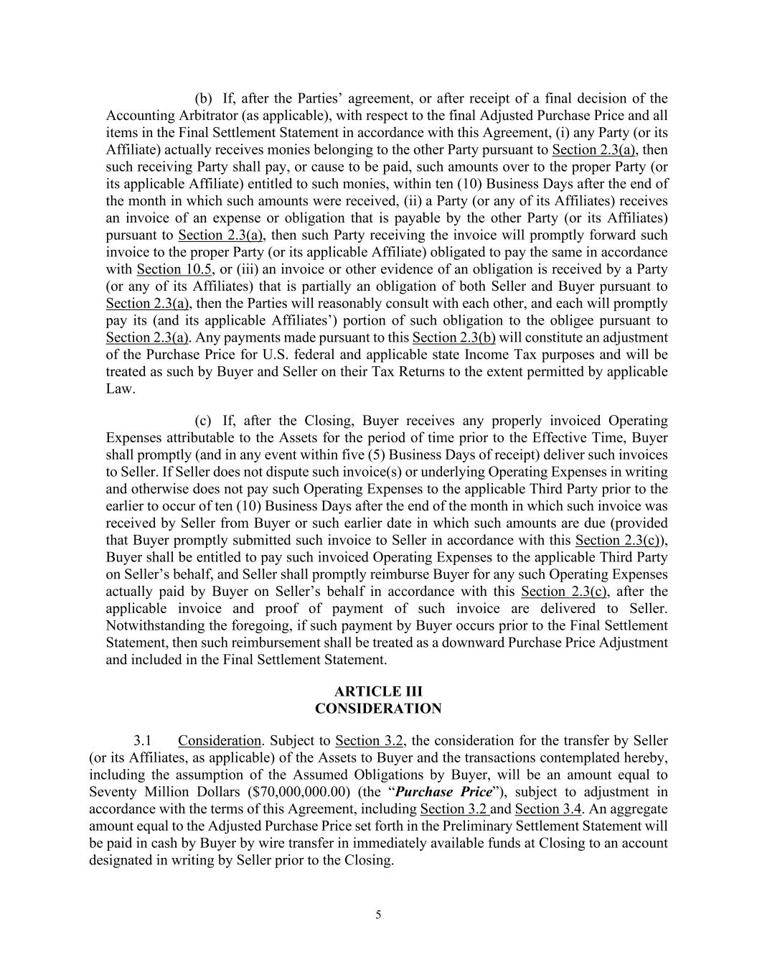
5 (b) If, after the Parties’ agreement, or after receipt of a final decision of the Accounting Arbitrator (as applicable), with respect to the final Adjusted Purchase Price and all items in the Final Settlement Statement in accordance with this Agreement, (i) any Party (or its Affiliate) actually receives monies belonging to the other Party pursuant to Section 2.3(a), then such receiving Party shall pay, or cause to be paid, such amounts over to the proper Party (or its applicable Affiliate) entitled to such monies, within ten (10) Business Days after the end of the month in which such amounts were received, (ii) a Party (or any of its Affiliates) receives an invoice of an expense or obligation that is payable by the other Party (or its Affiliates) pursuant to Section 2.3(a), then such Party receiving the invoice will promptly forward such invoice to the proper Party (or its applicable Affiliate) obligated to pay the same in accordance with Section 10.5, or (iii) an invoice or other evidence of an obligation is received by a Party (or any of its Affiliates) that is partially an obligation of both Seller and Buyer pursuant to Section 2.3(a), then the Parties will reasonably consult with each other, and each will promptly pay its (and its applicable Affiliates’) portion of such obligation to the obligee pursuant to Section 2.3(a). Any payments made pursuant to this Section 2.3(b) will constitute an adjustment of the Purchase Price for U.S. federal and applicable state Income Tax purposes and will be treated as such by Buyer and Seller on their Tax Returns to the extent permitted by applicable Law. (c) If, after the Closing, Buyer receives any properly invoiced Operating Expenses attributable to the Assets for the period of time prior to the Effective Time, Buyer shall promptly (and in any event within five (5) Business Days of receipt) deliver such invoices to Seller. If Seller does not dispute such invoice(s) or underlying Operating Expenses in writing and otherwise does not pay such Operating Expenses to the applicable Third Party prior to the earlier to occur of ten (10) Business Days after the end of the month in which such invoice was received by Seller from Buyer or such earlier date in which such amounts are due (provided that Buyer promptly submitted such invoice to Seller in accordance with this Section 2.3(c)), Buyer shall be entitled to pay such invoiced Operating Expenses to the applicable Third Party on Seller’s behalf, and Seller shall promptly reimburse Buyer for any such Operating Expenses actually paid by Buyer on Seller’s behalf in accordance with this Section 2.3(c), after the applicable invoice and proof of payment of such invoice are delivered to Seller. Notwithstanding the foregoing, if such payment by Buyer occurs prior to the Final Settlement Statement, then such reimbursement shall be treated as a downward Purchase Price Adjustment and included in the Final Settlement Statement. ARTICLE III CONSIDERATION 3.1 Consideration. Subject to Section 3.2, the consideration for the transfer by Seller (or its Affiliates, as applicable) of the Assets to Buyer and the transactions contemplated hereby, including the assumption of the Assumed Obligations by Buyer, will be an amount equal to Seventy Million Dollars ($70,000,000.00) (the “Purchase Price”), subject to adjustment in accordance with the terms of this Agreement, including Section 3.2 and Section 3.4. An aggregate amount equal to the Adjusted Purchase Price set forth in the Preliminary Settlement Statement will be paid in cash by Buyer by wire transfer in immediately available funds at Closing to an account designated in writing by Seller prior to the Closing.

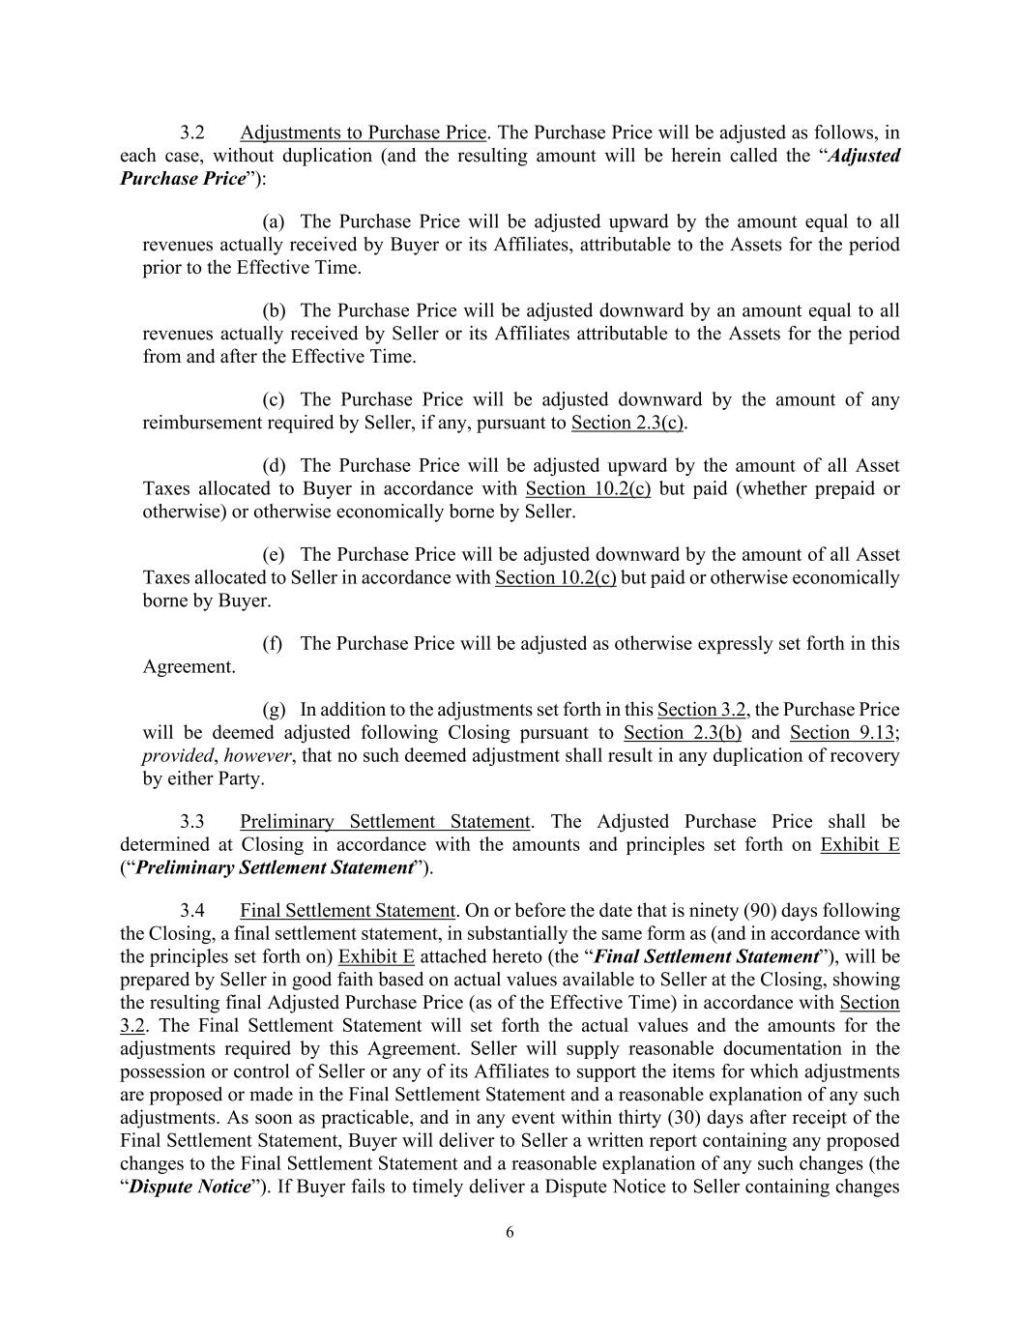
6 3.2 Adjustments to Purchase Price. The Purchase Price will be adjusted as follows, in each case, without duplication (and the resulting amount will be herein called the “Adjusted Purchase Price”): (a) The Purchase Price will be adjusted upward by the amount equal to all revenues actually received by Buyer or its Affiliates, attributable to the Assets for the period prior to the Effective Time. (b) The Purchase Price will be adjusted downward by an amount equal to all revenues actually received by Seller or its Affiliates attributable to the Assets for the period from and after the Effective Time. (c) The Purchase Price will be adjusted downward by the amount of any reimbursement required by Seller, if any, pursuant to Section 2.3(c). (d) The Purchase Price will be adjusted upward by the amount of all Asset Taxes allocated to Buyer in accordance with Section 10.2(c) but paid (whether prepaid or otherwise) or otherwise economically borne by Seller. (e) The Purchase Price will be adjusted downward by the amount of all Asset Taxes allocated to Seller in accordance with Section 10.2(c) but paid or otherwise economically borne by Buyer. (f) The Purchase Price will be adjusted as otherwise expressly set forth in this Agreement. (g) In addition to the adjustments set forth in this Section 3.2, the Purchase Price will be deemed adjusted following Closing pursuant to Section 2.3(b) and Section 9.13; provided, however, that no such deemed adjustment shall result in any duplication of recovery by either Party. 3.3 Preliminary Settlement Statement. The Adjusted Purchase Price shall be determined at Closing in accordance with the amounts and principles set forth on Exhibit E (“Preliminary Settlement Statement”). 3.4 Final Settlement Statement. On or before the date that is ninety (90) days following the Closing, a final settlement statement, in substantially the same form as (and in accordance with the principles set forth on) Exhibit E attached hereto (the “Final Settlement Statement”), will be prepared by Seller in good faith based on actual values available to Seller at the Closing, showing the resulting final Adjusted Purchase Price (as of the Effective Time) in accordance with Section 3.2. The Final Settlement Statement will set forth the actual values and the amounts for the adjustments required by this Agreement. Seller will supply reasonable documentation in the possession or control of Seller or any of its Affiliates to support the items for which adjustments are proposed or made in the Final Settlement Statement and a reasonable explanation of any such adjustments. As soon as practicable, and in any event within thirty (30) days after receipt of the Final Settlement Statement, Buyer will deliver to Seller a written report containing any proposed changes to the Final Settlement Statement and a reasonable explanation of any such changes (the “Dispute Notice”). If Buyer fails to timely deliver a Dispute Notice to Seller containing changes

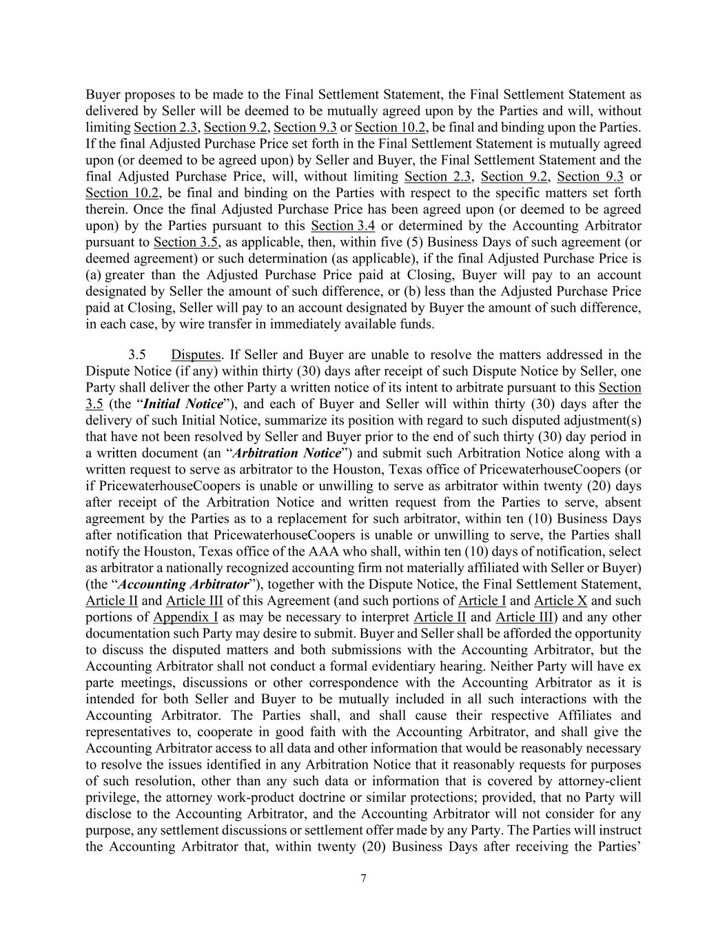
7 Buyer proposes to be made to the Final Settlement Statement, the Final Settlement Statement as delivered by Seller will be deemed to be mutually agreed upon by the Parties and will, without limiting Section 2.3, Section 9.2, Section 9.3 or Section 10.2, be final and binding upon the Parties. If the final Adjusted Purchase Price set forth in the Final Settlement Statement is mutually agreed upon (or deemed to be agreed upon) by Seller and Buyer, the Final Settlement Statement and the final Adjusted Purchase Price, will, without limiting Section 2.3, Section 9.2, Section 9.3 or Section 10.2, be final and binding on the Parties with respect to the specific matters set forth therein. Once the final Adjusted Purchase Price has been agreed upon (or deemed to be agreed upon) by the Parties pursuant to this Section 3.4 or determined by the Accounting Arbitrator pursuant to Section 3.5, as applicable, then, within five (5) Business Days of such agreement (or deemed agreement) or such determination (as applicable), if the final Adjusted Purchase Price is (a) greater than the Adjusted Purchase Price paid at Closing, Buyer will pay to an account designated by Seller the amount of such difference, or (b) less than the Adjusted Purchase Price paid at Closing, Seller will pay to an account designated by Buyer the amount of such difference, in each case, by wire transfer in immediately available funds. 3.5 Disputes. If Seller and Buyer are unable to resolve the matters addressed in the Dispute Notice (if any) within thirty (30) days after receipt of such Dispute Notice by Seller, one Party shall deliver the other Party a written notice of its intent to arbitrate pursuant to this Section 3.5 (the “Initial Notice”), and each of Buyer and Seller will within thirty (30) days after the delivery of such Initial Notice, summarize its position with regard to such disputed adjustment(s) that have not been resolved by Seller and Buyer prior to the end of such thirty (30) day period in a written document (an “Arbitration Notice”) and submit such Arbitration Notice along with a written request to serve as arbitrator to the Houston, Texas office of PricewaterhouseCoopers (or if PricewaterhouseCoopers is unable or unwilling to serve as arbitrator within twenty (20) days after receipt of the Arbitration Notice and written request from the Parties to serve, absent agreement by the Parties as to a replacement for such arbitrator, within ten (10) Business Days after notification that PricewaterhouseCoopers is unable or unwilling to serve, the Parties shall notify the Houston, Texas office of the AAA who shall, within ten (10) days of notification, select as arbitrator a nationally recognized accounting firm not materially affiliated with Seller or Buyer) (the “Accounting Arbitrator”), together with the Dispute Notice, the Final Settlement Statement, Article II and Article III of this Agreement (and such portions of Article I and Article X and such portions of Appendix I as may be necessary to interpret Article II and Article III) and any other documentation such Party may desire to submit. Buyer and Seller shall be afforded the opportunity to discuss the disputed matters and both submissions with the Accounting Arbitrator, but the Accounting Arbitrator shall not conduct a formal evidentiary hearing. Neither Party will have ex parte meetings, discussions or other correspondence with the Accounting Arbitrator as it is intended for both Seller and Buyer to be mutually included in all such interactions with the Accounting Arbitrator. The Parties shall, and shall cause their respective Affiliates and representatives to, cooperate in good faith with the Accounting Arbitrator, and shall give the Accounting Arbitrator access to all data and other information that would be reasonably necessary to resolve the issues identified in any Arbitration Notice that it reasonably requests for purposes of such resolution, other than any such data or information that is covered by attorney-client privilege, the attorney work-product doctrine or similar protections; provided, that no Party will disclose to the Accounting Arbitrator, and the Accounting Arbitrator will not consider for any purpose, any settlement discussions or settlement offer made by any Party. The Parties will instruct the Accounting Arbitrator that, within twenty (20) Business Days after receiving the Parties’

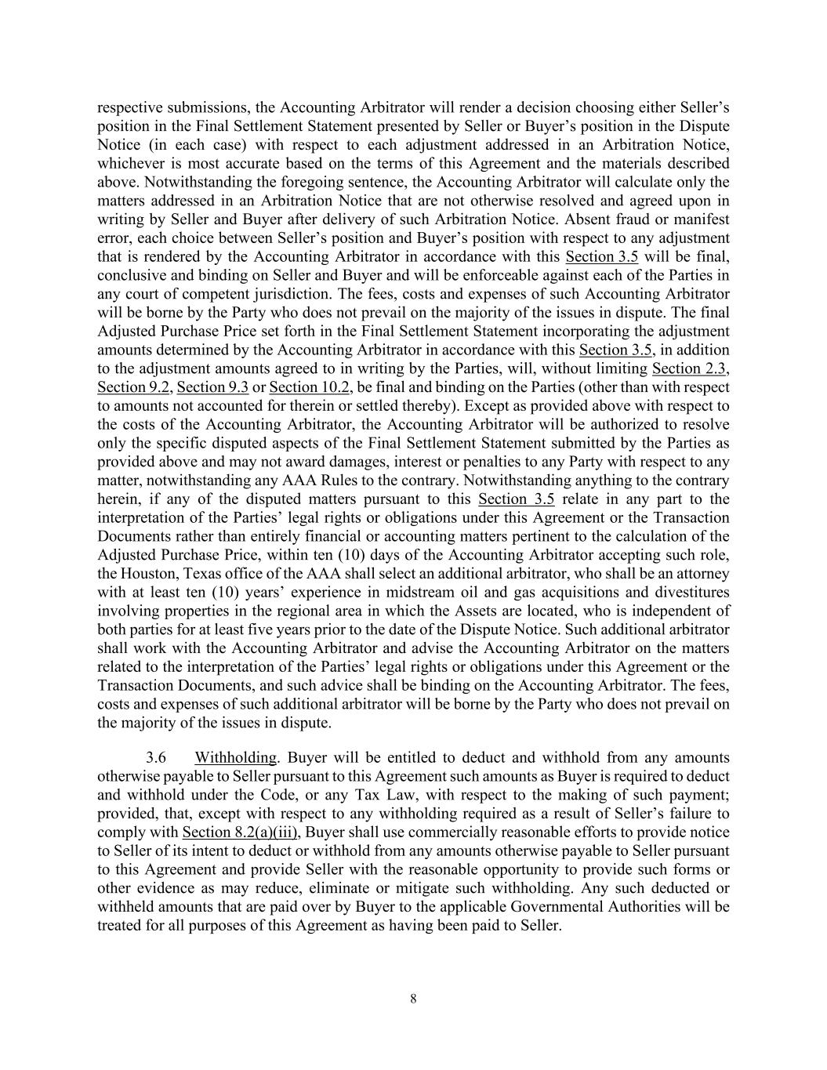
8 respective submissions, the Accounting Arbitrator will render a decision choosing either Seller’s position in the Final Settlement Statement presented by Seller or Buyer’s position in the Dispute Notice (in each case) with respect to each adjustment addressed in an Arbitration Notice, whichever is most accurate based on the terms of this Agreement and the materials described above. Notwithstanding the foregoing sentence, the Accounting Arbitrator will calculate only the matters addressed in an Arbitration Notice that are not otherwise resolved and agreed upon in writing by Seller and Buyer after delivery of such Arbitration Notice. Absent fraud or manifest error, each choice between Seller’s position and Buyer’s position with respect to any adjustment that is rendered by the Accounting Arbitrator in accordance with this Section 3.5 will be final, conclusive and binding on Seller and Buyer and will be enforceable against each of the Parties in any court of competent jurisdiction. The fees, costs and expenses of such Accounting Arbitrator will be borne by the Party who does not prevail on the majority of the issues in dispute. The final Adjusted Purchase Price set forth in the Final Settlement Statement incorporating the adjustment amounts determined by the Accounting Arbitrator in accordance with this Section 3.5, in addition to the adjustment amounts agreed to in writing by the Parties, will, without limiting Section 2.3, Section 9.2, Section 9.3 or Section 10.2, be final and binding on the Parties (other than with respect to amounts not accounted for therein or settled thereby). Except as provided above with respect to the costs of the Accounting Arbitrator, the Accounting Arbitrator will be authorized to resolve only the specific disputed aspects of the Final Settlement Statement submitted by the Parties as provided above and may not award damages, interest or penalties to any Party with respect to any matter, notwithstanding any AAA Rules to the contrary. Notwithstanding anything to the contrary herein, if any of the disputed matters pursuant to this Section 3.5 relate in any part to the interpretation of the Parties’ legal rights or obligations under this Agreement or the Transaction Documents rather than entirely financial or accounting matters pertinent to the calculation of the Adjusted Purchase Price, within ten (10) days of the Accounting Arbitrator accepting such role, the Houston, Texas office of the AAA shall select an additional arbitrator, who shall be an attorney with at least ten (10) years’ experience in midstream oil and gas acquisitions and divestitures involving properties in the regional area in which the Assets are located, who is independent of both parties for at least five years prior to the date of the Dispute Notice. Such additional arbitrator shall work with the Accounting Arbitrator and advise the Accounting Arbitrator on the matters related to the interpretation of the Parties’ legal rights or obligations under this Agreement or the Transaction Documents, and such advice shall be binding on the Accounting Arbitrator. The fees, costs and expenses of such additional arbitrator will be borne by the Party who does not prevail on the majority of the issues in dispute. 3.6 Withholding. Buyer will be entitled to deduct and withhold from any amounts otherwise payable to Seller pursuant to this Agreement such amounts as Buyer is required to deduct and withhold under the Code, or any Tax Law, with respect to the making of such payment; provided, that, except with respect to any withholding required as a result of Seller’s failure to comply with Section 8.2(a)(iii), Buyer shall use commercially reasonable efforts to provide notice to Seller of its intent to deduct or withhold from any amounts otherwise payable to Seller pursuant to this Agreement and provide Seller with the reasonable opportunity to provide such forms or other evidence as may reduce, eliminate or mitigate such withholding. Any such deducted or withheld amounts that are paid over by Buyer to the applicable Governmental Authorities will be treated for all purposes of this Agreement as having been paid to Seller.

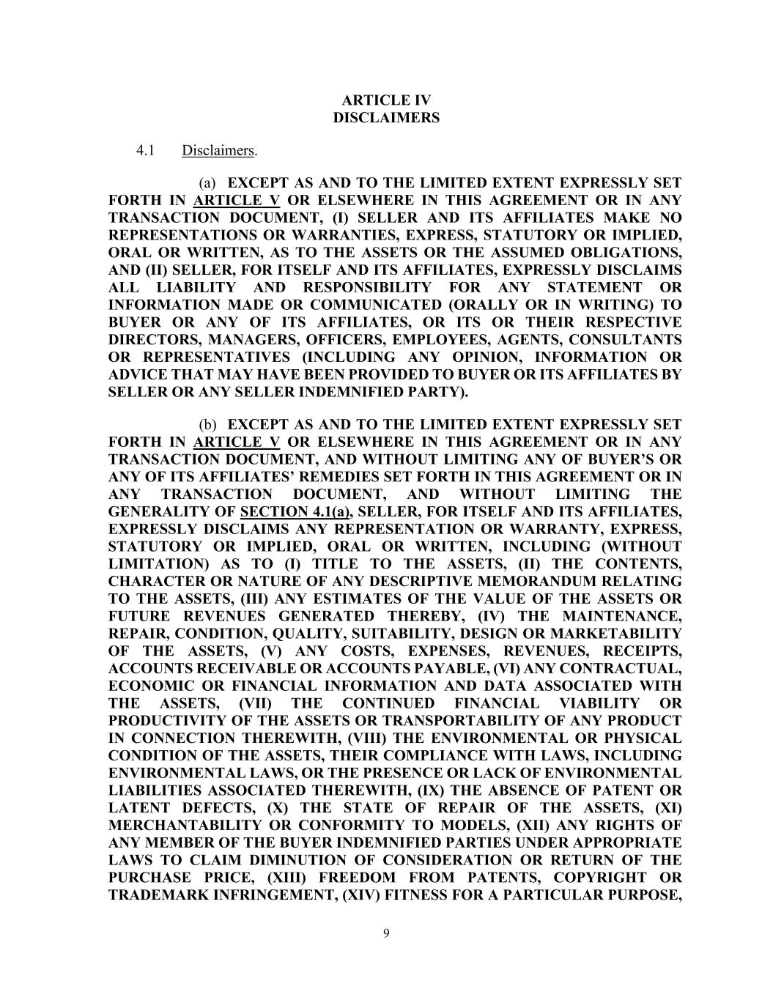
9 ARTICLE IV DISCLAIMERS 4.1 Disclaimers. (a) EXCEPT AS AND TO THE LIMITED EXTENT EXPRESSLY SET FORTH IN ARTICLE V OR ELSEWHERE IN THIS AGREEMENT OR IN ANY TRANSACTION DOCUMENT, (I) SELLER AND ITS AFFILIATES MAKE NO REPRESENTATIONS OR WARRANTIES, EXPRESS, STATUTORY OR IMPLIED, ORAL OR WRITTEN, AS TO THE ASSETS OR THE ASSUMED OBLIGATIONS, AND (II) SELLER, FOR ITSELF AND ITS AFFILIATES, EXPRESSLY DISCLAIMS ALL LIABILITY AND RESPONSIBILITY FOR ANY STATEMENT OR INFORMATION MADE OR COMMUNICATED (ORALLY OR IN WRITING) TO BUYER OR ANY OF ITS AFFILIATES, OR ITS OR THEIR RESPECTIVE DIRECTORS, MANAGERS, OFFICERS, EMPLOYEES, AGENTS, CONSULTANTS OR REPRESENTATIVES (INCLUDING ANY OPINION, INFORMATION OR ADVICE THAT MAY HAVE BEEN PROVIDED TO BUYER OR ITS AFFILIATES BY SELLER OR ANY SELLER INDEMNIFIED PARTY). (b) EXCEPT AS AND TO THE LIMITED EXTENT EXPRESSLY SET FORTH IN ARTICLE V OR ELSEWHERE IN THIS AGREEMENT OR IN ANY TRANSACTION DOCUMENT, AND WITHOUT LIMITING ANY OF BUYER’S OR ANY OF ITS AFFILIATES’ REMEDIES SET FORTH IN THIS AGREEMENT OR IN ANY TRANSACTION DOCUMENT, AND WITHOUT LIMITING THE GENERALITY OF SECTION 4.1(a), SELLER, FOR ITSELF AND ITS AFFILIATES, EXPRESSLY DISCLAIMS ANY REPRESENTATION OR WARRANTY, EXPRESS, STATUTORY OR IMPLIED, ORAL OR WRITTEN, INCLUDING (WITHOUT LIMITATION) AS TO (I) TITLE TO THE ASSETS, (II) THE CONTENTS, CHARACTER OR NATURE OF ANY DESCRIPTIVE MEMORANDUM RELATING TO THE ASSETS, (III) ANY ESTIMATES OF THE VALUE OF THE ASSETS OR FUTURE REVENUES GENERATED THEREBY, (IV) THE MAINTENANCE, REPAIR, CONDITION, QUALITY, SUITABILITY, DESIGN OR MARKETABILITY OF THE ASSETS, (V) ANY COSTS, EXPENSES, REVENUES, RECEIPTS, ACCOUNTS RECEIVABLE OR ACCOUNTS PAYABLE, (VI) ANY CONTRACTUAL, ECONOMIC OR FINANCIAL INFORMATION AND DATA ASSOCIATED WITH THE ASSETS, (VII) THE CONTINUED FINANCIAL VIABILITY OR PRODUCTIVITY OF THE ASSETS OR TRANSPORTABILITY OF ANY PRODUCT IN CONNECTION THEREWITH, (VIII) THE ENVIRONMENTAL OR PHYSICAL CONDITION OF THE ASSETS, THEIR COMPLIANCE WITH LAWS, INCLUDING ENVIRONMENTAL LAWS, OR THE PRESENCE OR LACK OF ENVIRONMENTAL LIABILITIES ASSOCIATED THEREWITH, (IX) THE ABSENCE OF PATENT OR LATENT DEFECTS, (X) THE STATE OF REPAIR OF THE ASSETS, (XI) MERCHANTABILITY OR CONFORMITY TO MODELS, (XII) ANY RIGHTS OF ANY MEMBER OF THE BUYER INDEMNIFIED PARTIES UNDER APPROPRIATE LAWS TO CLAIM DIMINUTION OF CONSIDERATION OR RETURN OF THE PURCHASE PRICE, (XIII) FREEDOM FROM PATENTS, COPYRIGHT OR TRADEMARK INFRINGEMENT, (XIV) FITNESS FOR A PARTICULAR PURPOSE,

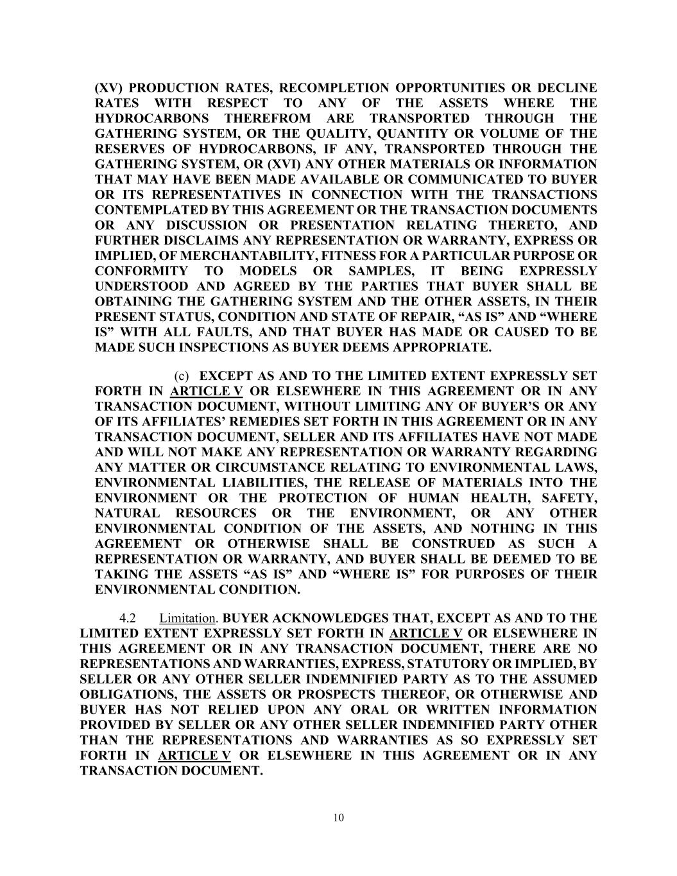
10 (XV) PRODUCTION RATES, RECOMPLETION OPPORTUNITIES OR DECLINE RATES WITH RESPECT TO ANY OF THE ASSETS WHERE THE HYDROCARBONS THEREFROM ARE TRANSPORTED THROUGH THE GATHERING SYSTEM, OR THE QUALITY, QUANTITY OR VOLUME OF THE RESERVES OF HYDROCARBONS, IF ANY, TRANSPORTED THROUGH THE GATHERING SYSTEM, OR (XVI) ANY OTHER MATERIALS OR INFORMATION THAT MAY HAVE BEEN MADE AVAILABLE OR COMMUNICATED TO BUYER OR ITS REPRESENTATIVES IN CONNECTION WITH THE TRANSACTIONS CONTEMPLATED BY THIS AGREEMENT OR THE TRANSACTION DOCUMENTS OR ANY DISCUSSION OR PRESENTATION RELATING THERETO, AND FURTHER DISCLAIMS ANY REPRESENTATION OR WARRANTY, EXPRESS OR IMPLIED, OF MERCHANTABILITY, FITNESS FOR A PARTICULAR PURPOSE OR CONFORMITY TO MODELS OR SAMPLES, IT BEING EXPRESSLY UNDERSTOOD AND AGREED BY THE PARTIES THAT BUYER SHALL BE OBTAINING THE GATHERING SYSTEM AND THE OTHER ASSETS, IN THEIR PRESENT STATUS, CONDITION AND STATE OF REPAIR, “AS IS” AND “WHERE IS” WITH ALL FAULTS, AND THAT BUYER HAS MADE OR CAUSED TO BE MADE SUCH INSPECTIONS AS BUYER DEEMS APPROPRIATE. (c) EXCEPT AS AND TO THE LIMITED EXTENT EXPRESSLY SET FORTH IN ARTICLE V OR ELSEWHERE IN THIS AGREEMENT OR IN ANY TRANSACTION DOCUMENT, WITHOUT LIMITING ANY OF BUYER’S OR ANY OF ITS AFFILIATES’ REMEDIES SET FORTH IN THIS AGREEMENT OR IN ANY TRANSACTION DOCUMENT, SELLER AND ITS AFFILIATES HAVE NOT MADE AND WILL NOT MAKE ANY REPRESENTATION OR WARRANTY REGARDING ANY MATTER OR CIRCUMSTANCE RELATING TO ENVIRONMENTAL LAWS, ENVIRONMENTAL LIABILITIES, THE RELEASE OF MATERIALS INTO THE ENVIRONMENT OR THE PROTECTION OF HUMAN HEALTH, SAFETY, NATURAL RESOURCES OR THE ENVIRONMENT, OR ANY OTHER ENVIRONMENTAL CONDITION OF THE ASSETS, AND NOTHING IN THIS AGREEMENT OR OTHERWISE SHALL BE CONSTRUED AS SUCH A REPRESENTATION OR WARRANTY, AND BUYER SHALL BE DEEMED TO BE TAKING THE ASSETS “AS IS” AND “WHERE IS” FOR PURPOSES OF THEIR ENVIRONMENTAL CONDITION. 4.2 Limitation. BUYER ACKNOWLEDGES THAT, EXCEPT AS AND TO THE LIMITED EXTENT EXPRESSLY SET FORTH IN ARTICLE V OR ELSEWHERE IN THIS AGREEMENT OR IN ANY TRANSACTION DOCUMENT, THERE ARE NO REPRESENTATIONS AND WARRANTIES, EXPRESS, STATUTORY OR IMPLIED, BY SELLER OR ANY OTHER SELLER INDEMNIFIED PARTY AS TO THE ASSUMED OBLIGATIONS, THE ASSETS OR PROSPECTS THEREOF, OR OTHERWISE AND BUYER HAS NOT RELIED UPON ANY ORAL OR WRITTEN INFORMATION PROVIDED BY SELLER OR ANY OTHER SELLER INDEMNIFIED PARTY OTHER THAN THE REPRESENTATIONS AND WARRANTIES AS SO EXPRESSLY SET FORTH IN ARTICLE V OR ELSEWHERE IN THIS AGREEMENT OR IN ANY TRANSACTION DOCUMENT.

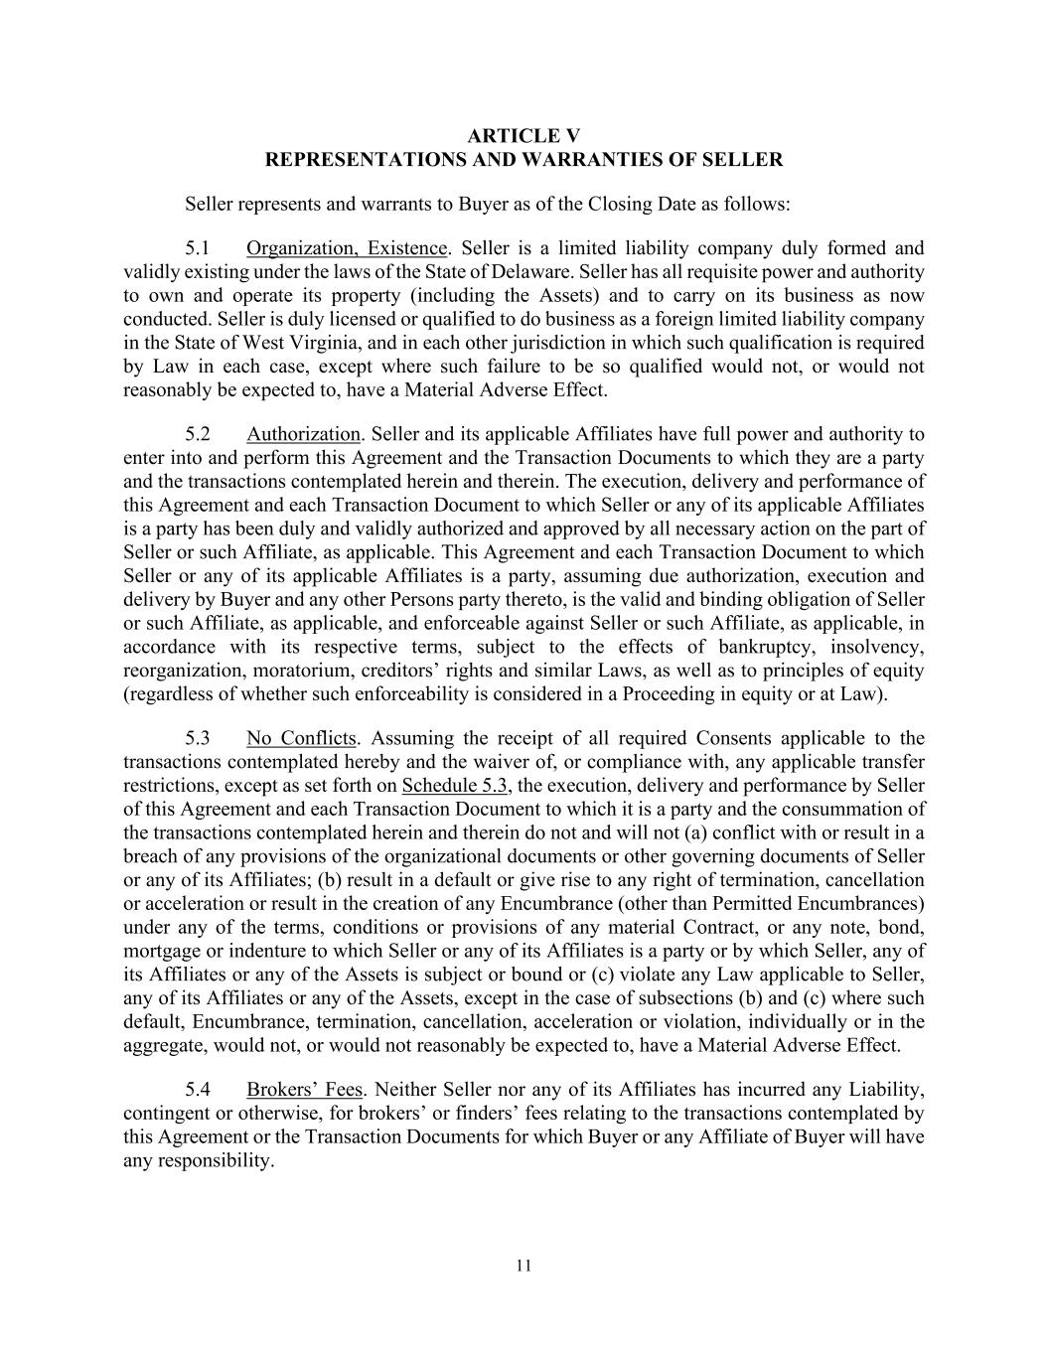
11 ARTICLE V REPRESENTATIONS AND WARRANTIES OF SELLER Seller represents and warrants to Buyer as of the Closing Date as follows: 5.1 Organization, Existence. Seller is a limited liability company duly formed and validly existing under the laws of the State of Delaware. Seller has all requisite power and authority to own and operate its property (including the Assets) and to carry on its business as now conducted. Seller is duly licensed or qualified to do business as a foreign limited liability company in the State of West Virginia, and in each other jurisdiction in which such qualification is required by Law in each case, except where such failure to be so qualified would not, or would not reasonably be expected to, have a Material Adverse Effect. 5.2 Authorization. Seller and its applicable Affiliates have full power and authority to enter into and perform this Agreement and the Transaction Documents to which they are a party and the transactions contemplated herein and therein. The execution, delivery and performance of this Agreement and each Transaction Document to which Seller or any of its applicable Affiliates is a party has been duly and validly authorized and approved by all necessary action on the part of Seller or such Affiliate, as applicable. This Agreement and each Transaction Document to which Seller or any of its applicable Affiliates is a party, assuming due authorization, execution and delivery by Buyer and any other Persons party thereto, is the valid and binding obligation of Seller or such Affiliate, as applicable, and enforceable against Seller or such Affiliate, as applicable, in accordance with its respective terms, subject to the effects of bankruptcy, insolvency, reorganization, moratorium, creditors’ rights and similar Laws, as well as to principles of equity (regardless of whether such enforceability is considered in a Proceeding in equity or at Law). 5.3 No Conflicts. Assuming the receipt of all required Consents applicable to the transactions contemplated hereby and the waiver of, or compliance with, any applicable transfer restrictions, except as set forth on Schedule 5.3, the execution, delivery and performance by Seller of this Agreement and each Transaction Document to which it is a party and the consummation of the transactions contemplated herein and therein do not and will not (a) conflict with or result in a breach of any provisions of the organizational documents or other governing documents of Seller or any of its Affiliates; (b) result in a default or give rise to any right of termination, cancellation or acceleration or result in the creation of any Encumbrance (other than Permitted Encumbrances) under any of the terms, conditions or provisions of any material Contract, or any note, bond, mortgage or indenture to which Seller or any of its Affiliates is a party or by which Seller, any of its Affiliates or any of the Assets is subject or bound or (c) violate any Law applicable to Seller, any of its Affiliates or any of the Assets, except in the case of subsections (b) and (c) where such default, Encumbrance, termination, cancellation, acceleration or violation, individually or in the aggregate, would not, or would not reasonably be expected to, have a Material Adverse Effect. 5.4 Brokers’ Fees. Neither Seller nor any of its Affiliates has incurred any Liability, contingent or otherwise, for brokers’ or finders’ fees relating to the transactions contemplated by this Agreement or the Transaction Documents for which Buyer or any Affiliate of Buyer will have any responsibility.

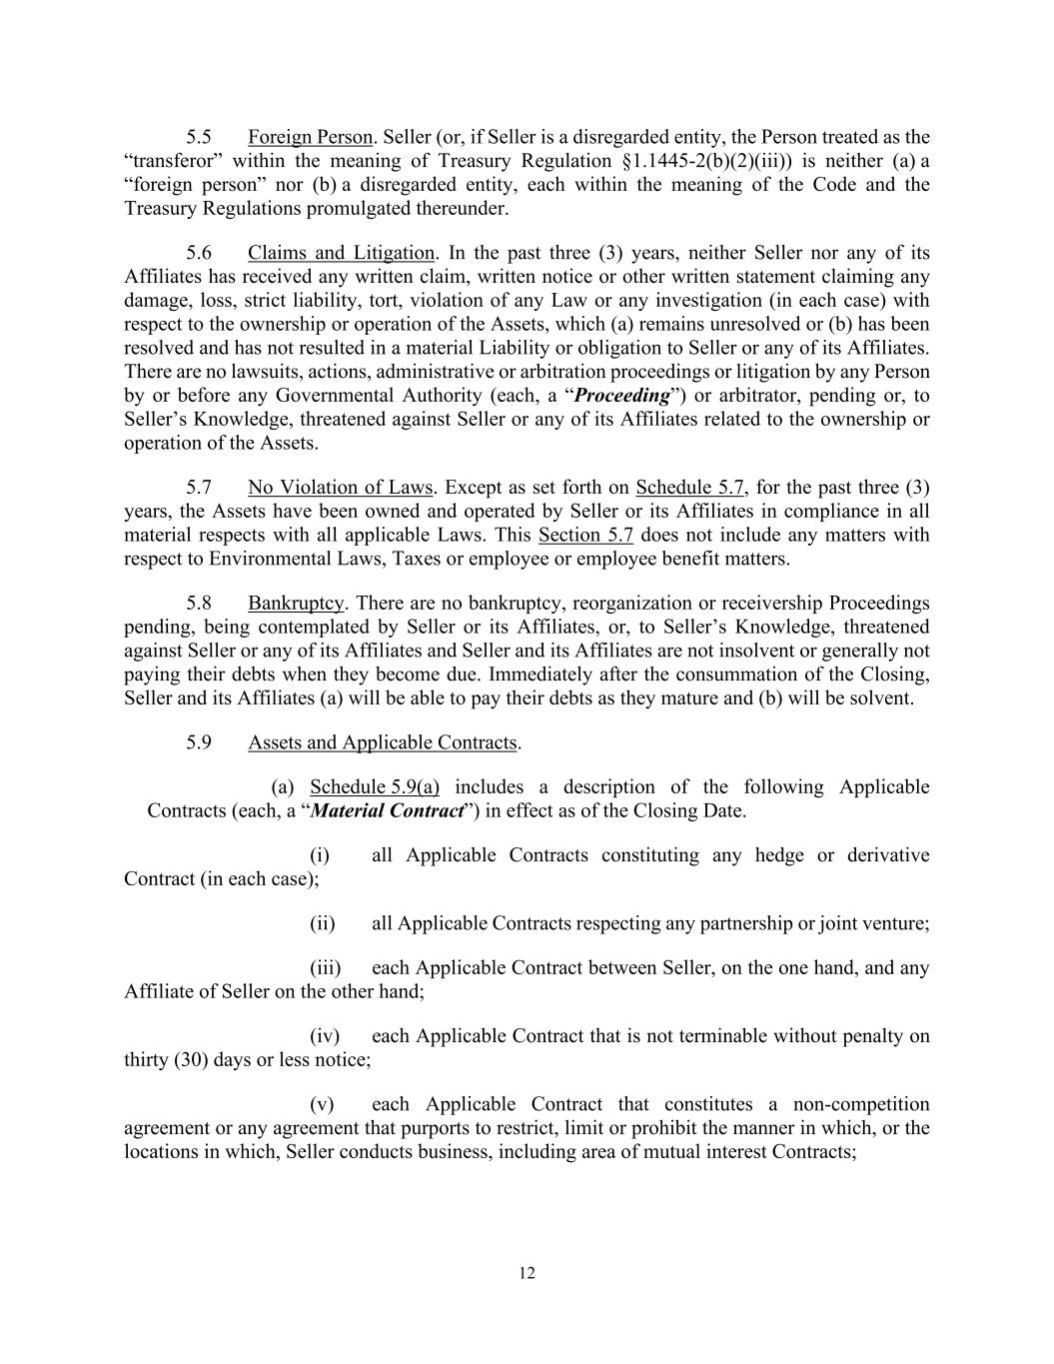
12 5.5 Foreign Person. Seller (or, if Seller is a disregarded entity, the Person treated as the “transferor” within the meaning of Treasury Regulation §1.1445-2(b)(2)(iii)) is neither (a) a “foreign person” nor (b) a disregarded entity, each within the meaning of the Code and the Treasury Regulations promulgated thereunder. 5.6 Claims and Litigation. In the past three (3) years, neither Seller nor any of its Affiliates has received any written claim, written notice or other written statement claiming any damage, loss, strict liability, tort, violation of any Law or any investigation (in each case) with respect to the ownership or operation of the Assets, which (a) remains unresolved or (b) has been resolved and has not resulted in a material Liability or obligation to Seller or any of its Affiliates. There are no lawsuits, actions, administrative or arbitration proceedings or litigation by any Person by or before any Governmental Authority (each, a “Proceeding”) or arbitrator, pending or, to Seller’s Knowledge, threatened against Seller or any of its Affiliates related to the ownership or operation of the Assets. 5.7 No Violation of Laws. Except as set forth on Schedule 5.7, for the past three (3) years, the Assets have been owned and operated by Seller or its Affiliates in compliance in all material respects with all applicable Laws. This Section 5.7 does not include any matters with respect to Environmental Laws, Taxes or employee or employee benefit matters. 5.8 Bankruptcy. There are no bankruptcy, reorganization or receivership Proceedings pending, being contemplated by Seller or its Affiliates, or, to Seller’s Knowledge, threatened against Seller or any of its Affiliates and Seller and its Affiliates are not insolvent or generally not paying their debts when they become due. Immediately after the consummation of the Closing, Seller and its Affiliates (a) will be able to pay their debts as they mature and (b) will be solvent. 5.9 Assets and Applicable Contracts. (a) Schedule 5.9(a) includes a description of the following Applicable Contracts (each, a “Material Contract”) in effect as of the Closing Date. (i) all Applicable Contracts constituting any hedge or derivative Contract (in each case); (ii) all Applicable Contracts respecting any partnership or joint venture; (iii) each Applicable Contract between Seller, on the one hand, and any Affiliate of Seller on the other hand; (iv) each Applicable Contract that is not terminable without penalty on thirty (30) days or less notice; (v) each Applicable Contract that constitutes a non-competition agreement or any agreement that purports to restrict, limit or prohibit the manner in which, or the locations in which, Seller conducts business, including area of mutual interest Contracts;

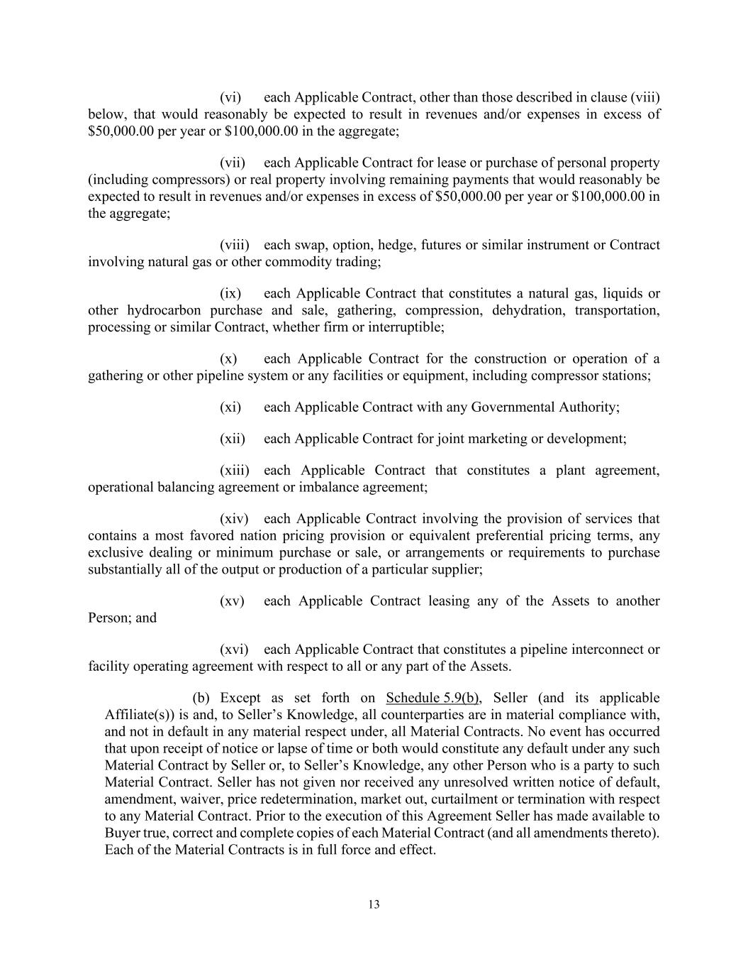
13 (vi) each Applicable Contract, other than those described in clause (viii) below, that would reasonably be expected to result in revenues and/or expenses in excess of $50,000.00 per year or $100,000.00 in the aggregate; (vii) each Applicable Contract for lease or purchase of personal property (including compressors) or real property involving remaining payments that would reasonably be expected to result in revenues and/or expenses in excess of $50,000.00 per year or $100,000.00 in the aggregate; (viii) each swap, option, hedge, futures or similar instrument or Contract involving natural gas or other commodity trading; (ix) each Applicable Contract that constitutes a natural gas, liquids or other hydrocarbon purchase and sale, gathering, compression, dehydration, transportation, processing or similar Contract, whether firm or interruptible; (x) each Applicable Contract for the construction or operation of a gathering or other pipeline system or any facilities or equipment, including compressor stations; (xi) each Applicable Contract with any Governmental Authority; (xii) each Applicable Contract for joint marketing or development; (xiii) each Applicable Contract that constitutes a plant agreement, operational balancing agreement or imbalance agreement; (xiv) each Applicable Contract involving the provision of services that contains a most favored nation pricing provision or equivalent preferential pricing terms, any exclusive dealing or minimum purchase or sale, or arrangements or requirements to purchase substantially all of the output or production of a particular supplier; (xv) each Applicable Contract leasing any of the Assets to another Person; and (xvi) each Applicable Contract that constitutes a pipeline interconnect or facility operating agreement with respect to all or any part of the Assets. (b) Except as set forth on Schedule 5.9(b), Seller (and its applicable Affiliate(s)) is and, to Seller’s Knowledge, all counterparties are in material compliance with, and not in default in any material respect under, all Material Contracts. No event has occurred that upon receipt of notice or lapse of time or both would constitute any default under any such Material Contract by Seller or, to Seller’s Knowledge, any other Person who is a party to such Material Contract. Seller has not given nor received any unresolved written notice of default, amendment, waiver, price redetermination, market out, curtailment or termination with respect to any Material Contract. Prior to the execution of this Agreement Seller has made available to Buyer true, correct and complete copies of each Material Contract (and all amendments thereto). Each of the Material Contracts is in full force and effect.

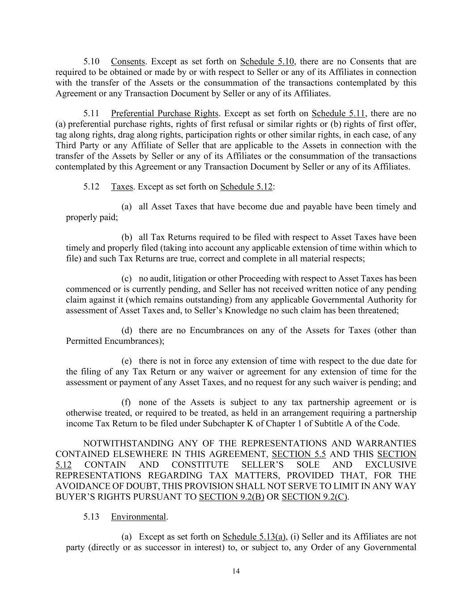
14 5.10 Consents. Except as set forth on Schedule 5.10, there are no Consents that are required to be obtained or made by or with respect to Seller or any of its Affiliates in connection with the transfer of the Assets or the consummation of the transactions contemplated by this Agreement or any Transaction Document by Seller or any of its Affiliates. 5.11 Preferential Purchase Rights. Except as set forth on Schedule 5.11, there are no (a) preferential purchase rights, rights of first refusal or similar rights or (b) rights of first offer, tag along rights, drag along rights, participation rights or other similar rights, in each case, of any Third Party or any Affiliate of Seller that are applicable to the Assets in connection with the transfer of the Assets by Seller or any of its Affiliates or the consummation of the transactions contemplated by this Agreement or any Transaction Document by Seller or any of its Affiliates. 5.12 Taxes. Except as set forth on Schedule 5.12: (a) all Asset Taxes that have become due and payable have been timely and properly paid; (b) all Tax Returns required to be filed with respect to Asset Taxes have been timely and properly filed (taking into account any applicable extension of time within which to file) and such Tax Returns are true, correct and complete in all material respects; (c) no audit, litigation or other Proceeding with respect to Asset Taxes has been commenced or is currently pending, and Seller has not received written notice of any pending claim against it (which remains outstanding) from any applicable Governmental Authority for assessment of Asset Taxes and, to Seller’s Knowledge no such claim has been threatened; (d) there are no Encumbrances on any of the Assets for Taxes (other than Permitted Encumbrances); (e) there is not in force any extension of time with respect to the due date for the filing of any Tax Return or any waiver or agreement for any extension of time for the assessment or payment of any Asset Taxes, and no request for any such waiver is pending; and (f) none of the Assets is subject to any tax partnership agreement or is otherwise treated, or required to be treated, as held in an arrangement requiring a partnership income Tax Return to be filed under Subchapter K of Chapter 1 of Subtitle A of the Code. NOTWITHSTANDING ANY OF THE REPRESENTATIONS AND WARRANTIES CONTAINED ELSEWHERE IN THIS AGREEMENT, SECTION 5.5 AND THIS SECTION 5.12 CONTAIN AND CONSTITUTE SELLER’S SOLE AND EXCLUSIVE REPRESENTATIONS REGARDING TAX MATTERS, PROVIDED THAT, FOR THE AVOIDANCE OF DOUBT, THIS PROVISION SHALL NOT SERVE TO LIMIT IN ANY WAY BUYER’S RIGHTS PURSUANT TO SECTION 9.2(B) OR SECTION 9.2(C). 5.13 Environmental. (a) Except as set forth on Schedule 5.13(a), (i) Seller and its Affiliates are not party (directly or as successor in interest) to, or subject to, any Order of any Governmental

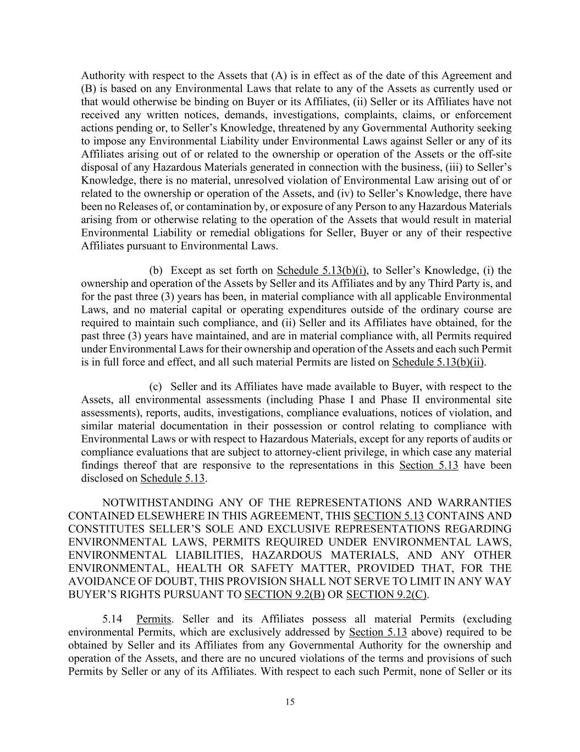
15 Authority with respect to the Assets that (A) is in effect as of the date of this Agreement and (B) is based on any Environmental Laws that relate to any of the Assets as currently used or that would otherwise be binding on Buyer or its Affiliates, (ii) Seller or its Affiliates have not received any written notices, demands, investigations, complaints, claims, or enforcement actions pending or, to Seller’s Knowledge, threatened by any Governmental Authority seeking to impose any Environmental Liability under Environmental Laws against Seller or any of its Affiliates arising out of or related to the ownership or operation of the Assets or the off-site disposal of any Hazardous Materials generated in connection with the business, (iii) to Seller’s Knowledge, there is no material, unresolved violation of Environmental Law arising out of or related to the ownership or operation of the Assets, and (iv) to Seller’s Knowledge, there have been no Releases of, or contamination by, or exposure of any Person to any Hazardous Materials arising from or otherwise relating to the operation of the Assets that would result in material Environmental Liability or remedial obligations for Seller, Buyer or any of their respective Affiliates pursuant to Environmental Laws. (b) Except as set forth on Schedule 5.13(b)(i), to Seller’s Knowledge, (i) the ownership and operation of the Assets by Seller and its Affiliates and by any Third Party is, and for the past three (3) years has been, in material compliance with all applicable Environmental Laws, and no material capital or operating expenditures outside of the ordinary course are required to maintain such compliance, and (ii) Seller and its Affiliates have obtained, for the past three (3) years have maintained, and are in material compliance with, all Permits required under Environmental Laws for their ownership and operation of the Assets and each such Permit is in full force and effect, and all such material Permits are listed on Schedule 5.13(b)(ii). (c) Seller and its Affiliates have made available to Buyer, with respect to the Assets, all environmental assessments (including Phase I and Phase II environmental site assessments), reports, audits, investigations, compliance evaluations, notices of violation, and similar material documentation in their possession or control relating to compliance with Environmental Laws or with respect to Hazardous Materials, except for any reports of audits or compliance evaluations that are subject to attorney-client privilege, in which case any material findings thereof that are responsive to the representations in this Section 5.13 have been disclosed on Schedule 5.13. NOTWITHSTANDING ANY OF THE REPRESENTATIONS AND WARRANTIES CONTAINED ELSEWHERE IN THIS AGREEMENT, THIS SECTION 5.13 CONTAINS AND CONSTITUTES SELLER’S SOLE AND EXCLUSIVE REPRESENTATIONS REGARDING ENVIRONMENTAL LAWS, PERMITS REQUIRED UNDER ENVIRONMENTAL LAWS, ENVIRONMENTAL LIABILITIES, HAZARDOUS MATERIALS, AND ANY OTHER ENVIRONMENTAL, HEALTH OR SAFETY MATTER, PROVIDED THAT, FOR THE AVOIDANCE OF DOUBT, THIS PROVISION SHALL NOT SERVE TO LIMIT IN ANY WAY BUYER’S RIGHTS PURSUANT TO SECTION 9.2(B) OR SECTION 9.2(C). 5.14 Permits. Seller and its Affiliates possess all material Permits (excluding environmental Permits, which are exclusively addressed by Section 5.13 above) required to be obtained by Seller and its Affiliates from any Governmental Authority for the ownership and operation of the Assets, and there are no uncured violations of the terms and provisions of such Permits by Seller or any of its Affiliates. With respect to each such Permit, none of Seller or its

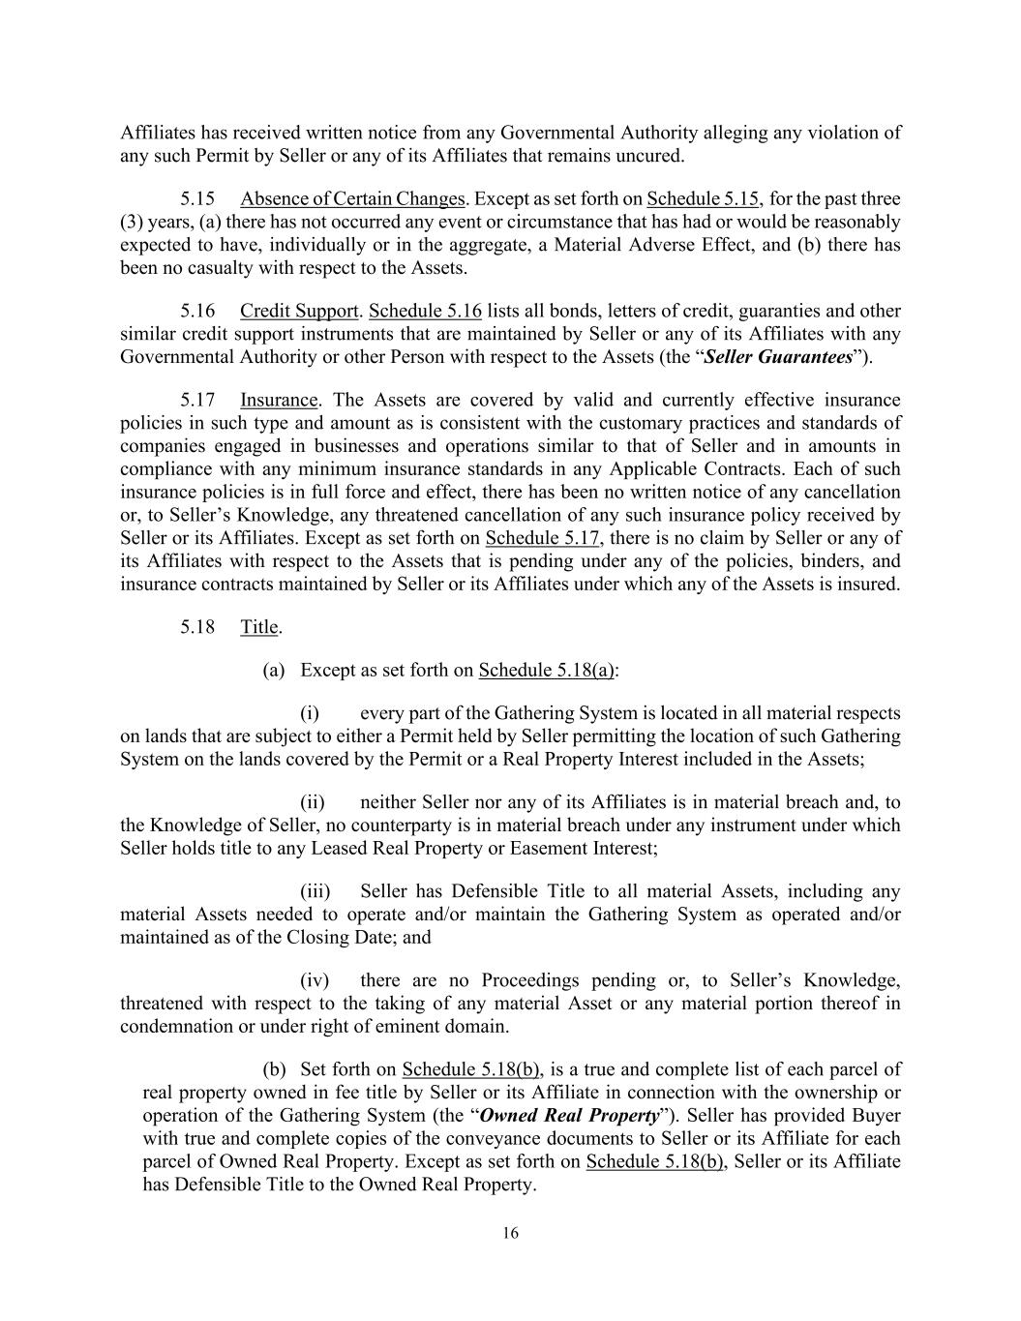
16 Affiliates has received written notice from any Governmental Authority alleging any violation of any such Permit by Seller or any of its Affiliates that remains uncured. 5.15 Absence of Certain Changes. Except as set forth on Schedule 5.15, for the past three (3) years, (a) there has not occurred any event or circumstance that has had or would be reasonably expected to have, individually or in the aggregate, a Material Adverse Effect, and (b) there has been no casualty with respect to the Assets. 5.16 Credit Support. Schedule 5.16 lists all bonds, letters of credit, guaranties and other similar credit support instruments that are maintained by Seller or any of its Affiliates with any Governmental Authority or other Person with respect to the Assets (the “Seller Guarantees”). 5.17 Insurance. The Assets are covered by valid and currently effective insurance policies in such type and amount as is consistent with the customary practices and standards of companies engaged in businesses and operations similar to that of Seller and in amounts in compliance with any minimum insurance standards in any Applicable Contracts. Each of such insurance policies is in full force and effect, there has been no written notice of any cancellation or, to Seller’s Knowledge, any threatened cancellation of any such insurance policy received by Seller or its Affiliates. Except as set forth on Schedule 5.17, there is no claim by Seller or any of its Affiliates with respect to the Assets that is pending under any of the policies, binders, and insurance contracts maintained by Seller or its Affiliates under which any of the Assets is insured. 5.18 Title. (a) Except as set forth on Schedule 5.18(a): (i) every part of the Gathering System is located in all material respects on lands that are subject to either a Permit held by Seller permitting the location of such Gathering System on the lands covered by the Permit or a Real Property Interest included in the Assets; (ii) neither Seller nor any of its Affiliates is in material breach and, to the Knowledge of Seller, no counterparty is in material breach under any instrument under which Seller holds title to any Leased Real Property or Easement Interest; (iii) Seller has Defensible Title to all material Assets, including any material Assets needed to operate and/or maintain the Gathering System as operated and/or maintained as of the Closing Date; and (iv) there are no Proceedings pending or, to Seller’s Knowledge, threatened with respect to the taking of any material Asset or any material portion thereof in condemnation or under right of eminent domain. (b) Set forth on Schedule 5.18(b), is a true and complete list of each parcel of real property owned in fee title by Seller or its Affiliate in connection with the ownership or operation of the Gathering System (the “Owned Real Property”). Seller has provided Buyer with true and complete copies of the conveyance documents to Seller or its Affiliate for each parcel of Owned Real Property. Except as set forth on Schedule 5.18(b), Seller or its Affiliate has Defensible Title to the Owned Real Property.

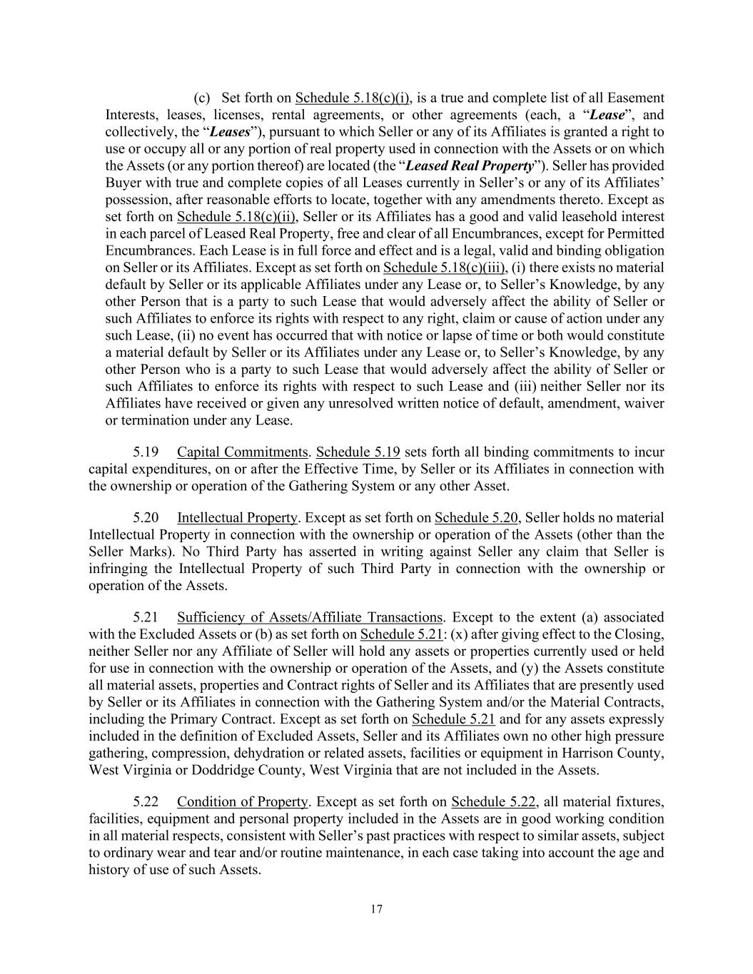
17 (c) Set forth on Schedule 5.18(c)(i), is a true and complete list of all Easement Interests, leases, licenses, rental agreements, or other agreements (each, a “Lease”, and collectively, the “Leases”), pursuant to which Seller or any of its Affiliates is granted a right to use or occupy all or any portion of real property used in connection with the Assets or on which the Assets (or any portion thereof) are located (the “Leased Real Property”). Seller has provided Buyer with true and complete copies of all Leases currently in Seller’s or any of its Affiliates’ possession, after reasonable efforts to locate, together with any amendments thereto. Except as set forth on Schedule 5.18(c)(ii), Seller or its Affiliates has a good and valid leasehold interest in each parcel of Leased Real Property, free and clear of all Encumbrances, except for Permitted Encumbrances. Each Lease is in full force and effect and is a legal, valid and binding obligation on Seller or its Affiliates. Except as set forth on Schedule 5.18(c)(iii), (i) there exists no material default by Seller or its applicable Affiliates under any Lease or, to Seller’s Knowledge, by any other Person that is a party to such Lease that would adversely affect the ability of Seller or such Affiliates to enforce its rights with respect to any right, claim or cause of action under any such Lease, (ii) no event has occurred that with notice or lapse of time or both would constitute a material default by Seller or its Affiliates under any Lease or, to Seller’s Knowledge, by any other Person who is a party to such Lease that would adversely affect the ability of Seller or such Affiliates to enforce its rights with respect to such Lease and (iii) neither Seller nor its Affiliates have received or given any unresolved written notice of default, amendment, waiver or termination under any Lease. 5.19 Capital Commitments. Schedule 5.19 sets forth all binding commitments to incur capital expenditures, on or after the Effective Time, by Seller or its Affiliates in connection with the ownership or operation of the Gathering System or any other Asset. 5.20 Intellectual Property. Except as set forth on Schedule 5.20, Seller holds no material Intellectual Property in connection with the ownership or operation of the Assets (other than the Seller Marks). No Third Party has asserted in writing against Seller any claim that Seller is infringing the Intellectual Property of such Third Party in connection with the ownership or operation of the Assets. 5.21 Sufficiency of Assets/Affiliate Transactions. Except to the extent (a) associated with the Excluded Assets or (b) as set forth on Schedule 5.21: (x) after giving effect to the Closing, neither Seller nor any Affiliate of Seller will hold any assets or properties currently used or held for use in connection with the ownership or operation of the Assets, and (y) the Assets constitute all material assets, properties and Contract rights of Seller and its Affiliates that are presently used by Seller or its Affiliates in connection with the Gathering System and/or the Material Contracts, including the Primary Contract. Except as set forth on Schedule 5.21 and for any assets expressly included in the definition of Excluded Assets, Seller and its Affiliates own no other high pressure gathering, compression, dehydration or related assets, facilities or equipment in Harrison County, West Virginia or Doddridge County, West Virginia that are not included in the Assets. 5.22 Condition of Property. Except as set forth on Schedule 5.22, all material fixtures, facilities, equipment and personal property included in the Assets are in good working condition in all material respects, consistent with Seller’s past practices with respect to similar assets, subject to ordinary wear and tear and/or routine maintenance, in each case taking into account the age and history of use of such Assets.

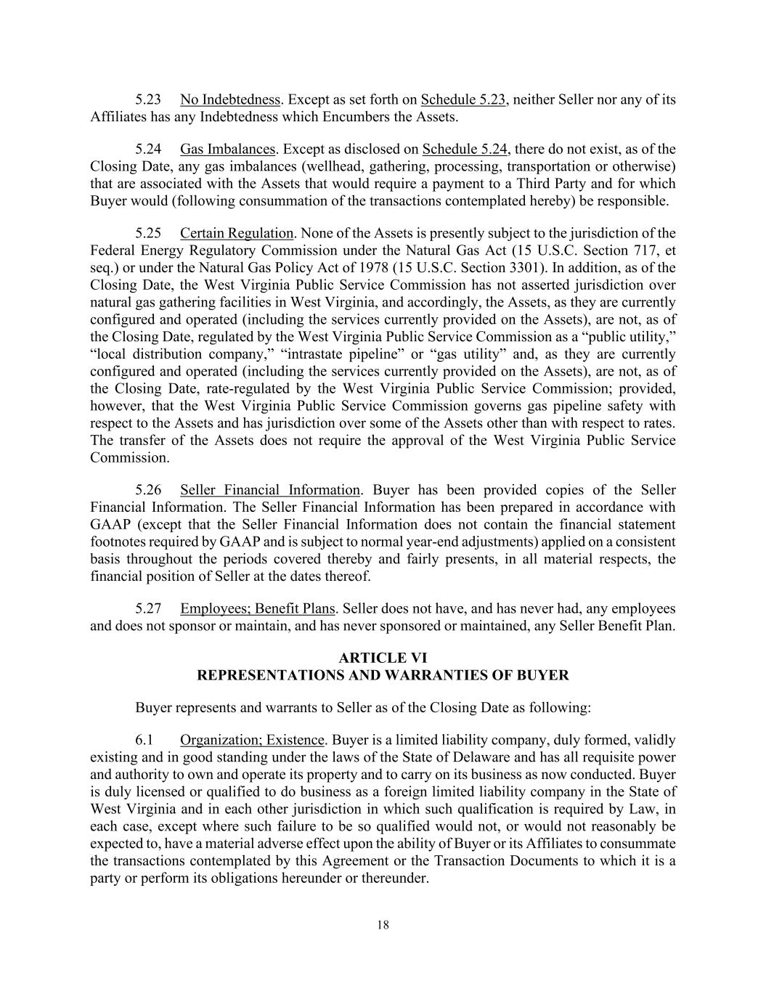
18 5.23 No Indebtedness. Except as set forth on Schedule 5.23, neither Seller nor any of its Affiliates has any Indebtedness which Encumbers the Assets. 5.24 Gas Imbalances. Except as disclosed on Schedule 5.24, there do not exist, as of the Closing Date, any gas imbalances (wellhead, gathering, processing, transportation or otherwise) that are associated with the Assets that would require a payment to a Third Party and for which Buyer would (following consummation of the transactions contemplated hereby) be responsible. 5.25 Certain Regulation. None of the Assets is presently subject to the jurisdiction of the Federal Energy Regulatory Commission under the Natural Gas Act (15 U.S.C. Section 717, et seq.) or under the Natural Gas Policy Act of 1978 (15 U.S.C. Section 3301). In addition, as of the Closing Date, the West Virginia Public Service Commission has not asserted jurisdiction over natural gas gathering facilities in West Virginia, and accordingly, the Assets, as they are currently configured and operated (including the services currently provided on the Assets), are not, as of the Closing Date, regulated by the West Virginia Public Service Commission as a “public utility,” “local distribution company,” “intrastate pipeline” or “gas utility” and, as they are currently configured and operated (including the services currently provided on the Assets), are not, as of the Closing Date, rate-regulated by the West Virginia Public Service Commission; provided, however, that the West Virginia Public Service Commission governs gas pipeline safety with respect to the Assets and has jurisdiction over some of the Assets other than with respect to rates. The transfer of the Assets does not require the approval of the West Virginia Public Service Commission. 5.26 Seller Financial Information. Buyer has been provided copies of the Seller Financial Information. The Seller Financial Information has been prepared in accordance with GAAP (except that the Seller Financial Information does not contain the financial statement footnotes required by GAAP and is subject to normal year-end adjustments) applied on a consistent basis throughout the periods covered thereby and fairly presents, in all material respects, the financial position of Seller at the dates thereof. 5.27 Employees; Benefit Plans. Seller does not have, and has never had, any employees and does not sponsor or maintain, and has never sponsored or maintained, any Seller Benefit Plan. ARTICLE VI REPRESENTATIONS AND WARRANTIES OF BUYER Buyer represents and warrants to Seller as of the Closing Date as following: 6.1 Organization; Existence. Buyer is a limited liability company, duly formed, validly existing and in good standing under the laws of the State of Delaware and has all requisite power and authority to own and operate its property and to carry on its business as now conducted. Buyer is duly licensed or qualified to do business as a foreign limited liability company in the State of West Virginia and in each other jurisdiction in which such qualification is required by Law, in each case, except where such failure to be so qualified would not, or would not reasonably be expected to, have a material adverse effect upon the ability of Buyer or its Affiliates to consummate the transactions contemplated by this Agreement or the Transaction Documents to which it is a party or perform its obligations hereunder or thereunder.

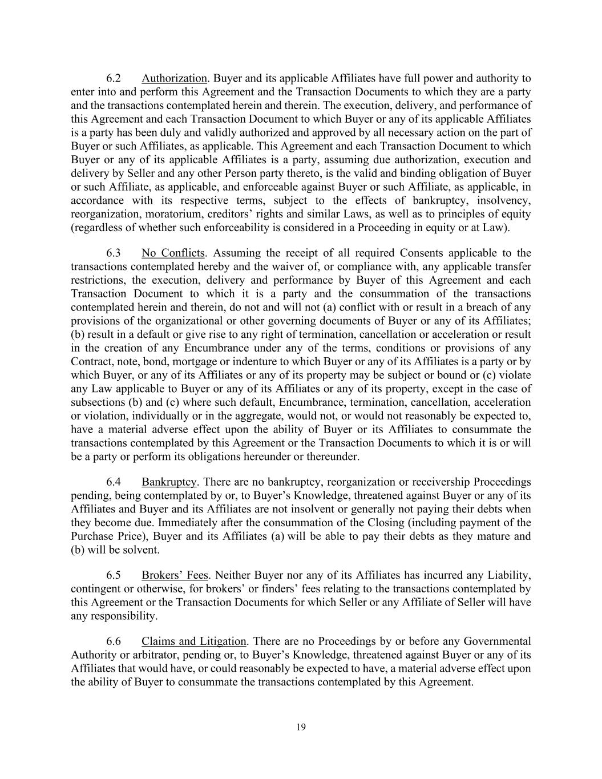
19 6.2 Authorization. Buyer and its applicable Affiliates have full power and authority to enter into and perform this Agreement and the Transaction Documents to which they are a party and the transactions contemplated herein and therein. The execution, delivery, and performance of this Agreement and each Transaction Document to which Buyer or any of its applicable Affiliates is a party has been duly and validly authorized and approved by all necessary action on the part of Buyer or such Affiliates, as applicable. This Agreement and each Transaction Document to which Buyer or any of its applicable Affiliates is a party, assuming due authorization, execution and delivery by Seller and any other Person party thereto, is the valid and binding obligation of Buyer or such Affiliate, as applicable, and enforceable against Buyer or such Affiliate, as applicable, in accordance with its respective terms, subject to the effects of bankruptcy, insolvency, reorganization, moratorium, creditors’ rights and similar Laws, as well as to principles of equity (regardless of whether such enforceability is considered in a Proceeding in equity or at Law). 6.3 No Conflicts. Assuming the receipt of all required Consents applicable to the transactions contemplated hereby and the waiver of, or compliance with, any applicable transfer restrictions, the execution, delivery and performance by Buyer of this Agreement and each Transaction Document to which it is a party and the consummation of the transactions contemplated herein and therein, do not and will not (a) conflict with or result in a breach of any provisions of the organizational or other governing documents of Buyer or any of its Affiliates; (b) result in a default or give rise to any right of termination, cancellation or acceleration or result in the creation of any Encumbrance under any of the terms, conditions or provisions of any Contract, note, bond, mortgage or indenture to which Buyer or any of its Affiliates is a party or by which Buyer, or any of its Affiliates or any of its property may be subject or bound or (c) violate any Law applicable to Buyer or any of its Affiliates or any of its property, except in the case of subsections (b) and (c) where such default, Encumbrance, termination, cancellation, acceleration or violation, individually or in the aggregate, would not, or would not reasonably be expected to, have a material adverse effect upon the ability of Buyer or its Affiliates to consummate the transactions contemplated by this Agreement or the Transaction Documents to which it is or will be a party or perform its obligations hereunder or thereunder. 6.4 Bankruptcy. There are no bankruptcy, reorganization or receivership Proceedings pending, being contemplated by or, to Buyer’s Knowledge, threatened against Buyer or any of its Affiliates and Buyer and its Affiliates are not insolvent or generally not paying their debts when they become due. Immediately after the consummation of the Closing (including payment of the Purchase Price), Buyer and its Affiliates (a) will be able to pay their debts as they mature and (b) will be solvent. 6.5 Brokers’ Fees. Neither Buyer nor any of its Affiliates has incurred any Liability, contingent or otherwise, for brokers’ or finders’ fees relating to the transactions contemplated by this Agreement or the Transaction Documents for which Seller or any Affiliate of Seller will have any responsibility. 6.6 Claims and Litigation. There are no Proceedings by or before any Governmental Authority or arbitrator, pending or, to Buyer’s Knowledge, threatened against Buyer or any of its Affiliates that would have, or could reasonably be expected to have, a material adverse effect upon the ability of Buyer to consummate the transactions contemplated by this Agreement.

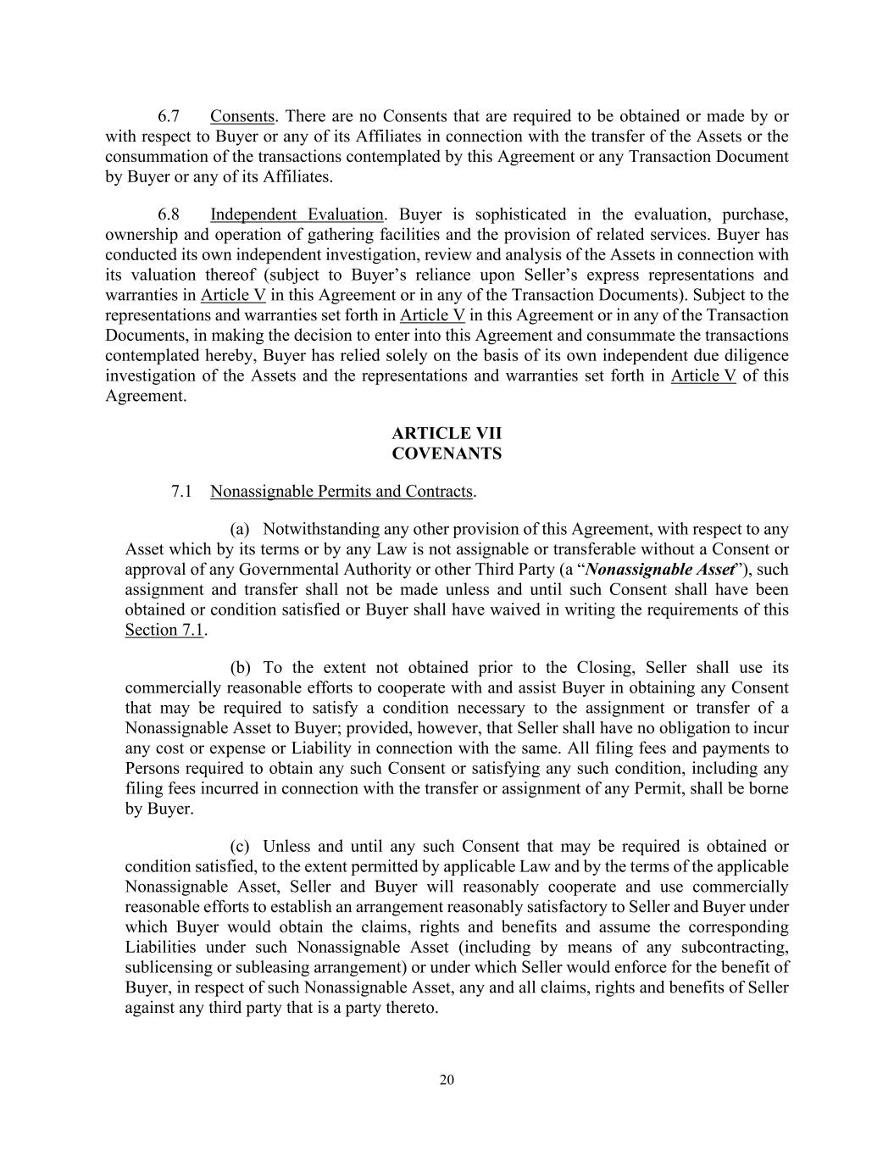
20 6.7 Consents. There are no Consents that are required to be obtained or made by or with respect to Buyer or any of its Affiliates in connection with the transfer of the Assets or the consummation of the transactions contemplated by this Agreement or any Transaction Document by Buyer or any of its Affiliates. 6.8 Independent Evaluation. Buyer is sophisticated in the evaluation, purchase, ownership and operation of gathering facilities and the provision of related services. Buyer has conducted its own independent investigation, review and analysis of the Assets in connection with its valuation thereof (subject to Buyer’s reliance upon Seller’s express representations and warranties in Article V in this Agreement or in any of the Transaction Documents). Subject to the representations and warranties set forth in Article V in this Agreement or in any of the Transaction Documents, in making the decision to enter into this Agreement and consummate the transactions contemplated hereby, Buyer has relied solely on the basis of its own independent due diligence investigation of the Assets and the representations and warranties set forth in Article V of this Agreement. ARTICLE VII COVENANTS 7.1 Nonassignable Permits and Contracts. (a) Notwithstanding any other provision of this Agreement, with respect to any Asset which by its terms or by any Law is not assignable or transferable without a Consent or approval of any Governmental Authority or other Third Party (a “Nonassignable Asset”), such assignment and transfer shall not be made unless and until such Consent shall have been obtained or condition satisfied or Buyer shall have waived in writing the requirements of this Section 7.1. (b) To the extent not obtained prior to the Closing, Seller shall use its commercially reasonable efforts to cooperate with and assist Buyer in obtaining any Consent that may be required to satisfy a condition necessary to the assignment or transfer of a Nonassignable Asset to Buyer; provided, however, that Seller shall have no obligation to incur any cost or expense or Liability in connection with the same. All filing fees and payments to Persons required to obtain any such Consent or satisfying any such condition, including any filing fees incurred in connection with the transfer or assignment of any Permit, shall be borne by Buyer. (c) Unless and until any such Consent that may be required is obtained or condition satisfied, to the extent permitted by applicable Law and by the terms of the applicable Nonassignable Asset, Seller and Buyer will reasonably cooperate and use commercially reasonable efforts to establish an arrangement reasonably satisfactory to Seller and Buyer under which Buyer would obtain the claims, rights and benefits and assume the corresponding Liabilities under such Nonassignable Asset (including by means of any subcontracting, sublicensing or subleasing arrangement) or under which Seller would enforce for the benefit of Buyer, in respect of such Nonassignable Asset, any and all claims, rights and benefits of Seller against any third party that is a party thereto.

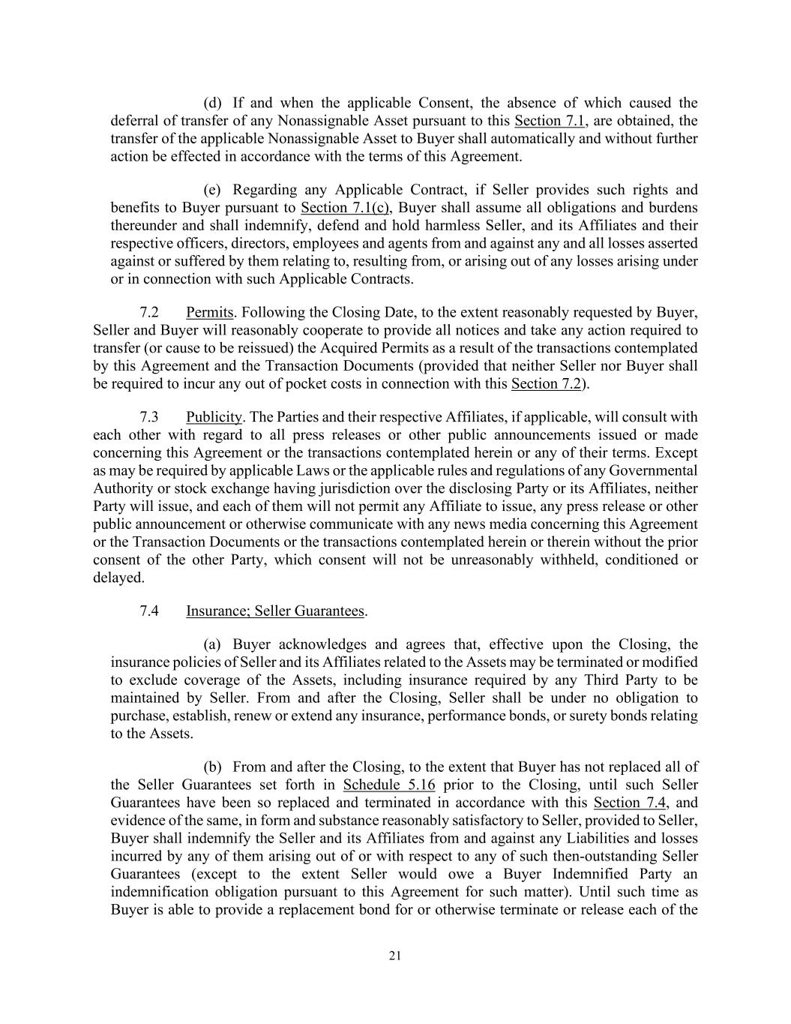
21 (d) If and when the applicable Consent, the absence of which caused the deferral of transfer of any Nonassignable Asset pursuant to this Section 7.1, are obtained, the transfer of the applicable Nonassignable Asset to Buyer shall automatically and without further action be effected in accordance with the terms of this Agreement. (e) Regarding any Applicable Contract, if Seller provides such rights and benefits to Buyer pursuant to Section 7.1(c), Buyer shall assume all obligations and burdens thereunder and shall indemnify, defend and hold harmless Seller, and its Affiliates and their respective officers, directors, employees and agents from and against any and all losses asserted against or suffered by them relating to, resulting from, or arising out of any losses arising under or in connection with such Applicable Contracts. 7.2 Permits. Following the Closing Date, to the extent reasonably requested by Buyer, Seller and Buyer will reasonably cooperate to provide all notices and take any action required to transfer (or cause to be reissued) the Acquired Permits as a result of the transactions contemplated by this Agreement and the Transaction Documents (provided that neither Seller nor Buyer shall be required to incur any out of pocket costs in connection with this Section 7.2). 7.3 Publicity. The Parties and their respective Affiliates, if applicable, will consult with each other with regard to all press releases or other public announcements issued or made concerning this Agreement or the transactions contemplated herein or any of their terms. Except as may be required by applicable Laws or the applicable rules and regulations of any Governmental Authority or stock exchange having jurisdiction over the disclosing Party or its Affiliates, neither Party will issue, and each of them will not permit any Affiliate to issue, any press release or other public announcement or otherwise communicate with any news media concerning this Agreement or the Transaction Documents or the transactions contemplated herein or therein without the prior consent of the other Party, which consent will not be unreasonably withheld, conditioned or delayed. 7.4 Insurance; Seller Guarantees. (a) Buyer acknowledges and agrees that, effective upon the Closing, the insurance policies of Seller and its Affiliates related to the Assets may be terminated or modified to exclude coverage of the Assets, including insurance required by any Third Party to be maintained by Seller. From and after the Closing, Seller shall be under no obligation to purchase, establish, renew or extend any insurance, performance bonds, or surety bonds relating to the Assets. (b) From and after the Closing, to the extent that Buyer has not replaced all of the Seller Guarantees set forth in Schedule 5.16 prior to the Closing, until such Seller Guarantees have been so replaced and terminated in accordance with this Section 7.4, and evidence of the same, in form and substance reasonably satisfactory to Seller, provided to Seller, Buyer shall indemnify the Seller and its Affiliates from and against any Liabilities and losses incurred by any of them arising out of or with respect to any of such then-outstanding Seller Guarantees (except to the extent Seller would owe a Buyer Indemnified Party an indemnification obligation pursuant to this Agreement for such matter). Until such time as Buyer is able to provide a replacement bond for or otherwise terminate or release each of the

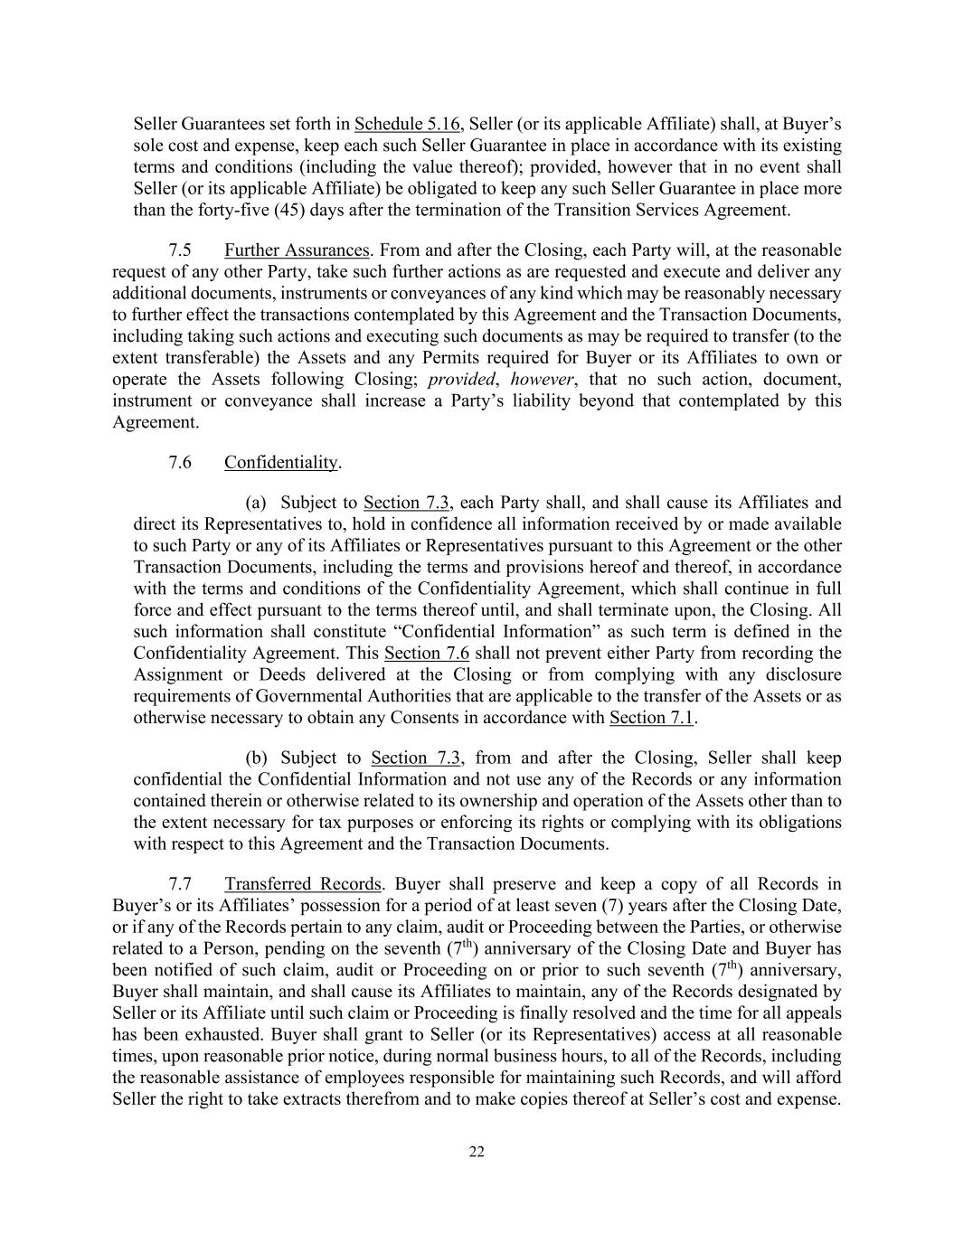
22 Seller Guarantees set forth in Schedule 5.16, Seller (or its applicable Affiliate) shall, at Buyer’s sole cost and expense, keep each such Seller Guarantee in place in accordance with its existing terms and conditions (including the value thereof); provided, however that in no event shall Seller (or its applicable Affiliate) be obligated to keep any such Seller Guarantee in place more than the forty-five (45) days after the termination of the Transition Services Agreement. 7.5 Further Assurances. From and after the Closing, each Party will, at the reasonable request of any other Party, take such further actions as are requested and execute and deliver any additional documents, instruments or conveyances of any kind which may be reasonably necessary to further effect the transactions contemplated by this Agreement and the Transaction Documents, including taking such actions and executing such documents as may be required to transfer (to the extent transferable) the Assets and any Permits required for Buyer or its Affiliates to own or operate the Assets following Closing; provided, however, that no such action, document, instrument or conveyance shall increase a Party’s liability beyond that contemplated by this Agreement. 7.6 Confidentiality. (a) Subject to Section 7.3, each Party shall, and shall cause its Affiliates and direct its Representatives to, hold in confidence all information received by or made available to such Party or any of its Affiliates or Representatives pursuant to this Agreement or the other Transaction Documents, including the terms and provisions hereof and thereof, in accordance with the terms and conditions of the Confidentiality Agreement, which shall continue in full force and effect pursuant to the terms thereof until, and shall terminate upon, the Closing. All such information shall constitute “Confidential Information” as such term is defined in the Confidentiality Agreement. This Section 7.6 shall not prevent either Party from recording the Assignment or Deeds delivered at the Closing or from complying with any disclosure requirements of Governmental Authorities that are applicable to the transfer of the Assets or as otherwise necessary to obtain any Consents in accordance with Section 7.1. (b) Subject to Section 7.3, from and after the Closing, Seller shall keep confidential the Confidential Information and not use any of the Records or any information contained therein or otherwise related to its ownership and operation of the Assets other than to the extent necessary for tax purposes or enforcing its rights or complying with its obligations with respect to this Agreement and the Transaction Documents. 7.7 Transferred Records. Buyer shall preserve and keep a copy of all Records in Buyer’s or its Affiliates’ possession for a period of at least seven (7) years after the Closing Date, or if any of the Records pertain to any claim, audit or Proceeding between the Parties, or otherwise related to a Person, pending on the seventh (7th) anniversary of the Closing Date and Buyer has been notified of such claim, audit or Proceeding on or prior to such seventh (7th) anniversary, Buyer shall maintain, and shall cause its Affiliates to maintain, any of the Records designated by Seller or its Affiliate until such claim or Proceeding is finally resolved and the time for all appeals has been exhausted. Buyer shall grant to Seller (or its Representatives) access at all reasonable times, upon reasonable prior notice, during normal business hours, to all of the Records, including the reasonable assistance of employees responsible for maintaining such Records, and will afford Seller the right to take extracts therefrom and to make copies thereof at Seller’s cost and expense.

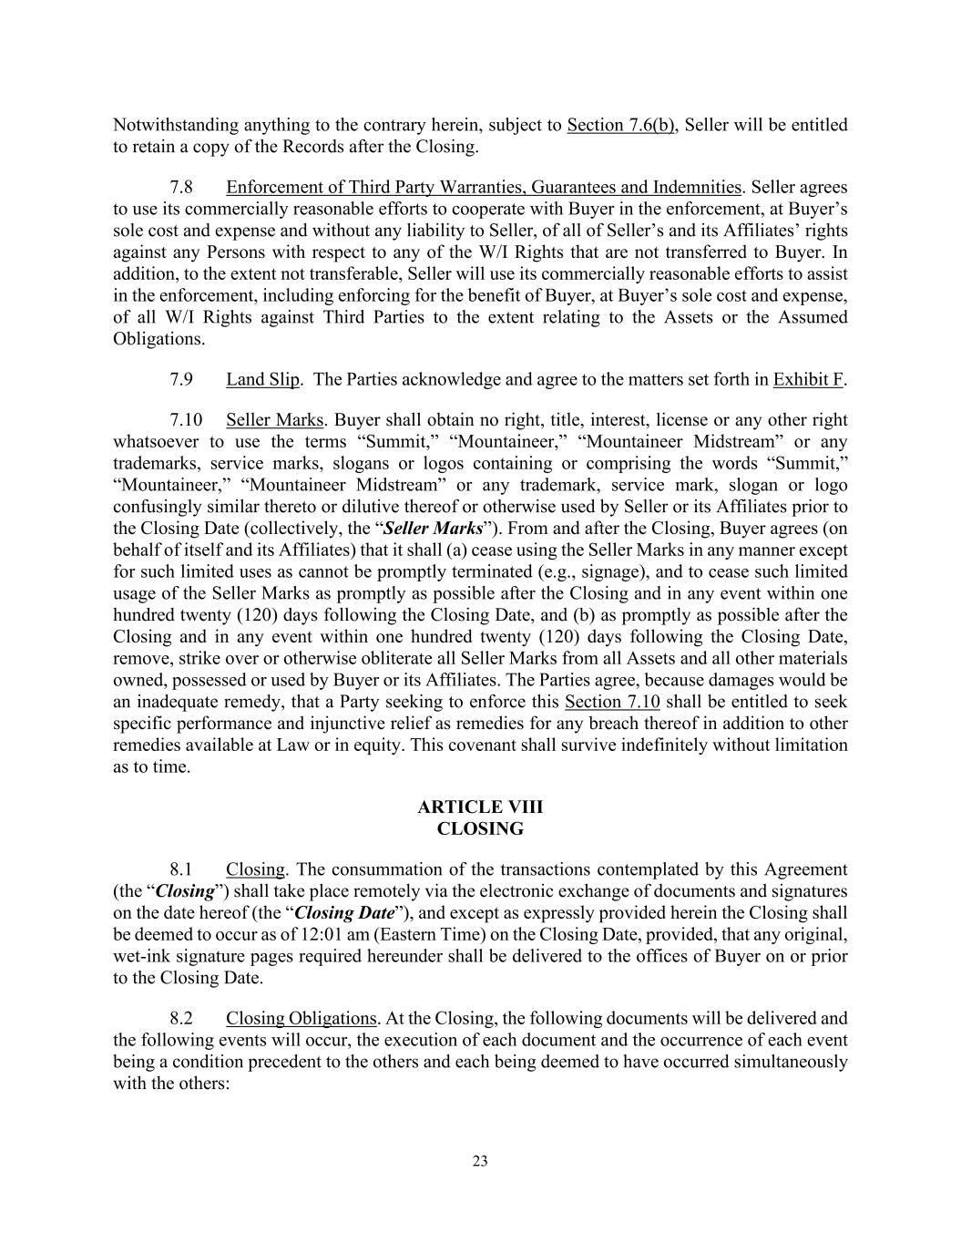
23 Notwithstanding anything to the contrary herein, subject to Section 7.6(b), Seller will be entitled to retain a copy of the Records after the Closing. 7.8 Enforcement of Third Party Warranties, Guarantees and Indemnities. Seller agrees to use its commercially reasonable efforts to cooperate with Buyer in the enforcement, at Buyer’s sole cost and expense and without any liability to Seller, of all of Seller’s and its Affiliates’ rights against any Persons with respect to any of the W/I Rights that are not transferred to Buyer. In addition, to the extent not transferable, Seller will use its commercially reasonable efforts to assist in the enforcement, including enforcing for the benefit of Buyer, at Buyer’s sole cost and expense, of all W/I Rights against Third Parties to the extent relating to the Assets or the Assumed Obligations. 7.9 Land Slip. The Parties acknowledge and agree to the matters set forth in Exhibit F. 7.10 Seller Marks. Buyer shall obtain no right, title, interest, license or any other right whatsoever to use the terms “Summit,” “Mountaineer,” “Mountaineer Midstream” or any trademarks, service marks, slogans or logos containing or comprising the words “Summit,” “Mountaineer,” “Mountaineer Midstream” or any trademark, service mark, slogan or logo confusingly similar thereto or dilutive thereof or otherwise used by Seller or its Affiliates prior to the Closing Date (collectively, the “Seller Marks”). From and after the Closing, Buyer agrees (on behalf of itself and its Affiliates) that it shall (a) cease using the Seller Marks in any manner except for such limited uses as cannot be promptly terminated (e.g., signage), and to cease such limited usage of the Seller Marks as promptly as possible after the Closing and in any event within one hundred twenty (120) days following the Closing Date, and (b) as promptly as possible after the Closing and in any event within one hundred twenty (120) days following the Closing Date, remove, strike over or otherwise obliterate all Seller Marks from all Assets and all other materials owned, possessed or used by Buyer or its Affiliates. The Parties agree, because damages would be an inadequate remedy, that a Party seeking to enforce this Section 7.10 shall be entitled to seek specific performance and injunctive relief as remedies for any breach thereof in addition to other remedies available at Law or in equity. This covenant shall survive indefinitely without limitation as to time. ARTICLE VIII CLOSING 8.1 Closing. The consummation of the transactions contemplated by this Agreement (the “Closing”) shall take place remotely via the electronic exchange of documents and signatures on the date hereof (the “Closing Date”), and except as expressly provided herein the Closing shall be deemed to occur as of 12:01 am (Eastern Time) on the Closing Date, provided, that any original, wet-ink signature pages required hereunder shall be delivered to the offices of Buyer on or prior to the Closing Date. 8.2 Closing Obligations. At the Closing, the following documents will be delivered and the following events will occur, the execution of each document and the occurrence of each event being a condition precedent to the others and each being deemed to have occurred simultaneously with the others:

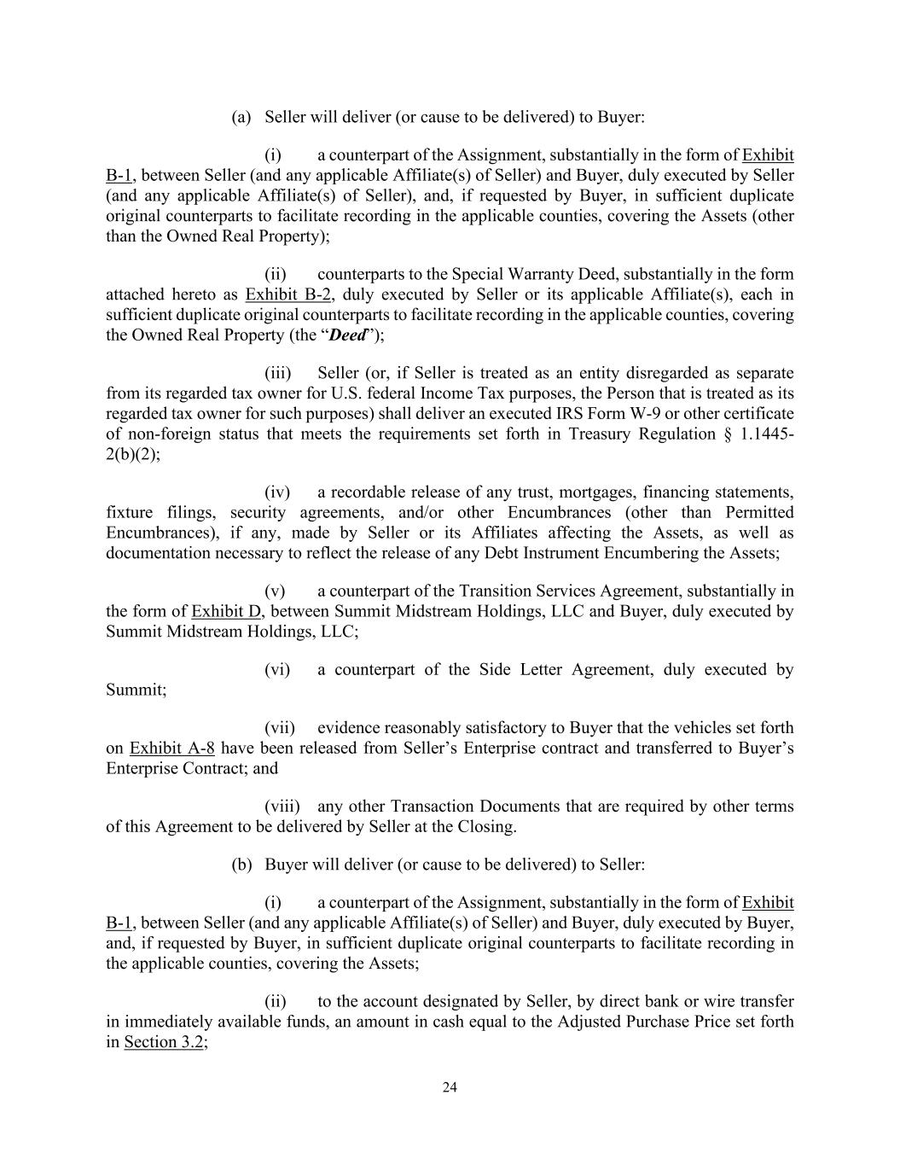
24 (a) Seller will deliver (or cause to be delivered) to Buyer: (i) a counterpart of the Assignment, substantially in the form of Exhibit B-1, between Seller (and any applicable Affiliate(s) of Seller) and Buyer, duly executed by Seller (and any applicable Affiliate(s) of Seller), and, if requested by Buyer, in sufficient duplicate original counterparts to facilitate recording in the applicable counties, covering the Assets (other than the Owned Real Property); (ii) counterparts to the Special Warranty Deed, substantially in the form attached hereto as Exhibit B-2, duly executed by Seller or its applicable Affiliate(s), each in sufficient duplicate original counterparts to facilitate recording in the applicable counties, covering the Owned Real Property (the “Deed”); (iii) Seller (or, if Seller is treated as an entity disregarded as separate from its regarded tax owner for U.S. federal Income Tax purposes, the Person that is treated as its regarded tax owner for such purposes) shall deliver an executed IRS Form W-9 or other certificate of non-foreign status that meets the requirements set forth in Treasury Regulation § 1.1445- 2(b)(2); (iv) a recordable release of any trust, mortgages, financing statements, fixture filings, security agreements, and/or other Encumbrances (other than Permitted Encumbrances), if any, made by Seller or its Affiliates affecting the Assets, as well as documentation necessary to reflect the release of any Debt Instrument Encumbering the Assets; (v) a counterpart of the Transition Services Agreement, substantially in the form of Exhibit D, between Summit Midstream Holdings, LLC and Buyer, duly executed by Summit Midstream Holdings, LLC; (vi) a counterpart of the Side Letter Agreement, duly executed by Summit; (vii) evidence reasonably satisfactory to Buyer that the vehicles set forth on Exhibit A-8 have been released from Seller’s Enterprise contract and transferred to Buyer’s Enterprise Contract; and (viii) any other Transaction Documents that are required by other terms of this Agreement to be delivered by Seller at the Closing. (b) Buyer will deliver (or cause to be delivered) to Seller: (i) a counterpart of the Assignment, substantially in the form of Exhibit B-1, between Seller (and any applicable Affiliate(s) of Seller) and Buyer, duly executed by Buyer, and, if requested by Buyer, in sufficient duplicate original counterparts to facilitate recording in the applicable counties, covering the Assets; (ii) to the account designated by Seller, by direct bank or wire transfer in immediately available funds, an amount in cash equal to the Adjusted Purchase Price set forth in Section 3.2;

25 (iii) a counterpart of the Transition Services Agreement, substantially in the form of Exhibit D, between Summit Midstream Holdings, LLC and Buyer, duly executed by Buyer; and (iv) a counterpart of the Side Letter Agreement, duly executed by ARC; (v) evidence reasonably satisfactory to Seller that the vehicles set forth on Exhibit A-8 have been released from Seller’s Enterprise contract and transferred to Buyer’s Enterprise Contract; and (vi) any other Transaction Documents that are required by other terms of this Agreement to be delivered by Buyer at the Closing. 8.3 Records. Seller will use its commercially reasonable efforts to deliver to Buyer as soon as practicable following the Closing, but in any event no later than ninety (90) days following the Closing, possession of the Records to which Buyer is entitled pursuant to the terms of this Agreement in the format customarily maintained by Seller. ARTICLE IX ASSUMPTION; INDEMNIFICATION; SURVIVAL 9.1 Assumption by Buyer. Without limiting Buyer’s rights to indemnity under this Article IX or waiving Buyer’s rights under the Transaction Documents, from and after the Closing, Buyer will assume and hereby agrees to fulfill, perform, pay and discharge (or cause to be fulfilled, performed, paid or discharged) (i) all obligations, Liabilities and commitments of Seller or its applicable Affiliate(s), known or unknown, to the extent arising from, based upon or related to the Assets (including the use, ownership or operation thereof) to the extent arising after and attributable to the period of time from and after the Closing, and (ii) those Liabilities of Seller to the limited extent and amount that there is a corresponding downward Purchase Price adjustment pursuant to Section 3.2 (all of said obligations and Liabilities, subject to the proviso below, the “Assumed Obligations”); provided, that Buyer does not assume (and the Assumed Obligations will not include) except to the limited extent and amount that there is a corresponding downward Purchase Price adjustment pursuant to Section 3.2, (a) any Indebtedness of Seller or any Affiliate of Seller, (b) Liabilities attributable to Seller’s obligations under Section 9.2, including with respect to any Retained Liabilities, (c) any Liability to the limited extent and amount for which there has been a corresponding upward Purchase Price adjustment pursuant to Section 3.2 and/or (d) any Seller Taxes. 9.2 Indemnities of Seller. Effective as of the Closing, subject to the other provisions and limitations of this Article IX, notwithstanding the knowledge and investigation of either Party, Seller will be responsible for and hereby agrees to defend, indemnify, release and hold harmless Buyer and its Affiliates, and all of its and their respective stockholders, partners, members, equityholders, and Representatives (collectively, including Buyer and its Affiliates, “Buyer Indemnified Parties”) from and against, any and all Liabilities, arising from, based upon or related to: (a) any breach by Seller of any of its representations or warranties contained in Article V;

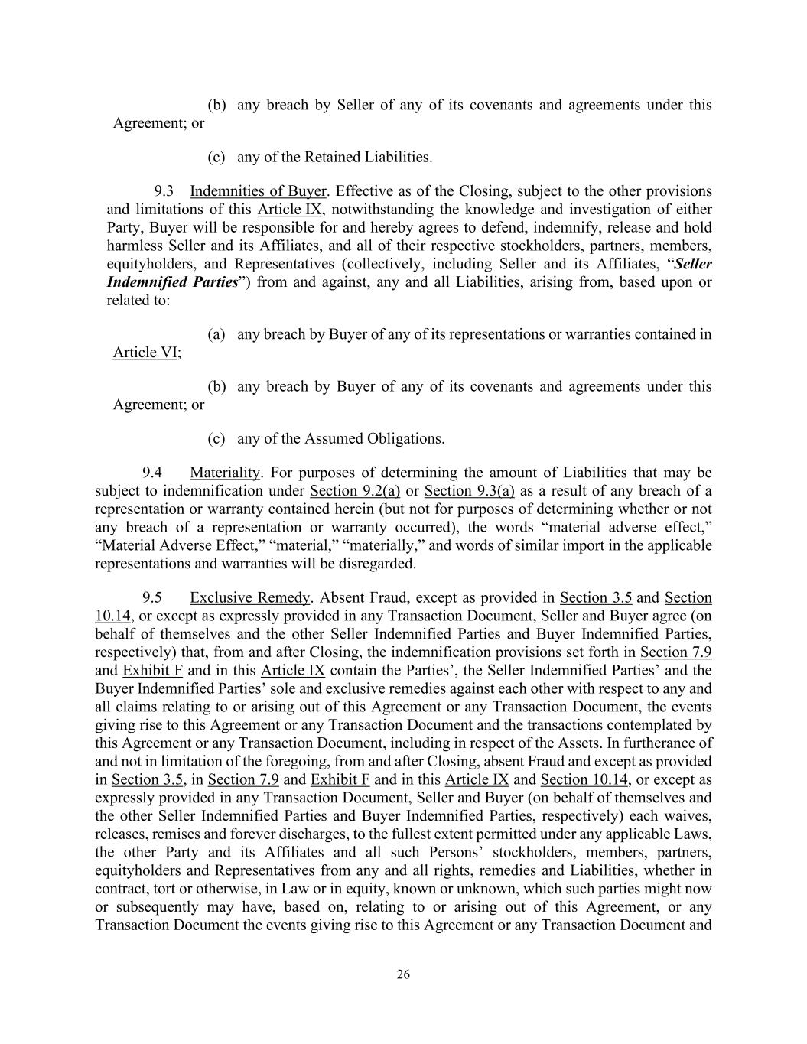
26 (b) any breach by Seller of any of its covenants and agreements under this Agreement; or (c) any of the Retained Liabilities. 9.3 Indemnities of Buyer. Effective as of the Closing, subject to the other provisions and limitations of this Article IX, notwithstanding the knowledge and investigation of either Party, Buyer will be responsible for and hereby agrees to defend, indemnify, release and hold harmless Seller and its Affiliates, and all of their respective stockholders, partners, members, equityholders, and Representatives (collectively, including Seller and its Affiliates, “Seller Indemnified Parties”) from and against, any and all Liabilities, arising from, based upon or related to: (a) any breach by Buyer of any of its representations or warranties contained in Article VI; (b) any breach by Buyer of any of its covenants and agreements under this Agreement; or (c) any of the Assumed Obligations. 9.4 Materiality. For purposes of determining the amount of Liabilities that may be subject to indemnification under Section 9.2(a) or Section 9.3(a) as a result of any breach of a representation or warranty contained herein (but not for purposes of determining whether or not any breach of a representation or warranty occurred), the words “material adverse effect,” “Material Adverse Effect,” “material,” “materially,” and words of similar import in the applicable representations and warranties will be disregarded. 9.5 Exclusive Remedy. Absent Fraud, except as provided in Section 3.5 and Section 10.14, or except as expressly provided in any Transaction Document, Seller and Buyer agree (on behalf of themselves and the other Seller Indemnified Parties and Buyer Indemnified Parties, respectively) that, from and after Closing, the indemnification provisions set forth in Section 7.9 and Exhibit F and in this Article IX contain the Parties’, the Seller Indemnified Parties’ and the Buyer Indemnified Parties’ sole and exclusive remedies against each other with respect to any and all claims relating to or arising out of this Agreement or any Transaction Document, the events giving rise to this Agreement or any Transaction Document and the transactions contemplated by this Agreement or any Transaction Document, including in respect of the Assets. In furtherance of and not in limitation of the foregoing, from and after Closing, absent Fraud and except as provided in Section 3.5, in Section 7.9 and Exhibit F and in this Article IX and Section 10.14, or except as expressly provided in any Transaction Document, Seller and Buyer (on behalf of themselves and the other Seller Indemnified Parties and Buyer Indemnified Parties, respectively) each waives, releases, remises and forever discharges, to the fullest extent permitted under any applicable Laws, the other Party and its Affiliates and all such Persons’ stockholders, members, partners, equityholders and Representatives from any and all rights, remedies and Liabilities, whether in contract, tort or otherwise, in Law or in equity, known or unknown, which such parties might now or subsequently may have, based on, relating to or arising out of this Agreement, or any Transaction Document the events giving rise to this Agreement or any Transaction Document and

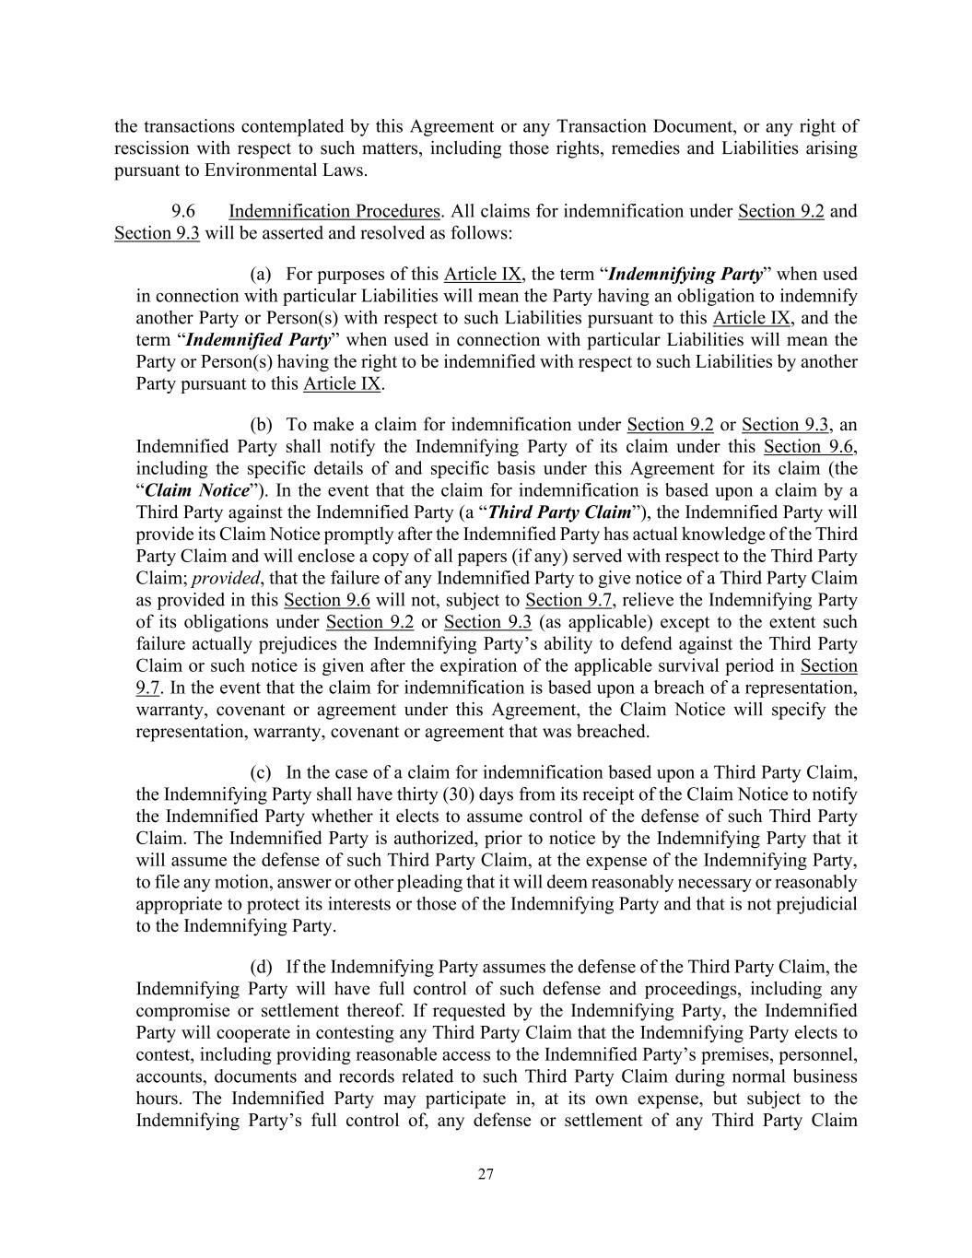
27 the transactions contemplated by this Agreement or any Transaction Document, or any right of rescission with respect to such matters, including those rights, remedies and Liabilities arising pursuant to Environmental Laws. 9.6 Indemnification Procedures. All claims for indemnification under Section 9.2 and Section 9.3 will be asserted and resolved as follows: (a) For purposes of this Article IX, the term “Indemnifying Party” when used in connection with particular Liabilities will mean the Party having an obligation to indemnify another Party or Person(s) with respect to such Liabilities pursuant to this Article IX, and the term “Indemnified Party” when used in connection with particular Liabilities will mean the Party or Person(s) having the right to be indemnified with respect to such Liabilities by another Party pursuant to this Article IX. (b) To make a claim for indemnification under Section 9.2 or Section 9.3, an Indemnified Party shall notify the Indemnifying Party of its claim under this Section 9.6, including the specific details of and specific basis under this Agreement for its claim (the “Claim Notice”). In the event that the claim for indemnification is based upon a claim by a Third Party against the Indemnified Party (a “Third Party Claim”), the Indemnified Party will provide its Claim Notice promptly after the Indemnified Party has actual knowledge of the Third Party Claim and will enclose a copy of all papers (if any) served with respect to the Third Party Claim; provided, that the failure of any Indemnified Party to give notice of a Third Party Claim as provided in this Section 9.6 will not, subject to Section 9.7, relieve the Indemnifying Party of its obligations under Section 9.2 or Section 9.3 (as applicable) except to the extent such failure actually prejudices the Indemnifying Party’s ability to defend against the Third Party Claim or such notice is given after the expiration of the applicable survival period in Section 9.7. In the event that the claim for indemnification is based upon a breach of a representation, warranty, covenant or agreement under this Agreement, the Claim Notice will specify the representation, warranty, covenant or agreement that was breached. (c) In the case of a claim for indemnification based upon a Third Party Claim, the Indemnifying Party shall have thirty (30) days from its receipt of the Claim Notice to notify the Indemnified Party whether it elects to assume control of the defense of such Third Party Claim. The Indemnified Party is authorized, prior to notice by the Indemnifying Party that it will assume the defense of such Third Party Claim, at the expense of the Indemnifying Party, to file any motion, answer or other pleading that it will deem reasonably necessary or reasonably appropriate to protect its interests or those of the Indemnifying Party and that is not prejudicial to the Indemnifying Party. (d) If the Indemnifying Party assumes the defense of the Third Party Claim, the Indemnifying Party will have full control of such defense and proceedings, including any compromise or settlement thereof. If requested by the Indemnifying Party, the Indemnified Party will cooperate in contesting any Third Party Claim that the Indemnifying Party elects to contest, including providing reasonable access to the Indemnified Party’s premises, personnel, accounts, documents and records related to such Third Party Claim during normal business hours. The Indemnified Party may participate in, at its own expense, but subject to the Indemnifying Party’s full control of, any defense or settlement of any Third Party Claim

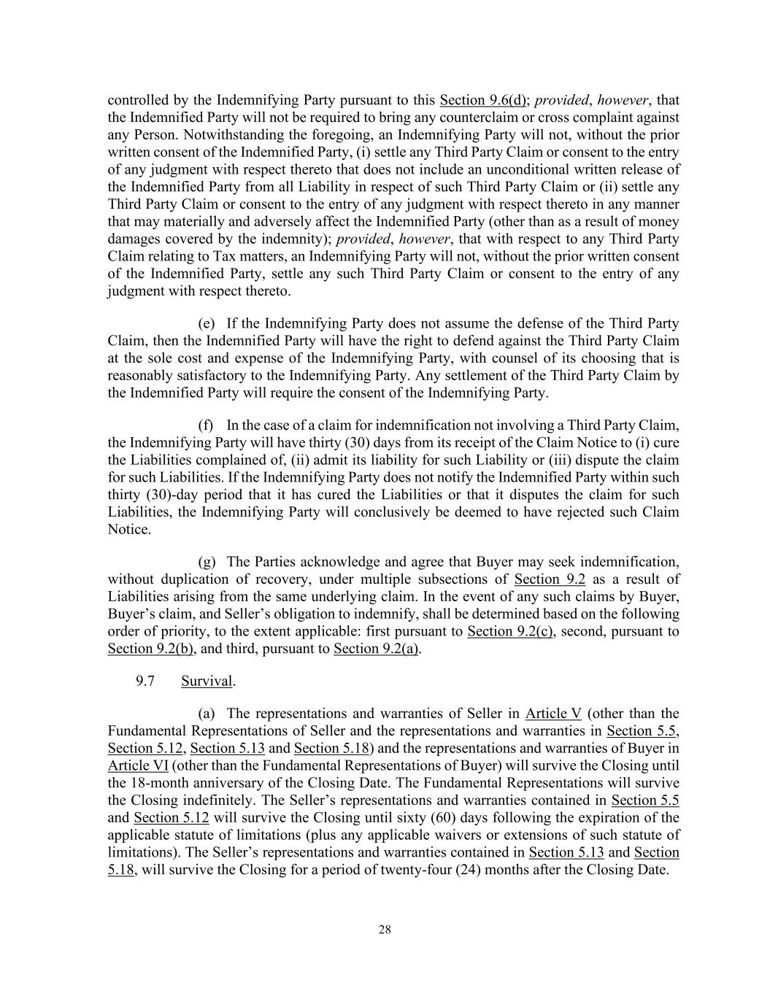
28 controlled by the Indemnifying Party pursuant to this Section 9.6(d); provided, however, that the Indemnified Party will not be required to bring any counterclaim or cross complaint against any Person. Notwithstanding the foregoing, an Indemnifying Party will not, without the prior written consent of the Indemnified Party, (i) settle any Third Party Claim or consent to the entry of any judgment with respect thereto that does not include an unconditional written release of the Indemnified Party from all Liability in respect of such Third Party Claim or (ii) settle any Third Party Claim or consent to the entry of any judgment with respect thereto in any manner that may materially and adversely affect the Indemnified Party (other than as a result of money damages covered by the indemnity); provided, however, that with respect to any Third Party Claim relating to Tax matters, an Indemnifying Party will not, without the prior written consent of the Indemnified Party, settle any such Third Party Claim or consent to the entry of any judgment with respect thereto. (e) If the Indemnifying Party does not assume the defense of the Third Party Claim, then the Indemnified Party will have the right to defend against the Third Party Claim at the sole cost and expense of the Indemnifying Party, with counsel of its choosing that is reasonably satisfactory to the Indemnifying Party. Any settlement of the Third Party Claim by the Indemnified Party will require the consent of the Indemnifying Party. (f) In the case of a claim for indemnification not involving a Third Party Claim, the Indemnifying Party will have thirty (30) days from its receipt of the Claim Notice to (i) cure the Liabilities complained of, (ii) admit its liability for such Liability or (iii) dispute the claim for such Liabilities. If the Indemnifying Party does not notify the Indemnified Party within such thirty (30)-day period that it has cured the Liabilities or that it disputes the claim for such Liabilities, the Indemnifying Party will conclusively be deemed to have rejected such Claim Notice. (g) The Parties acknowledge and agree that Buyer may seek indemnification, without duplication of recovery, under multiple subsections of Section 9.2 as a result of Liabilities arising from the same underlying claim. In the event of any such claims by Buyer, Buyer’s claim, and Seller’s obligation to indemnify, shall be determined based on the following order of priority, to the extent applicable: first pursuant to Section 9.2(c), second, pursuant to Section 9.2(b), and third, pursuant to Section 9.2(a). 9.7 Survival. (a) The representations and warranties of Seller in Article V (other than the Fundamental Representations of Seller and the representations and warranties in Section 5.5, Section 5.12, Section 5.13 and Section 5.18) and the representations and warranties of Buyer in Article VI (other than the Fundamental Representations of Buyer) will survive the Closing until the 18-month anniversary of the Closing Date. The Fundamental Representations will survive the Closing indefinitely. The Seller’s representations and warranties contained in Section 5.5 and Section 5.12 will survive the Closing until sixty (60) days following the expiration of the applicable statute of limitations (plus any applicable waivers or extensions of such statute of limitations). The Seller’s representations and warranties contained in Section 5.13 and Section 5.18, will survive the Closing for a period of twenty-four (24) months after the Closing Date.

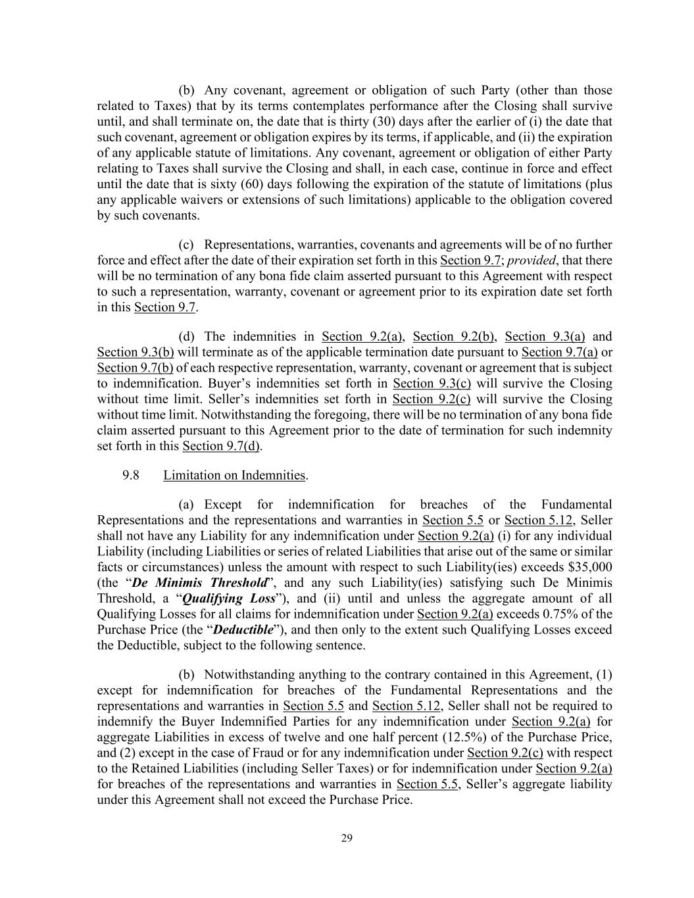
29 (b) Any covenant, agreement or obligation of such Party (other than those related to Taxes) that by its terms contemplates performance after the Closing shall survive until, and shall terminate on, the date that is thirty (30) days after the earlier of (i) the date that such covenant, agreement or obligation expires by its terms, if applicable, and (ii) the expiration of any applicable statute of limitations. Any covenant, agreement or obligation of either Party relating to Taxes shall survive the Closing and shall, in each case, continue in force and effect until the date that is sixty (60) days following the expiration of the statute of limitations (plus any applicable waivers or extensions of such limitations) applicable to the obligation covered by such covenants. (c) Representations, warranties, covenants and agreements will be of no further force and effect after the date of their expiration set forth in this Section 9.7; provided, that there will be no termination of any bona fide claim asserted pursuant to this Agreement with respect to such a representation, warranty, covenant or agreement prior to its expiration date set forth in this Section 9.7. (d) The indemnities in Section 9.2(a), Section 9.2(b), Section 9.3(a) and Section 9.3(b) will terminate as of the applicable termination date pursuant to Section 9.7(a) or Section 9.7(b) of each respective representation, warranty, covenant or agreement that is subject to indemnification. Buyer’s indemnities set forth in Section 9.3(c) will survive the Closing without time limit. Seller’s indemnities set forth in Section 9.2(c) will survive the Closing without time limit. Notwithstanding the foregoing, there will be no termination of any bona fide claim asserted pursuant to this Agreement prior to the date of termination for such indemnity set forth in this Section 9.7(d). 9.8 Limitation on Indemnities. (a) Except for indemnification for breaches of the Fundamental Representations and the representations and warranties in Section 5.5 or Section 5.12, Seller shall not have any Liability for any indemnification under Section 9.2(a) (i) for any individual Liability (including Liabilities or series of related Liabilities that arise out of the same or similar facts or circumstances) unless the amount with respect to such Liability(ies) exceeds $35,000 (the “De Minimis Threshold”, and any such Liability(ies) satisfying such De Minimis Threshold, a “Qualifying Loss”), and (ii) until and unless the aggregate amount of all Qualifying Losses for all claims for indemnification under Section 9.2(a) exceeds 0.75% of the Purchase Price (the “Deductible”), and then only to the extent such Qualifying Losses exceed the Deductible, subject to the following sentence. (b) Notwithstanding anything to the contrary contained in this Agreement, (1) except for indemnification for breaches of the Fundamental Representations and the representations and warranties in Section 5.5 and Section 5.12, Seller shall not be required to indemnify the Buyer Indemnified Parties for any indemnification under Section 9.2(a) for aggregate Liabilities in excess of twelve and one half percent (12.5%) of the Purchase Price, and (2) except in the case of Fraud or for any indemnification under Section 9.2(c) with respect to the Retained Liabilities (including Seller Taxes) or for indemnification under Section 9.2(a) for breaches of the representations and warranties in Section 5.5, Seller’s aggregate liability under this Agreement shall not exceed the Purchase Price.

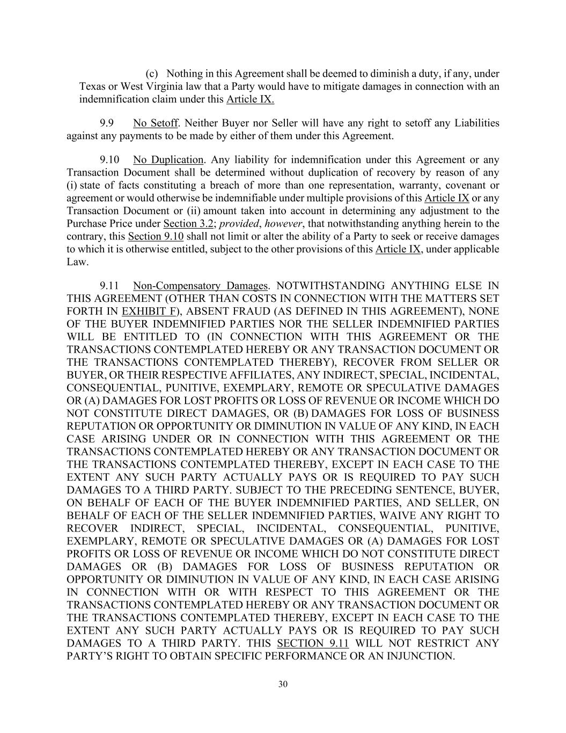
30 (c) Nothing in this Agreement shall be deemed to diminish a duty, if any, under Texas or West Virginia law that a Party would have to mitigate damages in connection with an indemnification claim under this Article IX. 9.9 No Setoff. Neither Buyer nor Seller will have any right to setoff any Liabilities against any payments to be made by either of them under this Agreement. 9.10 No Duplication. Any liability for indemnification under this Agreement or any Transaction Document shall be determined without duplication of recovery by reason of any (i) state of facts constituting a breach of more than one representation, warranty, covenant or agreement or would otherwise be indemnifiable under multiple provisions of this Article IX or any Transaction Document or (ii) amount taken into account in determining any adjustment to the Purchase Price under Section 3.2; provided, however, that notwithstanding anything herein to the contrary, this Section 9.10 shall not limit or alter the ability of a Party to seek or receive damages to which it is otherwise entitled, subject to the other provisions of this Article IX, under applicable Law. 9.11 Non-Compensatory Damages. NOTWITHSTANDING ANYTHING ELSE IN THIS AGREEMENT (OTHER THAN COSTS IN CONNECTION WITH THE MATTERS SET FORTH IN EXHIBIT F), ABSENT FRAUD (AS DEFINED IN THIS AGREEMENT), NONE OF THE BUYER INDEMNIFIED PARTIES NOR THE SELLER INDEMNIFIED PARTIES WILL BE ENTITLED TO (IN CONNECTION WITH THIS AGREEMENT OR THE TRANSACTIONS CONTEMPLATED HEREBY OR ANY TRANSACTION DOCUMENT OR THE TRANSACTIONS CONTEMPLATED THEREBY), RECOVER FROM SELLER OR BUYER, OR THEIR RESPECTIVE AFFILIATES, ANY INDIRECT, SPECIAL, INCIDENTAL, CONSEQUENTIAL, PUNITIVE, EXEMPLARY, REMOTE OR SPECULATIVE DAMAGES OR (A) DAMAGES FOR LOST PROFITS OR LOSS OF REVENUE OR INCOME WHICH DO NOT CONSTITUTE DIRECT DAMAGES, OR (B) DAMAGES FOR LOSS OF BUSINESS REPUTATION OR OPPORTUNITY OR DIMINUTION IN VALUE OF ANY KIND, IN EACH CASE ARISING UNDER OR IN CONNECTION WITH THIS AGREEMENT OR THE TRANSACTIONS CONTEMPLATED HEREBY OR ANY TRANSACTION DOCUMENT OR THE TRANSACTIONS CONTEMPLATED THEREBY, EXCEPT IN EACH CASE TO THE EXTENT ANY SUCH PARTY ACTUALLY PAYS OR IS REQUIRED TO PAY SUCH DAMAGES TO A THIRD PARTY. SUBJECT TO THE PRECEDING SENTENCE, BUYER, ON BEHALF OF EACH OF THE BUYER INDEMNIFIED PARTIES, AND SELLER, ON BEHALF OF EACH OF THE SELLER INDEMNIFIED PARTIES, WAIVE ANY RIGHT TO RECOVER INDIRECT, SPECIAL, INCIDENTAL, CONSEQUENTIAL, PUNITIVE, EXEMPLARY, REMOTE OR SPECULATIVE DAMAGES OR (A) DAMAGES FOR LOST PROFITS OR LOSS OF REVENUE OR INCOME WHICH DO NOT CONSTITUTE DIRECT DAMAGES OR (B) DAMAGES FOR LOSS OF BUSINESS REPUTATION OR OPPORTUNITY OR DIMINUTION IN VALUE OF ANY KIND, IN EACH CASE ARISING IN CONNECTION WITH OR WITH RESPECT TO THIS AGREEMENT OR THE TRANSACTIONS CONTEMPLATED HEREBY OR ANY TRANSACTION DOCUMENT OR THE TRANSACTIONS CONTEMPLATED THEREBY, EXCEPT IN EACH CASE TO THE EXTENT ANY SUCH PARTY ACTUALLY PAYS OR IS REQUIRED TO PAY SUCH DAMAGES TO A THIRD PARTY. THIS SECTION 9.11 WILL NOT RESTRICT ANY PARTY’S RIGHT TO OBTAIN SPECIFIC PERFORMANCE OR AN INJUNCTION.

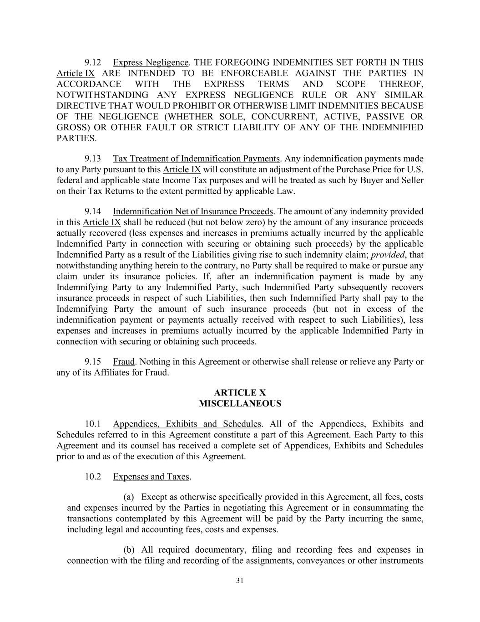
31 9.12 Express Negligence. THE FOREGOING INDEMNITIES SET FORTH IN THIS Article IX ARE INTENDED TO BE ENFORCEABLE AGAINST THE PARTIES IN ACCORDANCE WITH THE EXPRESS TERMS AND SCOPE THEREOF, NOTWITHSTANDING ANY EXPRESS NEGLIGENCE RULE OR ANY SIMILAR DIRECTIVE THAT WOULD PROHIBIT OR OTHERWISE LIMIT INDEMNITIES BECAUSE OF THE NEGLIGENCE (WHETHER SOLE, CONCURRENT, ACTIVE, PASSIVE OR GROSS) OR OTHER FAULT OR STRICT LIABILITY OF ANY OF THE INDEMNIFIED PARTIES. 9.13 Tax Treatment of Indemnification Payments. Any indemnification payments made to any Party pursuant to this Article IX will constitute an adjustment of the Purchase Price for U.S. federal and applicable state Income Tax purposes and will be treated as such by Buyer and Seller on their Tax Returns to the extent permitted by applicable Law. 9.14 Indemnification Net of Insurance Proceeds. The amount of any indemnity provided in this Article IX shall be reduced (but not below zero) by the amount of any insurance proceeds actually recovered (less expenses and increases in premiums actually incurred by the applicable Indemnified Party in connection with securing or obtaining such proceeds) by the applicable Indemnified Party as a result of the Liabilities giving rise to such indemnity claim; provided, that notwithstanding anything herein to the contrary, no Party shall be required to make or pursue any claim under its insurance policies. If, after an indemnification payment is made by any Indemnifying Party to any Indemnified Party, such Indemnified Party subsequently recovers insurance proceeds in respect of such Liabilities, then such Indemnified Party shall pay to the Indemnifying Party the amount of such insurance proceeds (but not in excess of the indemnification payment or payments actually received with respect to such Liabilities), less expenses and increases in premiums actually incurred by the applicable Indemnified Party in connection with securing or obtaining such proceeds. 9.15 Fraud. Nothing in this Agreement or otherwise shall release or relieve any Party or any of its Affiliates for Fraud. ARTICLE X MISCELLANEOUS 10.1 Appendices, Exhibits and Schedules. All of the Appendices, Exhibits and Schedules referred to in this Agreement constitute a part of this Agreement. Each Party to this Agreement and its counsel has received a complete set of Appendices, Exhibits and Schedules prior to and as of the execution of this Agreement. 10.2 Expenses and Taxes. (a) Except as otherwise specifically provided in this Agreement, all fees, costs and expenses incurred by the Parties in negotiating this Agreement or in consummating the transactions contemplated by this Agreement will be paid by the Party incurring the same, including legal and accounting fees, costs and expenses. (b) All required documentary, filing and recording fees and expenses in connection with the filing and recording of the assignments, conveyances or other instruments

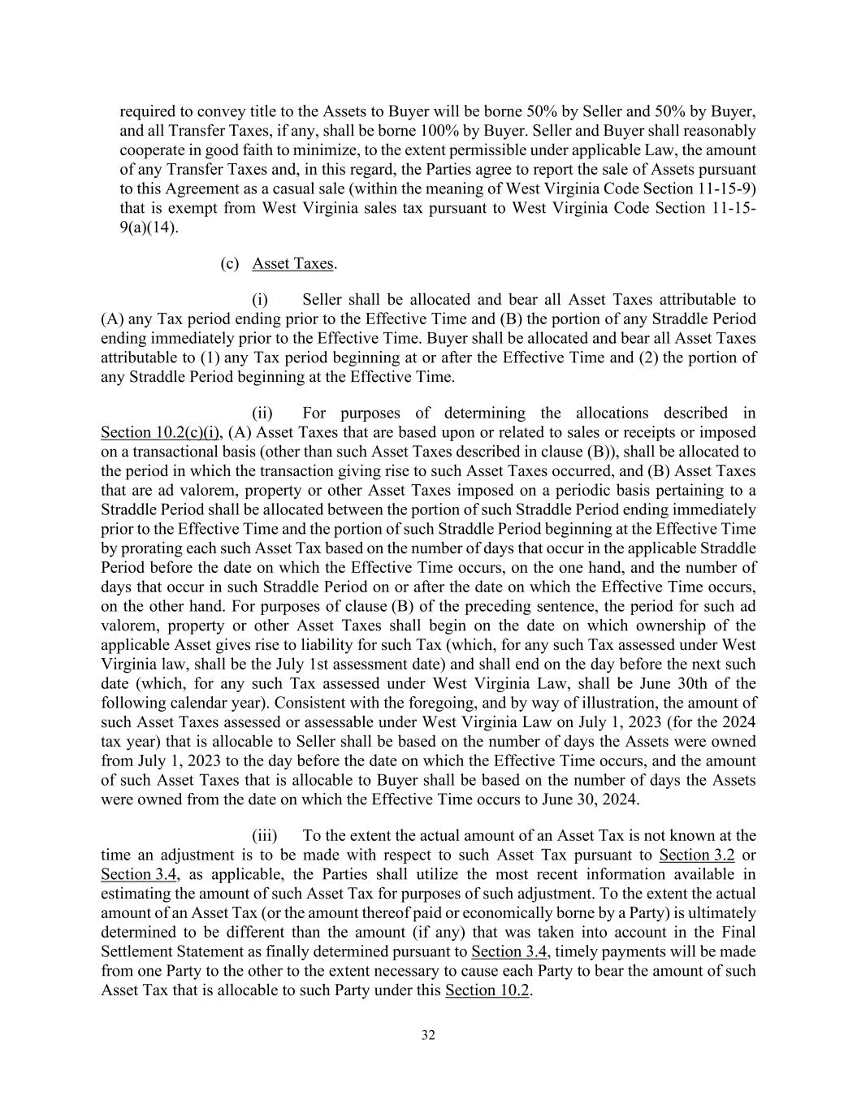
32 required to convey title to the Assets to Buyer will be borne 50% by Seller and 50% by Buyer, and all Transfer Taxes, if any, shall be borne 100% by Buyer. Seller and Buyer shall reasonably cooperate in good faith to minimize, to the extent permissible under applicable Law, the amount of any Transfer Taxes and, in this regard, the Parties agree to report the sale of Assets pursuant to this Agreement as a casual sale (within the meaning of West Virginia Code Section 11-15-9) that is exempt from West Virginia sales tax pursuant to West Virginia Code Section 11-15- 9(a)(14). (c) Asset Taxes. (i) Seller shall be allocated and bear all Asset Taxes attributable to (A) any Tax period ending prior to the Effective Time and (B) the portion of any Straddle Period ending immediately prior to the Effective Time. Buyer shall be allocated and bear all Asset Taxes attributable to (1) any Tax period beginning at or after the Effective Time and (2) the portion of any Straddle Period beginning at the Effective Time. (ii) For purposes of determining the allocations described in Section 10.2(c)(i), (A) Asset Taxes that are based upon or related to sales or receipts or imposed on a transactional basis (other than such Asset Taxes described in clause (B)), shall be allocated to the period in which the transaction giving rise to such Asset Taxes occurred, and (B) Asset Taxes that are ad valorem, property or other Asset Taxes imposed on a periodic basis pertaining to a Straddle Period shall be allocated between the portion of such Straddle Period ending immediately prior to the Effective Time and the portion of such Straddle Period beginning at the Effective Time by prorating each such Asset Tax based on the number of days that occur in the applicable Straddle Period before the date on which the Effective Time occurs, on the one hand, and the number of days that occur in such Straddle Period on or after the date on which the Effective Time occurs, on the other hand. For purposes of clause (B) of the preceding sentence, the period for such ad valorem, property or other Asset Taxes shall begin on the date on which ownership of the applicable Asset gives rise to liability for such Tax (which, for any such Tax assessed under West Virginia law, shall be the July 1st assessment date) and shall end on the day before the next such date (which, for any such Tax assessed under West Virginia Law, shall be June 30th of the following calendar year). Consistent with the foregoing, and by way of illustration, the amount of such Asset Taxes assessed or assessable under West Virginia Law on July 1, 2023 (for the 2024 tax year) that is allocable to Seller shall be based on the number of days the Assets were owned from July 1, 2023 to the day before the date on which the Effective Time occurs, and the amount of such Asset Taxes that is allocable to Buyer shall be based on the number of days the Assets were owned from the date on which the Effective Time occurs to June 30, 2024. (iii) To the extent the actual amount of an Asset Tax is not known at the time an adjustment is to be made with respect to such Asset Tax pursuant to Section 3.2 or Section 3.4, as applicable, the Parties shall utilize the most recent information available in estimating the amount of such Asset Tax for purposes of such adjustment. To the extent the actual amount of an Asset Tax (or the amount thereof paid or economically borne by a Party) is ultimately determined to be different than the amount (if any) that was taken into account in the Final Settlement Statement as finally determined pursuant to Section 3.4, timely payments will be made from one Party to the other to the extent necessary to cause each Party to bear the amount of such Asset Tax that is allocable to such Party under this Section 10.2.

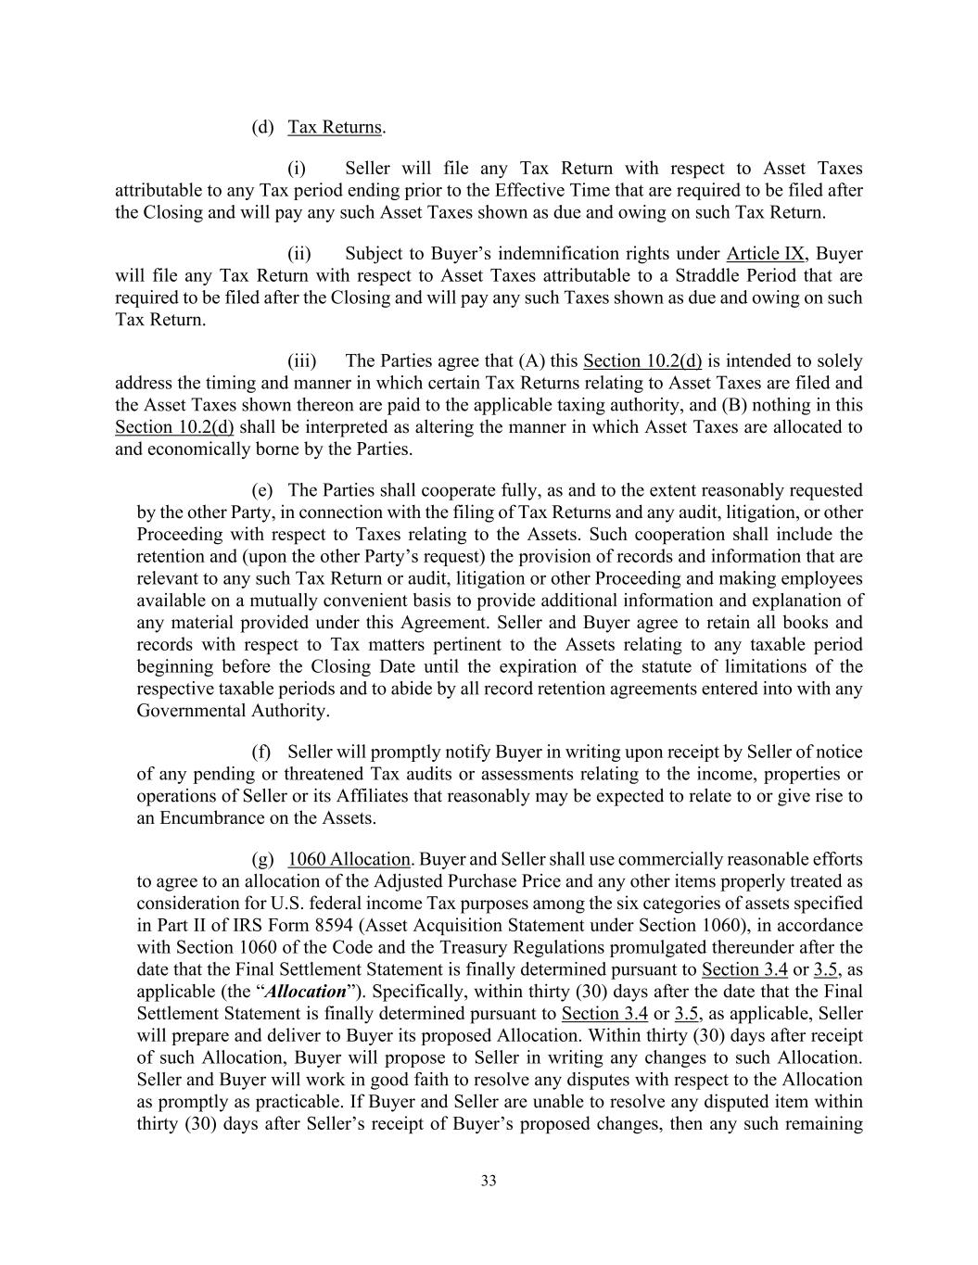
33 (d) Tax Returns. (i) Seller will file any Tax Return with respect to Asset Taxes attributable to any Tax period ending prior to the Effective Time that are required to be filed after the Closing and will pay any such Asset Taxes shown as due and owing on such Tax Return. (ii) Subject to Buyer’s indemnification rights under Article IX, Buyer will file any Tax Return with respect to Asset Taxes attributable to a Straddle Period that are required to be filed after the Closing and will pay any such Taxes shown as due and owing on such Tax Return. (iii) The Parties agree that (A) this Section 10.2(d) is intended to solely address the timing and manner in which certain Tax Returns relating to Asset Taxes are filed and the Asset Taxes shown thereon are paid to the applicable taxing authority, and (B) nothing in this Section 10.2(d) shall be interpreted as altering the manner in which Asset Taxes are allocated to and economically borne by the Parties. (e) The Parties shall cooperate fully, as and to the extent reasonably requested by the other Party, in connection with the filing of Tax Returns and any audit, litigation, or other Proceeding with respect to Taxes relating to the Assets. Such cooperation shall include the retention and (upon the other Party’s request) the provision of records and information that are relevant to any such Tax Return or audit, litigation or other Proceeding and making employees available on a mutually convenient basis to provide additional information and explanation of any material provided under this Agreement. Seller and Buyer agree to retain all books and records with respect to Tax matters pertinent to the Assets relating to any taxable period beginning before the Closing Date until the expiration of the statute of limitations of the respective taxable periods and to abide by all record retention agreements entered into with any Governmental Authority. (f) Seller will promptly notify Buyer in writing upon receipt by Seller of notice of any pending or threatened Tax audits or assessments relating to the income, properties or operations of Seller or its Affiliates that reasonably may be expected to relate to or give rise to an Encumbrance on the Assets. (g) 1060 Allocation. Buyer and Seller shall use commercially reasonable efforts to agree to an allocation of the Adjusted Purchase Price and any other items properly treated as consideration for U.S. federal income Tax purposes among the six categories of assets specified in Part II of IRS Form 8594 (Asset Acquisition Statement under Section 1060), in accordance with Section 1060 of the Code and the Treasury Regulations promulgated thereunder after the date that the Final Settlement Statement is finally determined pursuant to Section 3.4 or 3.5, as applicable (the “Allocation”). Specifically, within thirty (30) days after the date that the Final Settlement Statement is finally determined pursuant to Section 3.4 or 3.5, as applicable, Seller will prepare and deliver to Buyer its proposed Allocation. Within thirty (30) days after receipt of such Allocation, Buyer will propose to Seller in writing any changes to such Allocation. Seller and Buyer will work in good faith to resolve any disputes with respect to the Allocation as promptly as practicable. If Buyer and Seller are unable to resolve any disputed item within thirty (30) days after Seller’s receipt of Buyer’s proposed changes, then any such remaining

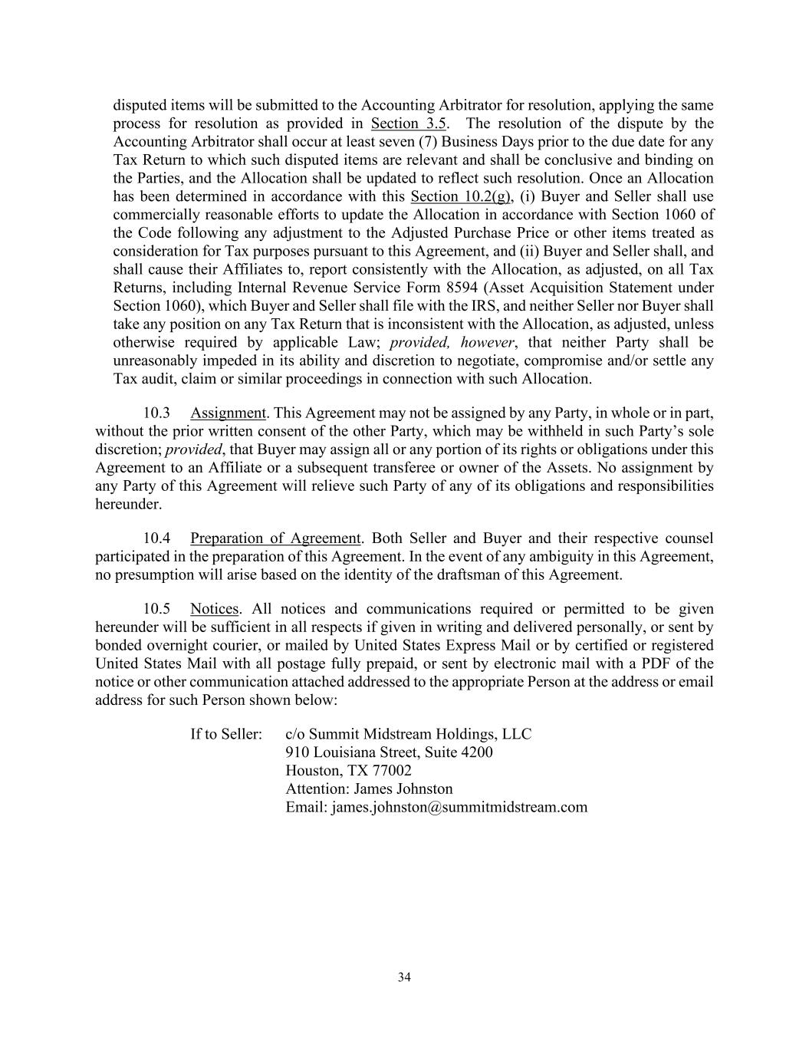
34 disputed items will be submitted to the Accounting Arbitrator for resolution, applying the same process for resolution as provided in Section 3.5. The resolution of the dispute by the Accounting Arbitrator shall occur at least seven (7) Business Days prior to the due date for any Tax Return to which such disputed items are relevant and shall be conclusive and binding on the Parties, and the Allocation shall be updated to reflect such resolution. Once an Allocation has been determined in accordance with this Section 10.2(g), (i) Buyer and Seller shall use commercially reasonable efforts to update the Allocation in accordance with Section 1060 of the Code following any adjustment to the Adjusted Purchase Price or other items treated as consideration for Tax purposes pursuant to this Agreement, and (ii) Buyer and Seller shall, and shall cause their Affiliates to, report consistently with the Allocation, as adjusted, on all Tax Returns, including Internal Revenue Service Form 8594 (Asset Acquisition Statement under Section 1060), which Buyer and Seller shall file with the IRS, and neither Seller nor Buyer shall take any position on any Tax Return that is inconsistent with the Allocation, as adjusted, unless otherwise required by applicable Law; provided, however, that neither Party shall be unreasonably impeded in its ability and discretion to negotiate, compromise and/or settle any Tax audit, claim or similar proceedings in connection with such Allocation. 10.3 Assignment. This Agreement may not be assigned by any Party, in whole or in part, without the prior written consent of the other Party, which may be withheld in such Party’s sole discretion; provided, that Buyer may assign all or any portion of its rights or obligations under this Agreement to an Affiliate or a subsequent transferee or owner of the Assets. No assignment by any Party of this Agreement will relieve such Party of any of its obligations and responsibilities hereunder. 10.4 Preparation of Agreement. Both Seller and Buyer and their respective counsel participated in the preparation of this Agreement. In the event of any ambiguity in this Agreement, no presumption will arise based on the identity of the draftsman of this Agreement. 10.5 Notices. All notices and communications required or permitted to be given hereunder will be sufficient in all respects if given in writing and delivered personally, or sent by bonded overnight courier, or mailed by United States Express Mail or by certified or registered United States Mail with all postage fully prepaid, or sent by electronic mail with a PDF of the notice or other communication attached addressed to the appropriate Person at the address or email address for such Person shown below: If to Seller: c/o Summit Midstream Holdings, LLC 910 Louisiana Street, Suite 4200 Houston, TX 77002 Attention: James Johnston Email: james.johnston@summitmidstream.com

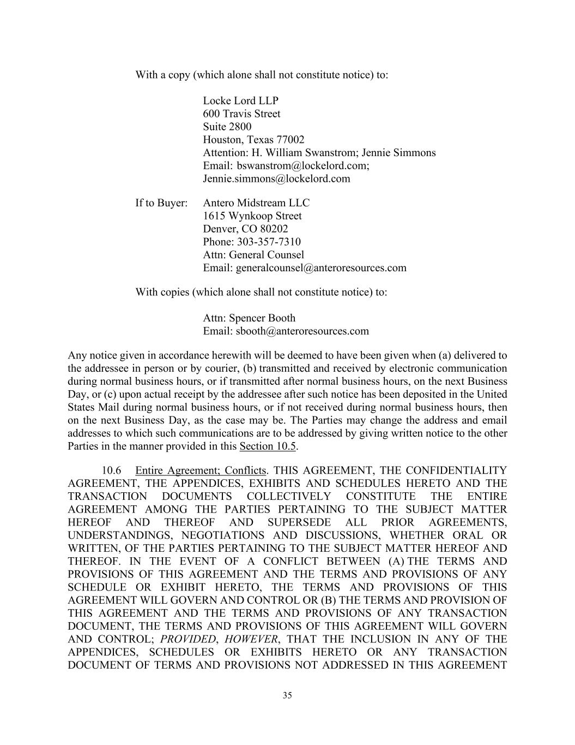
35 With a copy (which alone shall not constitute notice) to: Locke Lord LLP 600 Travis Street Suite 2800 Houston, Texas 77002 Attention: H. William Swanstrom; Jennie Simmons Email: bswanstrom@lockelord.com; Jennie.simmons@lockelord.com If to Buyer: Antero Midstream LLC 1615 Wynkoop Street Denver, CO 80202 Phone: 303-357-7310 Attn: General Counsel Email: generalcounsel@anteroresources.com With copies (which alone shall not constitute notice) to: Attn: Spencer Booth Email: sbooth@anteroresources.com Any notice given in accordance herewith will be deemed to have been given when (a) delivered to the addressee in person or by courier, (b) transmitted and received by electronic communication during normal business hours, or if transmitted after normal business hours, on the next Business Day, or (c) upon actual receipt by the addressee after such notice has been deposited in the United States Mail during normal business hours, or if not received during normal business hours, then on the next Business Day, as the case may be. The Parties may change the address and email addresses to which such communications are to be addressed by giving written notice to the other Parties in the manner provided in this Section 10.5. 10.6 Entire Agreement; Conflicts. THIS AGREEMENT, THE CONFIDENTIALITY AGREEMENT, THE APPENDICES, EXHIBITS AND SCHEDULES HERETO AND THE TRANSACTION DOCUMENTS COLLECTIVELY CONSTITUTE THE ENTIRE AGREEMENT AMONG THE PARTIES PERTAINING TO THE SUBJECT MATTER HEREOF AND THEREOF AND SUPERSEDE ALL PRIOR AGREEMENTS, UNDERSTANDINGS, NEGOTIATIONS AND DISCUSSIONS, WHETHER ORAL OR WRITTEN, OF THE PARTIES PERTAINING TO THE SUBJECT MATTER HEREOF AND THEREOF. IN THE EVENT OF A CONFLICT BETWEEN (A) THE TERMS AND PROVISIONS OF THIS AGREEMENT AND THE TERMS AND PROVISIONS OF ANY SCHEDULE OR EXHIBIT HERETO, THE TERMS AND PROVISIONS OF THIS AGREEMENT WILL GOVERN AND CONTROL OR (B) THE TERMS AND PROVISION OF THIS AGREEMENT AND THE TERMS AND PROVISIONS OF ANY TRANSACTION DOCUMENT, THE TERMS AND PROVISIONS OF THIS AGREEMENT WILL GOVERN AND CONTROL; PROVIDED, HOWEVER, THAT THE INCLUSION IN ANY OF THE APPENDICES, SCHEDULES OR EXHIBITS HERETO OR ANY TRANSACTION DOCUMENT OF TERMS AND PROVISIONS NOT ADDRESSED IN THIS AGREEMENT

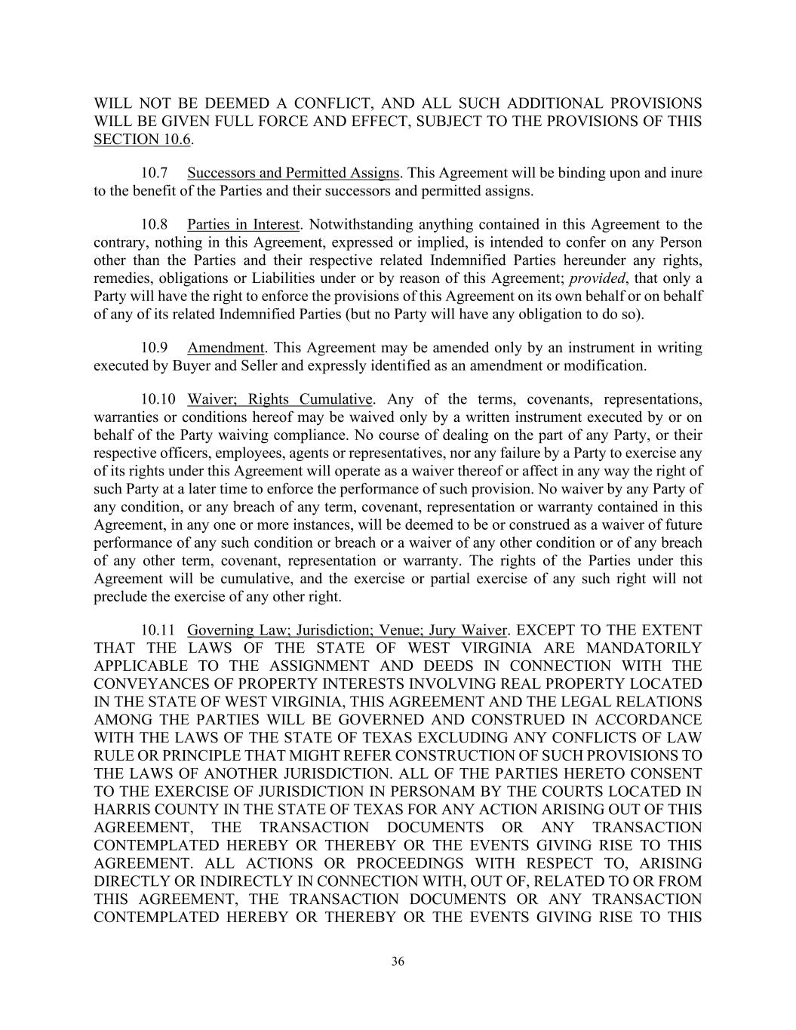
36 WILL NOT BE DEEMED A CONFLICT, AND ALL SUCH ADDITIONAL PROVISIONS WILL BE GIVEN FULL FORCE AND EFFECT, SUBJECT TO THE PROVISIONS OF THIS SECTION 10.6. 10.7 Successors and Permitted Assigns. This Agreement will be binding upon and inure to the benefit of the Parties and their successors and permitted assigns. 10.8 Parties in Interest. Notwithstanding anything contained in this Agreement to the contrary, nothing in this Agreement, expressed or implied, is intended to confer on any Person other than the Parties and their respective related Indemnified Parties hereunder any rights, remedies, obligations or Liabilities under or by reason of this Agreement; provided, that only a Party will have the right to enforce the provisions of this Agreement on its own behalf or on behalf of any of its related Indemnified Parties (but no Party will have any obligation to do so). 10.9 Amendment. This Agreement may be amended only by an instrument in writing executed by Buyer and Seller and expressly identified as an amendment or modification. 10.10 Waiver; Rights Cumulative. Any of the terms, covenants, representations, warranties or conditions hereof may be waived only by a written instrument executed by or on behalf of the Party waiving compliance. No course of dealing on the part of any Party, or their respective officers, employees, agents or representatives, nor any failure by a Party to exercise any of its rights under this Agreement will operate as a waiver thereof or affect in any way the right of such Party at a later time to enforce the performance of such provision. No waiver by any Party of any condition, or any breach of any term, covenant, representation or warranty contained in this Agreement, in any one or more instances, will be deemed to be or construed as a waiver of future performance of any such condition or breach or a waiver of any other condition or of any breach of any other term, covenant, representation or warranty. The rights of the Parties under this Agreement will be cumulative, and the exercise or partial exercise of any such right will not preclude the exercise of any other right. 10.11 Governing Law; Jurisdiction; Venue; Jury Waiver. EXCEPT TO THE EXTENT THAT THE LAWS OF THE STATE OF WEST VIRGINIA ARE MANDATORILY APPLICABLE TO THE ASSIGNMENT AND DEEDS IN CONNECTION WITH THE CONVEYANCES OF PROPERTY INTERESTS INVOLVING REAL PROPERTY LOCATED IN THE STATE OF WEST VIRGINIA, THIS AGREEMENT AND THE LEGAL RELATIONS AMONG THE PARTIES WILL BE GOVERNED AND CONSTRUED IN ACCORDANCE WITH THE LAWS OF THE STATE OF TEXAS EXCLUDING ANY CONFLICTS OF LAW RULE OR PRINCIPLE THAT MIGHT REFER CONSTRUCTION OF SUCH PROVISIONS TO THE LAWS OF ANOTHER JURISDICTION. ALL OF THE PARTIES HERETO CONSENT TO THE EXERCISE OF JURISDICTION IN PERSONAM BY THE COURTS LOCATED IN HARRIS COUNTY IN THE STATE OF TEXAS FOR ANY ACTION ARISING OUT OF THIS AGREEMENT, THE TRANSACTION DOCUMENTS OR ANY TRANSACTION CONTEMPLATED HEREBY OR THEREBY OR THE EVENTS GIVING RISE TO THIS AGREEMENT. ALL ACTIONS OR PROCEEDINGS WITH RESPECT TO, ARISING DIRECTLY OR INDIRECTLY IN CONNECTION WITH, OUT OF, RELATED TO OR FROM THIS AGREEMENT, THE TRANSACTION DOCUMENTS OR ANY TRANSACTION CONTEMPLATED HEREBY OR THEREBY OR THE EVENTS GIVING RISE TO THIS

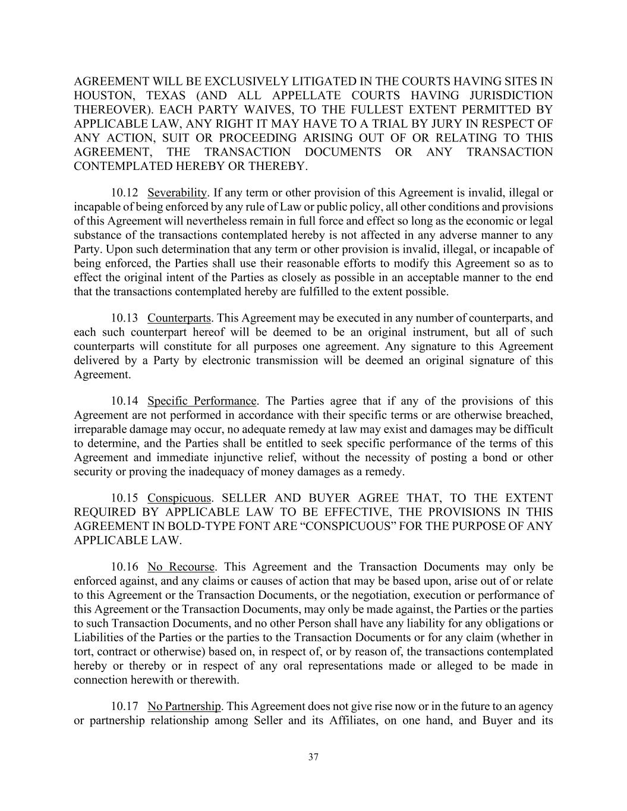
37 AGREEMENT WILL BE EXCLUSIVELY LITIGATED IN THE COURTS HAVING SITES IN HOUSTON, TEXAS (AND ALL APPELLATE COURTS HAVING JURISDICTION THEREOVER). EACH PARTY WAIVES, TO THE FULLEST EXTENT PERMITTED BY APPLICABLE LAW, ANY RIGHT IT MAY HAVE TO A TRIAL BY JURY IN RESPECT OF ANY ACTION, SUIT OR PROCEEDING ARISING OUT OF OR RELATING TO THIS AGREEMENT, THE TRANSACTION DOCUMENTS OR ANY TRANSACTION CONTEMPLATED HEREBY OR THEREBY. 10.12 Severability. If any term or other provision of this Agreement is invalid, illegal or incapable of being enforced by any rule of Law or public policy, all other conditions and provisions of this Agreement will nevertheless remain in full force and effect so long as the economic or legal substance of the transactions contemplated hereby is not affected in any adverse manner to any Party. Upon such determination that any term or other provision is invalid, illegal, or incapable of being enforced, the Parties shall use their reasonable efforts to modify this Agreement so as to effect the original intent of the Parties as closely as possible in an acceptable manner to the end that the transactions contemplated hereby are fulfilled to the extent possible. 10.13 Counterparts. This Agreement may be executed in any number of counterparts, and each such counterpart hereof will be deemed to be an original instrument, but all of such counterparts will constitute for all purposes one agreement. Any signature to this Agreement delivered by a Party by electronic transmission will be deemed an original signature of this Agreement. 10.14 Specific Performance. The Parties agree that if any of the provisions of this Agreement are not performed in accordance with their specific terms or are otherwise breached, irreparable damage may occur, no adequate remedy at law may exist and damages may be difficult to determine, and the Parties shall be entitled to seek specific performance of the terms of this Agreement and immediate injunctive relief, without the necessity of posting a bond or other security or proving the inadequacy of money damages as a remedy. 10.15 Conspicuous. SELLER AND BUYER AGREE THAT, TO THE EXTENT REQUIRED BY APPLICABLE LAW TO BE EFFECTIVE, THE PROVISIONS IN THIS AGREEMENT IN BOLD-TYPE FONT ARE “CONSPICUOUS” FOR THE PURPOSE OF ANY APPLICABLE LAW. 10.16 No Recourse. This Agreement and the Transaction Documents may only be enforced against, and any claims or causes of action that may be based upon, arise out of or relate to this Agreement or the Transaction Documents, or the negotiation, execution or performance of this Agreement or the Transaction Documents, may only be made against, the Parties or the parties to such Transaction Documents, and no other Person shall have any liability for any obligations or Liabilities of the Parties or the parties to the Transaction Documents or for any claim (whether in tort, contract or otherwise) based on, in respect of, or by reason of, the transactions contemplated hereby or thereby or in respect of any oral representations made or alleged to be made in connection herewith or therewith. 10.17 No Partnership. This Agreement does not give rise now or in the future to an agency or partnership relationship among Seller and its Affiliates, on one hand, and Buyer and its

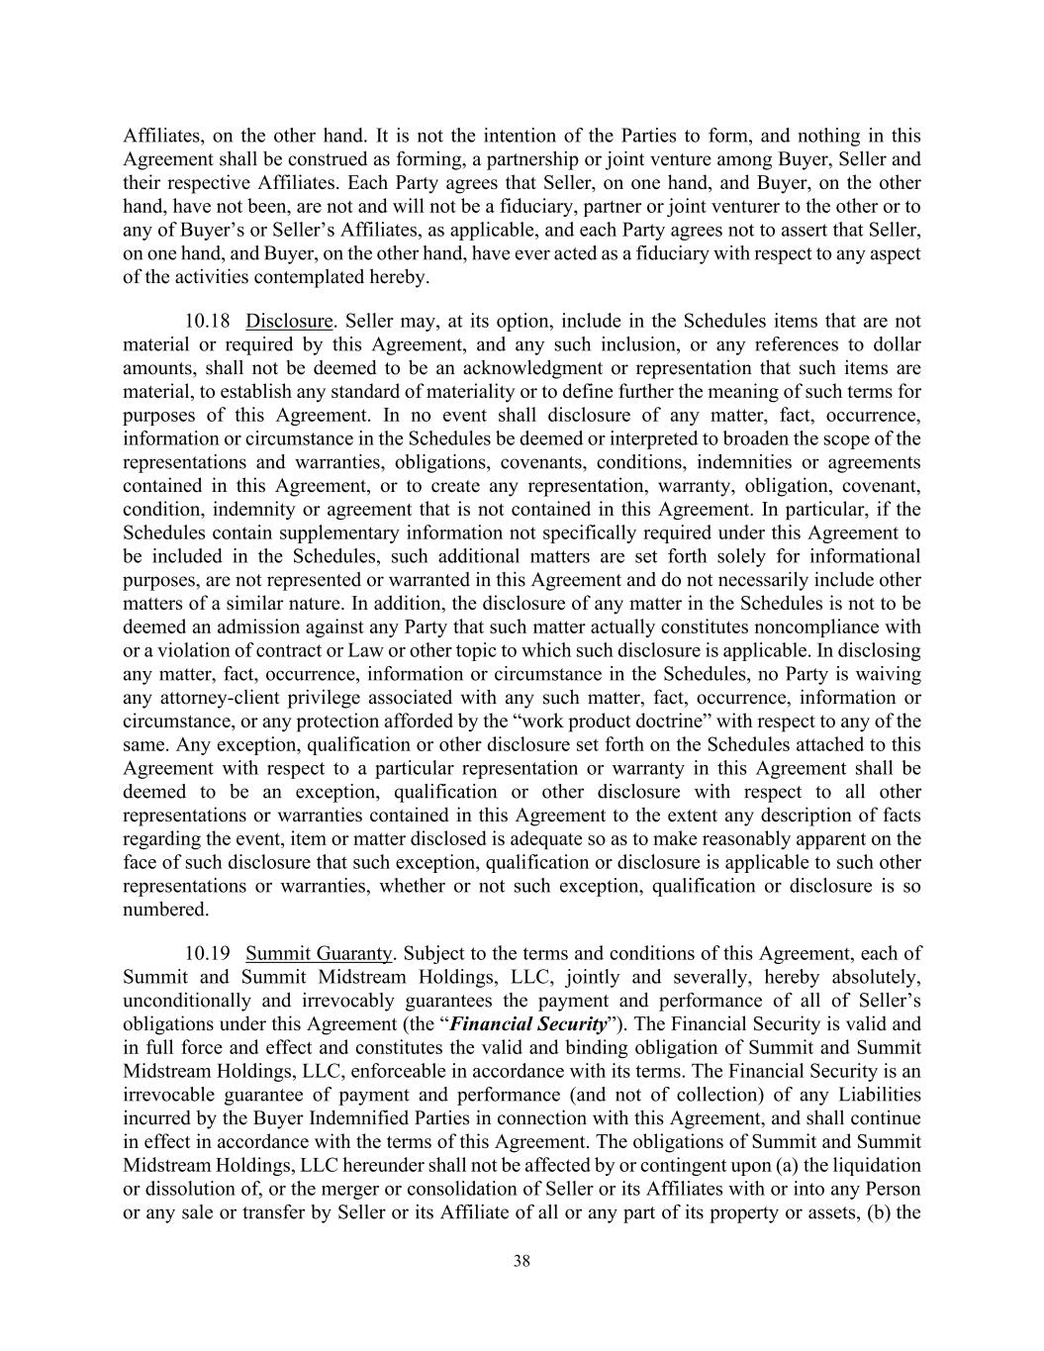
38 Affiliates, on the other hand. It is not the intention of the Parties to form, and nothing in this Agreement shall be construed as forming, a partnership or joint venture among Buyer, Seller and their respective Affiliates. Each Party agrees that Seller, on one hand, and Buyer, on the other hand, have not been, are not and will not be a fiduciary, partner or joint venturer to the other or to any of Buyer’s or Seller’s Affiliates, as applicable, and each Party agrees not to assert that Seller, on one hand, and Buyer, on the other hand, have ever acted as a fiduciary with respect to any aspect of the activities contemplated hereby. 10.18 Disclosure. Seller may, at its option, include in the Schedules items that are not material or required by this Agreement, and any such inclusion, or any references to dollar amounts, shall not be deemed to be an acknowledgment or representation that such items are material, to establish any standard of materiality or to define further the meaning of such terms for purposes of this Agreement. In no event shall disclosure of any matter, fact, occurrence, information or circumstance in the Schedules be deemed or interpreted to broaden the scope of the representations and warranties, obligations, covenants, conditions, indemnities or agreements contained in this Agreement, or to create any representation, warranty, obligation, covenant, condition, indemnity or agreement that is not contained in this Agreement. In particular, if the Schedules contain supplementary information not specifically required under this Agreement to be included in the Schedules, such additional matters are set forth solely for informational purposes, are not represented or warranted in this Agreement and do not necessarily include other matters of a similar nature. In addition, the disclosure of any matter in the Schedules is not to be deemed an admission against any Party that such matter actually constitutes noncompliance with or a violation of contract or Law or other topic to which such disclosure is applicable. In disclosing any matter, fact, occurrence, information or circumstance in the Schedules, no Party is waiving any attorney-client privilege associated with any such matter, fact, occurrence, information or circumstance, or any protection afforded by the “work product doctrine” with respect to any of the same. Any exception, qualification or other disclosure set forth on the Schedules attached to this Agreement with respect to a particular representation or warranty in this Agreement shall be deemed to be an exception, qualification or other disclosure with respect to all other representations or warranties contained in this Agreement to the extent any description of facts regarding the event, item or matter disclosed is adequate so as to make reasonably apparent on the face of such disclosure that such exception, qualification or disclosure is applicable to such other representations or warranties, whether or not such exception, qualification or disclosure is so numbered. 10.19 Summit Guaranty. Subject to the terms and conditions of this Agreement, each of Summit and Summit Midstream Holdings, LLC, jointly and severally, hereby absolutely, unconditionally and irrevocably guarantees the payment and performance of all of Seller’s obligations under this Agreement (the “Financial Security”). The Financial Security is valid and in full force and effect and constitutes the valid and binding obligation of Summit and Summit Midstream Holdings, LLC, enforceable in accordance with its terms. The Financial Security is an irrevocable guarantee of payment and performance (and not of collection) of any Liabilities incurred by the Buyer Indemnified Parties in connection with this Agreement, and shall continue in effect in accordance with the terms of this Agreement. The obligations of Summit and Summit Midstream Holdings, LLC hereunder shall not be affected by or contingent upon (a) the liquidation or dissolution of, or the merger or consolidation of Seller or its Affiliates with or into any Person or any sale or transfer by Seller or its Affiliate of all or any part of its property or assets, (b) the

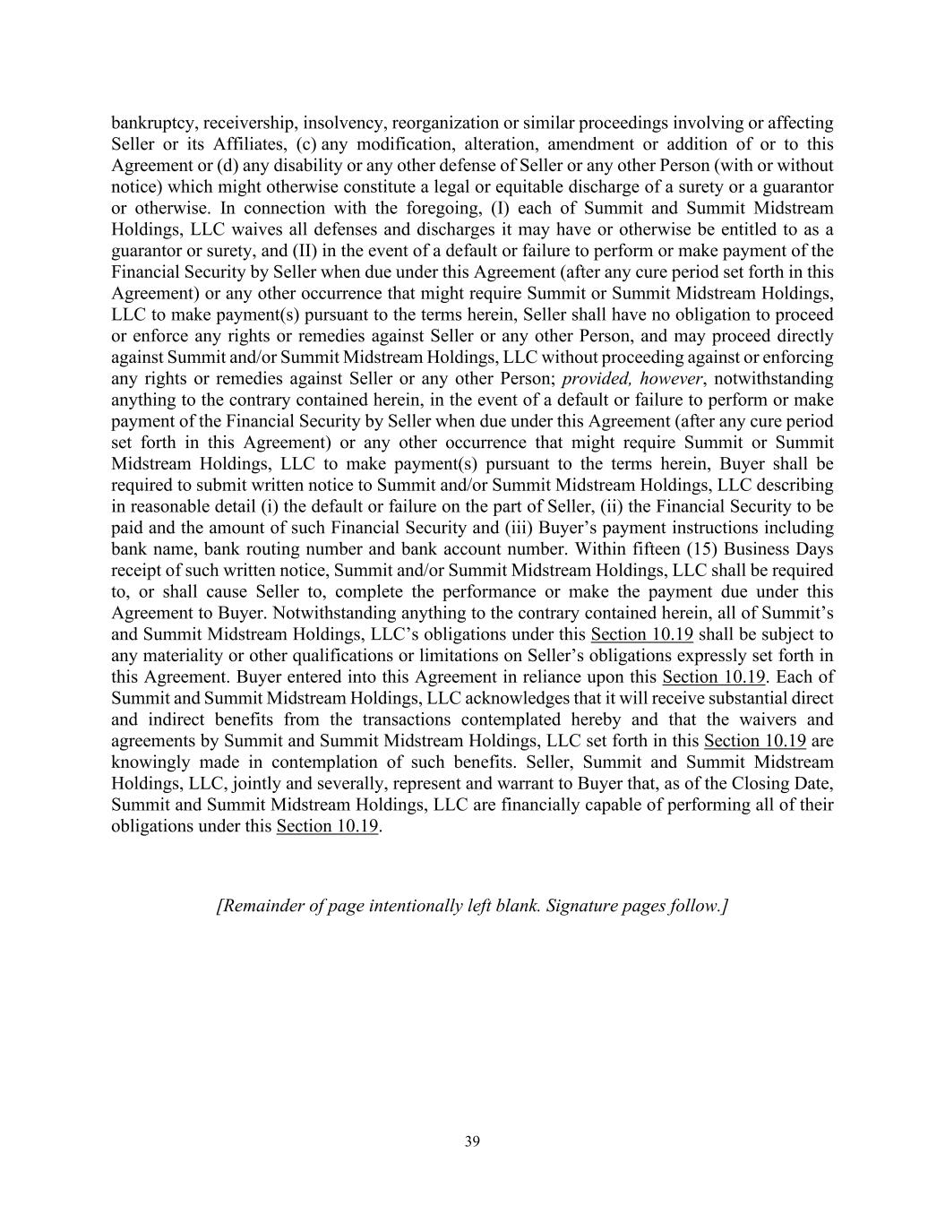
39 bankruptcy, receivership, insolvency, reorganization or similar proceedings involving or affecting Seller or its Affiliates, (c) any modification, alteration, amendment or addition of or to this Agreement or (d) any disability or any other defense of Seller or any other Person (with or without notice) which might otherwise constitute a legal or equitable discharge of a surety or a guarantor or otherwise. In connection with the foregoing, (I) each of Summit and Summit Midstream Holdings, LLC waives all defenses and discharges it may have or otherwise be entitled to as a guarantor or surety, and (II) in the event of a default or failure to perform or make payment of the Financial Security by Seller when due under this Agreement (after any cure period set forth in this Agreement) or any other occurrence that might require Summit or Summit Midstream Holdings, LLC to make payment(s) pursuant to the terms herein, Seller shall have no obligation to proceed or enforce any rights or remedies against Seller or any other Person, and may proceed directly against Summit and/or Summit Midstream Holdings, LLC without proceeding against or enforcing any rights or remedies against Seller or any other Person; provided, however, notwithstanding anything to the contrary contained herein, in the event of a default or failure to perform or make payment of the Financial Security by Seller when due under this Agreement (after any cure period set forth in this Agreement) or any other occurrence that might require Summit or Summit Midstream Holdings, LLC to make payment(s) pursuant to the terms herein, Buyer shall be required to submit written notice to Summit and/or Summit Midstream Holdings, LLC describing in reasonable detail (i) the default or failure on the part of Seller, (ii) the Financial Security to be paid and the amount of such Financial Security and (iii) Buyer’s payment instructions including bank name, bank routing number and bank account number. Within fifteen (15) Business Days receipt of such written notice, Summit and/or Summit Midstream Holdings, LLC shall be required to, or shall cause Seller to, complete the performance or make the payment due under this Agreement to Buyer. Notwithstanding anything to the contrary contained herein, all of Summit’s and Summit Midstream Holdings, LLC’s obligations under this Section 10.19 shall be subject to any materiality or other qualifications or limitations on Seller’s obligations expressly set forth in this Agreement. Buyer entered into this Agreement in reliance upon this Section 10.19. Each of Summit and Summit Midstream Holdings, LLC acknowledges that it will receive substantial direct and indirect benefits from the transactions contemplated hereby and that the waivers and agreements by Summit and Summit Midstream Holdings, LLC set forth in this Section 10.19 are knowingly made in contemplation of such benefits. Seller, Summit and Summit Midstream Holdings, LLC, jointly and severally, represent and warrant to Buyer that, as of the Closing Date, Summit and Summit Midstream Holdings, LLC are financially capable of performing all of their obligations under this Section 10.19. [Remainder of page intentionally left blank. Signature pages follow.]

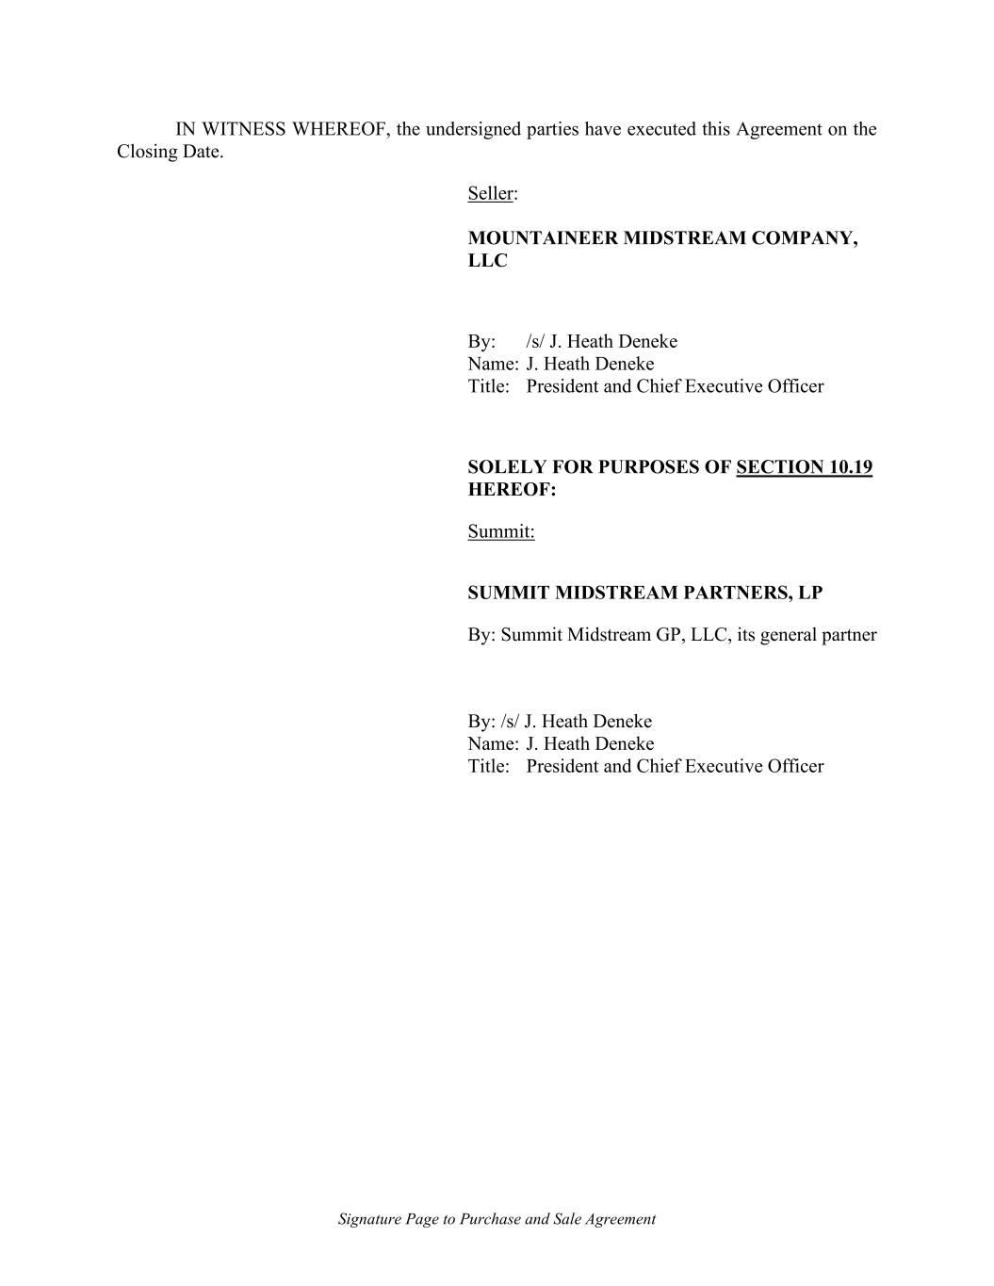
Signature Page to Purchase and Sale Agreement IN WITNESS WHEREOF, the undersigned parties have executed this Agreement on the Closing Date. Seller: MOUNTAINEER MIDSTREAM COMPANY, LLC By: /s/ J. Heath Deneke Name: J. Heath Deneke Title: President and Chief Executive Officer SOLELY FOR PURPOSES OF SECTION 10.19 HEREOF: Summit: SUMMIT MIDSTREAM PARTNERS, LP By: Summit Midstream GP, LLC, its general partner By: /s/ J. Heath Deneke Name: J. Heath Deneke Title: President and Chief Executive Officer

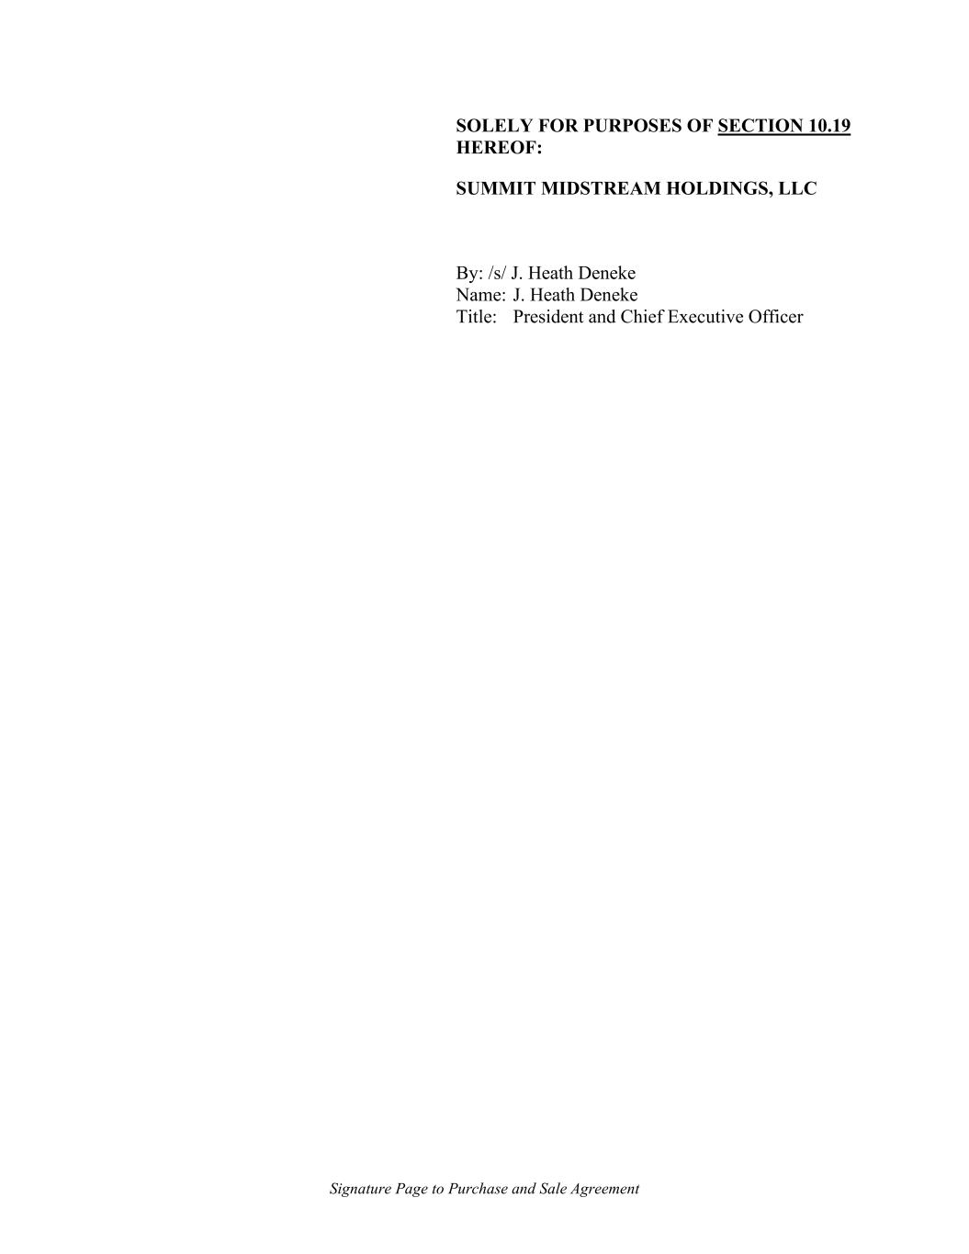
Signature Page to Purchase and Sale Agreement SOLELY FOR PURPOSES OF SECTION 10.19 HEREOF: SUMMIT MIDSTREAM HOLDINGS, LLC By: /s/ J. Heath Deneke Name: J. Heath Deneke Title: President and Chief Executive Officer

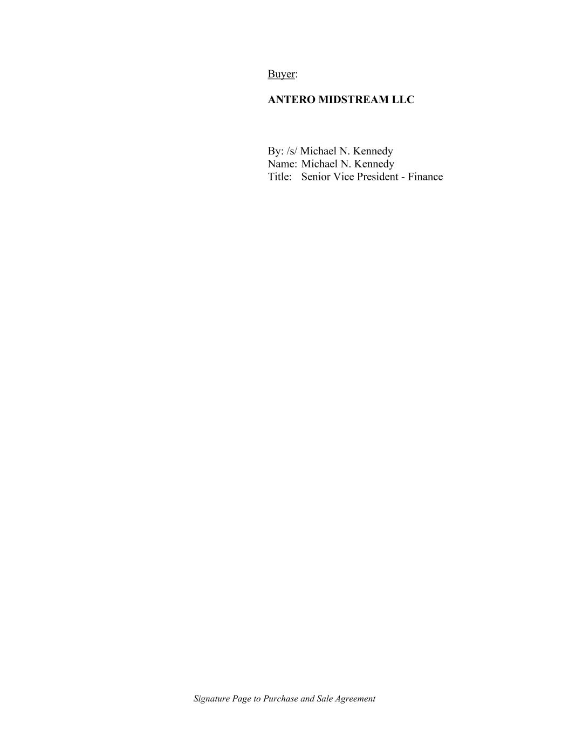
Signature Page to Purchase and Sale Agreement Buyer: ANTERO MIDSTREAM LLC By: /s/ Michael N. Kennedy Name: Michael N. Kennedy Title: Senior Vice President - Finance

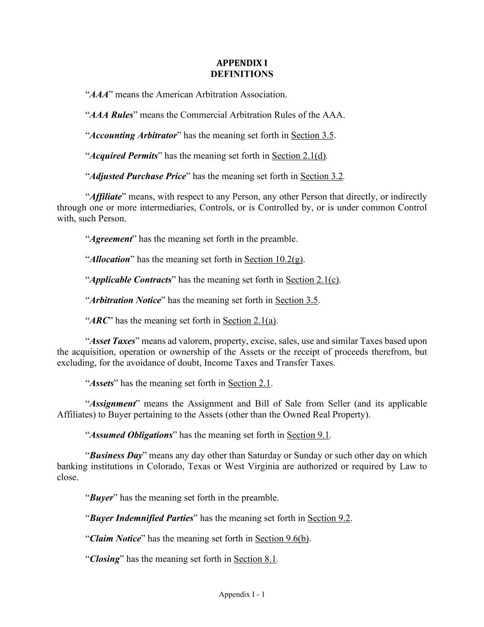
Appendix I - 1 APPENDIX I DEFINITIONS “AAA” means the American Arbitration Association. “AAA Rules” means the Commercial Arbitration Rules of the AAA. “Accounting Arbitrator” has the meaning set forth in Section 3.5. “Acquired Permits” has the meaning set forth in Section 2.1(d). “Adjusted Purchase Price” has the meaning set forth in Section 3.2. “Affiliate” means, with respect to any Person, any other Person that directly, or indirectly through one or more intermediaries, Controls, or is Controlled by, or is under common Control with, such Person. “Agreement” has the meaning set forth in the preamble. “Allocation” has the meaning set forth in Section 10.2(g). “Applicable Contracts” has the meaning set forth in Section 2.1(c). “Arbitration Notice” has the meaning set forth in Section 3.5. “ARC” has the meaning set forth in Section 2.1(a). “Asset Taxes” means ad valorem, property, excise, sales, use and similar Taxes based upon the acquisition, operation or ownership of the Assets or the receipt of proceeds therefrom, but excluding, for the avoidance of doubt, Income Taxes and Transfer Taxes. “Assets” has the meaning set forth in Section 2.1. “Assignment” means the Assignment and Bill of Sale from Seller (and its applicable Affiliates) to Buyer pertaining to the Assets (other than the Owned Real Property). “Assumed Obligations” has the meaning set forth in Section 9.1. “Business Day” means any day other than Saturday or Sunday or such other day on which banking institutions in Colorado, Texas or West Virginia are authorized or required by Law to close. “Buyer” has the meaning set forth in the preamble. “Buyer Indemnified Parties” has the meaning set forth in Section 9.2. “Claim Notice” has the meaning set forth in Section 9.6(b). “Closing” has the meaning set forth in Section 8.1.

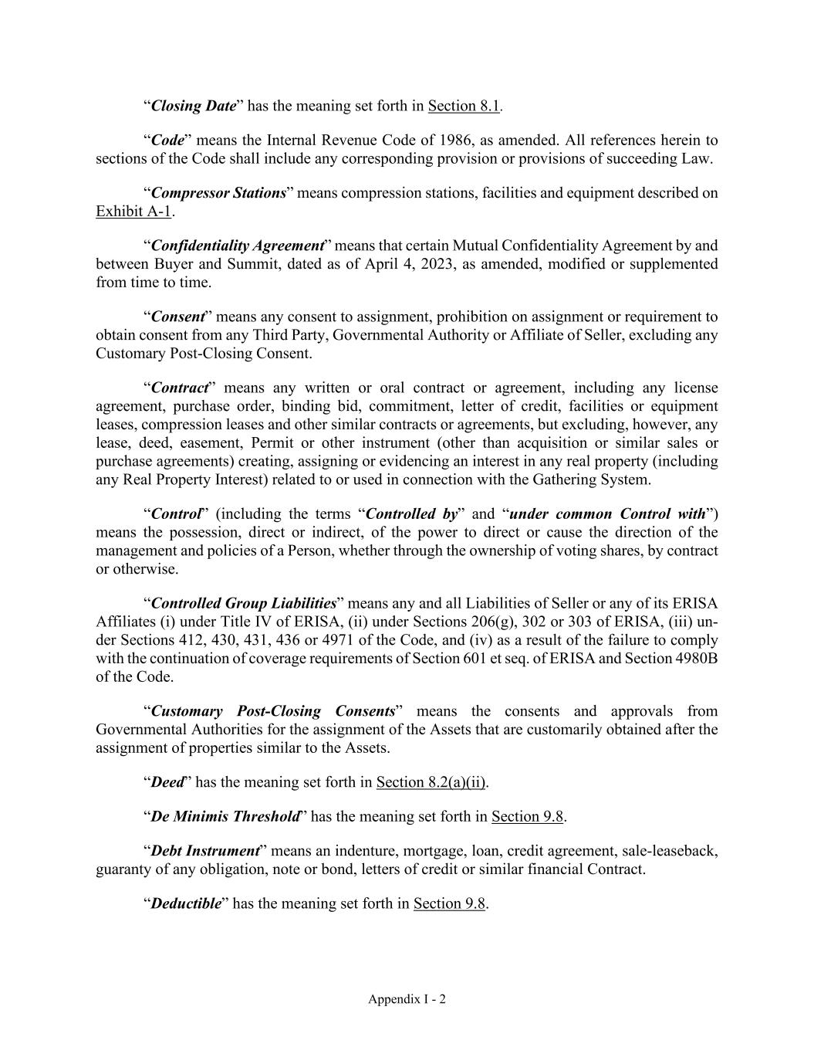
Appendix I - 2 “Closing Date” has the meaning set forth in Section 8.1. “Code” means the Internal Revenue Code of 1986, as amended. All references herein to sections of the Code shall include any corresponding provision or provisions of succeeding Law. “Compressor Stations” means compression stations, facilities and equipment described on Exhibit A-1. “Confidentiality Agreement” means that certain Mutual Confidentiality Agreement by and between Buyer and Summit, dated as of April 4, 2023, as amended, modified or supplemented from time to time. “Consent” means any consent to assignment, prohibition on assignment or requirement to obtain consent from any Third Party, Governmental Authority or Affiliate of Seller, excluding any Customary Post-Closing Consent. “Contract” means any written or oral contract or agreement, including any license agreement, purchase order, binding bid, commitment, letter of credit, facilities or equipment leases, compression leases and other similar contracts or agreements, but excluding, however, any lease, deed, easement, Permit or other instrument (other than acquisition or similar sales or purchase agreements) creating, assigning or evidencing an interest in any real property (including any Real Property Interest) related to or used in connection with the Gathering System. “Control” (including the terms “Controlled by” and “under common Control with”) means the possession, direct or indirect, of the power to direct or cause the direction of the management and policies of a Person, whether through the ownership of voting shares, by contract or otherwise. “Controlled Group Liabilities” means any and all Liabilities of Seller or any of its ERISA Affiliates (i) under Title IV of ERISA, (ii) under Sections 206(g), 302 or 303 of ERISA, (iii) un- der Sections 412, 430, 431, 436 or 4971 of the Code, and (iv) as a result of the failure to comply with the continuation of coverage requirements of Section 601 et seq. of ERISA and Section 4980B of the Code. “Customary Post-Closing Consents” means the consents and approvals from Governmental Authorities for the assignment of the Assets that are customarily obtained after the assignment of properties similar to the Assets. “Deed” has the meaning set forth in Section 8.2(a)(ii). “De Minimis Threshold” has the meaning set forth in Section 9.8. “Debt Instrument” means an indenture, mortgage, loan, credit agreement, sale-leaseback, guaranty of any obligation, note or bond, letters of credit or similar financial Contract. “Deductible” has the meaning set forth in Section 9.8.

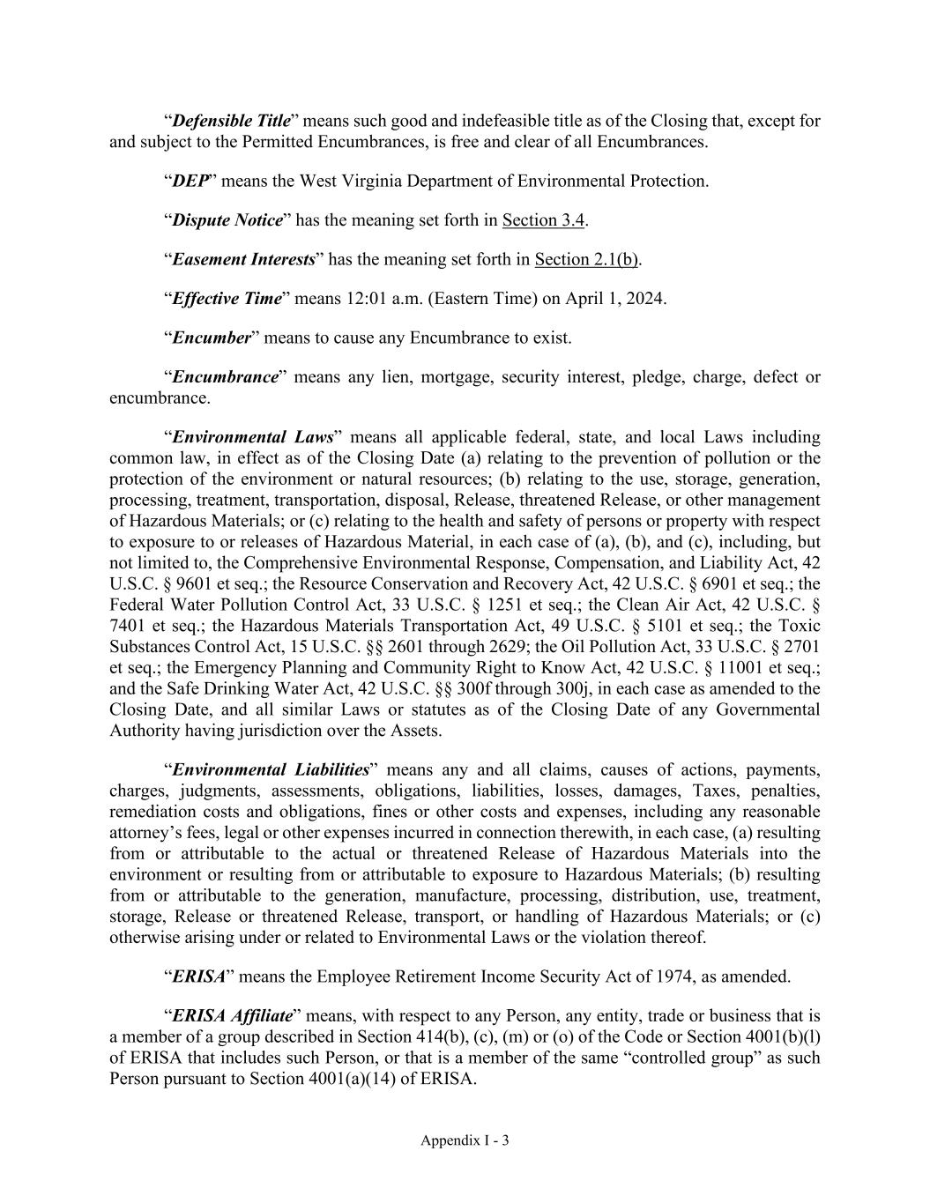
Appendix I - 3 “Defensible Title” means such good and indefeasible title as of the Closing that, except for and subject to the Permitted Encumbrances, is free and clear of all Encumbrances. “DEP” means the West Virginia Department of Environmental Protection. “Dispute Notice” has the meaning set forth in Section 3.4. “Easement Interests” has the meaning set forth in Section 2.1(b). “Effective Time” means 12:01 a.m. (Eastern Time) on April 1, 2024. “Encumber” means to cause any Encumbrance to exist. “Encumbrance” means any lien, mortgage, security interest, pledge, charge, defect or encumbrance. “Environmental Laws” means all applicable federal, state, and local Laws including common law, in effect as of the Closing Date (a) relating to the prevention of pollution or the protection of the environment or natural resources; (b) relating to the use, storage, generation, processing, treatment, transportation, disposal, Release, threatened Release, or other management of Hazardous Materials; or (c) relating to the health and safety of persons or property with respect to exposure to or releases of Hazardous Material, in each case of (a), (b), and (c), including, but not limited to, the Comprehensive Environmental Response, Compensation, and Liability Act, 42 U.S.C. § 9601 et seq.; the Resource Conservation and Recovery Act, 42 U.S.C. § 6901 et seq.; the Federal Water Pollution Control Act, 33 U.S.C. § 1251 et seq.; the Clean Air Act, 42 U.S.C. § 7401 et seq.; the Hazardous Materials Transportation Act, 49 U.S.C. § 5101 et seq.; the Toxic Substances Control Act, 15 U.S.C. §§ 2601 through 2629; the Oil Pollution Act, 33 U.S.C. § 2701 et seq.; the Emergency Planning and Community Right to Know Act, 42 U.S.C. § 11001 et seq.; and the Safe Drinking Water Act, 42 U.S.C. §§ 300f through 300j, in each case as amended to the Closing Date, and all similar Laws or statutes as of the Closing Date of any Governmental Authority having jurisdiction over the Assets. “Environmental Liabilities” means any and all claims, causes of actions, payments, charges, judgments, assessments, obligations, liabilities, losses, damages, Taxes, penalties, remediation costs and obligations, fines or other costs and expenses, including any reasonable attorney’s fees, legal or other expenses incurred in connection therewith, in each case, (a) resulting from or attributable to the actual or threatened Release of Hazardous Materials into the environment or resulting from or attributable to exposure to Hazardous Materials; (b) resulting from or attributable to the generation, manufacture, processing, distribution, use, treatment, storage, Release or threatened Release, transport, or handling of Hazardous Materials; or (c) otherwise arising under or related to Environmental Laws or the violation thereof. “ERISA” means the Employee Retirement Income Security Act of 1974, as amended. “ERISA Affiliate” means, with respect to any Person, any entity, trade or business that is a member of a group described in Section 414(b), (c), (m) or (o) of the Code or Section 4001(b)(l) of ERISA that includes such Person, or that is a member of the same “controlled group” as such Person pursuant to Section 4001(a)(14) of ERISA.

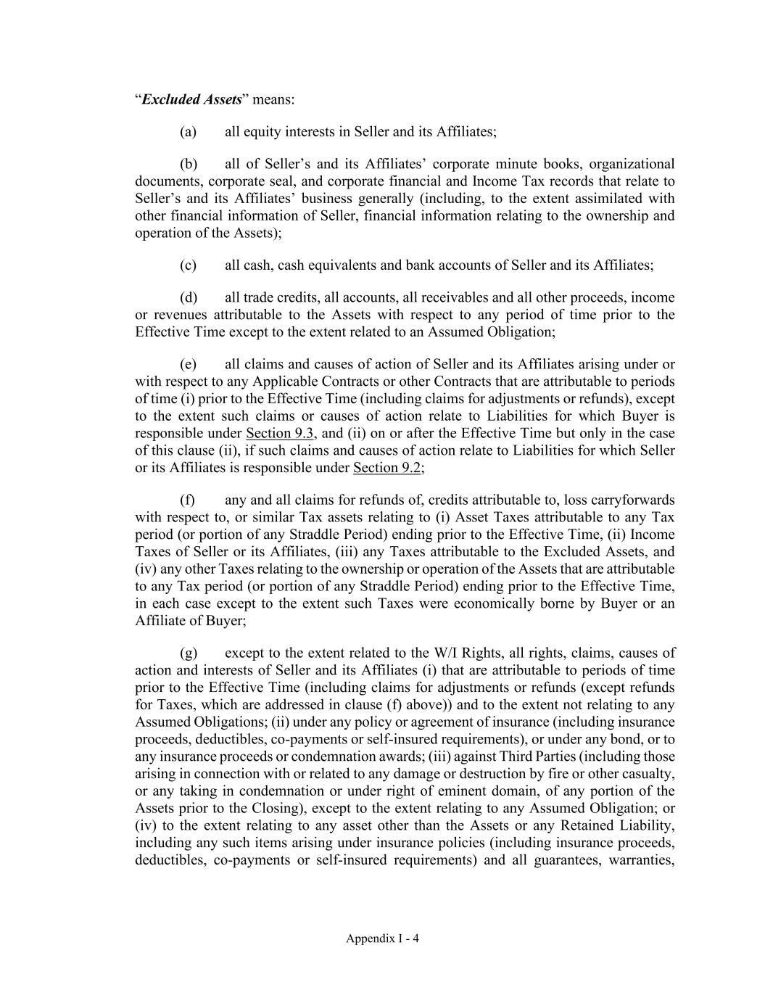
Appendix I - 4 “Excluded Assets” means: (a) all equity interests in Seller and its Affiliates; (b) all of Seller’s and its Affiliates’ corporate minute books, organizational documents, corporate seal, and corporate financial and Income Tax records that relate to Seller’s and its Affiliates’ business generally (including, to the extent assimilated with other financial information of Seller, financial information relating to the ownership and operation of the Assets); (c) all cash, cash equivalents and bank accounts of Seller and its Affiliates; (d) all trade credits, all accounts, all receivables and all other proceeds, income or revenues attributable to the Assets with respect to any period of time prior to the Effective Time except to the extent related to an Assumed Obligation; (e) all claims and causes of action of Seller and its Affiliates arising under or with respect to any Applicable Contracts or other Contracts that are attributable to periods of time (i) prior to the Effective Time (including claims for adjustments or refunds), except to the extent such claims or causes of action relate to Liabilities for which Buyer is responsible under Section 9.3, and (ii) on or after the Effective Time but only in the case of this clause (ii), if such claims and causes of action relate to Liabilities for which Seller or its Affiliates is responsible under Section 9.2; (f) any and all claims for refunds of, credits attributable to, loss carryforwards with respect to, or similar Tax assets relating to (i) Asset Taxes attributable to any Tax period (or portion of any Straddle Period) ending prior to the Effective Time, (ii) Income Taxes of Seller or its Affiliates, (iii) any Taxes attributable to the Excluded Assets, and (iv) any other Taxes relating to the ownership or operation of the Assets that are attributable to any Tax period (or portion of any Straddle Period) ending prior to the Effective Time, in each case except to the extent such Taxes were economically borne by Buyer or an Affiliate of Buyer; (g) except to the extent related to the W/I Rights, all rights, claims, causes of action and interests of Seller and its Affiliates (i) that are attributable to periods of time prior to the Effective Time (including claims for adjustments or refunds (except refunds for Taxes, which are addressed in clause (f) above)) and to the extent not relating to any Assumed Obligations; (ii) under any policy or agreement of insurance (including insurance proceeds, deductibles, co-payments or self-insured requirements), or under any bond, or to any insurance proceeds or condemnation awards; (iii) against Third Parties (including those arising in connection with or related to any damage or destruction by fire or other casualty, or any taking in condemnation or under right of eminent domain, of any portion of the Assets prior to the Closing), except to the extent relating to any Assumed Obligation; or (iv) to the extent relating to any asset other than the Assets or any Retained Liability, including any such items arising under insurance policies (including insurance proceeds, deductibles, co-payments or self-insured requirements) and all guarantees, warranties,

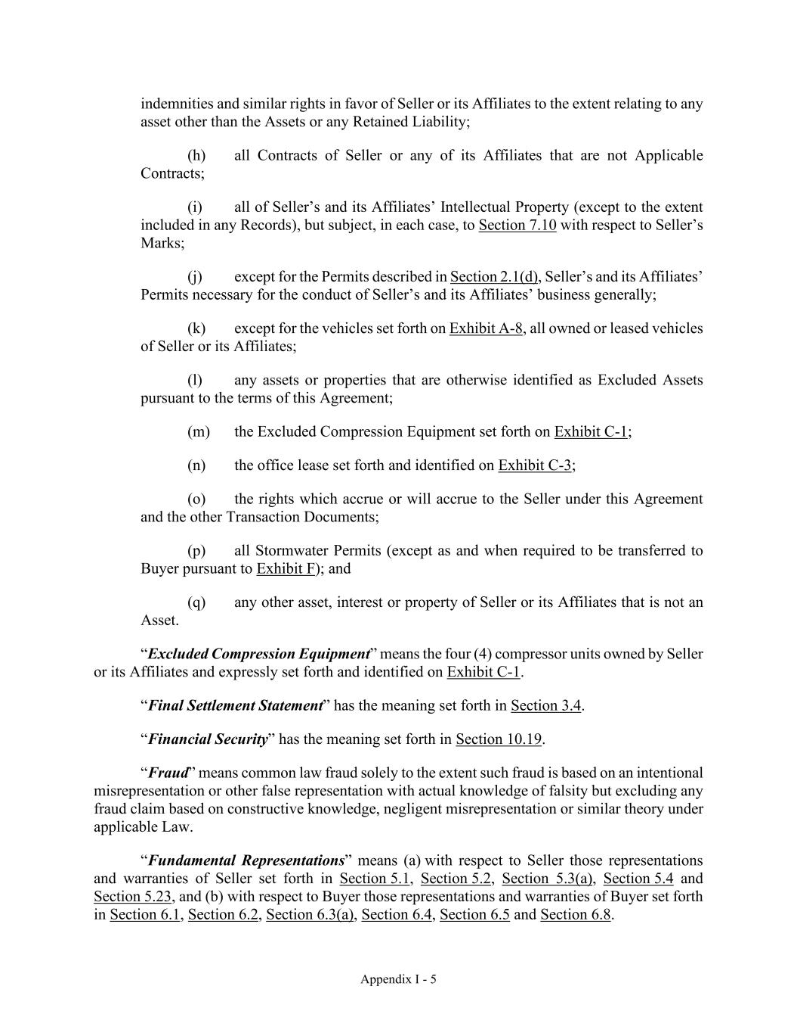
Appendix I - 5 indemnities and similar rights in favor of Seller or its Affiliates to the extent relating to any asset other than the Assets or any Retained Liability; (h) all Contracts of Seller or any of its Affiliates that are not Applicable Contracts; (i) all of Seller’s and its Affiliates’ Intellectual Property (except to the extent included in any Records), but subject, in each case, to Section 7.10 with respect to Seller’s Marks; (j) except for the Permits described in Section 2.1(d), Seller’s and its Affiliates’ Permits necessary for the conduct of Seller’s and its Affiliates’ business generally; (k) except for the vehicles set forth on Exhibit A-8, all owned or leased vehicles of Seller or its Affiliates; (l) any assets or properties that are otherwise identified as Excluded Assets pursuant to the terms of this Agreement; (m) the Excluded Compression Equipment set forth on Exhibit C-1; (n) the office lease set forth and identified on Exhibit C-3; (o) the rights which accrue or will accrue to the Seller under this Agreement and the other Transaction Documents; (p) all Stormwater Permits (except as and when required to be transferred to Buyer pursuant to Exhibit F); and (q) any other asset, interest or property of Seller or its Affiliates that is not an Asset. “Excluded Compression Equipment” means the four (4) compressor units owned by Seller or its Affiliates and expressly set forth and identified on Exhibit C-1. “Final Settlement Statement” has the meaning set forth in Section 3.4. “Financial Security” has the meaning set forth in Section 10.19. “Fraud” means common law fraud solely to the extent such fraud is based on an intentional misrepresentation or other false representation with actual knowledge of falsity but excluding any fraud claim based on constructive knowledge, negligent misrepresentation or similar theory under applicable Law. “Fundamental Representations” means (a) with respect to Seller those representations and warranties of Seller set forth in Section 5.1, Section 5.2, Section 5.3(a), Section 5.4 and Section 5.23, and (b) with respect to Buyer those representations and warranties of Buyer set forth in Section 6.1, Section 6.2, Section 6.3(a), Section 6.4, Section 6.5 and Section 6.8.

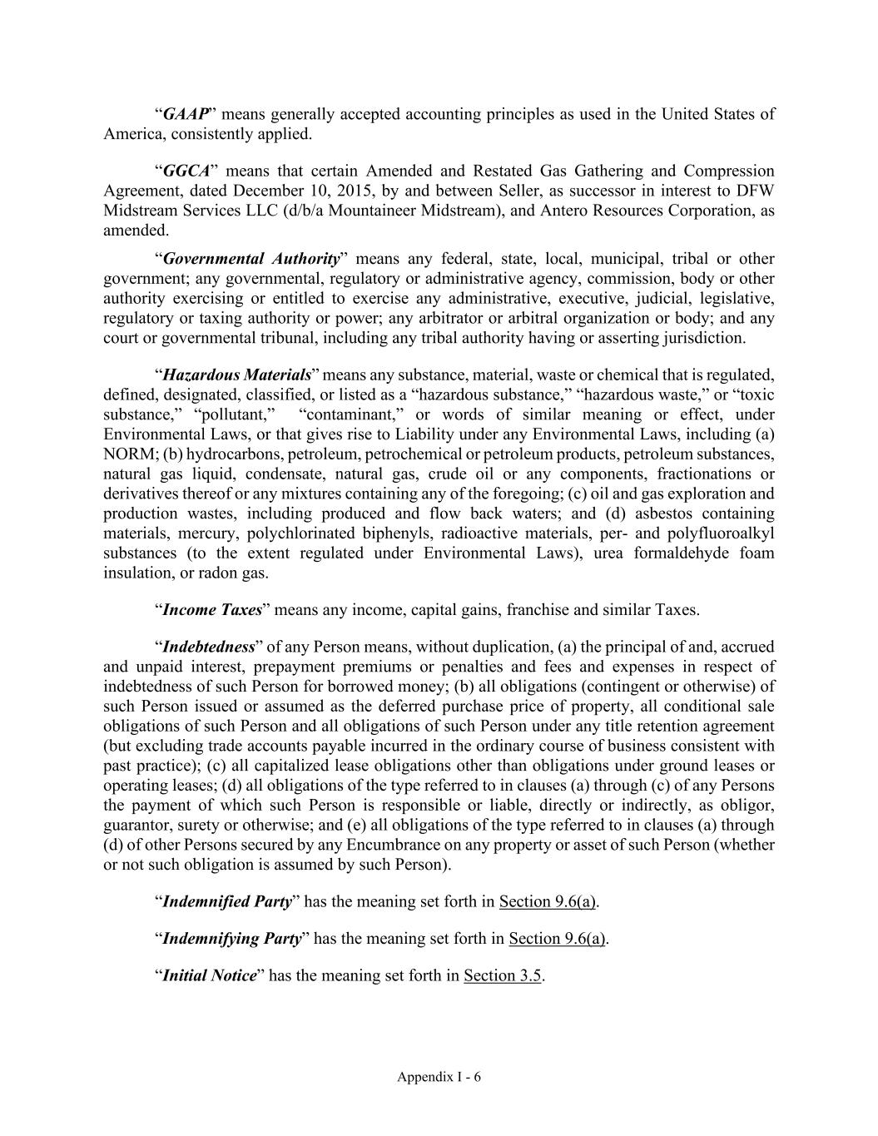
Appendix I - 6 “GAAP” means generally accepted accounting principles as used in the United States of America, consistently applied. “GGCA” means that certain Amended and Restated Gas Gathering and Compression Agreement, dated December 10, 2015, by and between Seller, as successor in interest to DFW Midstream Services LLC (d/b/a Mountaineer Midstream), and Antero Resources Corporation, as amended. “Governmental Authority” means any federal, state, local, municipal, tribal or other government; any governmental, regulatory or administrative agency, commission, body or other authority exercising or entitled to exercise any administrative, executive, judicial, legislative, regulatory or taxing authority or power; any arbitrator or arbitral organization or body; and any court or governmental tribunal, including any tribal authority having or asserting jurisdiction. “Hazardous Materials” means any substance, material, waste or chemical that is regulated, defined, designated, classified, or listed as a “hazardous substance,” “hazardous waste,” or “toxic substance,” “pollutant,” “contaminant,” or words of similar meaning or effect, under Environmental Laws, or that gives rise to Liability under any Environmental Laws, including (a) NORM; (b) hydrocarbons, petroleum, petrochemical or petroleum products, petroleum substances, natural gas liquid, condensate, natural gas, crude oil or any components, fractionations or derivatives thereof or any mixtures containing any of the foregoing; (c) oil and gas exploration and production wastes, including produced and flow back waters; and (d) asbestos containing materials, mercury, polychlorinated biphenyls, radioactive materials, per- and polyfluoroalkyl substances (to the extent regulated under Environmental Laws), urea formaldehyde foam insulation, or radon gas. “Income Taxes” means any income, capital gains, franchise and similar Taxes. “Indebtedness” of any Person means, without duplication, (a) the principal of and, accrued and unpaid interest, prepayment premiums or penalties and fees and expenses in respect of indebtedness of such Person for borrowed money; (b) all obligations (contingent or otherwise) of such Person issued or assumed as the deferred purchase price of property, all conditional sale obligations of such Person and all obligations of such Person under any title retention agreement (but excluding trade accounts payable incurred in the ordinary course of business consistent with past practice); (c) all capitalized lease obligations other than obligations under ground leases or operating leases; (d) all obligations of the type referred to in clauses (a) through (c) of any Persons the payment of which such Person is responsible or liable, directly or indirectly, as obligor, guarantor, surety or otherwise; and (e) all obligations of the type referred to in clauses (a) through (d) of other Persons secured by any Encumbrance on any property or asset of such Person (whether or not such obligation is assumed by such Person). “Indemnified Party” has the meaning set forth in Section 9.6(a). “Indemnifying Party” has the meaning set forth in Section 9.6(a). “Initial Notice” has the meaning set forth in Section 3.5.

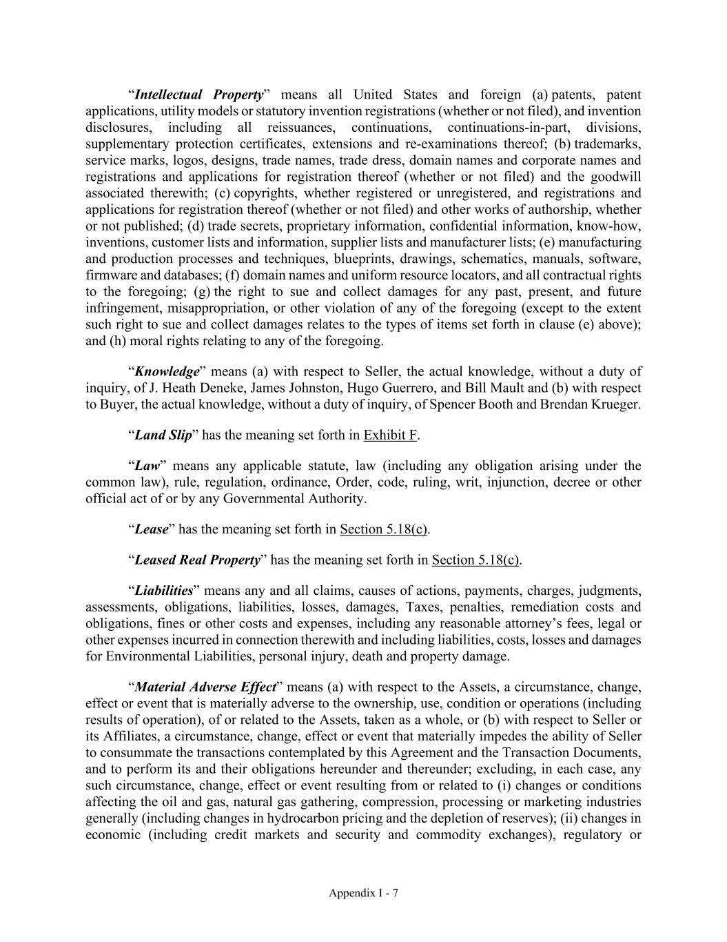
Appendix I - 7 “Intellectual Property” means all United States and foreign (a) patents, patent applications, utility models or statutory invention registrations (whether or not filed), and invention disclosures, including all reissuances, continuations, continuations-in-part, divisions, supplementary protection certificates, extensions and re-examinations thereof; (b) trademarks, service marks, logos, designs, trade names, trade dress, domain names and corporate names and registrations and applications for registration thereof (whether or not filed) and the goodwill associated therewith; (c) copyrights, whether registered or unregistered, and registrations and applications for registration thereof (whether or not filed) and other works of authorship, whether or not published; (d) trade secrets, proprietary information, confidential information, know-how, inventions, customer lists and information, supplier lists and manufacturer lists; (e) manufacturing and production processes and techniques, blueprints, drawings, schematics, manuals, software, firmware and databases; (f) domain names and uniform resource locators, and all contractual rights to the foregoing; (g) the right to sue and collect damages for any past, present, and future infringement, misappropriation, or other violation of any of the foregoing (except to the extent such right to sue and collect damages relates to the types of items set forth in clause (e) above); and (h) moral rights relating to any of the foregoing. “Knowledge” means (a) with respect to Seller, the actual knowledge, without a duty of inquiry, of J. Heath Deneke, James Johnston, Hugo Guerrero, and Bill Mault and (b) with respect to Buyer, the actual knowledge, without a duty of inquiry, of Spencer Booth and Brendan Krueger. “Land Slip” has the meaning set forth in Exhibit F. “Law” means any applicable statute, law (including any obligation arising under the common law), rule, regulation, ordinance, Order, code, ruling, writ, injunction, decree or other official act of or by any Governmental Authority. “Lease” has the meaning set forth in Section 5.18(c). “Leased Real Property” has the meaning set forth in Section 5.18(c). “Liabilities” means any and all claims, causes of actions, payments, charges, judgments, assessments, obligations, liabilities, losses, damages, Taxes, penalties, remediation costs and obligations, fines or other costs and expenses, including any reasonable attorney’s fees, legal or other expenses incurred in connection therewith and including liabilities, costs, losses and damages for Environmental Liabilities, personal injury, death and property damage. “Material Adverse Effect” means (a) with respect to the Assets, a circumstance, change, effect or event that is materially adverse to the ownership, use, condition or operations (including results of operation), of or related to the Assets, taken as a whole, or (b) with respect to Seller or its Affiliates, a circumstance, change, effect or event that materially impedes the ability of Seller to consummate the transactions contemplated by this Agreement and the Transaction Documents, and to perform its and their obligations hereunder and thereunder; excluding, in each case, any such circumstance, change, effect or event resulting from or related to (i) changes or conditions affecting the oil and gas, natural gas gathering, compression, processing or marketing industries generally (including changes in hydrocarbon pricing and the depletion of reserves); (ii) changes in economic (including credit markets and security and commodity exchanges), regulatory or

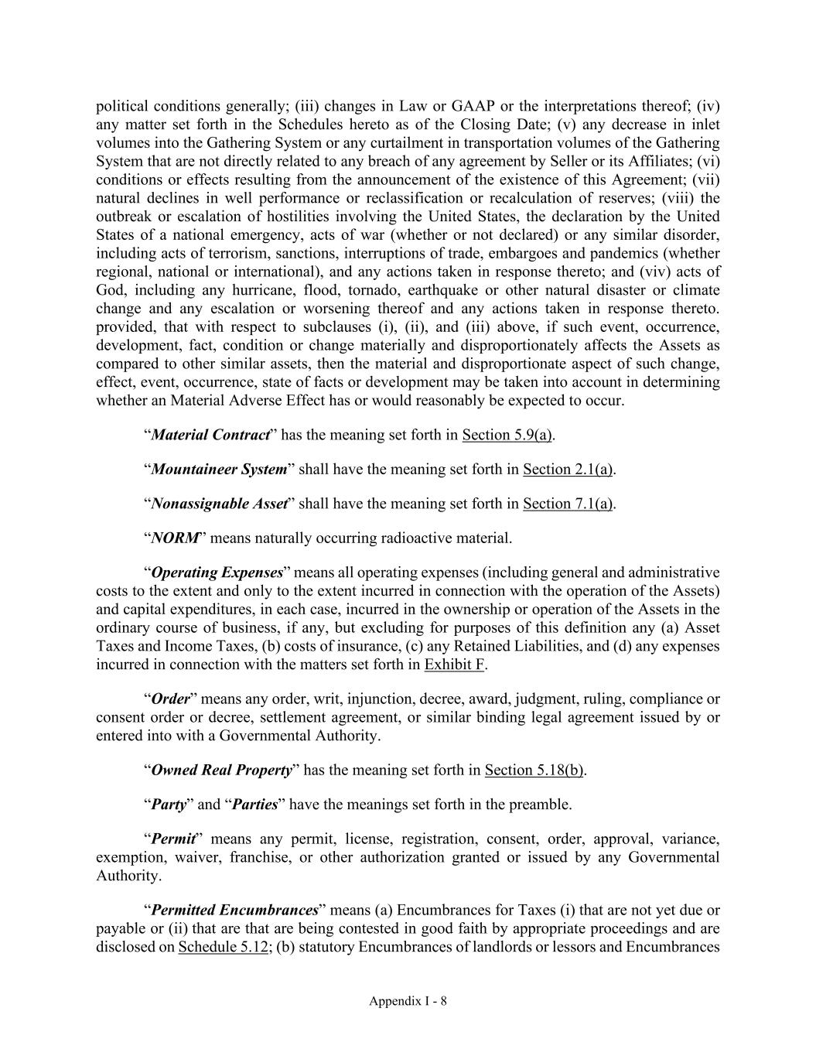
Appendix I - 8 political conditions generally; (iii) changes in Law or GAAP or the interpretations thereof; (iv) any matter set forth in the Schedules hereto as of the Closing Date; (v) any decrease in inlet volumes into the Gathering System or any curtailment in transportation volumes of the Gathering System that are not directly related to any breach of any agreement by Seller or its Affiliates; (vi) conditions or effects resulting from the announcement of the existence of this Agreement; (vii) natural declines in well performance or reclassification or recalculation of reserves; (viii) the outbreak or escalation of hostilities involving the United States, the declaration by the United States of a national emergency, acts of war (whether or not declared) or any similar disorder, including acts of terrorism, sanctions, interruptions of trade, embargoes and pandemics (whether regional, national or international), and any actions taken in response thereto; and (viv) acts of God, including any hurricane, flood, tornado, earthquake or other natural disaster or climate change and any escalation or worsening thereof and any actions taken in response thereto. provided, that with respect to subclauses (i), (ii), and (iii) above, if such event, occurrence, development, fact, condition or change materially and disproportionately affects the Assets as compared to other similar assets, then the material and disproportionate aspect of such change, effect, event, occurrence, state of facts or development may be taken into account in determining whether an Material Adverse Effect has or would reasonably be expected to occur. “Material Contract” has the meaning set forth in Section 5.9(a). “Mountaineer System” shall have the meaning set forth in Section 2.1(a). “Nonassignable Asset” shall have the meaning set forth in Section 7.1(a). “NORM” means naturally occurring radioactive material. “Operating Expenses” means all operating expenses (including general and administrative costs to the extent and only to the extent incurred in connection with the operation of the Assets) and capital expenditures, in each case, incurred in the ownership or operation of the Assets in the ordinary course of business, if any, but excluding for purposes of this definition any (a) Asset Taxes and Income Taxes, (b) costs of insurance, (c) any Retained Liabilities, and (d) any expenses incurred in connection with the matters set forth in Exhibit F. “Order” means any order, writ, injunction, decree, award, judgment, ruling, compliance or consent order or decree, settlement agreement, or similar binding legal agreement issued by or entered into with a Governmental Authority. “Owned Real Property” has the meaning set forth in Section 5.18(b). “Party” and “Parties” have the meanings set forth in the preamble. “Permit” means any permit, license, registration, consent, order, approval, variance, exemption, waiver, franchise, or other authorization granted or issued by any Governmental Authority. “Permitted Encumbrances” means (a) Encumbrances for Taxes (i) that are not yet due or payable or (ii) that are that are being contested in good faith by appropriate proceedings and are disclosed on Schedule 5.12; (b) statutory Encumbrances of landlords or lessors and Encumbrances

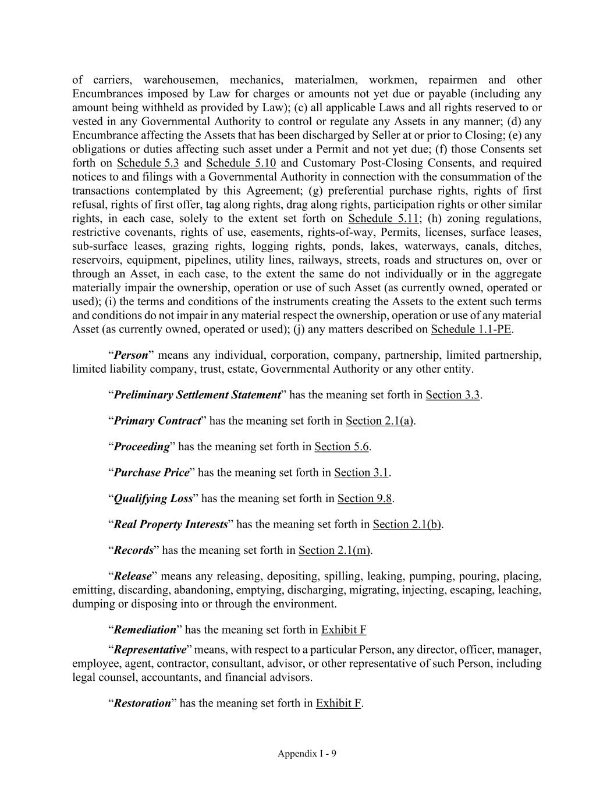
Appendix I - 9 of carriers, warehousemen, mechanics, materialmen, workmen, repairmen and other Encumbrances imposed by Law for charges or amounts not yet due or payable (including any amount being withheld as provided by Law); (c) all applicable Laws and all rights reserved to or vested in any Governmental Authority to control or regulate any Assets in any manner; (d) any Encumbrance affecting the Assets that has been discharged by Seller at or prior to Closing; (e) any obligations or duties affecting such asset under a Permit and not yet due; (f) those Consents set forth on Schedule 5.3 and Schedule 5.10 and Customary Post-Closing Consents, and required notices to and filings with a Governmental Authority in connection with the consummation of the transactions contemplated by this Agreement; (g) preferential purchase rights, rights of first refusal, rights of first offer, tag along rights, drag along rights, participation rights or other similar rights, in each case, solely to the extent set forth on Schedule 5.11; (h) zoning regulations, restrictive covenants, rights of use, easements, rights-of-way, Permits, licenses, surface leases, sub-surface leases, grazing rights, logging rights, ponds, lakes, waterways, canals, ditches, reservoirs, equipment, pipelines, utility lines, railways, streets, roads and structures on, over or through an Asset, in each case, to the extent the same do not individually or in the aggregate materially impair the ownership, operation or use of such Asset (as currently owned, operated or used); (i) the terms and conditions of the instruments creating the Assets to the extent such terms and conditions do not impair in any material respect the ownership, operation or use of any material Asset (as currently owned, operated or used); (j) any matters described on Schedule 1.1-PE. “Person” means any individual, corporation, company, partnership, limited partnership, limited liability company, trust, estate, Governmental Authority or any other entity. “Preliminary Settlement Statement” has the meaning set forth in Section 3.3. “Primary Contract” has the meaning set forth in Section 2.1(a). “Proceeding” has the meaning set forth in Section 5.6. “Purchase Price” has the meaning set forth in Section 3.1. “Qualifying Loss” has the meaning set forth in Section 9.8. “Real Property Interests” has the meaning set forth in Section 2.1(b). “Records” has the meaning set forth in Section 2.1(m). “Release” means any releasing, depositing, spilling, leaking, pumping, pouring, placing, emitting, discarding, abandoning, emptying, discharging, migrating, injecting, escaping, leaching, dumping or disposing into or through the environment. “Remediation” has the meaning set forth in Exhibit F “Representative” means, with respect to a particular Person, any director, officer, manager, employee, agent, contractor, consultant, advisor, or other representative of such Person, including legal counsel, accountants, and financial advisors. “Restoration” has the meaning set forth in Exhibit F.

Appendix I - 10 “Retained Employee-Related Liabilities” means all Liabilities that are attributable to, associated with or related to, or that arise out of or in connection with (a) any Seller Benefit Plan or any other employee benefit or compensation plan, program or arrangement sponsored, maintained or contributed to by Seller or any of its ERISA Affiliates or to which Seller or any of its ERISA Affiliates was obligated to contribute at any time on or prior to the Closing, including all Controlled Group Liabilities; or (b) the employment or engagement of any employee or contractor, including all Liabilities arising at any time with respect to any act or omission or other practice arising from or relating to an employment or independent contractor relationship or the termination thereof. “Retained Liabilities” means all obligations and Liabilities, known or unknown, to the extent arising from, based upon or related to: (a) the ownership or operation of the Assets attributable to the period of time prior to the Closing and any Proceedings to the extent relating thereto; (b) any Seller Taxes; (c) any release, disposal or transportation of any Hazardous Materials prior to Closing including any Liabilities arising from the disposal or transportation of any Hazardous Materials generated or used by Seller, its Affiliates or any other Person on behalf of or at the direction of Seller or its Affiliates, and taken from the Assets to any location that is not an Asset, in each case, prior to the Closing; (d) personal injury (including death) claims or property damage claims attributable to Seller’s or its Affiliate’s or any other Person’s operation of the Assets prior to Closing; (e) any civil or administrative fines or penalties and criminal sanctions imposed on Seller or its Affiliates in connection with any pre-Closing violation of, or pre-Closing failure to comply with, any applicable Laws, including Environmental Laws; (f) any claim made by or on behalf of an employee or contractor of Seller or any Affiliate of Seller arising from or relating to an employment or contracting relationship with Seller or any Affiliate of Seller; (g) Retained Employee-Related Liabilities; (h) all Indebtedness of Seller and its Affiliates; (i) the Excluded Assets and all Liabilities with respect thereto; (j) all Liabilities to the extent related to or arising from the Land Slip, including the Restoration and Remediation of the Land Slip by Seller as set forth in Section 7.9 and Exhibit F (or by Buyer, if Buyer completes such Restoration and Remediation pursuant to Section 7.9 and Exhibit F); and (k) the environmental matters set forth on Schedule 5.13.

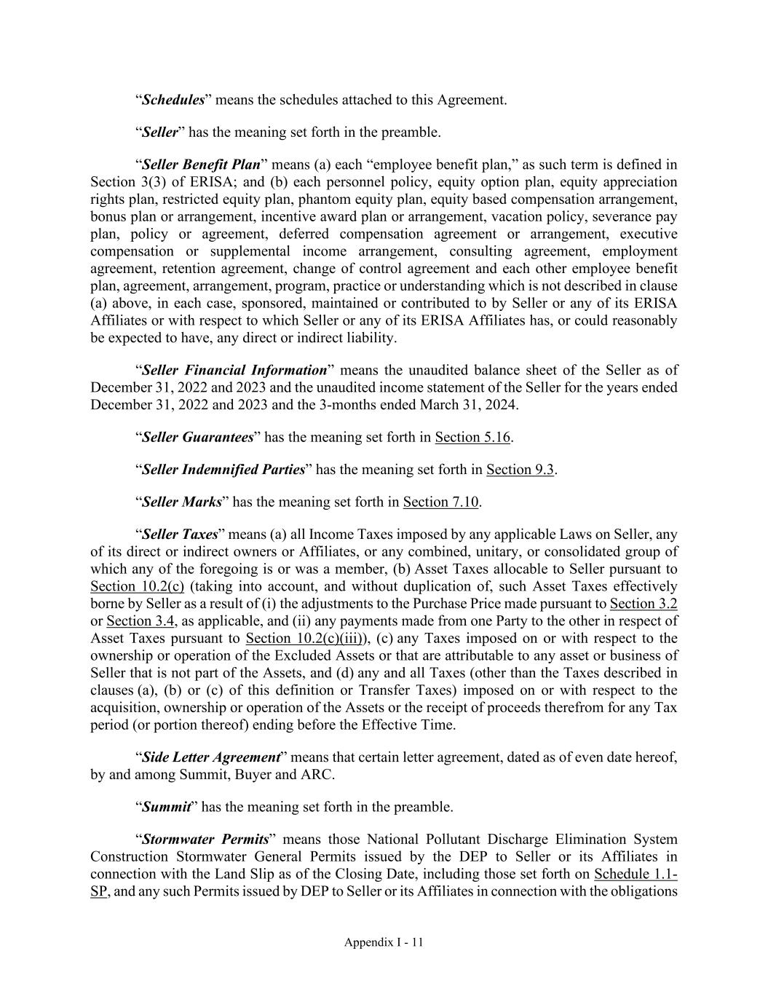
Appendix I - 11 “Schedules” means the schedules attached to this Agreement. “Seller” has the meaning set forth in the preamble. “Seller Benefit Plan” means (a) each “employee benefit plan,” as such term is defined in Section 3(3) of ERISA; and (b) each personnel policy, equity option plan, equity appreciation rights plan, restricted equity plan, phantom equity plan, equity based compensation arrangement, bonus plan or arrangement, incentive award plan or arrangement, vacation policy, severance pay plan, policy or agreement, deferred compensation agreement or arrangement, executive compensation or supplemental income arrangement, consulting agreement, employment agreement, retention agreement, change of control agreement and each other employee benefit plan, agreement, arrangement, program, practice or understanding which is not described in clause (a) above, in each case, sponsored, maintained or contributed to by Seller or any of its ERISA Affiliates or with respect to which Seller or any of its ERISA Affiliates has, or could reasonably be expected to have, any direct or indirect liability. “Seller Financial Information” means the unaudited balance sheet of the Seller as of December 31, 2022 and 2023 and the unaudited income statement of the Seller for the years ended December 31, 2022 and 2023 and the 3-months ended March 31, 2024. “Seller Guarantees” has the meaning set forth in Section 5.16. “Seller Indemnified Parties” has the meaning set forth in Section 9.3. “Seller Marks” has the meaning set forth in Section 7.10. “Seller Taxes” means (a) all Income Taxes imposed by any applicable Laws on Seller, any of its direct or indirect owners or Affiliates, or any combined, unitary, or consolidated group of which any of the foregoing is or was a member, (b) Asset Taxes allocable to Seller pursuant to Section 10.2(c) (taking into account, and without duplication of, such Asset Taxes effectively borne by Seller as a result of (i) the adjustments to the Purchase Price made pursuant to Section 3.2 or Section 3.4, as applicable, and (ii) any payments made from one Party to the other in respect of Asset Taxes pursuant to Section 10.2(c)(iii)), (c) any Taxes imposed on or with respect to the ownership or operation of the Excluded Assets or that are attributable to any asset or business of Seller that is not part of the Assets, and (d) any and all Taxes (other than the Taxes described in clauses (a), (b) or (c) of this definition or Transfer Taxes) imposed on or with respect to the acquisition, ownership or operation of the Assets or the receipt of proceeds therefrom for any Tax period (or portion thereof) ending before the Effective Time. “Side Letter Agreement” means that certain letter agreement, dated as of even date hereof, by and among Summit, Buyer and ARC. “Summit” has the meaning set forth in the preamble. “Stormwater Permits” means those National Pollutant Discharge Elimination System Construction Stormwater General Permits issued by the DEP to Seller or its Affiliates in connection with the Land Slip as of the Closing Date, including those set forth on Schedule 1.1- SP, and any such Permits issued by DEP to Seller or its Affiliates in connection with the obligations

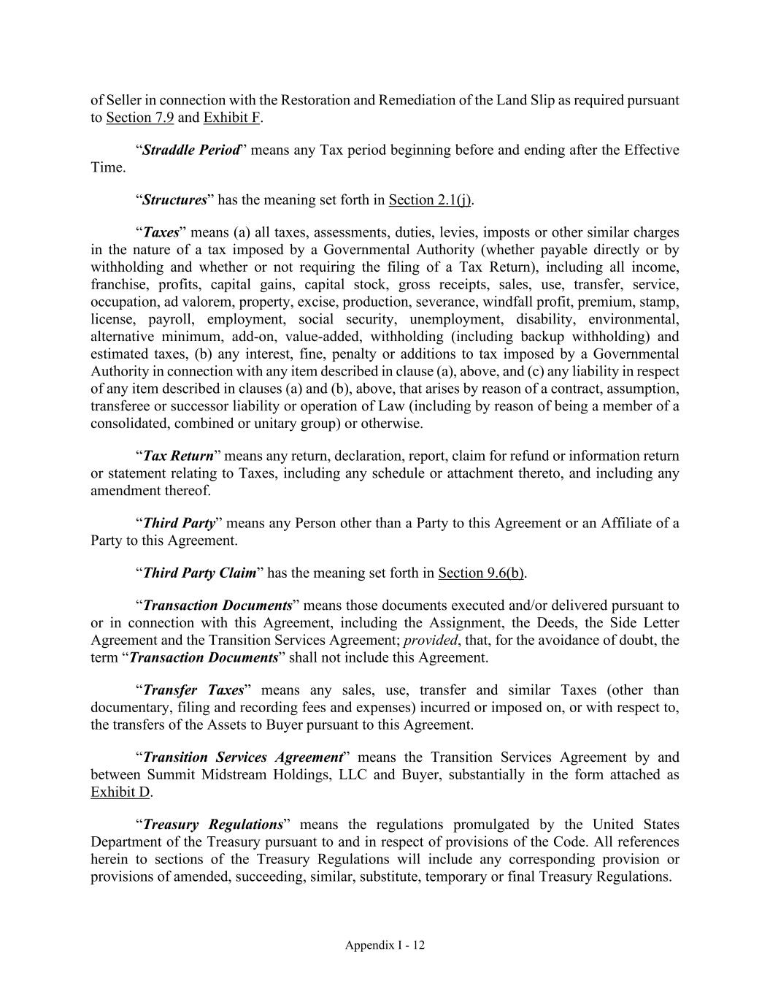
Appendix I - 12 of Seller in connection with the Restoration and Remediation of the Land Slip as required pursuant to Section 7.9 and Exhibit F. “Straddle Period” means any Tax period beginning before and ending after the Effective Time. “Structures” has the meaning set forth in Section 2.1(j). “Taxes” means (a) all taxes, assessments, duties, levies, imposts or other similar charges in the nature of a tax imposed by a Governmental Authority (whether payable directly or by withholding and whether or not requiring the filing of a Tax Return), including all income, franchise, profits, capital gains, capital stock, gross receipts, sales, use, transfer, service, occupation, ad valorem, property, excise, production, severance, windfall profit, premium, stamp, license, payroll, employment, social security, unemployment, disability, environmental, alternative minimum, add-on, value-added, withholding (including backup withholding) and estimated taxes, (b) any interest, fine, penalty or additions to tax imposed by a Governmental Authority in connection with any item described in clause (a), above, and (c) any liability in respect of any item described in clauses (a) and (b), above, that arises by reason of a contract, assumption, transferee or successor liability or operation of Law (including by reason of being a member of a consolidated, combined or unitary group) or otherwise. “Tax Return” means any return, declaration, report, claim for refund or information return or statement relating to Taxes, including any schedule or attachment thereto, and including any amendment thereof. “Third Party” means any Person other than a Party to this Agreement or an Affiliate of a Party to this Agreement. “Third Party Claim” has the meaning set forth in Section 9.6(b). “Transaction Documents” means those documents executed and/or delivered pursuant to or in connection with this Agreement, including the Assignment, the Deeds, the Side Letter Agreement and the Transition Services Agreement; provided, that, for the avoidance of doubt, the term “Transaction Documents” shall not include this Agreement. “Transfer Taxes” means any sales, use, transfer and similar Taxes (other than documentary, filing and recording fees and expenses) incurred or imposed on, or with respect to, the transfers of the Assets to Buyer pursuant to this Agreement. “Transition Services Agreement” means the Transition Services Agreement by and between Summit Midstream Holdings, LLC and Buyer, substantially in the form attached as Exhibit D. “Treasury Regulations” means the regulations promulgated by the United States Department of the Treasury pursuant to and in respect of provisions of the Code. All references herein to sections of the Treasury Regulations will include any corresponding provision or provisions of amended, succeeding, similar, substitute, temporary or final Treasury Regulations.


Appendix I - 13 “W/I Claim” means Seller’s (or its applicable Affiliate’s) ability to enforce its rights with respect to any warranty, indemnity or similar right or right, claim or cause of action under any such Applicable Contract to the extent relating to any Asset. “W/I Rights” has the meaning set forth in Section 2.1(f).

EXHIBIT 22.1

SUMMIT MIDSTREAM PARTNERS, LP
SUBSIDIARY ISSUERS AND GUARANTORS OF
REGISTERED SECURITIES

The below chart lists the subsidiary co-issuers and guarantors of the 5.75% senior notes due 2025 (the “Senior Notes”).
Subsidiary |  |  |  |  |  | Registered Security |  |  |  |  |  | Guarantor Status
Summit Midstream Holdings, LLC |  |  |  |  |  | Senior Notes |  |  |  |  |  | Co-Issuer, Not a guarantor
Summit Midstream Finance Corp. |  |  |  |  |  | Senior Notes |  |  |  |  |  | Co-Issuer, Not a guarantor
Summit Midstream Partners, LP |  |  |  |  |  | Senior Notes |  |  |  |  |  | Joint and Several, Fully and Unconditionally
Grand River Gathering, LLC |  |  |  |  |  | Senior Notes |  |  |  |  |  | Joint and Several, Fully and Unconditionally
Red Rock Gathering Company, LLC |  |  |  |  |  | Senior Notes |  |  |  |  |  | Joint and Several, Fully and Unconditionally
Summit Midstream Niobrara, LLC |  |  |  |  |  | Senior Notes |  |  |  |  |  | Joint and Several, Fully and Unconditionally
DFW Midstream Services LLC |  |  |  |  |  | Senior Notes |  |  |  |  |  | Joint and Several, Fully and Unconditionally
Polar Midstream, LLC |  |  |  |  |  | Senior Notes |  |  |  |  |  | Joint and Several, Fully and Unconditionally
Epping Transmission Company, LLC |  |  |  |  |  | Senior Notes |  |  |  |  |  | Joint and Several, Fully and Unconditionally
Summit Midstream Marketing, LLC |  |  |  |  |  | Senior Notes |  |  |  |  |  | Joint and Several, Fully and Unconditionally
Summit Midstream Permian II, LLC |  |  |  |  |  | Senior Notes |  |  |  |  |  | Joint and Several, Fully and Unconditionally
Summit Midstream OpCo, LP |  |  |  |  |  | Senior Notes |  |  |  |  |  | Joint and Several, Fully and Unconditionally
Meadowlark Midstream Company, LLC |  |  |  |  |  | Senior Notes |  |  |  |  |  | Joint and Several, Fully and Unconditionally
Summit DJ-O, LLC |  |  |  |  |  | Senior Notes |  |  |  |  |  | Joint and Several, Fully and Unconditionally
Summit DJ-S, LLC |  |  |  |  |  | Senior Notes |  |  |  |  |  | Joint and Several, Fully and Unconditionally
Summit DJ-O Operating, LLC |  |  |  |  |  | Senior Notes |  |  |  |  |  | Joint and Several, Fully and Unconditionally
Grasslands Energy Marketing LLC |  |  |  |  |  | Senior Notes |  |  |  |  |  | Joint and Several, Fully and Unconditionally

1
EXHIBIT 31.1
CERTIFICATIONS
I, Heath Deneke, certify that:
1. I have reviewed this quarterly report on Form 10-Q of Summit Midstream Partners, LP;
2. Based on my knowledge, this report does not contain any untrue statement of a material fact or omit to state a material fact necessary to make the statements made, in light of the circumstances under which such statements were made, not misleading with respect to the period covered by this report;
3. Based on my knowledge, the financial statements, and other financial information included in this report, fairly present in all material respects the financial condition, results of operations and cash flows of the registrant as of, and for, the periods presented in this report;
4. The registrant's other certifying officer(s) and I are responsible for establishing and maintaining disclosure controls and procedures (as defined in Exchange Act Rules 13a-15(e) and 15d-15(e)) and internal control over financial reporting (as defined in Exchange Act Rules 13a-15(f) and 15d-15(f)) for the registrant and have:
(a) Designed such disclosure controls and procedures, or caused such disclosure controls and procedures to be designed under our supervision, to ensure that material information relating to the registrant, including its consolidated subsidiaries, is made known to us by others within those entities, particularly during the period in which this report is being prepared;
(b) Designed such internal control over financial reporting, or caused such internal control over financial reporting to be designed under our supervision, to provide reasonable assurance regarding the reliability of financial reporting and the preparation of financial statements for external purposes in accordance with generally accepted accounting principles;
(c) Evaluated the effectiveness of the registrant's disclosure controls and procedures and presented in this report our conclusions about the effectiveness of the disclosure controls and procedures, as of the end of the period covered by this report based on such evaluation; and
(d) Disclosed in this report any change in the registrant's internal control over financial reporting that occurred during the registrant's most recent fiscal quarter (the registrant's fourth fiscal quarter in the case of an annual report) that has materially affected, or is reasonably likely to materially affect, the registrant's internal control over financial reporting; and
5. The registrant's other certifying officer(s) and I have disclosed, based on our most recent evaluation of internal control over financial reporting, to the registrant's auditors and the audit committee of the registrant's board of directors (or persons performing the equivalent functions):
(a) All significant deficiencies and material weaknesses in the design or operation of internal control over financial reporting which are reasonably likely to adversely affect the registrant's ability to record, process, summarize and report financial information; and
(b) Any fraud, whether or not material, that involves management or other employees who have a significant role in the registrant's internal control over financial reporting.
Date: |  |  | May 6, 2024 |  |  |  |  |  | /s/ Heath Deneke
Heath Deneke
President, Chief Executive Officer and Director of Summit Midstream GP, LLC (the general partner of Summit Midstream Partners, LP)

EX 31.1
EXHIBIT 31.2
CERTIFICATIONS
I, William J. Mault, certify that:
1. I have reviewed this quarterly report on Form 10-Q of Summit Midstream Partners, LP;
2. Based on my knowledge, this report does not contain any untrue statement of a material fact or omit to state a material fact necessary to make the statements made, in light of the circumstances under which such statements were made, not misleading with respect to the period covered by this report;
3. Based on my knowledge, the financial statements, and other financial information included in this report, fairly present in all material respects the financial condition, results of operations and cash flows of the registrant as of, and for, the periods presented in this report;
4. The registrant's other certifying officer(s) and I are responsible for establishing and maintaining disclosure controls and procedures (as defined in Exchange Act Rules 13a-15(e) and 15d-15(e)) and internal control over financial reporting (as defined in Exchange Act Rules 13a-15(f) and 15d-15(f)) for the registrant and have:
(a) Designed such disclosure controls and procedures, or caused such disclosure controls and procedures to be designed under our supervision, to ensure that material information relating to the registrant, including its consolidated subsidiaries, is made known to us by others within those entities, particularly during the period in which this report is being prepared;
(b) Designed such internal control over financial reporting, or caused such internal control over financial reporting to be designed under our supervision, to provide reasonable assurance regarding the reliability of financial reporting and the preparation of financial statements for external purposes in accordance with generally accepted accounting principles;
(c) Evaluated the effectiveness of the registrant's disclosure controls and procedures and presented in this report our conclusions about the effectiveness of the disclosure controls and procedures, as of the end of the period covered by this report based on such evaluation; and
(d) Disclosed in this report any change in the registrant's internal control over financial reporting that occurred during the registrant's most recent fiscal quarter (the registrant's fourth fiscal quarter in the case of an annual report) that has materially affected, or is reasonably likely to materially affect, the registrant's internal control over financial reporting; and
5. The registrant's other certifying officer(s) and I have disclosed, based on our most recent evaluation of internal control over financial reporting, to the registrant's auditors and the audit committee of the registrant's board of directors (or persons performing the equivalent functions):
(a) All significant deficiencies and material weaknesses in the design or operation of internal control over financial reporting which are reasonably likely to adversely affect the registrant's ability to record, process, summarize and report financial information; and
(b) Any fraud, whether or not material, that involves management or other employees who have a significant role in the registrant's internal control over financial reporting.

Date: |  |  | May 6, 2024 |  |  |  |  |  | /s/ William J. Mault
William J. Mault
Executive Vice President and Chief Financial Officer of Summit Midstream GP, LLC (the general partner of Summit Midstream Partners, LP)

EX 31.2
EXHIBIT 32.1
CERTIFICATION PURSUANT TO 18 U.S.C. SECTION 1350,
AS ADOPTED PURSUANT TO
SECTION 906 OF THE SARBANES-OXLEY ACT OF 2002
In connection with the quarterly report on Form 10-Q of Summit Midstream Partners, LP (the “Registrant”) for the quarterly period ended March 31, 2024, as filed with the Securities and Exchange Commission on the date hereof (the “Report”), the undersigned, Heath Deneke, as President, Chief Executive Officer and Director of Summit Midstream GP, LLC, the general partner of the Registrant, and William J. Mault, as Executive Vice President and Chief Financial Officer of Summit Midstream GP, LLC, the general partner of the Registrant, each hereby certify, pursuant to 18 U.S.C. Section 1350, as adopted pursuant to Section 906 of the Sarbanes-Oxley Act of 2002, that, to his knowledge:
(1)The Report fully complies with the requirements of Section 13(a) or 15(d) of the Securities Exchange Act of 1934; and
(2)The information contained in the Report fairly presents, in all material respects, the financial condition and results of operations of the Registrant.
/s/ Heath Deneke
Name: |  |  |  |  |  | Heath Deneke
Title: |  |  |  |  |  | President, Chief Executive Officer and Director of Summit Midstream GP, LLC  (the general partner of Summit Midstream Partners, LP)
Date: |  |  |  |  |  | May 6, 2024
/s/ William J. Mault
Name: |  |  |  |  |  | William J. Mault
Title: |  |  |  |  |  | Executive Vice President and Chief Financial Officer of Summit Midstream GP, LLC  (the general partner of Summit Midstream Partners, LP)
Date: |  |  |  |  |  | May 6, 2024

EX 32.1
EXHIBIT 99.1

SUMMIT MIDSTREAM PARTNERS, LP AND SUBSIDIARIES
PRO FORMA CONDENSED CONSOLIDATED FINANCIAL STATEMENTS (Unaudited)
March 2024 disposition of Summit Midstream Utica, LLC
On March 22, 2024, Summit Midstream Partners, LP (“Summit” and, together with its subsidiaries, “SMLP” or the “Partnership”), and Summit Midstream OpCo, LP, an indirectly owned subsidiary of Summit (“OpCo”), completed the sale of Summit Midstream Utica, LLC (“Utica”) to a subsidiary of MPLX LP (“MPLX”) for cash consideration of $625.0 million, subject to customary post-closing adjustments (the “Summit Utica Sale”), pursuant to a Purchase and Sale Agreement, dated March 22, 2024, by and among OpCo, as Seller, MPLX, as Buyer, and solely for purposes of Section 12.18 thereto, Summit, as Seller Parent (each as defined therein). Utica is the owner of (i) approximately 36% of the issued and outstanding equity interests in Ohio Gathering Company, L.L.C. (“OGC”), (ii) approximately 38% of the issued and outstanding equity interests in Ohio Condensate Company, L.L.C. (together with OGC, “Ohio Gathering”) and (iii) midstream assets located in the Utica Shale. Ohio Gathering is the owner of a natural gas gathering system and condensate stabilization facility located in Belmont and Monroe counties in the Utica Shale in southeastern Ohio. MPLX is the operator of Ohio Gathering and, prior to the closing of the Transaction, was OpCo’s joint venture partner.
May 2024 disposition of Mountaineer Midstream assets
On May 1, 2024, the Partnership completed the sale of its Mountaineer Midstream system to Antero Midstream LLC for a cash sale price of $70 million, subject to customary post-closing adjustments (the “Mountaineer Transaction”). Mountaineer is the owner of midstream assets located in the Marcellus Shale. Prior to closing the Mountaineer Transaction, the Partnership also sold related compression assets located in the Marcellus Shale to a compression service provider for approximately $5 million in April 2024.
Unaudited Pro Forma Condensed Consolidated Financial Statements
The following unaudited pro forma condensed consolidated financial statements of the Partnership are presented to illustrate the effect to the Partnership’s historical financial position and operating results of (i) the Mountaineer Transaction and (ii) the Summit Utica Sale.
The Mountaineer Transaction and the Summit Utica Sale each constitute significant dispositions for purposes of Item 2.01 of Form 8-K. As a result, the Partnership prepared the accompanying unaudited pro forma condensed consolidated financial statements in accordance with Article 11 of Regulation S-X. This divestiture does not qualify as a discontinued operation as it does not represent a strategic shift that will have a major effect on SMLP’s operations or financial results.
The accompanying unaudited pro forma condensed consolidated balance sheet as of March 31, 2024 has been prepared to reflect the Mountaineer Transaction as if it had occurred on March 31, 2024. The unaudited pro forma condensed consolidated statements of operations for the three months ended March 31, 2024 and for the year ended December 31, 2023 have been prepared as if the Mountaineer Transaction and Summit Utica Sale had occurred on January 1, 2023.
The unaudited pro forma condensed consolidated balance sheet and statements of operations included herein are for information purposes only and are not necessarily indicative of the results that might have occurred had the divestitures taken place on the respective dates assumed. Actual results may differ significantly from those reflected in the unaudited pro forma condensed consolidated financial statements for various reasons, including but not limited to, the differences between the assumptions used to prepare the unaudited pro forma condensed consolidated financial statements and actual results. The pro forma adjustments in the unaudited pro forma condensed consolidated balance sheet and the statements of operations included herein include the use of estimates and assumptions as described in the accompanying notes. The pro forma adjustments are based on information available to the Partnership at the time these unaudited pro forma condensed consolidated financial statements were prepared. The Partnership believes its current estimates provide a reasonable basis of presenting the significant effects of the divestitures. However, the estimates and assumptions are subject to change as additional information becomes available. The unaudited pro forma condensed consolidated financial statements include only those adjustments related to the divestitures.
The unaudited pro forma condensed consolidated financial statements are based on the historical consolidated financial statements of the Partnership and should be read in conjunction with the condensed consolidated financial statements and accompanying footnotes included in the Partnership’s Quarterly Report on Form 10-Q for the three months ended March 31, 2024 and the consolidated financial statements and accompanying footnotes included in the Partnership’s Annual Report on Form 10-K for the year ended December 31, 2023, filed with the Securities and Exchange Commission on May 6, 2024 and March 15, 2024, respectively.
1

SUMMIT MIDSTREAM PARTNERS, LP AND SUBSIDIARIES
PRO FORMA CONDENSED CONSOLIDATED BALANCE SHEET (UNAUDITED)
As of March 31, 2024
(In thousands, except unit amounts) |  |  | Historical |  |  |  |  |  | Pro forma  Adjustments |  |  |  |  |  |  |  | Pro forma  Combined
ASSETS
Cash and cash equivalents |  |  | $ | 344,590 |  |  |  |  | $ | 74,345 |  | (a) (b) |  |  |  |  | $ | 418,935
Restricted cash |  |  | 3,454 |  |  |  |  |  | — |  |  |  |  |  |  |  | 3,454
Accounts receivable |  |  | 66,587 |  |  |  |  |  | (6,005) |  |  | (b) |  |  |  |  | 60,582
Other current assets |  |  | 5,935 |  |  |  |  |  | (100) |  |  | (b) |  |  |  |  | 5,835
Total current assets |  |  | 420,566 |  |  |  |  |  | 68,240 |  |  |  |  |  |  |  | 488,806
Property, plant and equipment, net |  |  | 1,447,443 |  |  |  |  |  | (64,910) |  |  | (b) |  |  |  |  | 1,382,533
Intangible assets, net |  |  | 147,304 |  |  |  |  |  | (9,016) |  |  | (b) |  |  |  |  | 138,288
Investment in equity method investees |  |  | 273,476 |  |  |  |  |  | — |  |  |  |  |  |  |  | 273,476
Other noncurrent assets |  |  | 31,786 |  |  |  |  |  | (375) |  |  | (b) |  |  |  |  | 31,411
TOTAL ASSETS |  |  | $ | 2,320,575 |  |  |  |  | $ | (6,061) |  |  |  |  |  |  | $ | 2,314,514
LIABILITIES AND CAPITAL
Trade accounts payable |  |  | $ | 18,063 |  |  |  |  | $ | 931 |  | (b) (c) |  |  |  |  | $ | 18,994
Accrued expenses |  |  | 36,554 |  |  |  |  |  | (670) |  |  | (b) |  |  |  |  | 35,884
Deferred revenue |  |  | 8,899 |  |  |  |  |  | — |  |  |  |  |  |  |  | 8,899
Ad valorem taxes payable |  |  | 3,282 |  |  |  |  |  | (853) |  |  | (b) |  |  |  |  | 2,429
Accrued compensation and employee benefits |  |  | 2,824 |  |  |  |  |  | (51) |  |  | (b) |  |  |  |  | 2,773
Accrued interest |  |  | 44,826 |  |  |  |  |  | — |  |  |  |  |  |  |  | 44,826
Accrued environmental remediation |  |  | 1,854 |  |  |  |  |  | — |  |  |  |  |  |  |  | 1,854
Accrued settlement payable |  |  | 6,667 |  |  |  |  |  | — |  |  |  |  |  |  |  | 6,667
Current portion of long-term debt |  |  | 29,098 |  |  |  |  |  | — |  |  |  |  |  |  |  | 29,098
Other current liabilities |  |  | 7,476 |  |  |  |  |  | — |  |  |  |  |  |  |  | 7,476
Total current liabilities |  |  | 159,543 |  |  |  |  |  | (643) |  |  |  |  |  |  |  | 158,900
Long-term debt, net |  |  | 1,127,287 |  |  |  |  |  | — |  |  |  |  |  |  |  | 1,127,287
Noncurrent deferred revenue |  |  | 28,761 |  |  |  |  |  | — |  |  |  |  |  |  |  | 28,761
Noncurrent accrued environmental remediation |  |  | 1,278 |  |  |  |  |  | — |  |  |  |  |  |  |  | 1,278
Other noncurrent liabilities |  |  | 28,298 |  |  |  |  |  | — |  |  |  |  |  |  |  | 28,298
Total liabilities |  |  | 1,345,167 |  |  |  |  |  | (643) |  |  |  |  |  |  |  | 1,344,524
Commitments and contingencies
Mezzanine Capital
Subsidiary Series A Preferred Units |  |  | 126,794 |  |  |  |  |  | — |  |  |  |  |  |  |  | 126,794
Partners’ Capital
Series A Preferred Units |  |  | 100,113 |  |  |  |  |  | — |  |  |  |  |  |  |  | 100,113
Common limited partner capital |  |  | 748,501 |  |  |  |  |  | (5,418) |  |  | (b) (d) |  |  |  |  | 743,083
Total partners’ capital |  |  | 848,614 |  |  |  |  |  | (5,418) |  |  |  |  |  |  |  | 843,196
TOTAL LIABILITIES AND CAPITAL |  |  | $ | 2,320,575 |  |  |  |  | $ | (6,061) |  |  |  |  |  |  | $ | 2,314,514

The accompanying notes are an integral part of these unaudited pro forma condensed consolidated financial statements.

2
SUMMIT MIDSTREAM PARTNERS, LP AND SUBSIDIARIES
PRO FORMA CONDENSED CONSOLIDATED STATEMENT OF OPERATIONS (UNAUDITED)
For the Three Months Ended March 31, 2024
(In thousands, except per-unit amounts) |  |  | Historical |  |  |  |  |  | Mountaineer Conforming Adjustments |  |  |  |  |  | Utica Conforming Adjustments |  |  |  |  |  |  |  | Pro forma  Combined
Revenues:
Gathering services and related fees |  |  | $ | 61,985 |  |  |  |  | $ | (5,980) |  | (e) |  |  | $ | (10,873) |  | (e) |  |  |  |  | $ | 45,132
Natural gas, NGLs and condensate sales |  |  | 49,092 |  |  |  |  |  | — |  |  |  |  |  | — |  |  |  |  |  |  |  | 49,092
Other revenues |  |  | 7,794 |  |  |  |  |  | — |  |  |  |  |  | — |  |  |  |  |  |  |  | 7,794
Total revenues |  |  | 118,871 |  |  |  |  |  | (5,980) |  |  |  |  |  | (10,873) |  |  |  |  |  |  |  | 102,018
Costs and expenses:
Cost of natural gas and NGLs |  |  | 30,182 |  |  |  |  |  | — |  |  |  |  |  | — |  |  |  |  |  |  |  | 30,182
Operation and maintenance |  |  | 25,012 |  |  |  |  |  | (872) |  |  | (e) |  |  | (1,021) |  |  | (e) |  |  |  |  | 23,119
General and administrative |  |  | 14,785 |  |  |  |  |  | (108) |  |  | (e) |  |  | (92) |  |  | (e) |  |  |  |  | 14,585
Depreciation and amortization |  |  | 27,867 |  |  |  |  |  | (2,309) |  |  | (e) |  |  | (1,939) |  |  | (e) |  |  |  |  | 23,619
Transaction costs |  |  | 7,791 |  |  |  |  |  | — |  |  |  |  |  | — |  |  |  |  |  |  |  | 7,791
Acquisition integration costs |  |  | 40 |  |  |  |  |  | — |  |  |  |  |  | — |  |  |  |  |  |  |  | 40
Gain on asset sales, net |  |  | (27) |  |  |  |  |  | — |  |  |  |  |  | — |  |  |  |  |  |  |  | (27)
Long-lived asset impairments |  |  | 67,916 |  |  |  |  |  | (67,916) |  |  | (j) |  |  | — |  |  |  |  |  |  |  | —
Total costs and expenses |  |  | 173,566 |  |  |  |  |  | (71,205) |  |  |  |  |  | (3,052) |  |  |  |  |  |  |  | 99,309
Other income, net |  |  | (13) |  |  |  |  |  | 752 |  |  | (g) |  |  | 3,155 |  |  | (g) |  |  |  |  | 3,894
Gain on interest rate swaps |  |  | 2,590 |  |  |  |  |  | — |  |  |  |  |  | — |  |  |  |  |  |  |  | 2,590
Gain (loss) on sale of business |  |  | 86,202 |  |  |  |  |  | — |  |  |  |  |  | (86,202) |  |  | (i) |  |  |  |  | —
Gain on sale of equity method investment |  |  | 126,261 |  |  |  |  |  | — |  |  |  |  |  | (126,261) |  |  | (i) |  |  |  |  | —
Interest expense |  |  | (37,846) |  |  |  |  |  | — |  |  |  |  |  | 5,935 |  |  | (f) |  |  |  |  | (31,911)
Income (loss) before income taxes and equity method investment income |  |  | 122,499 |  |  |  |  |  | 65,977 |  |  |  |  |  | (211,194) |  |  |  |  |  |  |  | (22,718)
Income tax expense |  |  | (210) |  |  |  |  |  | — |  |  |  |  |  | — |  |  |  |  |  |  |  | (210)
Income from equity method investees |  |  | 10,638 |  |  |  |  |  | — |  |  |  |  |  | (7,039) |  |  | (e) |  |  |  |  | 3,599
Net income (loss) |  |  | $ | 132,927 |  |  |  |  | $ | 65,977 |  |  |  |  | $ | (218,233) |  |  |  |  |  |  | $ | (19,329)
Less: Net income attributable to Subsidiary Series A Preferred Units |  |  | (3,770) |  |  |  |  |  | — |  |  |  |  |  | — |  |  |  |  |  |  |  | (3,770)
Net income (loss) attributable to Summit Midstream Partners, LP |  |  | $ | 129,157 |  |  |  |  | $ | 65,977 |  |  |  |  | $ | (218,233) |  |  |  |  |  |  | $ | (23,099)
Less: net income attributable to Series A Preferred Units |  |  | (3,220) |  |  |  |  |  | — |  |  |  |  |  | — |  |  |  |  |  |  |  | (3,220)
Net income (loss) attributable to common limited partners |  |  | $ | 125,937 |  |  |  |  | $ | 65,977 |  |  |  |  | $ | (218,233) |  |  |  |  |  |  | $ | (26,319)
Net income (loss) per limited partner unit:
Common unit – basic |  |  | $ | 12.05 |  |  |  |  |  |  |  |  |  |  |  |  |  |  |  |  |  |  | $ | (2.52)
Common unit – diluted |  |  | $ | 11.47 |  |  |  |  |  |  |  |  |  |  |  |  |  |  |  |  |  |  | $ | (2.40)
Weighted-average limited partner units outstanding:
Common units – basic |  |  | 10,449 |  |  |  |  |  |  |  |  |  |  |  |  |  |  |  |  |  |  |  | 10,449
Common units – diluted |  |  | 10,980 |  |  |  |  |  |  |  |  |  |  |  |  |  |  |  |  |  |  |  | 10,980
The accompanying notes are an integral part of these unaudited pro forma condensed consolidated financial statements.

3
SUMMIT MIDSTREAM PARTNERS, LP AND SUBSIDIARIES
PRO FORMA CONDENSED CONSOLIDATED STATEMENT OF OPERATIONS (UNAUDITED)
For the Year Ended December 31, 2023
(In thousands, except per-unit amounts) |  |  | Historical |  |  |  |  |  | Mountaineer Conforming Adjustments |  |  |  |  |  | Utica Conforming Adjustments |  |  |  |  |  |  |  | Pro forma  Combined
Revenues:
Gathering services and related fees |  |  | $ | 248,223 |  |  |  |  | $ | (24,885) |  | (e) |  |  | $ | (38,920) |  | (e) |  |  |  |  | $ | 184,418
Natural gas, NGLs and condensate sales |  |  | 179,254 |  |  |  |  |  | — |  |  |  |  |  | — |  |  |  |  |  |  |  | 179,254
Other revenues |  |  | 31,426 |  |  |  |  |  | — |  |  |  |  |  | — |  |  |  |  |  |  |  | 31,426
Total revenues |  |  | 458,903 |  |  |  |  |  | (24,885) |  |  |  |  |  | (38,920) |  |  |  |  |  |  |  | 395,098
Costs and expenses:
Cost of natural gas and NGLs |  |  | 112,462 |  |  |  |  |  | — |  |  |  |  |  | — |  |  |  |  |  |  |  | 112,462
Operation and maintenance |  |  | 100,741 |  |  |  |  |  | (4,361) |  |  | (e) |  |  | (4,499) |  |  | (e) |  |  |  |  | 91,881
General and administrative |  |  | 42,135 |  |  |  |  |  | (398) |  |  | (e) |  |  | (470) |  |  | (e) |  |  |  |  | 41,267
Depreciation and amortization |  |  | 122,764 |  |  |  |  |  | (9,266) |  |  | (e) |  |  | (8,589) |  |  | (e) |  |  |  |  | 104,909
Transaction costs |  |  | 1,251 |  |  |  |  |  | 1,000 |  |  | (h) |  |  | 7,889 |  |  | (h) |  |  |  |  | 10,140
Acquisition integration costs |  |  | 2,654 |  |  |  |  |  | — |  |  |  |  |  | — |  |  |  |  |  |  |  | 2,654
Gain on asset sales, net |  |  | (260) |  |  |  |  |  | 7 |  |  | (e) |  |  | — |  |  |  |  |  |  |  | (253)
Long-lived asset impairments |  |  | 540 |  |  |  |  |  | 67,916 |  |  | (j) |  |  | — |  |  |  |  |  |  |  | 68,456
Total costs and expenses |  |  | 382,287 |  |  |  |  |  | 54,898 |  |  |  |  |  | (5,669) |  |  |  |  |  |  |  | 431,516
Other income, net |  |  | 865 |  |  |  |  |  | 3,017 |  |  | (g) |  |  | 12,312 |  |  | (g) |  |  |  |  | 16,194
Gain on interest rate swaps |  |  | 1,830 |  |  |  |  |  | — |  |  |  |  |  | — |  |  |  |  |  |  |  | 1,830
Gain (loss) on sale of business |  |  | (47) |  |  |  |  |  | — |  |  |  |  |  | 86,202 |  |  | (i) |  |  |  |  | 86,155
Gain on sale of equity method investment |  |  | — |  |  |  |  |  | — |  |  |  |  |  | 126,261 |  |  | (i) |  |  |  |  | 126,261
Interest expense |  |  | (140,784) |  |  |  |  |  | — |  |  |  |  |  | 26,227 |  |  | (f) |  |  |  |  | (114,557)
Loss on early extinguishment of debt |  |  | (10,934) |  |  |  |  |  | — |  |  |  |  |  | — |  |  |  |  |  |  |  | (10,934)
Income (loss) before income taxes and equity method investment income |  |  | (72,454) |  |  |  |  |  | (76,766) |  |  |  |  |  | 217,751 |  |  |  |  |  |  |  | 68,531
Income tax expense |  |  | (322) |  |  |  |  |  | — |  |  |  |  |  | — |  |  |  |  |  |  |  | (322)
Income from equity method investees |  |  | 33,829 |  |  |  |  |  | — |  |  |  |  |  | (22,922) |  |  | (e) |  |  |  |  | 10,907
Net income (loss) |  |  | $ | (38,947) |  |  |  |  | $ | (76,766) |  |  |  |  | $ | 194,829 |  |  |  |  |  |  | $ | 79,116
Less: Net income attributable to Subsidiary Series A Preferred Units |  |  | (12,581) |  |  |  |  |  | — |  |  |  |  |  | — |  |  |  |  |  |  |  | (12,581)
Net income (loss) attributable to Summit Midstream Partners, LP |  |  | $ | (51,528) |  |  |  |  | $ | (76,766) |  |  |  |  | $ | 194,829 |  |  |  |  |  |  | $ | 66,535
Less: net income attributable to Series A Preferred Units |  |  | (11,566) |  |  |  |  |  | — |  |  |  |  |  | — |  |  |  |  |  |  |  | (11,566)
Net income (loss) attributable to common limited partners |  |  | $ | (63,094) |  |  |  |  | $ | (76,766) |  |  |  |  | $ | 194,829 |  |  |  |  |  |  | $ | 54,969
Net income (loss) per limited partner unit:
Common unit – basic |  |  | $ | (6.11) |  |  |  |  |  |  |  |  |  |  |  |  |  |  |  |  |  |  | $ | 5.32
Common unit – diluted |  |  | $ | (6.11) |  |  |  |  |  |  |  |  |  |  |  |  |  |  |  |  |  |  | $ | 5.21
Weighted-average limited partner units outstanding:
Common units – basic |  |  | 10,334 |  |  |  |  |  |  |  |  |  |  |  |  |  |  |  |  |  |  |  | 10,334
Common units – diluted |  |  | 10,334 |  |  |  |  |  |  |  |  |  |  |  |  |  |  |  |  |  |  |  | 10,544
The accompanying notes are an integral part of these unaudited pro forma condensed consolidated financial statements.

4
SUMMIT MIDSTREAM PARTNERS, LP AND SUBSIDIARIES
NOTES TO PRO FORMA CONDENSED CONSOLIDATED FINANCIAL STATEMENTS (Unaudited)
1. BASIS OF PRESENTATION
The March 31, 2024 unaudited pro forma condensed consolidated balance sheet gives effect to the pro forma adjustments necessary to reflect the Mountaineer Transaction as if it had occurred on March 31, 2024. The unaudited pro forma condensed consolidated statement of operations gives effect to the pro forma adjustments necessary to reflect the Mountaineer Transaction and the Summit Utica Sale as if they had occurred on January 1, 2023. The unaudited pro forma adjustments related to the dispositions are based on available information and assumptions that management believes are (i) directly attributable to the Mountaineer Transaction and Summit Utica Sale; (ii) factually supportable and (iii) with respect to the unaudited consolidated statements of operations, expected to have a continuing impact on consolidated operating results.
2. PRO FORMA ADJUSTMENTS
The unaudited pro forma condensed consolidated statements reflect the following adjustments:
Balance Sheet
“Historical” - represents the historical unaudited consolidated balance sheet of the Partnership as of March 31, 2024.
(a) To adjust Partnership balance sheet accounts for cash proceeds received associated with the Mountaineer Transaction and the sale of compression assets.
b) To remove the Partnership’s assets and liabilities associated with the Mountaineer Transaction. The following is a summarization of the application of net proceeds and estimated loss on the Mountaineer Transaction and sale of compression equipment.
(in thousands)
Sale price |  |  | $ | 74,400
Cash on hand |  |  | (55)
Accounts receivable |  |  | (6,005)
Other current assets |  |  | (100)
Property, plant and equipment, net |  |  | (64,910)
Intangible assets |  |  | (9,016)
Other noncurrent assets |  |  | (375)
Trade accounts payable, accrued expenses and other current liabilities |  |  | 643
(c) To adjust for the unrecognized transaction costs associated with the Mountaineer Transaction, primarily for investment bank, advisory and legal fees.
(d) To adjust for the estimated loss to be recognized by the Partnership related to the Mountaineer Transaction.
Income Statement
“Historical” - represents the historical audited statement of operations of the Partnership for the year ended December 31, 2023.
(e) Adjustments are to eliminate revenues and costs of Utica and Mountaineer from the Partnership’s consolidated financial results.
(f) To adjust interest expense for the impact of an estimated $313.0 million pay down of the Partnership’s asset-based revolving credit facility with proceeds received from the Summit Utica Sale, partially offset by increased interest expense resulting from an increase in commitment fees owed on the asset-based revolving credit facility.
(g) To adjust for the estimated interest income associated with the proceeds received from the Mountaineer Transaction and Summit Utica Sale.
(h) To adjust for unrecognized transaction costs associated with the Mountaineer Transaction and Summit Utica Sale, primarily for investment bank, advisory, and legal fees.
(i) To adjust the gain recognized as a result of the Summit Utica Sale as if the transaction had occurred on January 1, 2023.
(j) To adjust impairment associated with the Mountaineer Transaction as if the transaction had occurred on January 1, 2023.
5

